|  |
| --- |
| **E:\My Documents\Desktop\Logo_FPT_University_doc.jpgMinistry of education and training** |
| Capstone Project Document |
| Place Sharing Network |
|  |
| |  |  | | --- | --- | | **PSN Team** | | | **Group Members** | Võ Thanh Quảng – 00308 – QuangVT00308  Lê Minh Quang – 00518 – QuangLM00518  Trương Quang Dũng – 00440 – DungTQ00440  Nguyễn Minh Quốc – 00319 – QuocNM00319  Nguyễn Minh Vượng – 00335 – VuongNM00335 | | **Supervisor** | Teacher Huỳnh Anh Dũng | | **Ext Supervisor** |  | | **Capstone Project code** | PSN | |
| **Hanoi, 22nd Apr, 2011** |

**Record of Changes**

|  |  |  |  |  |
| --- | --- | --- | --- | --- |
| **Date** | **Change Item** | **Description** | **By** | **Version** |
| 19/04/2011 | All | Create the document | DungTQ | 0.1 |
| 20/04/2011 | All | Edit format document | DungTQ | 0.2 |
| 20/04/2011 | Coding conventions specific for this Project | Add content  Edit format in section A | DungTQ | 0.3 |
| 22/04/2011 | Coding conventions specific for this Project | Edit content | DungTQ | 0.4 |
| 23/04/2011 | Database design | Update some database field definitions | QuangVT | 1.0 |
|  |  |  |  |  |

# Table of Contents

[Table of Contents 2](#_Toc291316130)

[A. Introduction 13](#_Toc291316131)

[I. Project Information 13](#_Toc291316132)

[II. Purposes 13](#_Toc291316133)

[III. The People 13](#_Toc291316134)

[IV. Background 13](#_Toc291316135)

[V. Literature Review of Existing Systems 14](#_Toc291316136)

[VI. Our Proposal 15](#_Toc291316137)

[VII. Products 15](#_Toc291316138)

[B. Software Project Management Plan 16](#_Toc291316139)

[I. Problem Definition 16](#_Toc291316140)

[1. Name of this Capstone Project 16](#_Toc291316141)

[2. Problem Abstract 16](#_Toc291316142)

[3. Project Overview 16](#_Toc291316143)

[3.1 The Current System 16](#_Toc291316144)

[3.2 The Proposed System 16](#_Toc291316145)

[3.3 Boundaries of the System 17](#_Toc291316146)

[3.4 Development Environment 17](#_Toc291316147)

[II. Project Organization 17](#_Toc291316148)

[1. Software Process Model 17](#_Toc291316149)

[2. Roles and Responsibilities 18](#_Toc291316150)

[3. Tools and Techniques 19](#_Toc291316151)

[III. Project Management Plan 19](#_Toc291316152)

[1. Tasks 19](#_Toc291316153)

[1.1 Create Software Requirements Specification 19](#_Toc291316155)

[1.2 Design Database 19](#_Toc291316156)

[1.3 Create Software Design Description 20](#_Toc291316157)

[1.4 Layout Design 20](#_Toc291316158)

[1.5 Create Coding Framework 20](#_Toc291316159)

[1.6 Coding 21](#_Toc291316160)

[1.7 System Test 21](#_Toc291316161)

[1.8 Input Initial Data 22](#_Toc291316162)

[1.9 Deployment 22](#_Toc291316163)

[2. Task Sheet: Assignments and Timetable 23](#_Toc291316164)

[3. Meeting Minutes 23](#_Toc291316165)

[3.1 Kickoff Meeting 6/1/2011 23](#_Toc291316166)

[3.2 Meeting 11/1/2011 24](#_Toc291316167)

[3.3 Meeting 13/1/2011 25](#_Toc291316168)

[3.4 Meeting 15/1/2011 26](#_Toc291316169)

[3.5 Meeting 18/1/2011 27](#_Toc291316170)

[3.6 Meeting 21/1/2011 28](#_Toc291316171)

[3.7 Meeting 24/2/2011 29](#_Toc291316172)

[IV. Coding Conventions 29](#_Toc291316173)

[1. Naming Conventions 29](#_Toc291316174)

[Pascal Casing 29](#_Toc291316175)

[Camel Casing 29](#_Toc291316176)

[Uppercase 29](#_Toc291316177)

[Naming rules 29](#_Toc291316178)

[2. Coding Styles 33](#_Toc291316179)

[3. Comments 37](#_Toc291316180)

[4. Coding Conventions Specific for this Project 37](#_Toc291316181)

[C. Software Requirement Specifications 38](#_Toc291316182)

[I. User Requirement Specification 38](#_Toc291316183)

[1. User Requirements 38](#_Toc291316184)

[2. Administration requirements 39](#_Toc291316185)

[3. Ranking requirements 39](#_Toc291316186)

[4. Comment/Answer requirement 40](#_Toc291316187)

[5. Place Requirement 40](#_Toc291316188)

[6. Search Requirement 40](#_Toc291316189)

[II. System Requirement Specification (Specific Requirements) 41](#_Toc291316190)

[1. External Interface Requirements 41](#_Toc291316191)

[1.1 User Interfaces 41](#_Toc291316192)

[1.2 Hardware Interfaces 41](#_Toc291316193)

[1.3 Software Interfaces 41](#_Toc291316194)

[1.4 Communications Protocol 42](#_Toc291316195)

[2. System Features 42](#_Toc291316196)

[2.1 Create a New Place 42](#_Toc291316197)

[2.2 Edit a Place’s Information 47](#_Toc291316198)

[2.3 Edit a Place’s Location 53](#_Toc291316199)

[2.4 View Edit History of a Place 57](#_Toc291316200)

[2.5 View a Revision of a Place 61](#_Toc291316201)

[2.6 Compare 2 Revisions of a Place 66](#_Toc291316202)

[2.7 Approve a Revision 70](#_Toc291316203)

[2.8 Set a revision as current 75](#_Toc291316204)

[2.9 View a Place Detail 79](#_Toc291316205)

[2.10 Search Places 86](#_Toc291316206)

[2.11 Report a Place 92](#_Toc291316207)

[2.12 Mark a Place as Visited 95](#_Toc291316208)

[2.13 Rate a Place 97](#_Toc291316209)

[2.14 Post a Comment 100](#_Toc291316210)

[2.15 Delete a Comment 104](#_Toc291316211)

[2.16 Vote a Comment 106](#_Toc291316212)

[2.17 Highlight Best Comment 111](#_Toc291316213)

[2.18 Report a Comment 113](#_Toc291316214)

[2.19 Question & Answer Page 118](#_Toc291316215)

[2.20 View Question Detail 121](#_Toc291316216)

[2.21 Create a New Question 126](#_Toc291316217)

[2.22 Vote a Question 130](#_Toc291316218)

[2.23 Report a Question 134](#_Toc291316219)

[2.24 Post an answer 138](#_Toc291316220)

[2.25 Vote an answer 141](#_Toc291316221)

[2.26 Report an answer 145](#_Toc291316222)

[2.27 Delete an answer 150](#_Toc291316223)

[2.28 View Favorite List 152](#_Toc291316224)

[2.29 Add a Place to Favorite List 155](#_Toc291316225)

[2.30 Remove Places from Favorite List 158](#_Toc291316226)

[2.31 List Top Places of Month 161](#_Toc291316227)

[2.32 List Newest Places 162](#_Toc291316228)

[2.33 List Most Searched Categories 165](#_Toc291316229)

[2.34 List Most Contributors 168](#_Toc291316230)

[2.35 Log In 170](#_Toc291316231)

[2.36 Log Out 175](#_Toc291316232)

[2.37 Register an Account 177](#_Toc291316233)

[2.38 Reset Forgot Password 182](#_Toc291316234)

[2.39 Edit Your Profile 186](#_Toc291316235)

[2.40 Change Password 191](#_Toc291316236)

[2.41 View an User’s Profile 194](#_Toc291316237)

[2.42 <Admin> List all Users 200](#_Toc291316238)

[2.43 <Admin> View User Detail 203](#_Toc291316239)

[2.44 <Admin> Edit an User 205](#_Toc291316240)

[2.45 <Admin> Delete Users 209](#_Toc291316241)

[2.46 <Admin> List All Categories 211](#_Toc291316242)

[2.47 <Admin> Create a New Category 214](#_Toc291316243)

[2.48 <Admin> Edit a Category 217](#_Toc291316244)

[2.49 <Admin> Delete Categories 221](#_Toc291316245)

[2.50 <Admin> List All Advertises 224](#_Toc291316246)

[2.51 <Admin> Create New Advertise 226](#_Toc291316247)

[2.52 <Admin> Edit an Advertise 229](#_Toc291316248)

[2.53 <Admin> Delete Advertise 233](#_Toc291316249)

[2.54 <Admin> Manage Reported Places 235](#_Toc291316250)

[2.55 <Admin> Manage Reported Comments 239](#_Toc291316251)

[2.56 <Admin> Manage Reported Questions 243](#_Toc291316252)

[2.57 <Admin> Manage Reported Answers 247](#_Toc291316253)

[3. Software System Attributes 251](#_Toc291316254)

[3.1 Usability 251](#_Toc291316255)

[3.2 Reliability 251](#_Toc291316256)

[3.3 Availability 252](#_Toc291316257)

[3.4 Security 252](#_Toc291316258)

[3.5 Maintainability 252](#_Toc291316259)

[3.6 Portability 253](#_Toc291316260)

[3.7 Performance 253](#_Toc291316261)

[D. Software Design Description 254](#_Toc291316262)

[I. Design Overview 254](#_Toc291316263)

[II. System Architectural Design 255](#_Toc291316264)

[1. Overall System Architecture 255](#_Toc291316265)

[2. Web Application Architecture 256](#_Toc291316266)

[2.1 Psn.Common Component 256](#_Toc291316267)

[2.2 Psn.Resources Component 257](#_Toc291316268)

[2.3 Psn.Business Component 257](#_Toc291316269)

[2.4 Psn.Web Component 257](#_Toc291316270)

[III. Detailed Design 259](#_Toc291316271)

[1. Comment 259](#_Toc291316272)

[1.1 Class Diagram 260](#_Toc291316273)

[1.2 Class Explanations 261](#_Toc291316274)

[1.3 Sequence Diagrams 264](#_Toc291316275)

[2. Search Place 267](#_Toc291316279)

[2.1 Class Diagram 268](#_Toc291316280)

[2.2 Class Explanations 268](#_Toc291316281)

[2.3 Sequence Diagrams 271](#_Toc291316282)

[3. Statistics 271](#_Toc291316283)

[3.1 Class Diagram 272](#_Toc291316284)

[3.2 Class Explanations 272](#_Toc291316285)

[3.3 Sequence Diagrams 274](#_Toc291316286)

[4. Question 277](#_Toc291316287)

[4.1 Class Diagram 278](#_Toc291316288)

[4.2 Class Explanations 279](#_Toc291316289)

[4.3 Sequence Diagrams 282](#_Toc291316290)

[5. Answer 287](#_Toc291316291)

[5.1 Class Diagram 288](#_Toc291316292)

[5.2 Class Explanations 289](#_Toc291316293)

[5.3 Sequence Diagrams 291](#_Toc291316294)

[6. Favorite 294](#_Toc291316295)

[6.1 Class Diagram 295](#_Toc291316296)

[6.2 Class Explanations 295](#_Toc291316297)

[6.3 Sequence Diagrams 298](#_Toc291316298)

[7. Manage Categories 300](#_Toc291316299)

[7.1 Class Diagram 301](#_Toc291316300)

[7.2 Class Explanations 301](#_Toc291316301)

[7.3 Sequence Diagrams 304](#_Toc291316302)

[8. Manage Spam Places 307](#_Toc291316303)

[8.1 Class Diagram 308](#_Toc291316304)

[8.2 Class Explanations 308](#_Toc291316305)

[8.3 Sequence Diagrams 311](#_Toc291316306)

[9. Manage Spam Comments 313](#_Toc291316307)

[9.1 Class Diagram 314](#_Toc291316308)

[9.2 Class Explanations 314](#_Toc291316309)

[9.3 Sequence Diagrams 317](#_Toc291316310)

[10. Manage Spam Answers 319](#_Toc291316311)

[10.1 Class Diagram 320](#_Toc291316312)

[10.2 Class Explanations 320](#_Toc291316313)

[10.3 Sequence Diagrams 323](#_Toc291316314)

[11. Login/Logout/Register 325](#_Toc291316315)

[11.1 Class Diagram 326](#_Toc291316316)

[11.2 Class Explanations 327](#_Toc291316317)

[11.3 Sequence Diagrams 329](#_Toc291316318)

[12. Forgot Password 330](#_Toc291316319)

[12.1 Class Diagram 331](#_Toc291316320)

[12.2 Class Explanations 331](#_Toc291316321)

[12.3 Sequence Diagrams 334](#_Toc291316331)

[13. Change Password 335](#_Toc291316332)

[13.1 Class Diagram 336](#_Toc291316333)

[13.2 Class Explanations 336](#_Toc291316334)

[13.3 Sequence Diagrams 338](#_Toc291316335)

[14. Update User Profile 338](#_Toc291316336)

[14.1 Class Diagram 339](#_Toc291316337)

[14.2 Class Explanations 339](#_Toc291316338)

[14.3 Sequence Diagrams 341](#_Toc291316339)

[15. View other user's profile 341](#_Toc291316340)

[15.1 Class Diagram 342](#_Toc291316341)

[15.2 Class Explanations 342](#_Toc291316342)

[15.3 Sequence Diagrams 343](#_Toc291316343)

[16. Manager Users 344](#_Toc291316344)

[16.1 Class Diagram 344](#_Toc291316361)

[16.2 Class Explanations 345](#_Toc291316362)

[16.3 Sequence Diagrams 347](#_Toc291316363)

[17. Place 349](#_Toc291316364)

[17.1 Class Diagram 350](#_Toc291316365)

[17.2 Class Explanations 351](#_Toc291316366)

[17.3 Sequence Diagrams 355](#_Toc291316367)

[18. Revision 361](#_Toc291316368)

[18.1 Class Diagram 362](#_Toc291316369)

[18.2 Class Explanations 362](#_Toc291316370)

[18.3 Sequence Diagrams 365](#_Toc291316371)

[19. Management Ads 368](#_Toc291316372)

[19.1 Class Diagram 369](#_Toc291316373)

[19.2 Class Explanations 369](#_Toc291316374)

[19.3 Sequence Diagrams 372](#_Toc291316375)

[20. Manage Spam Questions 377](#_Toc291316376)

[20.1 Class Diagram 377](#_Toc291316377)

[20.2 Class Explanations 378](#_Toc291316378)

[20.3 Sequence Diagrams 380](#_Toc291316379)

[IV. Database Design 382](#_Toc291316380)

[1. ERDs 382](#_Toc291316381)

[2. Tables 382](#_Toc291316382)

[3. Addresses table 383](#_Toc291316383)

[4. AddressPartPrefixes table 383](#_Toc291316384)

[5. AddressParts table 384](#_Toc291316385)

[6. Answers table 384](#_Toc291316386)

[7. Categories table 385](#_Toc291316387)

[8. CategoryAlternatives table 385](#_Toc291316388)

[9. Contacts table 385](#_Toc291316389)

[10. FavoritePlaces table 385](#_Toc291316390)

[11. Featured Places table 386](#_Toc291316391)

[12. Locations table 386](#_Toc291316392)

[13. Permissions table 386](#_Toc291316393)

[14. PlaceComments table 386](#_Toc291316394)

[15. PlaceImages table 387](#_Toc291316395)

[16. PlaceResponses table 387](#_Toc291316396)

[17. PlaceRevisions table 388](#_Toc291316397)

[18. Places table 388](#_Toc291316398)

[19. PointConfigs table 389](#_Toc291316399)

[20. Questions table 389](#_Toc291316400)

[21. RatedPlaces table 390](#_Toc291316401)

[22. ReportedAnswers table 390](#_Toc291316402)

[23. ReportedComments table 390](#_Toc291316403)

[24. ReportedImages table 390](#_Toc291316404)

[25. ReportedPlaces table 391](#_Toc291316405)

[26. ReportedQuestions table 391](#_Toc291316406)

[27. ReportedRevisions table 391](#_Toc291316407)

[28. RevisionStates table 392](#_Toc291316408)

[29. RolePermissions table 392](#_Toc291316409)

[30. Roles table 392](#_Toc291316410)

[31. UserRoles table 392](#_Toc291316411)

[32. Users table 393](#_Toc291316412)

[33. UserStates table 393](#_Toc291316413)

[34. VisitedPlaces table 393](#_Toc291316414)

[35. VisitorNumbers table 394](#_Toc291316415)

[36. VotedAnswers table 394](#_Toc291316416)

[37. VotedComments table 394](#_Toc291316417)

[38. VotedImages table 395](#_Toc291316418)

[39. VotedQuestions table 395](#_Toc291316419)

[E. Software Test Documentation 395](#_Toc291316420)

[I. Introduction 395](#_Toc291316421)

[1. System Overview 395](#_Toc291316422)

[2. Test Approach 395](#_Toc291316423)

[II. Test Plan 396](#_Toc291316424)

[1. Features to be tested 396](#_Toc291316425)

[1.1 Admin – Roles 396](#_Toc291316426)

[1.2 Admin – Users 396](#_Toc291316427)

[1.3 Admin – Featured Places 396](#_Toc291316428)

[1.4 Admin – Unlocated Places 396](#_Toc291316429)

[1.5 Admin – Categories 396](#_Toc291316430)

[1.6 Admin – Contacts 396](#_Toc291316431)

[1.7 Admin – Address Paths 396](#_Toc291316432)

[1.8 Admin – Manage Reported Places 396](#_Toc291316433)

[1.9 Admin – Manage Reported Comments 397](#_Toc291316434)

[1.10 Admin – Manage Reported Questions 397](#_Toc291316435)

[1.11 Admin – Manage Reported Answers 397](#_Toc291316436)

[1.12 Users 397](#_Toc291316437)

[1.13 Search 397](#_Toc291316438)

[1.14 Place Details 397](#_Toc291316439)

[1.15 Create Place 397](#_Toc291316440)

[1.16 Edit Place 397](#_Toc291316441)

[1.17 Q&A 397](#_Toc291316442)

[1.18 Revisions 397](#_Toc291316443)

[2. Features not to be tested 397](#_Toc291316444)

[2.1 Admin – Manage Places 397](#_Toc291316447)

[2.2 Admin – Manage Place Images 397](#_Toc291316448)

[2.3 Admin – Manage Reported Images 397](#_Toc291316449)

[2.4 Admin – Statistics 398](#_Toc291316450)

[2.5 Network Connection & Security 398](#_Toc291316451)

[2.6 Performance 398](#_Toc291316452)

[3. Test Cases 399](#_Toc291316453)

[3.1 Admin – Roles 399](#_Toc291316457)

[3.2 Admin – Users 404](#_Toc291316458)

[3.3 Admin - Featured Places 408](#_Toc291316459)

[3.4 Admin - Unlocated Places 414](#_Toc291316460)

[3.5 Admin – Categories 417](#_Toc291316461)

[3.6 Admin – Contacts 421](#_Toc291316462)

[3.7 Admin – Address Parts 424](#_Toc291316463)

[3.8 Admin – Manage Reported Places 428](#_Toc291316464)

[3.9 Admin – Manage Reported Comments 434](#_Toc291316465)

[3.10 Admin – Manage Reported Questions 440](#_Toc291316466)

[3.11 Admin – Manage Reported Answers 446](#_Toc291316467)

[3.12 Users 452](#_Toc291316468)

[3.13 Search 460](#_Toc291316469)

[3.14 Place Details 464](#_Toc291316470)

[3.15 Create Place 482](#_Toc291316471)

[3.16 Edit Place 489](#_Toc291316472)

[3.17 Q&A 496](#_Toc291316473)

[3.18 Revisions 516](#_Toc291316474)

[4. Checklists 525](#_Toc291316475)

[4.1 Checklist of Validation 525](#_Toc291316477)

[4.2 Submission Checklist 525](#_Toc291316478)

[III. Appendix A: Test Logs 526](#_Toc291316479)

[1. Test Results 526](#_Toc291316480)

[2. Incident Report 527](#_Toc291316481)

[2.1 Popup window doesn’t work properly on all browsers 527](#_Toc291316483)

[2.2 Inconsistent Date format 527](#_Toc291316484)

[2.3 Authentication Incident 528](#_Toc291316485)

[2.4 Database Duplication 528](#_Toc291316486)

[2.5 Viewing Place Detail Problem 528](#_Toc291316487)

[F. Software User Manual 528](#_Toc291316488)

[I. Installation Guide 528](#_Toc291316489)

[1. Setting up the environment at server side 528](#_Toc291316490)

[2. Deployment at server side 528](#_Toc291316491)

[2.1 Prepare deployment package 528](#_Toc291316492)

[2.2 Deploy Database 529](#_Toc291316493)

[2.3 Deploy web application 531](#_Toc291316494)

[2.4 Change configurations 535](#_Toc291316495)

[3. Setting up the environment at Client side 536](#_Toc291316496)

[II. User’s Guide 537](#_Toc291316497)

[1. General Guide 537](#_Toc291316498)

[1.1 Login 537](#_Toc291316499)

[1.2 View your profile 539](#_Toc291316500)

[1.3 Quick Search 540](#_Toc291316501)

[1.4 View place details 541](#_Toc291316502)

[1.5 View question and answer 544](#_Toc291316503)

[1.6 View other user’s profile 546](#_Toc291316504)

[2. Form Guide 547](#_Toc291316505)

[2.1 Register a new PSN account and Activation 547](#_Toc291316508)

[2.2 Forgot password 549](#_Toc291316509)

[2.3 Create a new place 550](#_Toc291316510)

[2.4 Create a new question 553](#_Toc291316511)

[2.5 Create an answer 554](#_Toc291316512)

[2.6 Create a new contact 555](#_Toc291316513)

[3. Admin Guide 556](#_Toc291316514)

[3.1 Manage Places 556](#_Toc291316518)

[3.2 Manage Spam 557](#_Toc291316522)

[3.3 Manage Users 561](#_Toc291316523)

[3.4 Manage Categories 564](#_Toc291316526)

[3.5 Manage Address Parts 565](#_Toc291316527)

[3.6 Manage Contacts 566](#_Toc291316528)

[G. Appendix 567](#_Toc291316529)

[1. Glossary 567](#_Toc291316530)

[2. References 567](#_Toc291316531)

[3. Others 568](#_Toc291316532)

# Introduction

## Project Information

* Project name: **Place Sharing Network**
* Project code: **PSN**
* Product type: **website and mobile application**
* Timeline: **from Jan 2011 to Apr 2011**

## Purposes

This project is registered and implemented as the capstone project for the team members. The first purpose is to fulfill the requirements from FPT University studying program. The second purpose is to create a complete product for going live.

## The People

Supervisors:

|  |  |  |  |  |
| --- | --- | --- | --- | --- |
|  | **Full name** | **Phone** | **E-Mail** | **Title** |
| Supervisor 1 | Huỳnh Anh Dũng | 0944937974 | [dungha@fpt.edu.vn](mailto:dungha@fpt.edu.vn) | Lecturer |

Team members:

|  |  |  |  |  |  |
| --- | --- | --- | --- | --- | --- |
|  | **Full name** | **Student code** | **Phone** | **E-mail** | **Role in Group** |
| Student 1 | Võ Thanh Quảng | 00308 | 0972311833 | [quangvt00308@fpt.edu.vn](mailto:quangvt00308@fpt.edu.vn) | Leader |
| Student 2 | Lê Minh Quang | 00518 | 01658566851 | [quanglm00518@fpt.edu.vn](mailto:quanglm00518@fpt.edu.vn) | Member |
| Student 3 | Trương Quang Dũng | 00440 | 0983120089 | [dungtq00440@fpt.edu.vn](mailto:dungtq00440@fpt.edu.vn) | Member |
| Student 4 | Nguyễn Minh Quốc | 00319 | 0976612661 | [quocnm00319@fpt.edu.vn](mailto:quocnm00319@fpt.edu.vn) | Member |
| Student 5 | Nguyễn Minh Vượng | 00335 | 0906180081 | [vuongnm00335@fpt.edu.vn](mailto:vuongnm00335@fpt.edu.vn) | Member |

## Background

Statistics show that **one out of five** search queries on the Internet are for finding places.

People are often confused about where they should go for doing something. They often spend lots of time “googling”, or asking their friends just to know where is the best place for eating, buying, entertaining… For example, a boy was going to have his first date, and he wanted it to take place at a romantic coffee shop. He googled, and lots of confusing results were returned. He asked his best friend, but the advised place was 10km far away! Finally he decided to go to a coffee shop, where he hardly heard a word about what his girlfriend was saying because it was too noisy!

Another example, a woman was on her way to a shop. However she realized that there was little cash in her purse. She had an ATM card, but the place was unfamiliar to her so she did not know where to withdraw the money.

For the above examples, is it better if the boy can go to a site and search for coffee shops and view all the comments as well as rating from other people, and then easily decide what is the best place for such a romantic date? Is it better if the woman just asks her iPhone and has the address of the nearest ATM post answered immediately?

The answer is definitely yes. And we are going to implementing such services. **We will build a centralized place where people can go to and share their favorite places, and search for places in need. They can comment, rate, mark… a place to make the information about that place most valuable to others.** The places are of any kinds: from coffee shops to supermarkets, from ATM posts to 5-star hotels. We will change the going out habit of Vietnamese people, save their time, money, and youth.

## Literature Review of Existing Systems

Currently, there are some popular systems with quite similar services in comparison to our system. They are: Google Places, Facebook Places, Thodia.vn, Infomap.vn and Diadiem.com.

* **Google Places**: is a place sharing network focusing on business owners. It allows business owners to edit the content of their existing listing, or to add a brand new listing to Google's local database. By ensuring that basic information is up-to-date and providing additional details, like photos, hours, and coupons, business owners can stand out on the map to attract more customers (not fully support in Viet Nam).
* **Facebook Places**: is a Facebook mobile application that allows you to see where your friends are and share your physical location. You can check in to nearby Places to tell your friends where you are, tag your friends in the Places you visit, and view comments your friends have made about the Places you visit (beta in US only)
* **Thodia.vn**: is a place sharing network of Vietnam (mainly for Ho Chi Minh city). But the shared information is not much, and not detailed. It is only about names, addresses and phone numbers. And the places were sorted by view number only.
* **Infomap.vn**: is another place sharing network of Vietnam. Like Thodia.vn, this website does not provide much information about a place. The information is about names, addresses and images. That’s all. There is no sorting feature in order to help users find out the best choice. And the share is come from 1 side of the ones adding places. Other users cannot share their information about posted places by comment, rating, like... There are so many places in infomap.vn with very low quality that make the users hard to decide.

**Diadiem.com**: this website mainly focuses on finding way from places to places. Sharing place is just an extension, not the core functionality. Like Thodia and Infomap, the shared information is useless to users who want to find a good place because the information is too short; lack of details, there is no description, review or introduction.

## Our Proposal

Google was not the first one to create a search engine. There were 13 existing search engines when Google introduced their product. And today, nearly all of us know nothing about them, but Google!

The idea to create a centralized database for places is not new. The products above do exist and go live at the moment (actually Google Places and Facebook Places have been come to the world for only some months). However, all of them do not have all the strengths that our product will possess. For example, Google Places and Facebook Places are good and support well for some foreign countries, not Vietnam. And the 3 Vietnamese products above do not really consider places as the main entities of the system, and there are too many things on the websites that distract the users from the main purpose.

**By implementing a place-based social network for Vietnamese users, our product will have the following advantages:**

* Specialized for Vietnamese users and Vietnamese addresses.
* With the contribution and opinion from all users, the places are correctly rated and will give the users the best information they need.
* Utilize social network model to make the process of contributing information more interesting and more spam-free.
* Utilized newest technologies to make the system user-friendly and have best performance.

## Products

The main product of this project is a website as mentioned above. The website is a place-based social network. Users will use the website to share, comment, rate, review, update places to make the “**value**” of the places. Users can search for places with particular criteria like type, area, popularity.... to find the place best fitting their need. The website will integrate with other social networks as well as web services, and expose its services to the web.

Other products may include mobile applications. The applications will run on popular mobile OS like iOS, Android, WP7, Blackberry… However they are not in the scope of this capstone project and are not described in this document.

# Software Project Management Plan

## Problem Definition

### Name of this Capstone Project

The official and formal project name is Place Sharing Network. The product name is Place.vn but it might be different once the project is completed and comes to deployment.

### Problem Abstract

The authors of this project find it necessary to build a system for Vietnamese users to share and find best places for any purposes. The project has no customer other than the authors ourselves.

The need for such services is really high. There are currently some other products providing quite the same services, but all have their own disadvantages. The purpose of this project is to create a product that overcomes all those disadvantages and becomes the leader in the Vietnamese market.

Once completed, the product must possess the following characteristics:

* Running as a social network and utilizing web 2.0 technologies to make the users responsible for most of the data
* Having a good initial database for many kinds of places in the main regions of the countries. It can be quantified as 1000 places for 200 different categories in Hanoi and Ho Chi Minh cities.
* Can be used by all levels of Internet users
* Having a good rating system that makes the places most reliable
* Can be commercialized

### Project Overview

#### The Current System

There is no current system. The product is building from scratch as a new idea.

#### The Proposed System

The main system will be a website. There will be mobile applications running on popular operating systems as well.

The system will provide the following main features in front-end:

* Anyone can visit the site and search for places of any kinds
* Authenticated users can post places to the site
* Authenticated users can involve in the rating system to evaluate places. The rating system includes rating, review, comments, visiting…
* Authorized users can edit the information of a place to make it more correct
* Users can ask for the most suitable place for a particular purpose
* The system can integrate well with some other popular networks

The back-end will allow the administrators to manage the most important activities as well as information on the site.

The system can be commercialized by providing some advanced functions to advanced users:

* Place owners may want their places to be the first item in search result or home page
* Place owners may want to post special offers on their places’ page
* Provide service for verifying places
* Other businesses may want to place ad banners on the site
* Selling mobile applications
* …

#### Boundaries of the System

The system under development of this Capstone Project will include:

* The complete website
* All the process documents involved

#### Development Environment

Below is the list of hardware and software requirements needed for development environment:

##### Hardware requirements:

* Personal computers for developing with the minimum configuration: 3 Gb of RAM, 100Gb of hard disk, Core 2 Duo 2.0 Ghz
* A server computer for testing with the minimum configuration: 4 Gb of RAM, 100Gb of hard disk, Core 2 Duo 2.0 Ghz
* An Android smart phone with GPS and wi-fi powered

##### Software requirements:

* Operating system: Windows 7/Windows Server 2008
* Web Server: IIS 7
* Framework: .NET Framework 4.0
* IDE: Visual Studio 2010
* DBMS: SQL Server 2008 R2
* Source Control: Team Foundation Server 2010

## Project Organization

### Software Process Model

The process model used for developing this project is waterfall model.

[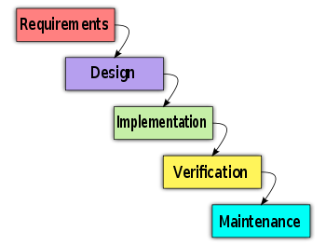](http://en.wikipedia.org/wiki/File:Waterfall_model.svg)

All of the phases in the waterfall models are included in the scope of this project and are the responsibilities of the team.

### Roles and Responsibilities

|  |  |  |  |
| --- | --- | --- | --- |
| No | **Full name** | **Role in Group** | **Responsibilities** |
| 1 | Võ Thanh Quảng | PM, Tech Lead | * Managing process * Designing database * Creating high-level design and coding framework * Training * Coding * Testing |
| 2 | Lê Minh Quang | Dev, Tester, QA | * Coding * Managing documents * Creating system test cases * Testing |
| 3 | Trương Quang Dũng | Dev, BA | * Coding * Clarifying requirements * Creating test plan and system test cases * Testing |
| 4 | Nguyễn Minh Quốc | Dev, CM | * Coding * Managing configuration * Deployment |
| 5 | Nguyễn Minh Vượng | Dev, Designer | * Coding * GUI Design * Testing |

### Tools and Techniques

* Front-end technologies: ASP.NET MVC 3.0, jQuery, AJAX
* Tools: JetBrain Resharper, RedGate SQL Prompt, NUnit, TFS Power Tools
* ORM: Entity Framework
* Architecture and design patterns: MVC, Inversion of Control, Dependency Injection, Layered, Repository

## Project Management Plan

### Tasks



#### Create Software Requirements Specification

##### Description

Create software requirements specification

##### Output

Software Requirement Specification (SRS) document

##### Deliverables

Deliver SRS document before 14/2/2011

##### Resources Needed

5 people for 1.5 weeks

##### Dependencies and Constraints

None

##### Risks

Because there is no actual user, and the requirements come from all the team members, conflicts may happen regularly.

#### Design Database

##### Description

Create logical and physical database design

##### Output

Database Design and Database script

##### Deliverables

Deliver with Software Design Description before 28/2/2010

##### Resources Needed

2 people for 3 days

##### Dependencies and Constraints

Depends on the completion of SRS

##### Risks

SRS may not be detailed enough to capture the business rules, causing the database design to be inappropriate or will be changed much in the future.

#### Create Software Design Description

##### Description

Design the system in an OOP manner.

##### Output

Architecture design, detailed design, diagrams and design specification

##### Deliverables

SDD before 28/2/2010

##### Resources Needed

5 people for 1.5 weeks

##### Dependencies and Constraints

Depends on the completion of SRS

##### Risks

Risks may include choosing inappropriate architecture and design patterns, causing the system hard to maintain, or causing high coding efforts

#### Layout Design

##### Description

Create the main GUI for layout, and create global styles that will be applied to the GUI

##### Output

HTML layout and CSS files

##### Deliverables

None

##### Resources Needed

1 person for 1 week

##### Dependencies and Constraints

None

##### Risks

None

#### Create Coding Framework

##### Description

Map the architecture design into source code, create the project solution files and common classes, and implement common functions.

##### Output

Visual Studio project and solution files containing coding framework

##### Deliverables

None

##### Resources Needed

1 person for 1 week

##### Dependencies and Constraints

Dependent on Architecture design and SRS

##### Risks

All the technologies used in this project are so new that the team leader may not master before creating coding framework. This leads to inappropriate implementation and hard to train other members.

#### Coding

##### Description

Implement the system to reflect the requirements

##### Output

Source code of the project, unit test reports

##### Deliverables

Executable programs and source code before 20/4/2011

##### Resources Needed

5 people for 5 weeks

##### Dependencies and Constraints

Depends on the completion of SRS, SDD, Database design, Coding framework

##### Risks

* Unit test may not be performed thoroughly causing spending many efforts in system test phase.
* May lack of time to implement all the requirements
* The team don’t have a common place, so it is hard to perform collaboration and CM
* Team members may not easily get used to new technologies

#### System Test

##### Description

Perform system test for the system

##### Output

System test report

##### Deliverables

Software Test Documentation before 20/4/2011

##### Resources Needed

5 people for 1.5 weeks

##### Dependencies and Constraints

Coding is finished

##### Risks

* Lack of professional testers in team
* Developers are also responsible for system testing, this may lead to compromise

#### Input Initial Data

##### Description

Collect and input initial data for the system before going live

##### Output

Initial data

##### Deliverables

None

##### Resources Needed

5 people for 1 week

##### Dependencies and Constraints

Coding and system test are finished

##### Risks

None

#### Deployment

##### Description

Deploy the system to the Internet

##### Output

Running website with domain and hosting

##### Deliverables

None

##### Resources Needed

2 people for 3 days

##### Dependencies and Constraints

Coding and system test are finished, initial data is inputted

##### Risks

None

### Task Sheet: Assignments and Timetable

Refer to the Master Plan document.

### Meeting Minutes

#### Kickoff Meeting 6/1/2011

**Meeting Minutes**

|  |  |  |  |
| --- | --- | --- | --- |
| **Subject** | Kickoff Meeting | **Date** | 06/01/2011 |
| **Facilitator** | Beef Grill Restaurant | **Time** | 19:00 – 21:00 |
| **Location** | Cau Giay Str. | **Scribe** | QuangLM |
| **Attendees** | DungHA (Supervisor), QuangVT (Team Lead), QuangLM, DungTQ, QuocNM, VuongNM | | |
| **Absent** |  | | |

| **Key Points Discussed** | | |
| --- | --- | --- |
| No. | Topic | Highlights |
| 1. | Team member introduction | Introduce all members of team to supervisor |
| 2. | Project introduction | Introduce briefly about the project |
| 3. | Kick-off Party | Make all team member closer |

| **Action Plan** | | | |
| --- | --- | --- | --- |
| No. | Action Item(s) | Owner | Target Date |
| 1. | Writing Report 1: Introduction | QuangVT | 9/1 |

#### Meeting 11/1/2011

**Meeting Minutes**

|  |  |  |  |
| --- | --- | --- | --- |
| **Subject** | Requirement Brainstorming | **Date** | 11/01/2011 |
| **Facilitator** | Detech Building | **Time** | 9:00 – 11:00 |
| **Location** | 8 - Ton That Thuyet Street, Cau Giay District | **Scribe** | QuangLM |
| **Attendees** | DungHA (Supervisor), QuangVT (Team Lead), QuangLM, DungTQ, QuocNM, VuongNM | | |
| **Absent** |  | | |

| **Key Points Discussed** | | |
| --- | --- | --- |
| No. | Topic | Highlights |
| 1 | Place Information Structure | Discuss about what kind of information a place should have |
| 2 | System Functions | Discuss about what function the system should have |
| 3 | Domain, Website Name | Discuss and choose a name for domain, website |

| **Action Plan** | | | |
| --- | --- | --- | --- |
| No. | Action Item(s) | Owner | Target Date |
| 1 | Writing Function List | All members | 12/1 |

#### Meeting 13/1/2011

**Meeting Minutes**

|  |  |  |  |
| --- | --- | --- | --- |
| **Subject** | Requirement Brainstorming | **Date** | 13/01/2011 |
| **Facilitator** | Detech Building | **Time** | 9:00 – 11:00 |
| **Location** | 8 - Ton That Thuyet Street, Cau Giay District | **Scribe** | QuangLM |
| **Attendees** | QuangVT (Team Lead), QuangLM, DungTQ, VuongNM | | |
| **Absent** | QuocNM | | |

| **Key Points Discussed** | | |
| --- | --- | --- |
| No. | Topic | Highlights |
| 1 | Brief Function Analysis | Analyze all functions listed and discuss briefly how it works |
| 2 | Assign Writing Use Case | Assign to all members writing use case base on function list |
| 3 | Technic Preparation | Discuss, share documents, software to prepare basic knowledge, tools for project |

| **Action Plan** | | | |
| --- | --- | --- | --- |
| No. | Action Item(s) | Owner | Target Date |
| 1 | Writing Use Case | All members | 20/1 |

#### Meeting 15/1/2011

**Meeting Minutes**

|  |  |  |  |
| --- | --- | --- | --- |
| **Subject** | Requirement Brainstorming | **Date** | 15/01/2011 |
| **Facilitator** | Detech Building | **Time** | 10:00 – 13:00 |
| **Location** | 8 - Ton That Thuyet Street, Cau Giay District | **Scribe** | QuangLM |
| **Attendees** | QuangVT (Team Lead), QuangLM, DungTQ, QuocNM | | |
| **Absent** | VuongNM | | |

| **Key Points Discussed** | | |
| --- | --- | --- |
| No. | Topic | Highlights |
| 1 | Use Case discussion | Discuss about hard use cases, problems happen when writing use case |
| 2 | Prepare Report 2: Planning | Discuss about planning, schedule |
| 3 | Other discussion | Discuss about newly released technologies which can be applied to develop the system |

| **Action Plan** | | | |
| --- | --- | --- | --- |
| No. | Action Item(s) | Owner | Target Date |
| 1 | Update/Edit/Continue Use Case document | All members | 20/1 |

#### Meeting 18/1/2011

**Meeting Minutes**

|  |  |  |  |
| --- | --- | --- | --- |
| **Subject** | Database design brainstorming | **Date** | 18/01/2011 |
| **Facilitator** | Detech Building | **Time** | 10:00 – 13:00 |
| **Location** | 8 - Ton That Thuyet Street, Cau Giay District | **Scribe** | QuangLM |
| **Attendees** | QuangVT (Team Lead), QuangLM, DungTQ, QuocNM | | |
| **Absent** |  | | |

| **Key Points Discussed** | | |
| --- | --- | --- |
| No. | Topic | Highlights |
| 1 | Discuss about database design |  |

| **Action Plan** | | | |
| --- | --- | --- | --- |
| No. | Action Item(s) | Owner | Target Date |
| 1 | Create Database Design | All members | 25/1 |

#### Meeting 21/1/2011

**Meeting Minutes**

|  |  |  |  |
| --- | --- | --- | --- |
| **Subject** | Training about SDD | **Date** | 21/01/2011 |
| **Facilitator** | Detech Building | **Time** | 10:00 – 13:00 |
| **Location** | 8 - Ton That Thuyet Street, Cau Giay District | **Scribe** | QuangLM |
| **Attendees** | QuangVT (Team Lead), QuangLM, DungTQ, QuocNM | | |
| **Absent** |  | | |

| **Key Points Discussed** | | |
| --- | --- | --- |
| No. | Topic | Highlights |
| 1 | Introduction about Software Design Description document | Introduce what are included in SDD |
| 2 | How to create some common kinds of design diagrams | How to use Visio and Visual Studio to create Component Diagram, Class Diagram and Sequence Diagram |
| 3 | Review Database design |  |

| **Action Plan** | | | |
| --- | --- | --- | --- |
| No. | Action Item(s) | Owner | Target Date |
| 1 | Create SDD | All members | 20/2 |

#### Meeting 24/2/2011

**Meeting Minutes**

|  |  |  |  |
| --- | --- | --- | --- |
| **Subject** | Training about coding framework | **Date** | 24/02/2011 |
| **Facilitator** | Detech Building | **Time** | 10:00 – 13:00 |
| **Location** | 8 - Ton That Thuyet Street, Cau Giay District | **Scribe** | QuangLM |
| **Attendees** | QuangVT (Team Lead), QuangLM, DungTQ, QuocNM | | |
| **Absent** |  | | |

| **Key Points Discussed** | | |
| --- | --- | --- |
| No. | Topic | Highlights |
| 1 | Training about coding framework |  |
| 2 | Training about development tools | Visual Studio, Resharper, Baretail… |

| **Action Plan** | | | |
| --- | --- | --- | --- |
| No. | Action Item(s) | Owner | Target Date |
| 1 | Prepare to implementation phase | All members | 26/2 |

## Coding Conventions

The following rules follow the standard rules for developing applications using .NET and C#.

### Naming Conventions

The following terms describe different ways to case identifiers.

#### Pascal Casing

The first letter in the identifier and the first letter of each subsequent concatenated word are capitalized. You can use Pascal case for identifiers of three or more characters. For example:

BackColor

#### Camel Casing

The first letter of an identifier is lowercase and the first letter of each subsequent concatenated word is capitalized. For example:

backColor

#### Uppercase

All letters in the identifier are capitalized. For example:

IO

#### Naming rules

* Use Pascal casing for Class names.

public class HelloWorld

{

...

}

* Use Pascal casing for Method names

void SayHello(string name)

{

...

}

* Use Camel casing for variables and method parameters

void SayHello(string name)

{

string fullMessage = "Hello " + name;

...

}

* All private member variables must be prefixed with underscore (\_) so that they can be identified from other local variables.

public class HelloWorld

{

private int \_count;

}

* Use Meaningful, descriptive words to name variables. Do not use abbreviations.

string address (not addr)

int salary (not sal)

* Do not use variable names that resemble keywords.
* Prefix boolean variables, properties and methods with “is” or similar prefixes.

private bool \_isFinished;

* Namespace names should follow the standard pattern.

***<company name>.<product name>.<top level module>.<bottom level module>***

* Use appropriate prefix for the UI elements to identify them from the rest of the variables.

|  |  |
| --- | --- |
| **Control** | **Prefix** |
| Label | lbl |
| TextBox | txt |
| DataGrid | dtg |
| Button | btn |
| ImageButton | imb |
| Hyperlink | hlk |
| DropDownList | ddl |
| ListBox | lst |
| DataList | dtl |
| Repeater | rep |
| Checkbox | chk |
| CheckBoxList | cbl |
| RadioButton | rdo |
| RadioButtonList | rbl |
| Image | img |
| Panel | pnl |
| PlaceHolder | phd |
| Table | tbl |
| Validators | val |

* File name should match with class name.

***For the class*** HelloWorld***, the file name should be HelloWorld.cs***

* Use #region to group related pieces of code together. If you use proper grouping using #region, the page should like this when all definitions are collapsed.
* Keep private member variables, properties and methods in the top of the file and public members in the bottom.
* Compound words should be cased correctly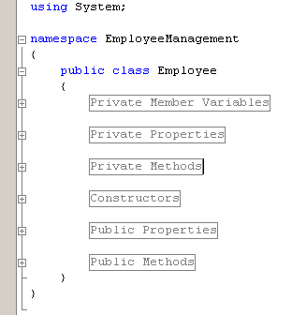 (FxCop Microsoft.Naming CA1702)

Avoid creating compound words from terms which exist in the dictionary as discrete terms. Do not create a compound word such as ***'StopWatch'*** or ***'PopUp'***. These terms are recognized in the dictionary and should be cased as ***'Stopwatch'*** and ***'Popup'.***

* Identifiers should differ by more than case. (FxCop Microsoft.Naming CA1708)

Do not use names that require case sensitivity for uniqueness. Components must be fully usable from both case-sensitive and case-insensitive languages. Since case-insensitive languages cannot distinguish between two names within the same context that differ only by case, components must avoid this situation.

* Identifiers should have correct prefix (FxCop Microsoft.Naming CA1715)

Prefix interface names with the letter 'I' to indicate that the type is an interface, as in IFormattable. Prefix generic type parameter names with the letter 'T' and provide them with descriptive names, as in Dictionary<TKey, TValue>, unless a single 'T' is completely self-explanatory, as in Collection<T>. Use Pascal casing for both interface and type parameter names. Use abbreviations sparingly. Do not use the underscore character. Do use similar names when defining a class/interface pair where the class is a standard implementation of the interface. The names should differ only by the letter I prefixed on the interface name, as with Component and IComponent.

* Identifiers should have correct suffix (FxCop Microsoft.Naming CA1710)

Types that extend certain base types have specified name suffixes. Types that extend Attribute, for example, should be suffixed in 'Attribute', as in ObsoleteAttribute. This rules checks types that extend several base types, including Attribute, Exception, EventArgs, IMembershipPermission, Stream, and others.

* Identifiers should not match keywords (FxCop Microsoft.Naming CA1716)

Identifiers which conflict with reserved language keywords should be avoided. Using a reserved keyword as an identifier makes it harder for consumers in other languages to use your API.

* Parameter names should not match member names (FxCop Microsoft.Naming CA1719)

Parameter names should be distinct from member names.

public class HelloWorld

{

private int \_count;

public HelloWorld(int count)

{

\_count = count; //Should not change the parameter name to \_count

}

}

* Property names should not match get methods (FxCop Microsoft.Naming CA1721)

A Get method was found with the same name as a property. Get methods and properties should have names that clearly distinguish their function. See the design guidelines for information regarding choosing properties over methods.

* Type names should not match namespaces (FxCop Microsoft.Naming CA1724)

Identifiers which conflict in whole or in part with namespace names should be avoided. Names that describe the purpose or contents of a type are preferred.

### Coding Styles

* Avoid writing very long methods. A method should typically have 1~50 lines of code. If a method has more than 50 lines of code, you must consider re factoring into separate methods.
* Do not hardcode configuration data. Configuration data should be put into configuration file or database.
* Avoid using member variables. Declare local variables wherever necessary and pass it to other methods instead of sharing a member variable between methods. When sharing a member variable between methods, it will be difficult to track which method changed the value and when.
* Do not make the member variables public or protected. Keep them private and expose public/protected Properties.
* Do not have more than one class in a single file.
* Avoid public methods and properties, unless they really need to be accessed from outside the class. Use “internal” if they are accessed only within the same assembly.
* Declare variables as close as possible to where it is first used. Use one variable declaration per line.
* Use StringBuilder class instead of String when manipulating string objects in a loop. The String object works in weird way in .NET. Each time a string is appended, it is actually discarding the old string object and recreating a new object, which is a relatively expensive operations.
* Never do a 'catch exception and do nothing'. If hiding an exception, there is no way to notice the exception happened or not. Lot of developers uses this handy method to ignore non significant errors. Best practices are to avoid exceptions by checking all the error conditions programmatically. In any case, catching an exception and doing nothing is not allowed. In the worst case, exceptions should be logged for later investigation and system should not be halted.
* When you re throw an exception, use the throw statement without specifying the original exception. This way, the original call stack is preserved.
* Write your own custom exception classes if required in your application. Do not derive your custom exceptions from the base class SystemException. Instead, inherit from ApplicationException.
* A class should be declared as sealed if there is no further inheritance.
* Abstract types should not have constructors (FxCop Microsoft.Design CA1012). Public constructors for abstract types do not make sense because you cannot create instances of abstract types.
* Avoid empty interfaces (FxCop Microsoft.Design CA1040). Interfaces are meant to contain members that specify a set of behaviors. To mark or label a class, use an attribute instead of an empty interface.
* Avoid excessive parameters on generic types (FxCop Microsoft.Design CA1005). Avoid generic types with more than two type parameters as users have difficulties understanding what type parameters represent in types with long type parameter lists.
* Avoid out parameters (FxCop Microsoft.Design CA1021). Using out parameters might indicate a design flaw. Although there are legitimate times to use out parameters, their use frequently indicates a design that does not conform to the design guidelines for managed code.
* Declare types in namespaces (FxCop Microsoft.Design CA1050). A type should be defined inside a namespace to avoid duplication.
* Do not declare static members on generic types (FxCop Microsoft.Design CA1000). The syntax for calling static members on generic types is complex as the type parameter has to be specified for each call.
* Do not declare protected members in sealed types (FxCop Microsoft.Design CA1047). Sealed types cannot be extended, and protected members are only useful if you can extend the declaring type. Sealed types should not declare protected members.
* Do not declare virtual members in sealed types (FxCop Microsoft.Design CA1048). Sealed types cannot be extended, and virtual members are only useful if you can extend the declaring type.
* Do not expose generic lists (FxCop Microsoft.Design CA1002). Do not expose List<T> in object models. Use Collection<T>, ReadOnlyCollection<T> or KeyedCollection<K,V> instead. List<T> is meant to be used from implementation, not in object model API. List<T> is optimized for performance at the cost of long term versioning. For example, if you return List<T> to the client code, you will not ever be able to receive notifications when client code modifies the collection.
* Do not hide base class methods (FxCop Microsoft.Design CA1061). Defining a method in a derived class with the same name and parameters that are more weakly typed as one that is defined in the base class will obstruct access to the method defined in the base class.
* Do not overload operator equals on reference types (FxCop Microsoft.Design CA1046). Most reference types, including those that override System.Object.Equals, do not override the equality operator (==). Most languages provide a default implementation of this operator.
* Do not pass types by reference (FxCop Microsoft.Design CA1045). Although there are legitimate times to use reference parameters, such use frequently indicates a design that does not conform to the design guidelines for managed code.
* Enumerators should be strongly typed (FxCop Microsoft.Design CA1038). Types that implement IEnumerator should also provide a version of the Current property that returns a type other than Object. Implement the interface member explicitly and make the strongly typed version public.
* Exceptions should be public(FxCop Microsoft.Design CA1064). Exception classes should either be public, or have a non-generic public ancestor.
* Implement standard exception constructors (FxCop Microsoft.Design CA1032). Multiple constructors are required to correctly implement a custom exception. Missing constructors can make your exception unusable in certain scenarios. For example, the serialization constructor is required for handling exceptions in XML Web services.
* Lists are strongly typed (FxCop Microsoft.Design CA1039). IList implementations should also provide versions of the IList members that are strongly typed, namely they should specify types other than Object for method and property parameter and return types. Implement the interface members explicitly and make the strongly typed versions public. It is safe to ignore violations of this rule when you are implementing a new object-based collection, such as a linked list, where types based on your collection will determine what the strong type is. These types should expose strongly typed members.
* Override methods on comparable types (FxCop Microsoft.Design CA1036). Types that implement IComparable should redefine Equals and comparison operators to keep the meanings of less than, greater than, and equals consistent throughout the type.
* Replace repetitive arguments with params array (FxCop Microsoft.Design CA1025). Several instances of same-type arguments can be better implemented as a parameter array argument. Generally, if a member declares three or more arguments of the same type, consider using a parameter array.
* Static holder types should be sealed (FxCop Microsoft.Design CA1052). Static holder types do not provide functionality that derived instances can extend. Inheriting from such a type indicates a flawed design.
* Use events where appropriate (FxCop Microsoft.Design CA1030). A method name suggestive of event functionality was encountered.
* Use generic event handler instances (FxCop Microsoft.Design CA1007). Do not declare new delegates to be used as event handlers when targeting a version of the .NET Framework that supports generics. Use an instance EventHandler<T> instead.
* Use properties where appropriate (FxCop Microsoft.Design CA1024). Properties should be used instead of Get/Set methods in most situations. Methods are preferable to properties in the following situations: the operation is a conversion, is expensive or has an observable side-effect; the order of execution is important; calling the member twice in succession creates different results; a member is static but returns a mutable value; or the member returns an array.
* Do not hardcode locale specific strings (FxCop Microsoft.Globalization CA1302). Do not use string literals for system items that have locale-specific designations. Special system locations should be retrieved using provided API such as GetFolderPath. See the System.Environment.SpecialFolder enumeration for more information.
* Set locale for data types (FxCop Microsoft.Globalization CA1306). In most cases, Locale should be explicitly set to CultureInfo.InvariantCulture on DataSet and DataTable instances. Upon creation of a DataSet or DataTable instance, the Locale is set to the current culture. In most cases, the Locale should be set to CultureInfo.InvariantCulture to guarantee proper sorting behavior in all cultures.
* Specify CultureInfo (FxCop Microsoft.Globalization CA1304). If an overload exists that takes a CultureInfo argument, it should always be called in favor of an overload that does not. The CultureInfo type contains culture-specific information required for performing numeric and string operations, such as casing, formatting, and string comparisons. In scenarios where conversion and parsing behavior should never change between cultures, specify CultureInfo.InvariantCulture, otherwise, specify CultureInfo.CurrentCulture.
* Specify IFormatProvider (FxCop Microsoft.Globalization CA1305). If an overload exists that takes an IFormatProvider argument, it should always be called in favour of an overload that does not. Some methods in the runtime convert a value to or from a string representation and take a string parameter that contains one or more characters, called format specifies, which indicate how the value is to be converted. If the meaning of the format specified varies by culture, a formatting object supplies the actual characters used in the string representation. In scenarios where sorting and comparison behavior should never change between cultures, specify CultureInfo.InvariantCulture, otherwise, specify CultureInfo.CurrentCulture.
* Specify StringComparison (FxCop Microsoft.Globalization CA1307). If an overload exists that takes a StringComparison argument, it should always be called in favour of an overload that does not.
* Use ordinal StringComparison (FxCop Microsoft.Globalization CA1309). For non-linguistic comparisons, StringComparison.Ordinal or StringComparison. OrdinalIgnoreCase should be used instead of the linguistically-sensitive StringComparison.InvariantCulture.

### Comments

* Comments should be written in order to make code understandable and maintainable.
* Only write comments when necessary, do not write comments for every line of code and every variable declared.
* Use **//** or **///** for comments. Avoid using **/\* … \*/**
* Do not write comments if the code is easily understandable without comment. The drawback of having lot of comments is that if you change the code and forget to change the comment, it will lead to more confusion.
* Fewer lines of comments will make the code more elegant. But if the code is not clean/readable and there are less comments, that is worse.
* Writes clean, readable code such a way that it doesn't need any comments or very little to understand.
* Perform spelling check on comments and also make sure proper grammar and punctuation is used.

### Coding Conventions Specific for this Project

* All strings must be trimmed before inserting to the database. Empty strings (after trimmed) are inserted as null. (Framework handles this already, just for some special cases)
* All repository methods must return Feedback (or derived) type.
* All repository methods must handle every exception occurring in the methods. All exceptions must be logged as Error.
* All repository methods should be unit tested
* All repository’s insert methods should create a new object based on the parameter object, and then insert the new object to the data context, instead of inserting directly the parameter object.
* Never initiate a repository class by new operator. Use Dependency Injection instead. Except for unit test cases.
* All messages must be stored in Psn.Resources.Messages resource file.
* If a repository method returns a specific message for that method, the message name in Resource file should be: MethodShortName\_MessageName. I.e InsertCategory\_DuplicateName
* All validation messages must be stored in Psn.Resources.ValidationMessages resource file
* All caching items must have cache time configured in the config file AppSettings.config
* All constants must be stored in Psn.Common.Constants class
* All configurable constants must be stored in config file AppSettings.config (i.e. CommentsPerPage)
* All open source libraries must be installed via Nuget (if exist there).
* Never use inline style and javascript. Use CSS and jQuery instead.
* Never use fixed link for internal links. Use routes instead. For example: must not use <a href=”www.place.vn”>..., use Html.ActionLink(“Index”, “Home”) instead.
* Validation attributes must use localization. Use attributes in Psn.Common.DataAnnotations (i.e. RequiredExtended, StringLengthExtended) to use default settings
* Use POST and GET methods appropriately. Use POST for actions that may update data (i.e. update/delete). Use GET for actions to retrieve data only (i.e. get details/list).
* Do not hard delete a record in database if the record has IsDeleted field. Update IsDeleted=1 instead.

# Software Requirement Specifications

## User Requirement Specification

### User Requirements

* User can create accounts on the website. Email address and password are required for registering an account on the website. 1 email address can only be used once for registering
* User can edit his/her account information: Display Name, Avatar, and Password. But he/she can’t change his/her email address which was used for registering.
* User can use his/her account or third party account(Google and Yahoo) to log in to the website and log out
* User can change password which was registered in case he/she forgot it. Change Password link will be in content of email sent to user. This link will open Change Password page for user.
* User can change his/her password through his/her User Profile page
* User can see his/her account information and other’s
* User can see other user’s statistic like: Display Name, Registered Date, number of created places, number of posted comments, questions and asnwers.
* User can search for places by using Quick Search and Advanced Search
* User can view information of places, rate the place from 1 to 5 stars, add it to favorites list, mark it as visited, share it on social networks (Twitter and Facebook) or report it as spam.
* User can upload images for places
* User can vote for place images but can’t vote for images he/she uploaded
* The latest image or the most voted up image will be set as main image and used as place avatar
* User can view his/her favorites list and remove places from the list at his/her profile page
* User can see list of questions, places he/she posted at his/her profile page
* User can write comments for places or delete it
* User can vote up, vote down or report comments of other users but his/her comments
* User can create places and edit his/her places. Each user can only create 1 place each 10 minutes
* User can freely edit other’s places when they rank up in ranking system (has 1000 points and more) and have granted that privilege. With user haven’t granted that privilege, they can suggest an edit. And that suggestion after getting approvals from verified users (has 1000 points and more) or admins will be applied
* User can view edit history of places, compare different revisions.
* Verified Users (has 1000 points and more) can approve or disapprove revisions.
* Verified Users (has 1000 points and more) can set a revision as current revision. Current revision will be used to display at Place Detail page.
* User can view and post questions on Question & Answer page
* User can answer to questions, vote up, vote down or report as it as spam
* User can vote up, vote down or report other user’s answers but his/her answers
* User can delete his/her answers

### Administration requirements

* Admin can view a list of all categories in the system, add new categories, edit categories and delete categories.
* Admin can view a list of all users in the system, view and edit user information, active users on the system or delete users.
* Admin can view a list of all advertisers on the website, add new ones, edit or delete advertises.
* Admin can view a list of spam reports, decide they are spam or not. Spam reports include reports about places, reports about comments, reports about questions, reports about answers and reports about place images
* Admin can use all functions in the system.
* Admin can view a list of all places in the system, edit or delete these places.
* Admin can view list of all places that wasn’t located on map and set location for them
* Admin can view list of all featured places on the system, edit or delete these places. Featured places are places that their owner has paid money for them to be on top of search result.
* Admin can see list of contacts from users to admins, view detail or delete it.
* Admin can see statistics on the whole system: Registered User number, Activated User number, Place number, Comment number, Question number, Answer number, All the Time Visitor number, Today Visitor number, Online Visitor number

### Ranking requirements

* User Point will be used in user ranking system of the website
* User Point is calculated as follow:
* Starter point for every user is 10
* Create a place: +20
* 1 time spam (any kind): - 25
* CP will be used to set rank for user:
* Unverified user: < 1000 Points
* Verified user: >= 1000 Points
* Only verified users have full access to all functions for users on the website such as: edit place, approve revision, and upload images…
* 10 user who post most answers will be in on Most Contributors list in Q&A page
* There is a list for 20 Newest Questions at Q&A page and Home page
* 50 most searched categories will be displayed in a tag cloud. The tag cloud has 2 display modes: Short View and Detail View. In Short View, only 20 most searched categories are displayed. 50 categories are displayed only at Detail View. Based on the number of search time, each category has different size and saturation. The greater the search time number each category has, the bigger its size is and the deeper its saturation is. Tag cloud is displayed at Home page and Search page
* A list of 20 newest place is displayed at home page
* Every lists are updated each 10 minutes.

### Comment/Answer requirement

* A comment/answer can’t be blank and must be lesser than 4000 characters.
* When the number of comments/answers is big, the comments/replies will be displayed each time 10 comments/answers. To see more comments/answers users need click to “Xem thêm”
* 2 most voted up comments/answers will be highlighted and put on top of Comment Area/Answer Area. These highlighted comments/answers still can be treated as normal comments/answers
* Each user can only post 1 comment for a place or 1 answer for a question each 3 minutes

### Place Requirement

* A place has following information:
* Name (required)
* Detail Address (required)
* District/Town/Ward
* City/Province (required)
* Description
* Phone number
* Category (required)
* Number of view
* Rating
* Visited number
* Place Images: images include a main image displayed as the place’s avatar and other images.
* Location on the map: the map can be zoomed in and zoomed. There is a point indicating location of the on an area of 25 square kilometers (5x5) in which the place located at the center.
* Suggestion List: 15 highest popularity places in the same category

### Search Requirement

There are 2 kinds of search in the website: Quick Search and Advanced Search

* Quick Search

This is a main region on the home page and is displayed as a bar and is accessible from every page. The users will enter the category of places they want to search and the area they want to find places in. The search area fields will be auto populated by data from the user’s browser cookies if already existed. Otherwise, it will be based on the user’s IP address.

* Advanced Search

This function provides users more options to tailor search result in a way more precisely and short. These options are:

* Search by category and search by area, just like in quick search
* Search by distance to the user’s location based on Kilometer unit. In order to use this feature, the user must specify his location on the map. The location will be retrieved from the user info if he has logged in, or from the user’s browser cookies if existed there. If none of the two sources exists, the user will be prompted to select his location on the map. After the user specifies his location, the location is saved to the user info and the user’s browser cookies.
* Search by rating: search for places with equal or higher rating.

## System Requirement Specification (Specific Requirements)

### External Interface Requirements

#### User Interfaces

Interface need to attract the attention of users to the product image. Products are things having a lot of colors and diversity combination in order to attract users. Website should have the background simple, less color, less attention but that also shows clear boundaries between each section: photos with text, photos with photos, and photos with the background…So color choices should be pleasing to the eye and should stimulate the user's interest.

The look and feel of this website should be based on user requirements. Page layout and navigation should be as intuitive and easy as possible.

The overuse of product images should not increase the time in which a page downloads, which has a negative impact on usability.

#### Hardware Interfaces

PSN website needs to run are the peripheral devices mouse and keyboard. System can display many image formats, such as: jpg, png, jpeg

#### Software Interfaces

Products run on web application, it requires the use of programming languages supported on the browser.

Outside, the system should use the program to manage resources data, this program can be combined with the system, can change and update from the system. Data products will be exchanged between systems and external data through data management software

|  |  |  |
| --- | --- | --- |
| Software name | Version | Source |
| .NET Framework | 4.0 | Microsoft |
| SQL Server | R2 | Microsoft |
| Visual Studio | 2010 | Microsoft |
| MVC | 3.0 | Microsoft |
| Enterprise Library |  | Microsoft |

#### Communications Protocol

PSN website uses the protocol HTTP to call service from Google Map API. These web services use HTTP requests to specific URLs, passing URL parameters as arguments to the services. Generally, these services return data in the HTTP request as either JSON or XML for parsing and/or processing by system.

System implemented on the browser, using standard protocols to communicate between users and server.

In the process of communication, some important information of the user system will be encrypted using special algorithms.

Besides the design synchronize data and systems, all components of the system can access data at any time.

The system should produce nicely formatted HTML that popular social network such as Facebook, MySpace can share information.

The web pages must be easy for search bots such as Google, Yahoo to find and cache.

### System Features

#### Create a New Place

##### Use Case Diagram



##### Use Case Specification

|  |  |  |  |  |
| --- | --- | --- | --- | --- |
| **USE CASE - Create a new place SPECIFICATION** | | | | |
| **Use-case No.** | UC001 | **Use-case Version** | | 1.0 |
| **Use-case Name** | Create a new place | | | |
| **Author** | QuocNM | | | |
| **Date** | 15/01/2011 | **Priority** | Normal | |
| **Actor:**  User  **Summary:**  This use case allows the user to create a place in this system when the user knows an interesting place and wants to share it to everyone.  **Goal:**  Allows the user create a new place.  **Triggers**  Click to “Tạo địa điểm” in navigator at home page  **Preconditions:**  User logged into the system successfully.  **Post Conditions:**  System redirects user to the place detail page of the just-created place.  **Main Success Scenario:**   |  |  |  | | --- | --- | --- | | Step | Actor Action | System Response | | 1 | Click on “Tạo địa điểm” in navigator at home page | Redirect to Create Place page | | 2 | Fills all mandatory data fields |  | | 3 | Click to “Tạo địa điểm” button. | Redirect to new place’s details page. |   **Alternative Scenario:**   |  |  |  | | --- | --- | --- | | Step | Actor Action | System Response | | 1 | Click on “Tạo địa điểm” in navigator at home page | Redirect to Create Place page | | 2 | Fills all mandatory data fields |  | | 3 | Click to “Bỏ qua” button. | Redirect to new place’s details page. |   **Exceptions:**   |  |  |  | | --- | --- | --- | | Step | Actor Action | System Response | | 1 | Click on “Tạo địa điểm” in navigator at home page | Redirect to Create Place page | | 2 | User fills some data fields. Some mandatory data fields are skipped. |  | | 3 | Click to “Tạo địa điểm” button. | Shows all required messages for all missing mandatory data fields. |   **Relationships:**  Log in use case  **Business Rules:**  None | | | | |
| **Description:**  When user have a place to share, they only need click to “Tạo địa điểm” menu on the navigator and get redirect to Create Place page to create a new place. In order to create a new place, user need enter place name, category, city/province, district/town/ward and detail address. Place phone number and description are optional.   * Place name: required; must be less than 200 characters * Category: required; there is a suggest list displayed below as user typing place’s category in the text box. User must choose a category from the list. An unknown or new or invalid category won’t be accepted and a new place won’t be created * City/ province/ district/ town/ ward: user need choose from combo box list * Phone number: this number will be used to contact to place’s owner/manager * Detail Address: this is detail address of new place. It contains all parts left of place address except (city/ province/ district/ town/ ward) * Description: user can write review,comment, introduction, recommendation for new place * Place location: user can zoom in and out on the map and click to a location on the map to define place’s location   When user click to “Tạo địa điểm” button, the system will open Place Detail page of newly created place. By click to “Bỏ qua” button, the user will go back to previous page. | | | | |

**Screen**

**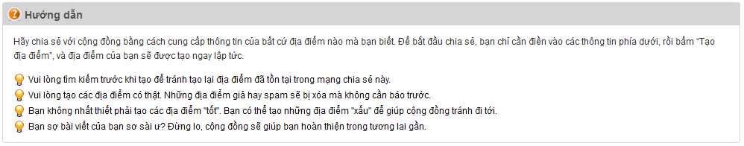**

**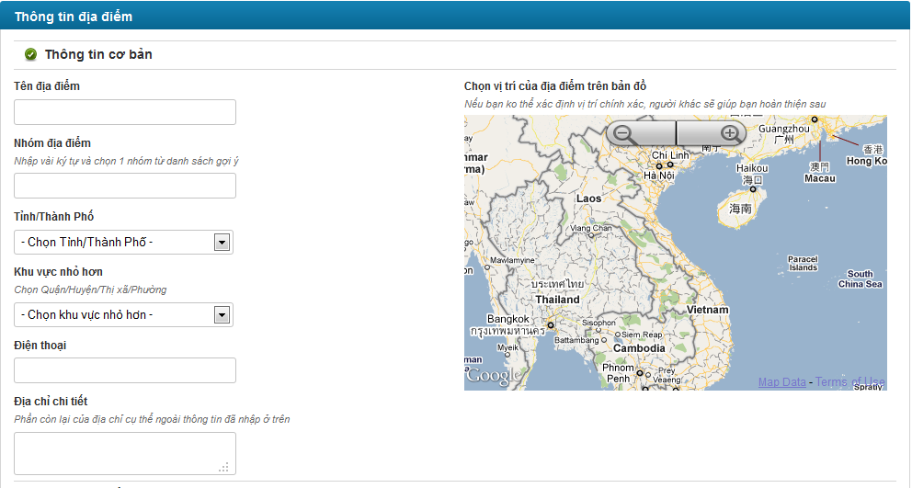**

**Data Fields Definition –Create Place Page**

|  |  |  |  |  |  |  |
| --- | --- | --- | --- | --- | --- | --- |
| **Field name** | **Description** | **Read**  **Only** | **Mandatory** | **Control Type** | **Data Type** | **Length** |
| **Instruction** | **This field contains instructions for creating a new place** | **N/A** | **N/A** | **Label** | **Text** | **Fixed** |
| **Basic information** | **The following fields will be surrounded by a border to allow logical grouping of data for the user. The border will have a heading titled “Thông tin cơ bản”** | **N/A** | **N/A** | **Group Box** | **Text** | **Fixed** |
| Place name label | A label with content “Tên địa điểm” | N/A | N/A | Label | Text | Fixed |
| Place name | The name of the place that to be created. | N | Y | Text Box | Text | 150 |
| Category label | A label with content “Nhóm địa điểm” | N/A | N/A | Label | Text | Fixed |
| Category small label | A small label with content “Nhập vài ký tự và chọn 1 nhóm từ danh sách gợi ý” | N/A | N/A | Label | Text | Fixed |
| Category | The category of the place that to be created. | N | Y | Combo Box |  |  |
| City label | A label with content “Tỉnh / Thành Phố” | N/A | N/A | Label | Text | Fixed |
| City | The name of place’s province or city. It contains all 58 provinces and 5 cities of Vietnam. | N | Y | Combo Box | Text | 100 |
| District label | A label with content “Khu vực nhỏ hơn” | N/A | N/A | Label | Text | Fixed |
| District small label | A small label with content “Chọn Quận/Huyện/Thị xã/Phường” | N/A | N/A | Label | Text | Fixed |
| District | The name of place’s district. Data of this field is filtered by selected item of City combo box. | N | Y | Combo Box | Text | 100 |
| Phone number label | A label with content “Điện thoại” | N/A | N/A | Label | Text | Fixed |
| Phone number | The telephone of place that to be created. | N | N | Numeric Text Box |  |  |
| Detail address label | A label with content “Địa chỉ chi tiết” | N/A | N/A | Label | Text | Fixed |
| Detail address small label | a small label with content “Phần còn lại của địa chỉ cụ thể ngoài thông tin đã nhập ở trên” |  |  |  |  |  |
| Detail address | The detail address of place that to be created. It can be number address, | N | Y | Text Box |  |  |
| **Detail description** | **The following fields will be surrounded by a border to allow logical grouping of data for the user. The border will have a heading titled “Mô tả chi tiết”** | **N/A** | **N/A** | **Group Box** | **Text** | **Fixed** |
| Description box | The user is able to enter text, css tag… to describe, advertise the place. | N | Y | Rich Text Box | Text | Max |
| **Location** | **The following fields will be surrounded by a border to allow logical grouping of data for the user. The border will have a heading titled “Vị trí trên bản đồ”** | **N/A** | **N/A** | **Group Box** | **Text** | **Fixed** |
| Google Map | A Google map for user chooses the location of place. This is control of Google. | N | N | Google API |  |  |

**Buttons / Hyper Links – Create Place Page**

|  |  |  |  |  |
| --- | --- | --- | --- | --- |
| **Function** | **Description** | **Available Criteria** | **Validations** | **Outcome** |
| Create a place | The button will allow the user to create a place in the system | Always available | Validate all mandatory fields and the location of the place is selected. | The record will be saved and user will be navigated to new place’s detail page |
| Cancel creating | The button will allow the user cancel creating new place | Always available | No | User will be navigated to home page |

#### Edit a Place’s Information

##### Use Case Diagram



##### Use Case Specification

|  |  |  |  |  |
| --- | --- | --- | --- | --- |
| **USE CASE- Edit a Place’s Information SPECIFICATION** | | | | |
| **Use-case No.** | UC002 | **Use-case Version** | | 1.0 |
| **Use-case Name** | Edit a Place’s Information | | | |
| **Author** | QuocNM | | | |
| **Date** | 15/01/2011 | **Priority** | Normal | |
| **Actor:**  Senior User (has more than 1000 Contribution Point) and administrator (View Business Rule for more detail)  **Summary:**  When some information of a place like telephone, title, address… is changed, the user with highest rank type or the admin can make it up-to-date by click to “Chỉnh sửa thông tin” hyperlink in the place’s details page.  **Goal:**  This use case allows the actor edit information of a place.  **Triggers**  Click to “Chỉnh sửa thông tin” hyperlink in the place’s details page  **Preconditions:**  Logged into the system successfully and open a place’s detail page.  **Post Conditions:**  Redirected back to Place Detail page  **Main Success Scenario:**   |  |  |  | | --- | --- | --- | | Sep | Actor Action | System Response | | 1 | User click to “Chỉnh sửa thông tin” hyperlink | System displays the page to edit place | | 2 | User edit some data fields |  | | 3 | User click to “Sửa” button | System will redirect to the place’s details page with te up-to-date data |   **Alternative Scenario:**   |  |  |  | | --- | --- | --- | | Step | Actor Action | System Response | | 1 | User click to “Chỉnh sửa thông tin” hyperlink | System displays the page to edit place | | 2 | User edit some data fields |  | | 3 | User click to “Bỏ qua” button | System will redirect to th place’s detailspage and the data still is as before. |   **Exceptions:**   |  |  |  | | --- | --- | --- | | Step | Actor Action | System Response | | 1 | User click to “Chỉnh sửa thông tin” hyperlink | System displays the page to edit place | | 2 | User delete orleave blank some mandatory data fields |  | | 3 | User click to “Bỏ qua” button | System validates data in this page and shows all required messages for all missing mandatory data fieds. |   **Relationships:**  Log in use case, View place use case  **Business Rules:**   |  |  |  | | --- | --- | --- | |  | Business Rule | Error Message | | 1 | Rank of a user will be se based on the user’s contribution point (CP) |  | | 2 | Contribution Point (CP) is calculated as follow: **-** Starter point for every user is 10 point - Create a place: + 20 point - Your place get deleted: - 25 point |  | | 3 | For user has more than 1000 point (senior user): - Can edit a place directly - Can upload place’s image directly - Can approve suggested edit - Can approve suggested images  - Set a revision as current |  | | 4 | For user has less than 1000 point (junior user): - an revision of a place created by these users need approvals from senior users or admins to be displayed | “Bạn chưa đủ điểm để sử dụng chức năng này” | | | | | |
| **Description:**  Edit place is one of main focuses on the website. Sharing a place isn’t just simply by post a new place on the system. It is also about sharing information between users. And the most useful method to sharing is every user make all places in the system more detail, more precisely, increase its reliability, up-to-date… everything can be carry through editing places. But because editing can be contribution but also can be destruction, we can’t let every user has access to this function. So only user who has more than 1000 point can edit places. When user has more than 1000 point, It means that user has taken quite a time using our website and he/she is trustable. The chance that user will take some destructive actions is rare.  For users with less than 1000 point, they still can go to Edit place page and edit information. But the changes they made will be taken as suggestions. These suggestions need approvals from verified users (>= 1000 point) or admin team.  To edit a place, user need go to its detail page first. After that, click to “Chỉnh sửa thông tin” hyperlink will redirect you to Edit Place page. At Edit place page, click to “Sửa” button to save all changes or click to “Bỏ qua” button to go back to Detail page. All validations still take effect as creating a new place. | | | | |

**Screen**

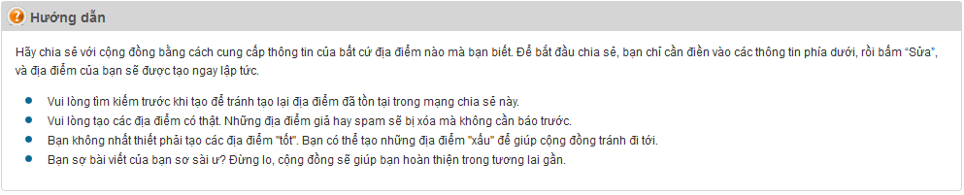

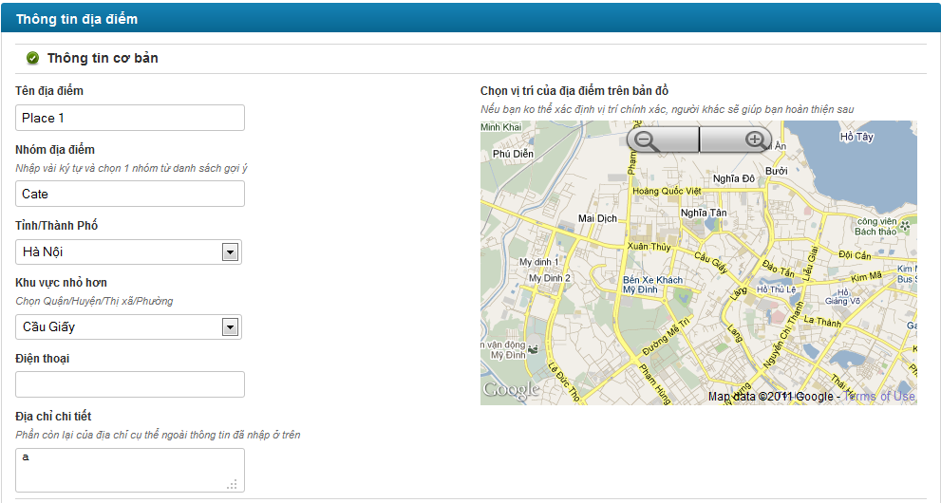

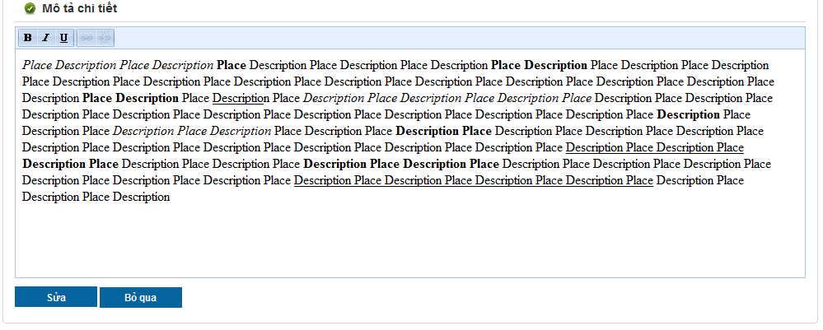

**Data Fields Definition – Attach Place Page**

|  |  |  |  |  |  |  |
| --- | --- | --- | --- | --- | --- | --- |
| **Field name** | **Description** | **Read**  **Only** | **Mandatory** | **Control Type** | **Data Type** | **Length** |
| **Instruction** | **This field contains instructions for edit a new place** | **N/A** | **N/A** | **Label** | **Text** | **Fixed** |
| **Basic information** | **The following fields will be surrounded by a border to allow logical grouping of data for the user. The border will have a heading titled “Thông tin cơ bản”** | **N/A** | **N/A** | **Group Box** | **Text** | **Fixed** |
| Place name label | A label with content “Tên địa điểm” | N/A | N/A | Label | Text | Fixed |
| Place name | The name of the place that to be edited. | N | Y | Text Box | Text | 150 |
| Category label | A label with content “Nhóm địa điểm” | N/A | N/A | Label | Text | Fixed |
| Category small label | A small label with content “Nhập vài ký tự và chọn 1 nhóm từ danh sách gợi ý” | N/A | N/A | Label | Text | Fixed |
| Category | The category of the place that to be edited. | N | Y | Combo Box |  |  |
| City label | A label with content “Tỉnh / Thành Phố” | N/A | N/A | Label | Text | Fixed |
| City | The name of place’s province or city. It contains all 58 provinces and 5 cities of Vietnam. | N | Y | Combo Box | Text | 100 |
| District label | A label with content “Khu vực nhỏ hơn” | N/A | N/A | Label | Text | Fixed |
| District small label | A small label with content “Chọn Quận/Huyện/Thị xã/Phường” | N/A | N/A | Label | Text | Fixed |
| District | The name of place’s district. Data of this field is filtered by selected item of City combo box. | N | Y | Combo Box | Text | 100 |
| Phone number label | A label with content “Điện thoại” | N/A | N/A | Label | Text | Fixed |
| Phone number | The telephone of place that to be edited. | N | N | Numeric Text Box |  |  |
| Detail address label | A label with content “Địa chỉ chi tiết” | N/A | N/A | Label | Text | Fixed |
| Detail address small label | a small label with content “Phần còn lại của địa chỉ cụ thể ngoài thông tin đã nhập ở trên” |  |  |  |  |  |
| Detail address | The detail address of place that to be edited. It can be number address, | N | Y | Text Box |  |  |
| **Detail description** | **The following fields will be surrounded by a border to allow logical grouping of data for the user. The border will have a heading titled “Mô tả chi tiết”** | **N/A** | **N/A** | **Group Box** | **Text** | **Fixed** |
| Description box | The user is able to enter text, css tag… to describe, advertise the place. | N | Y | Rich Text Box | Text | Max |
| **Location** | **The following fields will be surrounded by a border to allow logical grouping of data for the user. The border will have a heading titled “Vị trí trên bản đồ”** | **N/A** | **N/A** | **Group Box** | **Text** | **Fixed** |
| Google Map | A Google map for user chooses the location of place. This is control of Google. | N | N | Google API |  |  |

**Buttons / Hyper Links – Attach Place Page**

|  |  |  |  |  |
| --- | --- | --- | --- | --- |
| **Function** | **Description** | **Available Criteria** | **Validations** | **Outcome** |
| Save edited information | The button will allow the user to save the place information | Always available | Validate all mandatory fields and the location of the place is selected. | New information is saved. User get redirected back to Place Detail page |
| Cancel | The button will allow the user to cancel editing a place | Always available | No | User will be redirected back to Place Detail page |

#### Edit a Place’s Location

##### Use Case Diagram



##### Use Case Specification

|  |  |  |  |  |
| --- | --- | --- | --- | --- |
| **USE CASE- Edit place’s location SPECIFICATION** | | | | |
| **Use-case No.** | UC003 | **Use-case Version** | | 1.0 |
| **Use-case Name** | Edit a Place’s Location | | | |
| **Author** | QuocNM | | | |
| **Date** | 15/01/2011 | **Priority** | Normal | |
| **Actor:**  Senior User (has more than 1000 Contribution Point) and administrator (View Business Rule for more detail)  **Summary:**  This use case allows the highest rank type user and admin edit the location of the place on Google map.  **Goal:**  This use case allows the actor edit the location of the place on Google map.  **Triggers**  Click to “Vị trí không chính xác?” hyperlink in Place Detail page.  **Preconditions:**  Logged into the system successfully and open Place Detail page  **Post Conditions:**  The location of the place is changed on Google map and the user stays in Place Detail page  **Main Success Scenario:**   |  |  |  | | --- | --- | --- | | Step | Actor Action | System Response | | 1 | User click to “Vị trí không chính xác?” hyperlink | Popup a map displaying place current location | | 2 | User choose place’s location on displayed map | A symbol marks the lcation user choose | | 3 | User click to “Cập nhật” button | System save location and closes the popup. |   **Alternative Scenario:**   |  |  |  | | --- | --- | --- | | Step | Actor Action | System Response | | 1 | User click to “Vị trí không chính xác?” hyperlink | Popup a map displaying place currentlocation | | 2 | User click to “Bỏ qua” button | System closes the popup |   **Exceptions:**  None  **Relationships:**  Log in use case, View place detail use case, Edit place’s information use case  **Business Rules:**   |  |  |  | | --- | --- | --- | |  | Business Rule | Error Message | | 1 | Rank of an user ill be set based on the user’s contribution point (CP) |  | | 2 | Contribution Point (CP) is calculated as follow: **-** Starter point for every user is 10 point - Create a place: + 20 point - Your place get deleted: - 25 point |  | | 3 | For user has more than 1000 point (senior user): - Can edit a place directly - Can upload place’s image directly - Can approve suggested edit - Can approve suggested images  - Set a revision as current |  | | 4 | For user has less than 1000 point (junior user): - an revision of a place created by these users need approvals from senior users or admins to be displayed | “Bạn chưa đủ điểm để sử dụng chức năng này” | | | | | |
| **Description:**  This function is used when users want to change place location only. It’s quick and save time. Users only need click to “Vị trí không chính xác?” hyperlink, click to new location at popup map and click to “Cập nhật” button. Place location will be replaced by new one.  Location changing made by verified users (>= 1000 point) will take effect right away but the ones made by normal users (< 100 point) will be take in consider. | | | | |

**Screen**

**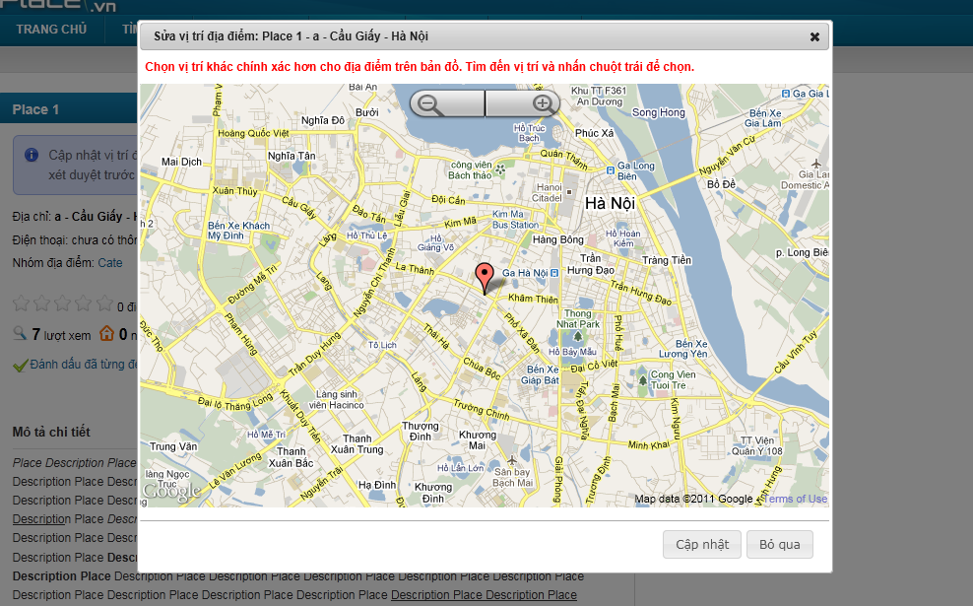**

**Data Fields Definition – Attach Place Page**

|  |  |  |  |  |  |  |
| --- | --- | --- | --- | --- | --- | --- |
| **Field name** | **Description** | **Read**  **Only** | **Mandatory** | **Control Type** | **Data Type** | **Length** |
| Map title | A title with content: “Sửa vị trí địa điểm:” + place name + ”-” + detail address + “-” + place’s district/town/ward + “-” + place’s city/province | N/A | N/A | Label | Text | Fixed |
| Map label | A label with content “**Chọn vị trí khác chính xác hơn cho địa điểm trên bản đồ. Tìm đến vị trí và nhấn chuột trái để chọn.**” | N/A | N/A | Label | Text | Fixed |

**Buttons / Hyper Links – Attach Place Page**

|  |  |  |  |  |
| --- | --- | --- | --- | --- |
| **Function** | **Description** | **Available Criteria** | **Validations** | **Outcome** |
| Save new location | The button will allow the user to save the place’s location. | Always available | No | New location is saved, popup is closed |
| cancel | The button will allow the user to close this popup | Always available | No | Pop up window will be closed |

#### View Edit History of a Place

##### Use Case Diagram



##### Use Case Specification

|  |  |  |  |  |
| --- | --- | --- | --- | --- |
| **USE CASE- View edit history of a place SPECIFICATION** | | | | |
| **Use-case No.** | UC004 | **Use-case Version** | | 1.0 |
| **Use-case Name** | View edit history of a place | | | |
| **Author** | QuocNM | | | |
| **Date** | 15/01/2011 | **Priority** | Normal | |
| **Actor:**  User  **Summary:**  This use case allows the actor track the changed history of a place from created time to current time.  **Goal:**  Display the edit history of a place  **Triggers**  Click to “Xem lịch sử sửa đổi” button in the place’s details page  **Preconditions:**  User is in the place’s details page.  **Post Conditions:**  Display edit history page  **Main Success Scenario:**   |  |  |  | | --- | --- | --- | | Step | Actor Action | System Response | | 1 | User click to “Xem lịch sử sửa đổi” hyperlink | System displays the edit history page |   **Exceptions:**  None  **Relationships:**  View place use case  **Business Rules:**  None | | | | |
| **Description:**  Because users can edit place information, functions to keep track and control all the changes become essential. Everyone can see change history of places by click to “Xem lịch sử sửa đổi” at Place Detail page. This page will display every change, users who made these changes and what type of changes they are.  Each time a place was edited, a new version of that place was born. We call these versions “Revision”. Users can compare 2 revisions to see what has changed from this revision to other revision. All users need is check 2 revisions and click to “So sánh” button.  In all revisions, only 1 revision is set as current revision. This revision will be used to display at Place Detail page. In revision list, current revision has “(\*)” sign beside its name.  Revisions created by verified users (>= 1000 point) will be set as current revision right away it was created. But revisions created by users with lesser point will be displayed in gray at revision list. These revisions need approvals from verified users or admin to become a truly revision. If a revision was disapproved, it will be strikethrough and displayed in red.  At Edit history page, users can go back to Place Detail page by clicking to “Quay lại trang địa điểm” hyperlink or go to Edit Place page by clicking to “Chỉnh sửa thông tin” hyperlink. | | | | |

**Screen**

**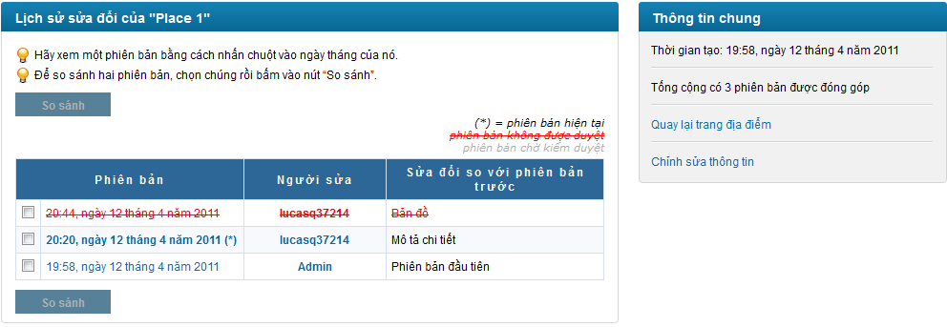**

**Data Fields Definition – Attach Place Page**

|  |  |  |  |  |  |  |
| --- | --- | --- | --- | --- | --- | --- |
| **Field name** | **Description** | **Read**  **Only** | **Mandatory** | **Control Type** | **Data Type** | **Length** |
| **Revision area** | **The following fields will be surrounded by a border to allow logical grouping of data for the user. The border will have a heading titled “Lịch sử sửa đổi của” + place name** | **N/A** | **N/A** | **Group Box** | **Text** | **Fixed** |
| Instruction | Contains instructions for viewing and compare revisions | N/A | N/A | Label | Label | Fixed |
| Revisions | A grid with 3 columns: “Phiên bản”, “Người sửa” and “sửa đổi so với phiên bản trước” | N/A | N/A | Label | Text | Fixed |
| **General information** | **The following fields will be surrounded by a border to allow logical grouping of data for the user. The border will have a heading titled “Thông tin chung”** | **N/A** | **N/A** | **Group Box** | **Text** | **Fixed** |
| Place created date | A label with content “Thời gian tạo:” + created date in vietnamese | N/A | N/A | Label | Label | Fixed |
| Revision number | A label with content “Tống cộng có” + revision number +“phiên bản được đóng góp” | N/A | N/A | Label | Label | Fixed |

**Buttons / Hyper Links – Attach Place Page**

|  |  |  |  |  |
| --- | --- | --- | --- | --- |
| **Function** | **Description** | **Available Criteria** | **Validations** | **Outcome** |
| Compare 2 revision | The button will allow the user to compare 2 edit versions. | Disable by default.  Enable when only 2 versions are selected | No validation | User is navigated to the version compare page |
| Revision hyperlink | The date time that the edit version is saved.  Open the edit version’s details page | Always available | No validation | display chosen edit version’s details in popup |
| Creator hyperlink | The username of the user that created this revision is displayed as hyperlink. | Always available | No validation | Redirect to user profile page |
| Edit page hyperlink | “[Quay lại trang địa điểm](http://localhost:2470/dia-diem/place-1-1)” hyperlink | Always available | No validation | Redirect user to Edit Place page |
| Detail page hyperlink | “[Chỉnh sửa thông tin](http://localhost:2470/places/edit/1)” hyperlink | Always available | No validation | Redirect user back to Place Detail page |

#### View a Revision of a Place

##### Use Case Diagram



##### Use Case Specification

|  |  |  |  |  |
| --- | --- | --- | --- | --- |
| **USE CASE- View a revision of a place SPECIFICATION** | | | | |
| **Use-case No.** | UC005 | **Use-case Version** | | 1.0 |
| **Use-case Name** | View a revision of a place | | | |
| **Author** | QuocNM | | | |
| **Date** | 15/01/2011 | **Priority** | Normal | |
| **Actor:**  User  **Summary:**  This use case allows the actor view in detail a revision of a place.  **Goal:**  Display detail information of a revision of a place  **Triggers**  Click to the revision name hyperlink  **Preconditions:**  User is in the history page.  **Post Conditions:**  Popup a window to display revision detail  **Main Success Scenario:**   |  |  |  | | --- | --- | --- | | Step | Actor Action | System Response | | 1 | User click to revision hyperlink | Popup a window to display revision detail |   **Exceptions:**  None  **Relationships:**  Log in use case, View history of a place use case  **Business Rules:**  None | | | | |
| **Description:**  Revisions created by users with less than 1000 points will be taken in consideration. Approvals from verified users (has 1000 points or more) and admins will make it become a real revision and can be displayed at Place Detail page. At Edit history page, when users click to a Revision, a popup will open and displayed all information of that revision. Revision’s information is not different with a place’s information. It has addition information that is State. State will let people know that the current viewing revision is in need of approvals or not. | | | | |

**Screen**

**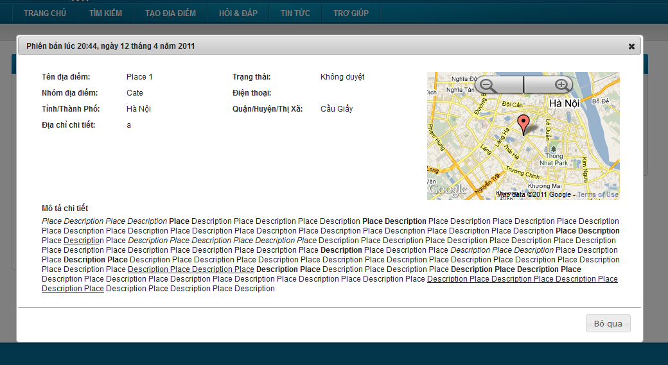**

**Data Fields Definition – Attach Place Page**

|  |  |  |  |  |  |  |
| --- | --- | --- | --- | --- | --- | --- |
| **Field name** | **Description** | **Read**  **Only** | **Mandatory** | **Control Type** | **Data Type** | **Length** |
| **Basic information** | **The following fields will be surrounded by a border to allow logical grouping of data for the user. The border will have a heading titled “Phiên bản” + created date in vietnamese** | **N/A** | **N/A** | **Group Box** | **Text** | **Fixed** |
| Place name label | A label with content “Tên địa điểm” | N/A | N/A | Label | Text | Fixed |
| Place name | Place name | N/A | N/A | Label | Text | Fixed |
| Revision state label | A label with content “Trạng thái” | N/A | N/A | Label | Text | Fixed |
| Revision state | Revision state | N/A | N/A | Label | Text | Fixed |
| Category label | A label with content “Nhóm địa điểm” | N/A | N/A | Label | Text | Fixed |
| Category | Place’s category | N/A | N/A | Label | Text | Fixed |
| City label | A label with content “Tỉnh / Thành Phố” | N/A | N/A | Label | Text | Fixed |
| City | Place’s city/province | N/A | N/A | Label | Text | Fixed |
| District label | A label with content “Quận / Huyện/Thị xã” | N/A | N/A | Label | Text | Fixed |
| District | Place’s district/town/ward | N/A | N/A | label | Text | Fixed |
| Phone number label | A label with content “Điện thoại” | N/A | N/A | Label | Text | Fixed |
| Phone number | Place’s phone number | N/A | N/A | Label | Text | Fixed |
| Detail address label | A label with content “Địa chỉ chi tiết” | N/A | N/A | Label | Text | Fixed |
| Detail address | Place’s detail address | N/A | N/A | Label | Text | Fixed |
| **Mini map** | **A mini map display place location** | N/A | N/A | **Google Map API** |  |  |
| **Detail description** | **The following fields will be surrounded by a border to allow logical grouping of data for the user. The border will have a heading titled “Mô tả chi tiết”** | **N/A** | **N/A** | **Group Box** | **Text** | Fixed |
| Description box | Place’s description | N/A | N/A | Label | Text | Fixed |

**Buttons / Hyper Links – Attach Place Page**

|  |  |  |  |  |
| --- | --- | --- | --- | --- |
| **Function** | **Description** | **Available Criteria** | **Validations** | **Outcome** |
| Cancel | This button is for closing popup | Always available | No validation | Close the popup |

#### Compare 2 Revisions of a Place

##### Use Case Diagram



##### Use Case Specification

|  |  |  |  |  |
| --- | --- | --- | --- | --- |
| **USE CASE- Compare 2 revisions of a place SPECIFICATION** | | | | |
| **Use-case No.** | UC006 | **Use-case Version** | | 1.0 |
| **Use-case Name** | Compare 2 revisions of a place | | | |
| **Author** | QuocNM | | | |
| **Date** | 15/01/2011 | **Priority** | Normal | |
| **Actor:**  User  **Summary:**  This use case allows the user compare 2 edit revision of a place and spot differences.  **Goal:**  Display comparison result of 2 revisions  **Triggers**  Click to the “So sánh” button in the edit history page  **Preconditions:**  User is in the edit history page.  **Post Conditions:**  Compare result is displayed  **Main Success Scenario:**   |  |  |  | | --- | --- | --- | | Step | Actor Action | System Response | | 1 | User click to 2 check boxes of 2 revisions | The “So sánh” button is enabled | | 2 | User click to “So sánh” button | System redirect user to compare revision page |   **Exceptions:**  None  **Relationships:**  Log in use case, View a place detail, Views history of a place use case  **Business Rules:**   |  |  |  | | --- | --- | --- | |  | Business Rule | Error Message | | 1 | Only compare 2 revisions |  | | 2 | Date fields contains differences is displayed in red background |  | | | | | |
| **Description:**  At Edit history page, users can compare 2 revisions by check these 2 revisions and click to “So sánh” button. A popup will open and display compares result. These results contain information of 2 revisions. The differences are displayed in red. About place location, the system only let users know if there is difference or not. | | | | |

**Screen**

**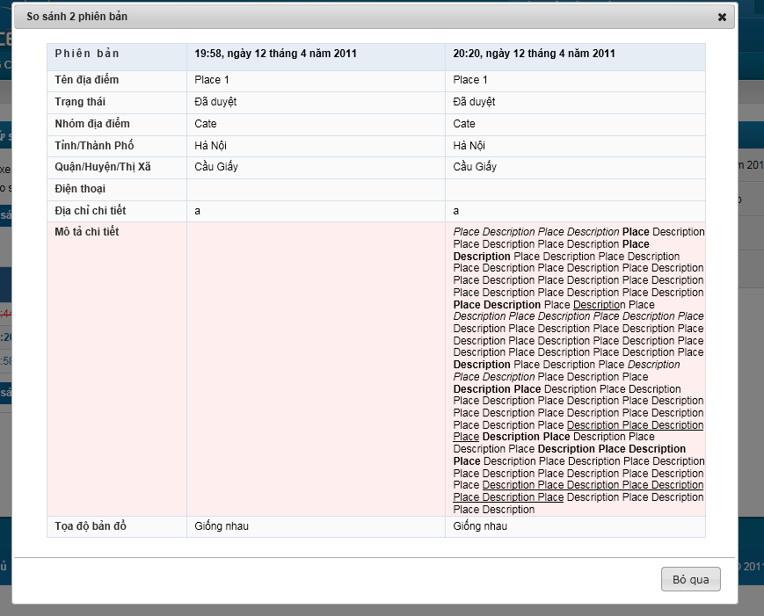**

**Data Fields Definition – Attach Place Page**

|  |  |  |  |  |  |  |
| --- | --- | --- | --- | --- | --- | --- |
| **Field name** | **Description** | **Read**  **Only** | **Mandatory** | **Control Type** | **Data Type** | **Length** |
| Place name label | A label with content “Tên địa điểm” | N/A | N/A | Label | Text | Fixed |
| Place name | Place name | N/A | N/A | Label | Text | Fixed |
| Revision state label | A label with content “Trạng thái” | N/A | N/A | Label | Text | Fixed |
| Revision state | Revision state | N/A | N/A | Label | Text | Fixed |
| Category label | A label with content “Nhóm địa điểm” | N/A | N/A | Label | Text | Fixed |
| Category | Place’s category | N/A | N/A | Label | Text | Fixed |
| City label | A label with content “Tỉnh / Thành Phố” | N/A | N/A | Label | Text | Fixed |
| City | Place’s city/province | N/A | N/A | Label | Text | Fixed |
| District label | A label with content “Quận / Huyện/Thị xã” | N/A | N/A | Label | Text | Fixed |
| District | Place’s district/town/ward | N/A | N/A | label | Text | Fixed |
| Phone number label | A label with content “Điện thoại” | N/A | N/A | Label | Text | Fixed |
| Phone number | Place’s phone number | N/A | N/A | Label | Text | Fixed |
| Detail address label | A label with content “Địa chỉ chi tiết” | N/A | N/A | Label | Text | Fixed |
| Detail address | Place’s detail address | N/A | N/A | Label | Text | Fixed |
| Description label | A label with content “Mô tả chi tiết” | N/A | N/A | Label | Text | Fixed |
| Description box | Place’s description | N/A | N/A | Label | Text | Fixed |
| Place location label | A label with content “Toạ độ bản đồ” | N/A | N/A | Label | Text | Fixed |
| Place location | “Giống nhau” or “Khác nhau” label | N/A | N/A | Label | Text | Fixed |

**Buttons / Hyper Links – Attach Place Page**

|  |  |  |  |  |
| --- | --- | --- | --- | --- |
| **Function** | **Description** | **Available Criteria** | **Validations** | **Outcome** |
| Cancel | This button is for closing popup | Always available | No validation | Close the popup |

#### Approve a Revision

##### Use Case Diagram



##### Use Case Specification

|  |  |  |  |  |
| --- | --- | --- | --- | --- |
| **USE CASE- Approve a version SPECIFICATION** | | | | |
| **Use-case No.** | UC007 | **Use-case Version** | | 1.0 |
| **Use-case Name** | Approve a revision | | | |
| **Author** | QuangLM | | | |
| **Date** | 15/01/2011 | **Priority** | Normal | |
| **Actor:**  Senior user (with more than 1000 Contribution Point) or Administrations (View more Business rules for detail)  **Summary:**  Revisions created by junior user won’t be set as current revision. It needs approval to be displayed. Senior users and admins can approve or disapprove revisions when viewing revision detail.  **Goal:**  Approve or disapprove a revision  **Triggers**  Click to “Duyệt sửa đổi” button or “Không duyệt sửa đổi” button at Revision Detail popup  **Preconditions:**  Logged into the system successful and open a revision’s details popup.  **Post Conditions:**  Update revision state and still stay at Edit history Page  **Main Success Scenario:**   |  |  |  | | --- | --- | --- | | Step | Actor Action | System Response | | 1 | Click to “Duyệt sửa đổi” button | Popup closes, revision state is changed to approved |   **Alternative Scenarios:**   |  |  |  | | --- | --- | --- | | Step | Actor Action | System Response | | 1 | Click to “Không duyệt sửa đổi” button | Popup closes, revision state is changed to disapproved |  |  |  |  | | --- | --- | --- | | Step | Actor Action | System esponse | | 1 | Click to “Bỏ qua” button | Popup closes |   **Exceptions:**  None  **Relationships:**  Log in use case, Views edit history of a place, view a revision use case.  **Business Rules:**   |  |  |  | | --- | --- | --- | |  | Business Rule | Error Message | | 1 | Rank of an user will be set based on th user’s contribution point (CP) |  | | 2 | Contribution Point (CP) is calculated as follow: **-** Starter point for every user is 10 point - Create a place: + 20 point - Your place get deleted: - 25 point |  | | 3 | For user has more than 1000 point (senior user): - Can edit a place directly - Can upload place’s image directly - Can approve suggested edit - Can approve suggested images  - Set a revision as current |  | | 4 | For user has less than 1000 point (junior user): - an revision of a place created by these users need approvals from senior users or admins to be displayed | “Bạn chưa đủ điểm để sử dụng chức năng này” | | | | | |
| **Description:**  Revisions created by users with less than 1000 points will be taken in consideration. Approvals from verified users (has 1000 points or more) and admins will make it become a real revision and can be displayed at Place Detail page. At Edit history page, when users click to a Revision, a popup will open and displayed all information of that revision.  When a verified user or admin check detail of a revision which are in need of approvals, “Duyệt sửa đổi” and “Không duyệt sửa đổi” buttons are displayed. Click to “Duyệt sửa đổi” will make the current viewing revision become a real revision. Otherwise, click to “Không duyệt sửa đổi” will mark the current revision as unapproved. | | | | |

**Screen**

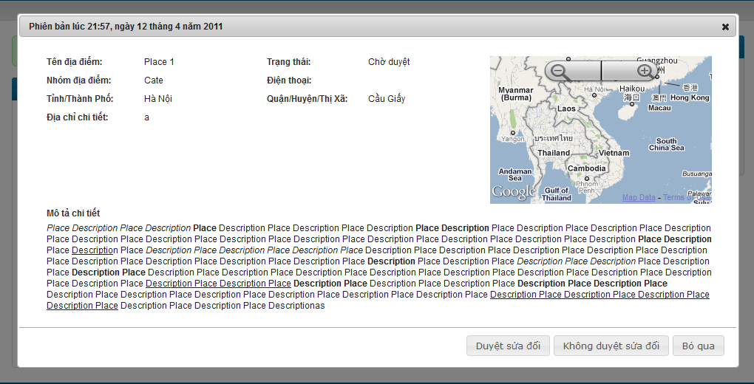

**Data Fields Definition – Attach Place Page**

|  |  |  |  |  |  |  |
| --- | --- | --- | --- | --- | --- | --- |
| **Field name** | **Description** | **Read**  **Only** | **Mandatory** | **Control Type** | **Data Type** | **Length** |
| **Basic information** | **The following fields will be surrounded by a border to allow logical grouping of data for the user. The border will have a heading titled “Phiên bản” + created date in vietnamese** | **N/A** | **N/A** | **Group Box** | **Text** | **Fixed** |
| Place name label | A label with content “Tên địa điểm” | N/A | N/A | Label | Text | Fixed |
| Place name | Place name | N/A | N/A | Label | Text | Fixed |
| Revision state label | A label with content “Trạng thái” | N/A | N/A | Label | Text | Fixed |
| Revision state | Revision state | N/A | N/A | Label | Text | Fixed |
| Category label | A label with content “Nhóm địa điểm” | N/A | N/A | Label | Text | Fixed |
| Category | Place’s category | N/A | N/A | Label | Text | Fixed |
| City label | A label with content “Tỉnh / Thành Phố” | N/A | N/A | Label | Text | Fixed |
| City | Place’s city/province | N/A | N/A | Label | Text | Fixed |
| District label | A label with content “Quận / Huyện/Thị xã” | N/A | N/A | Label | Text | Fixed |
| District | Place’s district/town/ward | N/A | N/A | label | Text | Fixed |
| Phone number label | A label with content “Điện thoại” | N/A | N/A | Label | Text | Fixed |
| Phone number | Place’s phone number | N/A | N/A | Label | Text | Fixed |
| Detail address label | A label with content “Địa chỉ chi tiết” | N/A | N/A | Label | Text | Fixed |
| Detail address | Place’s detail address | N/A | N/A | Label | Text | Fixed |
| **Mini map** | **A mini map display place location** | N/A | N/A | **Google Map API** |  |  |
| **Detail description** | **The following fields will be surrounded by a border to allow logical grouping of data for the user. The border will have a heading titled “Mô tả chi tiết”** | **N/A** | **N/A** | **Group Box** | **Text** | Fixed |
| Description box | Place’s description | N/A | N/A | Label | Text | Fixed |

**Buttons / Hyper Links – Attach Place Page**

|  |  |  |  |  |
| --- | --- | --- | --- | --- |
| **Function** | **Description** | **Available Criteria** | **Validations** | **Outcome** |
| Approve a revision | This button is used for approve a revision | Only available when revision state is unapproved | No | Revision state is updated, popup close |
| Disapprove a revision | This button is used for disapprove a revision | Only available when revision state is unapproved | No | Revision state is updated, popup close |
| cancel | The button will allow the user to close this popup | Always available | No | Popup closes |

#### Set a revision as current

##### Use Case Diagram



##### Use Case Specification

|  |  |  |  |  |
| --- | --- | --- | --- | --- |
| **USE CASE- Set a revision is current SPECIFICATION** | | | | |
| **Use-case No.** | UC008 | **Use-case Version** | | 1.0 |
| **Use-case Name** | Set a revision as current | | | |
| **Author** | QuangLM | | | |
| **Date** | 15/01/2011 | **Priority** | Normal | |
| **Actor:**  Senior user (with more than 1000 Contribution Point) or Administrations  **Summary:**  When the quality for current revision is worse than older revision or the place information is changed back, we can go back and set an older revision as current.  **Goal:**  Set a revision as current  **Triggers**  Click to “Đặt làm phiên bản hiện tại” button at Revision Detail popup  **Preconditions:**  Logged into the system successful and open a revision’s details popup.  **Post Conditions:**  Update revision state and still stay at Edit history Page  **Main Success Scenario:**   |  |  |  | | --- | --- | --- | | Step | Actor Action | System Response | | 1 | Click to “Đặt làm phiên bản hiện tại” button | Popup closes, revision state is changed to current revision |   **Alternative Scenarios:**   |  |  |  | | --- | --- | --- | | Step | Actor Action | System Response | | 1 | Click to “Bỏ qua” button | Popup closes |   **Exceptions:**  None  **Relationships:**  Log in use case, Views edit history of a place, view a revision use case.  **Business Rules:**   |  |  |  | | --- | --- | --- | |  | Business Rule | Error Message | | 1 | Rank of an user will be set based on the user’s contribution point (CP) |  | | 2 | Contribution Point (CP) is calculated as follow: **-** Starter point for every user is 10 point - Create a place: + 20 point - Your place get deleted: - 25 point |  | | 3 | For user has more than 1000 point (senior user): - Can edit a place directly - Can upload place’s image directly - Can approve suggested edit - Can approve suggested images  - Set a revision as current |  | | 4 | For user has less than 1000 point (junior user): - an revision of a place created by these users need approvals from senior users or admins to be displayed | “Bạn chưa đủ điểm để sử dụng chức năng này” | | | | | |

**Screen**

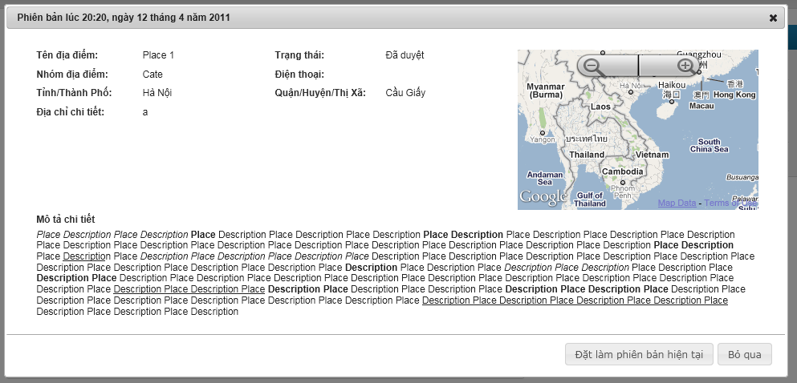

**Data Fields Definition**

|  |  |  |  |  |  |  |
| --- | --- | --- | --- | --- | --- | --- |
| **Field name** | **Description** | **Read**  **Only** | **Mandatory** | **Control Type** | **Data Type** | **Length** |
| **Basic information** | **The following fields will be surrounded by a border to allow logical grouping of data for the user. The border will have a heading titled “Phiên bản” + created date in vietnamese** | **N/A** | **N/A** | **Group Box** | **Text** | **Fixed** |
| Place name label | A label with content “Tên địa điểm” | N/A | N/A | Label | Text | Fixed |
| Place name | Place name | N/A | N/A | Label | Text | Fixed |
| Revision state label | A label with content “Trạng thái” | N/A | N/A | Label | Text | Fixed |
| Revision state | Revision state | N/A | N/A | Label | Text | Fixed |
| Category label | A label with content “Nhóm địa điểm” | N/A | N/A | Label | Text | Fixed |
| Category | Place’s category | N/A | N/A | Label | Text | Fixed |
| City label | A label with content “Tỉnh / Thành Phố” | N/A | N/A | Label | Text | Fixed |
| City | Place’s city/province | N/A | N/A | Label | Text | Fixed |
| District label | A label with content “Quận / Huyện/Thị xã” | N/A | N/A | Label | Text | Fixed |
| District | Place’s district/town/ward | N/A | N/A | label | Text | Fixed |
| Phone number label | A label with content “Điện thoại” | N/A | N/A | Label | Text | Fixed |
| Phone number | Place’s phone number | N/A | N/A | Label | Text | Fixed |
| Detail address label | A label with content “Địa chỉ chi tiết” | N/A | N/A | Label | Text | Fixed |
| Detail address | Place’s detail address | N/A | N/A | Label | Text | Fixed |
| **Mini map** | **A mini map display place location** | N/A | N/A | **Google Map API** |  |  |
| **Detail description** | **The following fields will be surrounded by a border to allow logical grouping of data for the user. The border will have a heading titled “Mô tả chi tiết”** | **N/A** | **N/A** | **Group Box** | **Text** | Fixed |
| Description box | Place’s description | N/A | N/A | Label | Text | Fixed |

**Buttons / Hyper Links**

|  |  |  |  |  |
| --- | --- | --- | --- | --- |
| **Function** | **Description** | **Available Criteria** | **Validations** | **Outcome** |
| Set a revision as current | This button is used for setting current viewing revision as current revision | Only available when revision state is approved and not current | No | Revision state is updated, popup close |
| cancel | The button will allow the user to close this popup | Always available | No | Popup closes |

#### View a Place Detail

##### Use Case Diagram



##### Use Case Specification

|  |  |  |  |  |
| --- | --- | --- | --- | --- |
| **USE CASE – View a place detail SPECIFICATION** | | | | |
| **Use-case No.** | UC009 | **Use-case Version** | | 1.0 |
| **Use-case Name** | View a Place Detail | | | |
| **Author** | QuangVT | | | |
| **Date** | 24/01/2011 | **Priority** | High | |
| **Actor:**  User  **Summary:**  After a user performs searching for places, the result is returned containing the most basic information of the places. If the user wants to view more information of a place, he/she can navigate to the place details page. From this page, the user can interact with the place as well as other users. The user can rate the place, comment, edit, mark as spam… All information of the place is displayed here.  The place details page may be navigated from other locations other than the search result page. For example the “top places” list. In general, the details page may be accessed from anywhere that displays the place’s identity.  **Goal:**  Display the place details to the users, and allow the users to interact with the place as well as other users.  **Triggers**  Users click a place link from anywhere in the system  **Preconditions:**  Access the website  **Post Conditions:**  The page navigates to the details page with the place’s information displayed  **Main Success Scenario:**   |  |  |  | | --- | --- | --- | | Step | Actor Action | System Response | | 1 | Searches for places by some criteria | Search result is returned | | 2 | Click a place link | The page navigates to the place details screen |   **Alternative Scenarios:**   |  |  |  | | --- | --- | --- | | Step | Actor Action | System Response | | 1 | Click to “Tạo địa điểm” tab in navigator | Rdirect to Create Place page | | 2 | Fill in required fields |  | | 3 | Click “Tạo địa điểm” button | Redirect to Place Detail page of new place |   **Exceptions:**   |  |  |  | | --- | --- | --- | | Step | Actor Action | System Response | | 1 | Click an invalid place link | Display erro page inform the user that the pge doesn’t exsit |   **Relationships:**  Search places, View edit history of a place, Edit place location on map, Report an edit of other users on a place, Report a place as fake/spam, Mark a place as visited, Share a place on other social networks, Delete a place, Place response, User comment  **Business Rules:**  None | | | | |
| **Description:**  After the user performs a search place action, he/she can choose to view details of some places from the result list. This will bring the user to the Place Details page. This page may also be navigated from anywhere that refers to its identity. After visiting this page, the user can view all information of the place.  The page will display the information of the place including:   * Place name: name of the place * Place address: full address of the place * Location on the map: the map will be shown as a medium picture and can be zoomed in/out (like Google Map). There is a point on the map indicating location of the place. The default map will show an area of 25 square kilometers (5x5) with the place spot located at the center. * Images of the place: images include a main image that displays as the place’s avatar, and other images. All images are contributed by the society, and the most liked image will become the main image. Only approved images are displayed.   The page will also show some related places to this place. They are places in the same category and have the highest popularity. The number of related places to show is 10 in maximum.  Users can perform various actions on this page, including:   * Edit the place info: refer to use case Edit a Place’s Information * Edit place location on the map: refer to use case Edit a Place’s Location * Rate the place: refer to use case Rate a Place * Comment: refer to use case Post a Comment * Mark the place as visited: refer to use case Mark a Place as Visited * Report a place as spam: refer to use case Report a Place * Upload images for the place * View a place’s revisions: refer to use case View Edit History of a Place * Add a place to your favorite list: refer to use case Add a Place to Favorite List   Increase page view  Each hit to the place details page will increase the number of page views for this place. | | | | |

**Screen**

**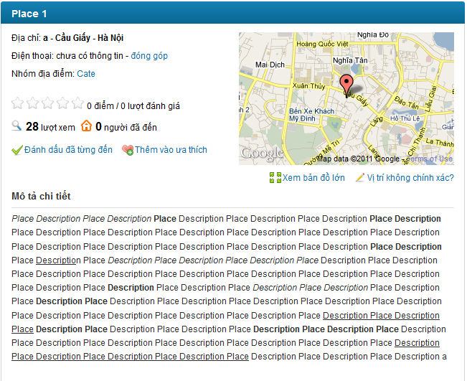**

**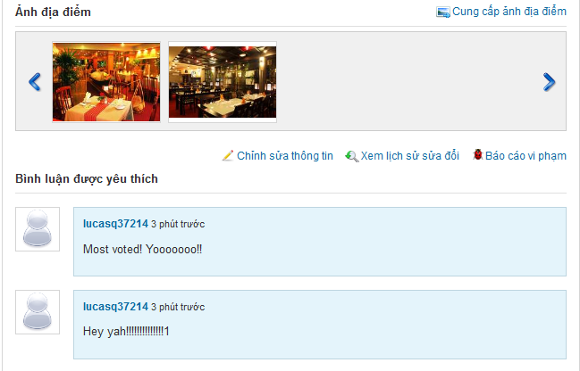**

**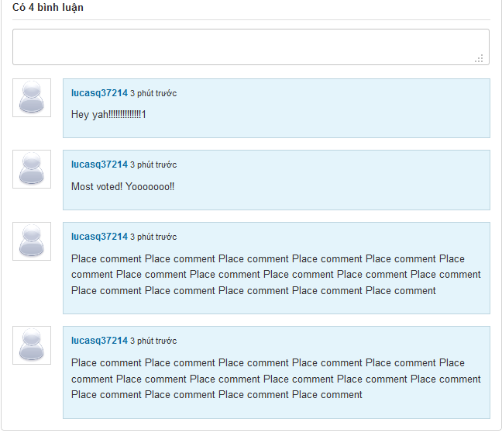**

**Data Fields Definition –Create Place Page**

|  |  |  |  |  |  |  |
| --- | --- | --- | --- | --- | --- | --- |
| **Field name** | **Description** | **Read**  **Only** | **Mandatory** | **Control Type** | **Data Type** | **Length** |
| Place name | Place name is displayed at header | N/A | N/A | Label | String | Fixed |
| Detail address | A label contains detail address, created by Detail Address + District/Town/Ward + City/Province | N/A | N/A | Label | String | Fixed |
| Phone number | A label contains place’s phone number | N/A | N/A | Label | String | Fixed |
| Rating | A label with content: 5 star symbols + current rating + rate times + “ lượt đánh giá” | N/A | N/A | Label | String | Fixed |
| View number | A label with content: view number + “lượt xem” | N/A | N/A | Label | String | Fixed |
| Visited number | A label with content: visited number + “người đã đến” | N/A | N/A | Label | String | Fixed |
| description | A label contains place description | N/A | N/A | Label | String | Fixed |

**Buttons / Hyper Links – Q&A Screen**

|  |  |  |  |  |
| --- | --- | --- | --- | --- |
| **Function** | **Description** | **Available Criteria** | **Validations** | **Outcome** |
| “đóng góp” hyperlink | Allow user open Edit Place page | Only Available when unrequired fields are leave blank when creating place | No validation | Redirect user to Edit Place page |
| “Xem bản đồ lớn” hyperlink | Allow user to see place location in bigger map | Always Available | No validation | Popup a window with bigger map |
| “Vị trí không chính xác?” hyperlink | Allow user to edit place location | Always Available | No validation | Popup a window with bigger map for changing location |
| “Đánh dấu đã từng đến” hyperlink | Allow user mark current viewing place as visited | Always Available | No validation | Visited number is increased by 1, display message “Địa điểm đã được đánh dấu.  ” |
| “Thêm vào ưa thích” hyperlink | Allow user to add current viewing place to favorite list | Always Available | No validation | Display message “Địa điểm đã được thêm vào ưa thích” |
| “Cung cấp ảnh địa điểm” hyperlink | Allow user to upload images for current viewing place | Always Available | No validation | Popup window with uploader for upload images |
| “Chỉnh sửa thông tin” hyperlink | Allow user edit open Edit Place page | Always Available | No validation | Redirect user to Edit Place page |
| “Xem lịch sử sửa đổi” hyperlink | Allow user to view revisions of current viewing place | Always Available | No validation | Redirect user to Revisions page |
| “Báo cáo vi phạm” hyperlink | Allow user to report a place | Always Available | No validation | Popup report window |
| Category link | This link will search all place belong to selected category | Always Available | No validation | Redirect user to Search Place page with search results contains all places belong to selected category |
| User link | This hyperlink helps user open User Profile page | Display with each comment | No validation | Redirect user to User Profile page |

#### Search Places

##### Use Case Diagram



##### Use Case Specification

|  |  |  |  |  |
| --- | --- | --- | --- | --- |
| **USE CASE – Search places SPECIFICATION** | | | | |
| **Use-case No.** | UC010 | **Use-case Version** | | 1.0 |
| **Use-case Name** | Search Places | | | |
| **Author** | QuangVT | | | |
| **Date** | 24/01/2011 | **Priority** | High | |
| **Actor:**  User  **Summary:**  This is one of the main functions of the system. Users can search for places by some criteria in order to find the best place suitable for their need. The criteria may include place category, distance, popularity… The search result will be filtered to support users find the right place as quick as possible.  The search function will include quick search and advanced search. Quick search is available to the user right from the home page and accept the most basic criteria like category and area. Advanced search will accept more criteria to help users filter search result more precisely.  **Goal:**  Search for places  **Triggers**  Users enter search criteria and click search button  **Preconditions:**  Access the website  **Post Conditions:**  The page navigates to search result screen with the result displayed  **Main Success Scenario:**   |  |  |  | | --- | --- | --- | | Step | Actor Action | System Response | | 1 | Enters place category to the search text box |  | | 2 | Clicks “Tìm kiếm” buton | Display search result |   **Alternative Scenario - Suggestion:**   |  |  |  | | --- | --- | --- | | Step | Actor Action | System Response | | 1 | Enters place category to the search text box | The system displays suggestions which have similar spellings with the text entered | | 2 | Chooses one of the suggestions |  | | 3 | Clicks “Tìm kiếm” button | Display search result |   **Alternative Scenario – Advanced Search**   |  |  |  | | --- | --- | --- | | Step | Actor Action | System Response | | 1 | Clicks “Tìm kiếm nâng cao” hyperlink | New region on the page is displayed with more search criteria inputs | | 2 | Enters search criteria |  | | 3 | Clicks “Tìm kiếm” button | Display search result |   **Alternative Scenario – No result**   |  |  |  | | --- | --- | --- | | Step | Actor Action | System Response | | 1 | Enter category which has no place belong to |  | | 2 | Clicks “Tìm kiếm” button | Display “Không tìm thấy địa điểm nào!” |   **Exceptions:**  N/A  **Relationships:**  None  **Business Rules:**  None | | | | |
| **Description:**  Users will use this function to search for places that best fit for their need. The user will input some search criteria and the system will return the result based on those criteria.  **Quick Search**  This is one of main regions on the system. Use can access to it right at the home page or go to Search Place page by click to “Tìm kiếm” at navigator. The region contains 2 fields: “Tìm gì, mua gì” and “Ở đâu”. With the first field, the users will enter place’s category or place name they want to search. For example: “cà phê”, “rửa xe”, “Ngân hàng ACB”… With the second field, the users will enter the area they want to find places in. The areas are specified as a city/province/district/town/ward... For example: “Hà Nội”, “Cầu Giấy, Hà Nội”…  A place is included in the search result if it matches all the search criteria. For example, if a user enters “Cà phê” as the category, and “Cầu Giấy, Hà Nội” as the area, only coffee shops in Cau Giay, Ha Noi are included in the search result.  The search area field will be auto populated by data from the user’s browser cookies if already existed. Otherwise, it will be based on the user’s IP address. That is if the user first visits the website, the search area text box will be populated based on the user’s IP. After the user performs the search function, the content of that text box will be stored in the user’s browser cookies and will be the retrieved to populate that text box the next time user performs searching.  **Advanced Search**  This function will provide users more options to tailor search result more precisely. The options include:   * Search category and search area: like quick search * Distance to the user’s location. The distance will be specified in Kilometers. In order to use this feature, the user must specify his location on the map. The location will be retrieved from the user info if he has logged in, or from the user’s browser cookies if existed there. If none of the two sources exists, the user will be prompted to select his location on the map. After the user specifies his location, the location is saved to the user info (if logged in) and the user’s browser cookies. Search result will only include places distance from which is not longer than the Km specified. * Rating must be greater than or equal to. Users can restrict this field to filter places with best rating.   **Search Suggestions**  After the user enters first characters into the search text boxes, the system will display some suggestions below the text boxes that have the similar spelling. Here are some considerations that take into account when display the suggestions:   * The suggestions are not case-sensitive. That is it doesn’t matter that the user enters upper or lower case characters into the text boxes, the suggestions must be the same. * The suggestions are not Unicode-sensitive. That is if the user enters “ca phe”, the suggestions will be the same as if the user enters “cà phê”. * An item will be included in the suggestions if it contains the character sequence entered in the text box, ignoring the spaces. Item containing the sequence at index i will be displayed before item containing the sequence at index j if i < j. If i = j, the items will be ordered based on the number of searches performed on that item.   For example: if the user input “Cà” in the search category, the system will suggest: “Cà phê”, “Cà chua”, “Cà pháo”, “Giáp lá cà”, if the term “Cà phê” is searched the most in the triplet. If the user inputs “Cà p”, only “Cà phê” and “Cà pháo” are displayed in the suggestions.   * A category is associated with many aliases. For example “Cà phê” may also be called “café”. The suggestions must be checked with those aliases as well. * Area text box will suggest only city/province/district/town/ward. For example: “Hà Nội”, “Cầu Giấy, Hà Nội”.   **Search Result**  Search result must match all the criteria inputted. Each place appearing in the search result will display the following information: Place name, place image, rating, number of raters, number of comments, number of page views.  Users will have the options to sort places by rating, number of comments and number of page views. Default will be “rating descending”.  Search result will be paged with 20 items per page. User only need click to “Xem thêm” at the end of result list to see more search result. | | | | |

**Screen**

**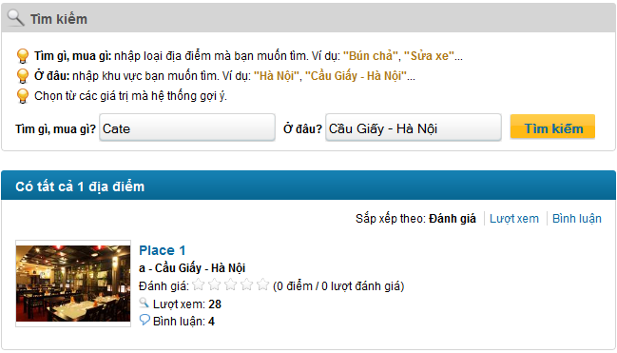**

**Data Fields Definition – Search Places**

|  |  |  |  |  |  |  |
| --- | --- | --- | --- | --- | --- | --- |
| **Field name** | **Description** | **Read**  **Only** | **Mandatory** | **Control Type** | **Data Type** | **Length** |
| **Search Area** | | | | | | |
| Instruction | Contains instructions for searching place | Y | Y | Label | String | Fixed |
| Category Seach label | A label with content “Tìm gì, mua gì?” | Y | Y | Label | String | Fixed |
| Category search | Category used for searched | N | Y | Text box | String | 100 |
| Address part search label | A label with content “Ở đâu?” | Y | Y | Label | String | Fixed |
| Address part seach | Address part used for searched | N | Y | Text box | String | 100 |
| **Sort Area** | | | | | | |
| Sort label | A label with content “Sắp xếp theo” | Y | Y | Label | String | Fixed |
| Rating label | A label with content “Đánh giá” | Y | Y | Label | String | Fixed |
| View label | A label with content “Lượt xem” | Y | Y | Label | String | Fixed |
| Comment label | A label with content “Bình luận” | Y | Y | Label | String | Fixed |
| **Result Area – each place contains:** | | | | | | |
| Place name | A label contains place name | Y | Y | Label | String | Fixed |
| Detail address | A label contains place detail address + district/town/ward + city/province | Y | Y | Label | String | Fixed |
| Rating | A label contains place rating | Y | Y | Label | String | Fixed |
| View number | A label contains place view number | Y | Y | Label | String | Fixed |
| Comment number | A label contains place comment number | Y | Y | Label | String | Fixed |

**Buttons / Hyper Links – Search Places**

|  |  |  |  |  |
| --- | --- | --- | --- | --- |
| **Function** | **Description** | **Available Criteria** | **Validations** | **Outcome** |
| Search place | A button which start searching for places based on inputted criteria | Always available | Category isn’t blank | Display results below search area or message “Không tìm thấy địa điểm nào!” |
| Sort by rating | A link that sort search results based on place’s rating, from highest to lowest | Available when dispay search results |  | All results are sorted by rating, from highest to lowest |
| Sort by view number | A link that sort search results based on place’s view number, from highest to lowest | Available when dispay search results |  | All results are sorted by view number, from highest to lowest |
| Sort by comment number | A link that sort search results based on place’s comment number, from highest to lowest | Available when dispay search results |  | All results are sorted by comment number, from highest to lowest |
| Place link | This link will navigate user to Place Detail page | Available when dispay search results |  | Redirect to Place Detail page |

#### Report a Place

##### Use Case Diagram



##### Use Case Specification

|  |  |  |  |  |
| --- | --- | --- | --- | --- |
| **USE CASE- Report a place SPECIFICATION** | | | | |
| **Use-case No.** | UC011 | **Use-case Version** | | 1.0 |
| **Use-case Name** | Report a place | | | |
| **Author** | QuocNM | | | |
| **Date** | 15/01/2011 | **Priority** | Normal | |
| **Actor:**  User  **Summary:**  When user detect a place is fake, doesn’t exist or created by untrusted user or contains inappropriate content, he/she can report that place to the administrator and let administrator team handle it.  **Goal:**  This use case allows the actor report a place as fake/spam/inappropriate.  **Triggers**  Click to “Báo cáo vi phạm” hyperlink in the place’s details page.  **Preconditions:**  Successfully logged into the system and open place’s details page.  **Post Conditions:**  Stay remains at Place Detail page  **Main Success Scenario:**   |  |  |  | | --- | --- | --- | | Step | Actor Action | System Response | | 1 | Click to “Báo cáo vi phạm” hyperlink | System shows a popup to confirm and user can add more reason why this lace is reported. | | 2 | Click to “Báo cáo” button. | Display popup notify success message “Báo cáo vi phạm hoàn tất! Ban quan trị sẽ kiểm tra lại trong thời gian sớm nhất.” | | 3 | Click to OK button | Popups close |   **Alternative Scenarios:**   |  |  |  | | --- | --- | --- | | Step | Actor Action | System Reponse | | 1 | Click to “Báo cáo vi phạm” hyperlink | System shows a popup to confirm and user can add more reason why this place is reported. | | 2 | Enter reason |  | | 3 | Click to “Báo cáo” button. | Display popup notify success message “Báo cáo vi phạm hoàn tất! Ban quan trị sẽ kiểm tra lại trong thời gian sớm nhất.” | | 4 | Click to OK button | Popups close |  |  |  |  | | --- | --- | --- | | Step | Actor Action | System Response | | 1 | Click to “Báo cáo vi phạm” hyperlink | System shows a popup to confirm and user can add more reason why this place is reported. | | 2 | Enter reason |  | | 3 | Click to “Bỏ qua” button. | Popup close |   **Exceptions:**   |  |  |  | | --- | --- | --- | | Step | Actor Action | System Response | | 1 | Click to “Báo cáo vi phạm” hyperlink | System shows a popup to confirm and user can add more reason why this place is reported. | | 2 | Enter reason |  | | 3 | Click to “Báo cáo” button. | Display popup notify success message “Báo cáo vi phạm hoàn tất! Ban quan trị sẽ kiểm tra lại trong thời gian sớm nhất.” | | 4 | Click to OK button | Popups close | | 5 | Click to “Báo cáo vi phạm” hyperlink | Display popup message “Báo cáo vi phạm hoàn tất! Ban quan trị sẽ kiểm tra lại trong thời gian sớm nhất.” |   **Relationships:**  Log in use case, View a place’s details use case.  **Business Rules:**   |  |  |  | | --- | --- | --- | |  | Business Rule | Error Message | | 1 | 1 place can only be reported by 1 user once |  | | | | | |

**Screen**

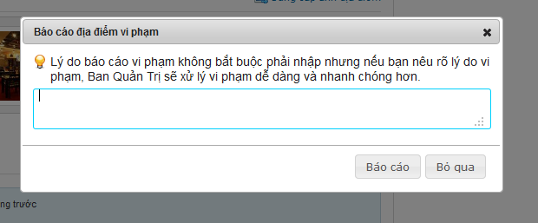

**Data Fields Definition – Comment Area**

|  |  |  |  |  |  |  |
| --- | --- | --- | --- | --- | --- | --- |
| **Field name** | **Description** | **Read**  **Only** | **Mandatory** | **Control Type** | **Data Type** | **Length** |
| instruction | Contains instructions for reporting a place | Y | Y | Label | String | Fixed |

**Buttons / Hyper Links – Comment Area**

|  |  |  |  |  |
| --- | --- | --- | --- | --- |
| **Function** | **Description** | **Available Criteria** | **Validations** | **Outcome** |
| Send a report | This button will send a report to server | Always available | No validation | Display popup notify success message “Báo cáo vi phạm hoàn tất! Ban quan trị sẽ kiểm tra lại trong thời gian sớm nhất.” |
| Cancel | This button will close popup | Always available | No validation | Close popup |

#### Mark a Place as Visited

##### Use Case Diagram



##### Use Case Specification

|  |  |  |  |  |
| --- | --- | --- | --- | --- |
| **USE CASE- Mark a place as visited SPECIFICATION** | | | | |
| **Use-case No.** | UC012 | **Use-case Version** | | 1.0 |
| **Use-case Name** | Mark a place as visited | | | |
| **Author** | QuocNM | | | |
| **Date** | 15/01/2011 | **Priority** | Normal | |
| **Actor:**  User  **Summary:**  When visiting a place, user realize that he/she visited this place it is an interesting place. So it’s very convenient if he/she can click to “Đánh dấu đã từng đến” hyperlink and make this place more reliable.  **Goal:**  This use case allows the actor mark a place as visited.  **Triggers**  Click to “Đánh dấu đã từng đến” hyperlink in the place’s details page.  **Preconditions:**  Successfully logged into the system  **Post Conditions:**  Visited number is increased by 1, stay remain at Place Detail page  **Main Success Scenario:**   |  |  |  | | --- | --- | --- | | Step | Actor Action | System Response | | 1 | Click to “Đánh dấu đã từng đến” hyperlink. | Visited number is increased by 1 and a message is displayed “Địa điểm đã được đánh dấu.” |   **Exceptions:**   |  |  |  | | --- | --- | --- | | Step | Actor Action | System Response | | 1 | Click to “Đánh dấu đã từng đến” hyperlink. | Visited number is increased by 1 and a message is displayed “Địa điểm đã được đánh dấu.” | | 2 | Click to “Đánh dấu đã từng đến” hyperlink. | a message is displayed “Địa điểm đã được đánh dấu.” |   **Relationships:**  Log in use case, View a place’s details use case.  **Business Rules:**   |  |  |  | | --- | --- | --- | |  | Business Rule | Error Mssage | | 1 | Each user has only 1 time to mark a place as visited. |  | | | | | |

**Screen**

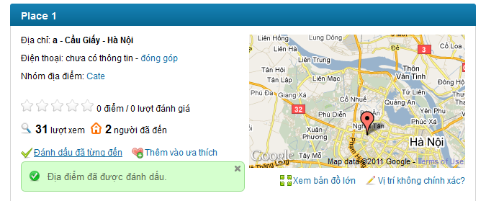

#### Rate a Place

##### Use Case Diagram



##### Use Case Specification

|  |  |  |  |  |
| --- | --- | --- | --- | --- |
| **USE CASE – Rate a place SPECIFICATION** | | | | |
| **Use-case No.** | UC013 | **Use-case Version** | | 1.0 |
| **Use-case Name** | Rate a place | | | |
| **Author** | QuangLM | | | |
| **Date** | 16/01/2011 | **Priority** | High | |
| **Actor:**  User  **Summary:**  When the user views information of a place, he/she can rate that place based on the usefulness of the information or his/her opinion about that place. The user only need move the mouse to the rating bar, choose rating and click. The user rating will be used to calculate the total rating of the place. User can change the rating by rate it again. The last rating time of the user will be used to calculate. The rating is from 1 to 5 stars.  **Goal:**  Rate a place from 1 to 5 stars  **Triggers**  Click to rating bar  **Preconditions:**  Successfully logged into the system and open a place detail page  **Post Conditions:**  Stay remains at current place page with a rating saved.  **Main Success Scenario:**   |  |  |  | | --- | --- | --- | | Step | Actor Action | System Response | | 1 | Click to rating bar at the decided rating | Rating is saved and displayed by number of star turn from white to orange. A message is displaed “Cảm ơn bạn đã đánh giá địa điểm này.” |   **Alternative Scenario:**   |  |  |  | | --- | --- | --- | | Step | Actor Action | System Response | | 1 | Click to rating bar at the decided rating | Rating is saved and displayed by number of star turn from white to orange. A message is displaed “Cảm ơn bạn đã đánh giá địa điểm này.” | | 2 | Click to rating bar again at new decided rating | Save the new user rating. A message is displaed “Cảm ơn bạn đã đánh giá địa điểm này.” |   **Exceptions: -**  **Relationships:**  Log in use case  **Business Rules:**   |  |  |  | | --- | --- | --- | | **No** | **Rule Description** | **Error Message** | | 1 | The rating of 1 place is average of all user rates |  | | 2 | The rating is from 1 to 5 stars. |  | | 3 | The user can only rate 1 place many times. The last rating will be count as the user’s rate |  | | | | | |
| **Description:**  When the user views information of a place, he/she can rate that place based on the usefulness of the information or his/her opinion about that place.The user only need move the mouse to the rating bar, choose rating and click. The user rating will be used to calculate the total rating of the place. User can change the rating by rate it again. The last rating time of the user will be used to calculate. The rating is from 1 to 5 stars. The rating bar has 5 white star symbols. The saved rating will be display in orange. Beside rating bar there is user rating displayed in text with number or rate times of current viewing place.  The rating will be used for ranking all places in the system and displayed hottest place as a list at homepage. It also will be used to sorted places in search result list. The rating used for sort isn’t averate rating of a place, but total rating. We used this method for sorting because we don’t want to let a 5 stars place with only 1 vote time be put above 4stars place with 1000 vote times. So this way will be much fairer in our opinion. | | | | |

**Screen**

**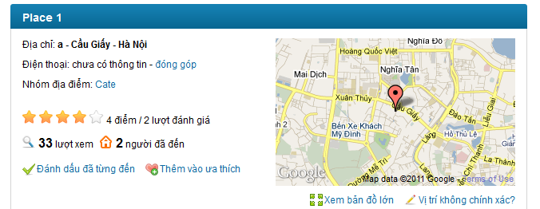**

#### Post a Comment

##### Use Case Diagram



##### Use Case Specification

|  |  |  |  |  |
| --- | --- | --- | --- | --- |
| **USE CASE – Post a comment SPECIFICATION** | | | | |
| **Use-case No.** | UC014 | **Use-case Version** | | 1.0 |
| **Use-case Name** | Post A Comment | | | |
| **Author** | QuangLM | | | |
| **Date** | 12/01/2011 | **Priority** | High | |
| **Actor:**  User  **Summary:**  When the user wants to express his/her opinion about how they feel about the place, the user can do it by post a comment. The user can enter whatever he/she would like to in comment box and click to “**Bình luận**” button to post it on a place detail page.    **Goal:**  Post a comment on a place page  **Triggers**  Click to comment textbox  **Preconditions:**  Successfully logged into the system and open a place detail page  **Post Conditions:**  Stay remain at current place page with a comment was added and displayed on top of comment area.  **Main Success Scenario:**   |  |  |  | | --- | --- | --- | | Step | Actor Action | System Response | | 1 | Click to comment text box | “Bình luận” and “Bỏ qua” button are visible | | 2 | Enter the content | - | | 3 | Click “**Bình luận”** button | Add user’s comment to comment area. User’s comment was put on top so that the user can see right away that his/her comment was posted |   **Alternative Scenario:**   |  |  |  | | --- | --- | --- | | Sep | Actor Action | System Response | | 1 | Click to comment text box | “Bình luận” and “Bỏ qua” button are visible | | 2 | Enter the content | - | | 3 | Click “**Bỏ qua”** button | Clear comment box, 2 buttons are hidden |   **Exceptions:**   |  |  |  | | --- | --- | --- | | Step | Actor Action | System Response | | 1 | Click to comment text box | “Bình luận” and “Bỏ qua” button are visible | | 2 | Click “**Bình luận”** button | Nothing happen |   **Relationships:**  Log in use case  **Business Rules:**   |  |  |  | | --- | --- | --- | | **No** | **Rule Description** | **Error Message** | | 1 | A comment with blank content won’t be posted |  | | | | | |
| **Description:**  When user want to express his/her opinion about how they feel about the place, the user can do it by enter whatever he/she would like to in comment box and click to “Bình luận” button to post it on a place page. The comment cannot be blank and must be less then 4000 characters because the maximum length that can be inserted into database is 4000. The “Bình luận” and “Bỏ qua” buttons will be showed only after the user click to the comment box. The user can easily cancel posting a question by click to “Bỏ qua” button. After successfully posting a comment, the comment will be displayed on top of comment area.  Comment area is an area which displayed comments posted by users. The latest comment will be put on top. By default, only 10 latest comments are displayed at Place Detail page, user need click to “Xem thêm” at the end of comment area to see more comments. | | | | |

**Screen**

**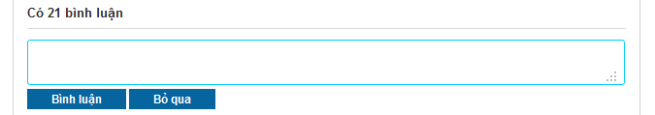**

**Buttons / Hyper Links – Comment Area**

|  |  |  |  |  |
| --- | --- | --- | --- | --- |
| **Function** | **Description** | **Available Criteria** | **Validations** | **Outcome** |
| Post a comment | This button will post a comment to place detail page | It will be showed when user click to Comment box | Comment shouldn’t be blank | Post validated comment to place detail page, put it on top of Comment area |
| Cancel | This button will clear the content of the comment | It will be showed when user click to comment box | No validation | Comment box was cleared and 2 buttons are hidden |

#### Delete a Comment

##### Use Case Diagram



##### Use Case Specification

|  |  |  |  |  |
| --- | --- | --- | --- | --- |
| **USE CASE – Delete a comment SPECIFICATION** | | | | |
| **Use-case No.** | UC015 | **Use-case Version** | | 1.0 |
| **Use-case Name** | Delete a comment | | | |
| **Author** | QuangLM | | | |
| **Date** | 13/01/2011 | **Priority** | High | |
| **Actor:**  User  **Summary:**  When the user post a double comment or post something that he/she regrets later, the user can delete it from comment area so no one can see what he/she just posted or avoid get reported as spam. He/ she can move the mouse to his/her comment then click to a button with X symbol just appear to delete the comment.  **Goal:**  Delete your comment from comment area.  **Triggers**  Move the mouse to your comment and click to a button with X symbol  **Preconditions:**  Successfully logged into the system and open a place detail page  **Post Conditions:**  Stay remain at current place page with a comment was deleted from comment area.  **Main Success Scenario:**   |  |  |  | | --- | --- | --- | | Step | Actor Action | System Response | | 1 | Move the mouse to your comment | A button with X symbol appear | | 2 | Click to X button | The comment disappear from comment area |   **Alternative Scenario:**  None  **Exceptions: -**  **Relationships:**  Log in use case  **Business Rules:**   |  |  |  | | --- | --- | --- | | **No** | **Rule Description** | **Error Message** | | 1 | You can only delete your own comment |  | | | | | |

**Screen**

**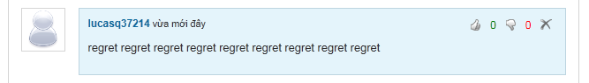**

**Buttons / Hyper Links**

|  |  |  |  |  |
| --- | --- | --- | --- | --- |
| **Function** | **Description** | **Available Criteria** | **Validations** | **Outcome** |
| Delete a comment | This button is displayed with a X symbol and it is used to delete the comment from comment area | It will be showed when user move the mouse pointer to his/her comment | No validation | The comment is deleted from comment area |
| Vote up | This button is displayed with thumb up symbol and it is used to vote up for a comment | It will be showed when user move the mouse pointer to a comment | No validation | Vote up number is increased by 1, thumb up symbol turn into green |
| Vote down | This button is displayed with thumb down symbol and it is used to vote down for a comment | It will be showed when user move the mouse pointer to a comment | No validation | Vote down number is increased by 1, thumb down symbol turn into red |

#### Vote a Comment

##### Use Case Diagram



##### Use Case Specification

|  |  |  |  |  |
| --- | --- | --- | --- | --- |
| **USE CASE – Vote a comment SPECIFICATION** | | | | |
| **Use-case No.** | UC016 | **Use-case Version** | | 1.0 |
| **Use-case Name** | Vote a comment | | | |
| **Author** | QuangLM | | | |
| **Date** | 13/01/2011 | **Priority** | Normal | |
| **Actor:**  User  **Summary:**  When the user see a good/bad comment, they want to do something to show that they like it or hate it. The user can do that. They can vote a comment by move the mouse to desired comment and click to button with thumb up symbol if they like it or button with thumb down symbol if they hate it.  **Goal:**  Vote up for comment you like or vote down for comment you hate.  **Triggers**  Move the mouse to a comment and click to button with thumb up symbol or button with thumb down symbol  **Preconditions:**  Successfully logged into the system and open a place detail page  **Post Conditions:**  Stay remain at current place page with a comment was voted.  **Main Success Scenario:**   |  |  |  | | --- | --- | --- | | Step | Actor Action | System Response | | 1 | Move the mouse to the comment needed to be voted | Button with thumb up symbol and button with thumb down symbol appear | | 2 | Click to thumb up button | Change the color of thumb up button (from white color to green color), vote up number is increased by 1 |   **Alternative Scenario:**   |  |  |  | | --- | --- | --- | | Step | Actor Action | System Response | | 1 | Move the mouse to the comment needed to be voted | Button with thumb up symbol and button with thumb down symbol appear | | 2 | Click to thumb down button | Change the color of thumb down button (from white color to red color), vote down comment is increased by 1 |  |  |  |  | | --- | --- | --- | | Step | Actor Action | System Response | | 1 | Move the mouse to the comment needed to be voted | Button with thumb up symbol and button with thumb down symbol appear | | 2 | Click to thumb up button | Change the color of thumb up button (from white color to green color), vote up number is increased by 1 | | 3 | Click to thumb up button again | Nothing happen |  |  |  |  | | --- | --- | --- | | Step | Actor Action | System Response | | 1 | Move the mouse to the comment needed to be voted | Button with thumb up symbol and button with thumb down symbol appear | | 2 | Click to thumb down button | Change the color of thumb down button (from white color to red color), vote down comment is increased by 1 | | 3 | Click to thumb down button again | Nothing happen |  |  |  |  | | --- | --- | --- | | Step | Actor Action | System Response | | 1 | Move the mouse to the comment needed to be voted | Button with thumb up symbol and button with thumb down symbol appear | | 2 | Click to thumb up button | Change the color of thumb up button (from white color to green color), vote up number is increased by 1 | | 3 | Click to thumb down button | Thumb up symbol turn back into white, thumb down symbol turn into red, vote up number is decreased by 1, vote down number is increased by 1 |  |  |  |  | | --- | --- | --- | | Step | Actor Action | System Response | | 1 | Move the mouse to the comment needed to be voted | Button with thumb up symbol and button with thumb down symbol appear | | 2 | Click to thumb down button | Change the color of thumb down button (from white color to red color), vote down comment is increased by 1 | | 3 | Click to thumb up button | Thumb down symbol turn back into white, thumb up symbol turn into green, vote down number is decreased by 1, vote up number is increased by 1 |   **Exceptions:**  **Relationships:**  Log in use case  **Business Rules:**   |  |  |  | | --- | --- | --- | | **No** | **Rule Description** | **Error Message** | | 1 | Each account can only vote up or vote down and only increased vote number by 1 per comment |  | | | | | |
| **Description:**  When the user see a good/bad comment, they want to do something to show that they like it or hate it. The user can do that. They can vote a comment by move the mouse to a comment and click to thumb up icon if they like it or thumb down icon if they hate it. The vote will be record and the 2 most voted up comments will be highlighted and put on top of comment area. The last vote count means that the user can change to vote up to vote down or change back to vote up and the system will using your last vote as your vote. The vote up is displayed as thumb up icon. The vote down is displayed as thumb down icon. Both icons in white at start. When the icon is clicked, its color will change (green in case of vote up and red in case of vote down). If the user clicks to 1 icon, then clicks other icon too. The last clicked icon will be in blue/red color, the other will be in white. 2 highlighted comments still can be voted like normal comment. Highlight Comment Area is above Comment Area. Each user can only vote for other user’s comments. You can’t vote for your own comment. When you click to thumb up or thumb down icon at your comment, nothing will happen. | | | | |

**Screen**

**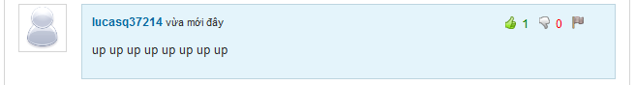**

**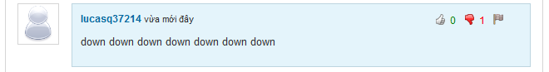**

**Buttons / Hyper Links**

|  |  |  |  |  |
| --- | --- | --- | --- | --- |
| **Function** | **Description** | **Available Criteria** | **Validations** | **Outcome** |
| Delete a comment | This button is displayed with a X symbol and it is used to delete the comment from comment area | It will be showed when user move the mouse pointer to his/her comment | No validation | The comment is deleted from comment area |
| Vote up | This button is displayed with thumb up symbol and it is used to vote up for a comment | It will be showed when user move the mouse pointer to a comment | No validation | Vote up number is increased by 1, thumb up symbol turn into green |
| Vote down | This button is displayed with thumb down symbol and it is used to vote down for a comment | It will be showed when user move the mouse pointer to a comment | No validation | Vote down number is increased by 1, thumb down symbol turn into red |

#### Highlight Best Comment

##### Use Case Diagram



##### Use Case Specification

|  |  |  |  |  |
| --- | --- | --- | --- | --- |
| **USE CASE – Highlight best comment SPECIFICATION** | | | | |
| **Use-case No.** | UC017 | **Use-case Version** | | 1.0 |
| **Use-case Name** | Highlight Best Comment | | | |
| **Author** | QuangLM | | | |
| **Date** | 13/01/2011 | **Priority** | Normal | |
| **Actor:**  User  **Summary:**  Each time the user vote for a comment, the vote will be counted. 2 comments which have most votes up and will be highlighted and put up on top of comment box. The user can see them and vote for them as normal comment. The highlight comment area will be displayed as the user open a place detail page.  **Goal:**  Show 2 most vote up comments  **Triggers**  Open a place detail page  **Preconditions:**  Access the website  **Post Conditions:**  Stay remains at place detail page  **Main Success Scenario:**   |  |  |  | | --- | --- | --- | | Step | Actor Action | System Response | | 1 | Open an place detail place | Display 2 most vote up comments on top of comment box |   **Alternative Scenario:**  **Exceptions:**   |  |  |  | | --- | --- | --- | | Step | Actor Action | System Response | | 1 | Open an place detail place which has no comment has vote up | The highlight comment area is hidden |  |  |  |  | | --- | --- | --- | | Step | Actor Action | System Response | | 1 | Open an place detail place which has only 1 comment has vote up | Display only 1 most vote up comments on top of comment box |   **Relationships:**  Log in use case  **Business Rules:**   |  |  |  | | --- | --- | --- | | **No** | **Rule Description** | **Error Message** | | 1 | Only 2 most vote up comment will be highlighted and put up on highlight comment area |  | | 2 | Highlighted comments can be treated as normal comment |  | | | | | |
| **Description:**  Based on vote system, we select 2 most voted up comments, highlight it and put it at different area. These 2 comments still acted as normal comment. The thing is these comment will get more attention from other users because they are put on Highlight Comment Area on top of Comment Area. When there isn’t any comment get vote up, Highlight Comment Area will be hidden. If there is only 1comment get voted up, the Highlight Comment Area will display this only comment. | | | | |

**Screen**

**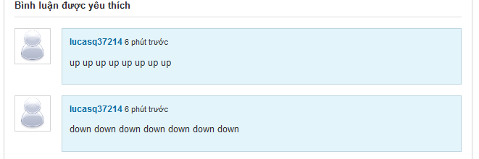**

#### Report a Comment

##### Use Case Diagram



##### Use Case Specification

|  |  |  |  |  |
| --- | --- | --- | --- | --- |
| **USE CASE – Report a comment SPECIFICATION** | | | | |
| **Use-case No.** | UC018 | **Use-case Version** | | 1.0 |
| **Use-case Name** | Report a comment | | | |
| **Author** | QuangLM | | | |
| **Date** | 13/01/2011 | **Priority** | High | |
| **Actor:**  User  **Summary:**  When the user sees someone is spamming by posting many comment with nonsense, unrelated inappropriate or advertising content, they can report it. The user must move the mouse to spam comment and click to button with flag symbol. The comment will be deleted manually by admins when they review the comment.  **Goal:**  Report a comment as spam or inappropriate.  **Triggers**  Move the mouse to a comment and click to button with flag symbol  **Preconditions:**  Successfully logged into the system and open a place detail page  **Post Conditions:**  Stay remain at current place page with a comment was reported.  **Main Success Scenario:**   |  |  |  | | --- | --- | --- | | Step | Actor Action | System Response | | 1 | Move the mouse to the comment needed to be reported | A button with flag symbol appears | | 2 | Click to flag button | Popup a window | | 3 | Click to “Báo cáo” button | Popup a message “Báo cáo vi phạm hoà tất! Ban quan trị sẽ kiểm tra lại trong thời gian sớm nhất.” | | 4 | Click OK | Popups close |   **Alternative Scenario:**   |  |  |  | | --- | --- | --- | | Step | Actor Action | System Response | | 1 | Move the mouse to the comment needed to be reported | A button with flag symbol appears | | 2 | Click to flag button | Popup a window | | 3 | Enter reason |  | | 4 | Click to “Báo cáo” button | Popup a message “Báo cáo vi phạm hoàn tất! Ban quan trị sẽ kiểm tra lại trong thời gian sớm nhất.” | | 5 | Click OK | Popups close |  |  |  |  | | --- | --- | --- | | Step | Actor Action | System Response | | 1 | Move the mouse to the comment needed to be reported | A button with flag symbol appears | | 2 | Click to flag button | Popup a window | | 3 | Enter reason with more than 100 characters |  | | 4 | Click to “Báo cáo” button | Popup a message “Lý do không dài quá 100 ký tự.” | | 5 | Click OK | Wanring popup closes, report popup still opens |  |  |  |  | | --- | --- | --- | | Step | Actor Action | System Response | | 1 | Move the mouse to the comment needed to be reported | A button with flag symbol appears | | 2 | Click to flag button | Popup a window | | 3 | Enter reason |  | | 4 | Click to “Bỏ qua” button | Popup closes |  |  |  |  | | --- | --- | --- | | Step | Actor Action | System Response | | 1 | Move the mouse to the comment needed to be reported | A button with flag symbol appears | | 2 | Click to flag button | Popup a window | | 3 | Enter reason |  | | 4 | Click to “Báo cáo” button | Popup a message “Báo cáo vi phạm hoàn tất! Ban quan trị sẽ kiểm tra lại trong thời gian sớm nhất.” | | 5 | Click OK | Popups close | | 6 | Click to flag button again | Popup a message “Báo cáo vi phạm hoàn tất! Ban quan trị sẽ kiểm tra lại trong thời gian sớm nhất.” |   **Exceptions: -**  **Relationships:**  Log in use case  **Business Rules:**   |  |  |  | | --- | --- | --- | | **No** | **Rule Description** | **Error Message** | | 1 | Each user can only report 1 comment once |  | | | | | |
| **Description:**  When the user sees someone is spamming by posting many comment with nonsense, unrelated inappropriate or advertising content, they can report it. The user must move the mouse to spam comment and click to flag icon. A popup will appear and require you to enter your reason. By entering your reason, admin work will be much easier when reviewing spam reports. The reason must be less then 100 character. If you enter more than that, an inform message will popup and required you to shorten your reason down. By clicking to “Báo cáo” button, your spam report will be sent to the system and wait there for admin checking. If you don’t want to send report anymore, just click to “Bỏ qua” button, the report popup will close.  The comment will be deleted manually by admins when they review the comment. The user can’t undo the click. Admin will set the comment back to normal if it isn’t a spam or doesn’t violate any rule. Each user can only report 1 comment once. You can do the report steps many times, but only your 1st report will be saved into the system. | | | | |

**Screen**

**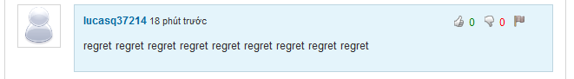**

**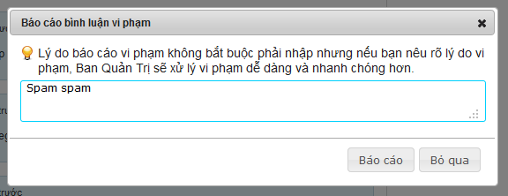**

**Button / Hyper links**

|  |  |  |  |  |
| --- | --- | --- | --- | --- |
| **Function** | **Description** | **Available Criteria** | **Validations** | **Outcome** |
| Report a comment | This button is displayed with flag symbol and it is used to report a comment | Only available when move mouse to other user’s comments | No validation | Popup report window for enter reason |
| Vote up | This button is displayed with thumb up symbol and it is used to vote up for a comment | It will be showed when user move the mouse pointer to a comment | No validation | Vote up number is increased by 1, thumb up symbol turn into green |
| Vote down | This button is displayed with thumb down symbol and it is used to vote down for a comment | It will be showed when user move the mouse pointer to a comment | No validation | Vote down number is increased by 1, thumb down symbol turn into red |
| Post a report | This button is used for post a report to the system | Always available with popup | No validation | Popup a message “Báo cáo vi phạm hoàn tất! Ban quan trị sẽ kiểm tra lại trong thời gian sớm nhất.” |
| Cancel posting a report | This button is used for cancel reporting and close the popup | Always available with popup | No validation | Popup closes |

#### Question & Answer Page

##### Use Case Diagram



##### Use Case Specification

|  |  |  |  |  |
| --- | --- | --- | --- | --- |
| **USE CASE – Question & Answer Page SPECIFICATION** | | | | |
| **Use-case No.** | UC019 | **Use-case Version** | | 1.0 |
| **Use-case Name** | Question & Answer Page | | | |
| **Author** | DungTQ | | | |
| **Date** | 10/01/2011 | **Priority** | Normal | |
| **Actor:**  User  **Summary:**  This Question Page displays all questions of users.If user doesn’t find what they want, he/she can post a new question by clicks to “Gửi câu hỏi mới” hyperlink. Besides, all questions are displayed in question page will be displayed with question title, creator name, created time, number of vote up and vote down, number of views and answers. In default, Q&A will display 10 questions. User need click to “Xem thêm” to view more questions  **Goal:**  Display Q&A page  **Triggers**  Click to “Hỏi và đáp” tab in navigator.  **Preconditions:**  Access the website  **Post Conditions:**  Q&A page is displayed  **Main Success Scenario:**   |  |  |  | | --- | --- | --- | | Step | Actor Action | System Response | | 1 | Click to “Hỏi và đáp” tab at navigator | Redirect user to Q&A page and displays all questions. |   **Alternative Scenario: -**  **Exceptions:-**  **Relationships: -**  **Business Rules:**   |  |  |  | | --- | --- | --- | | **No** | **Rule Description** | **Error Message** | | 1 | In default, display 20 questions. User need click “Xem thêm” to get more question |  | | | | | |
| **Description:**  This is a page where displays all questions of users. If the user can’t find what he/she wants, he/she can post a new question by clicks to “Gửi câu hỏi mới” button at the top of question list. When user clicks to this button, he/she will be redirected to Create Question page to fill information of question.  Besides, each question in “Hỏi và đáp” page will be displayed with title, creator, created date, answer number, view number, vote up number and vote down number. The title and answer number will be displayed in big size. You can vote for question at this page. If you want to vote for a question, click to its title and go to Question Detail page. At Detail page, you can do these things. Question title and creator name are displayed as link. Click to question title will get you to Question Detail page. Click to user name link will get you to User Profile page. | | | | |

**Screen**

**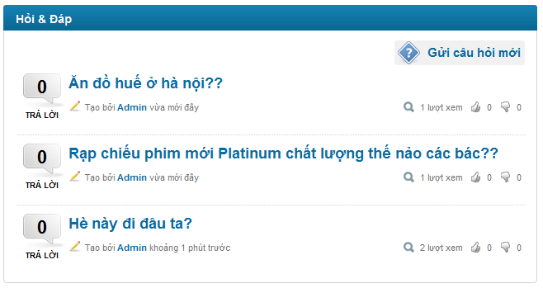**

**Buttons / Hyper Links – Q&A Screen**

|  |  |  |  |  |
| --- | --- | --- | --- | --- |
| **Function** | **Description** | **Available Criteria** | **Validations** | **Outcome** |
| Create Question | Allow user post a new question. | Always Available | No validation | Redirect user to create new question page |
| Question link | This hyperlink helps user open Question Detail page | Display with each question | No validation | Redirect user to Question Detail page |
| User link | This hyperlink helps user open User Profile page | Display with each question | No validation | Redirect user to User Profile page |

#### View Question Detail

##### Use Case Diagram



##### Use Case Specification

|  |  |  |  |  |
| --- | --- | --- | --- | --- |
| **USE CASE – View question detail SPECIFICATION** | | | | |
| **Use-case No.** | UC020 | **Use-case Version** | | 1.0 |
| **Use-case Name** | View question detail | | | |
| **Author** | DungTQ | | | |
| **Date** | 10/01/2011 | **Priority** | Normal | |
| **Actor:**  User  **Summary:**  When the user clicks on any question link, they will be redirected to corresponding question detail page. It contains question and its answers.  **Goal:**  Display question’s detail.  **Triggers**  Click to question’s detail hyperlink.  **Preconditions:**  Access the website  **Post Conditions:**  Question and its answers will be displayed  **Main Success Scenario:**   |  |  |  | | --- | --- | --- | | Step | Actor Action | System Response | | 1 | Click to question hyperlink | Redirect the user to question detail page |   **Alternative Scenario:**   |  |  |  | | --- | --- | --- | | Step | Actor Action | System Response | | 1 | User create a new question and click to “Gửi” button | Redirect the user to question detail page |   **Exceptions:**  None  **Relationships:**  Login use case, Create a New Question use case  **Business Rules:**  None | | | | |
| **Description:**  When user click to Question link at anywhere on the system or create a new question, he/she will be redirected to Question Detail page. This page displays all information of a question; all answers belong to it, newest questions and most contributors.  Question information includes:   * Question title * Question content * Name of user who post this question * The time that user post this question * Vote up number and a thumb up icon * Vote down number and a thumb down icon * A flag icon for report this question as spam * 2 highlighted answers: 2 most voted up answers in all answers belong to this question * And all answers for this question. Each answer is displayed with its content, name and avatar of the user who posts it and posted time.   Newest question list: this list contains 10 questions at maximum. All these questions are just posted. The list will be updated each 10 minutes.  Most contributor list: this list contains 10 users who contribute most to Q&A page. They are 10 users who have highest answer number. The list will be updated each 10 minutes. | | | | |

**Screen**

**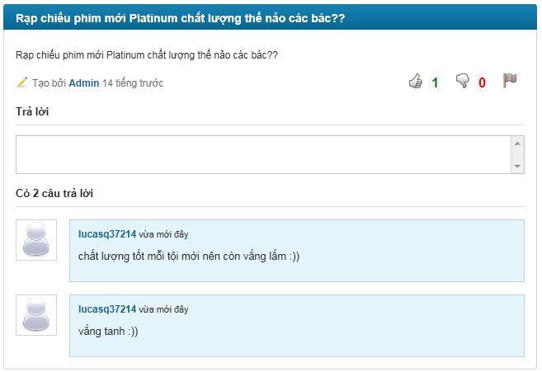**

**Data Fields Definition –Question Detail Screen**

|  |  |  |  |  |  |  |
| --- | --- | --- | --- | --- | --- | --- |
| **Field name** | **Description** | **Read**  **Only** | **Mandatory** | **Control Type** | **Data Type** | **Length** |
| Question Title | A label with content : question’s title | Y | - | Label | String | Fixed |
| Created Time | A label with content: question’s created time | Y | - | Label | Date | Fixed |
| Vote up number | A label contains vote up number | Y | - | Label | String | Fixed |
| Vote down number | A labelcontains vote down number | Y | - | Label | String | Fixed |
| Content | A label with content: content of question | Y | - | Label | String | Fixed |

**Buttons / Hyper Links – Question Detail Screen**

|  |  |  |  |  |
| --- | --- | --- | --- | --- |
| **Function** | **Description** | **Available Criteria** | **Validations** | **Outcome** |
| Vote up answer | This button is displayed with thumb up symbol and it is used to vote up for an answer | It will be showed when user move the mouse pointer to an answer | No validation | Vote up number is increased by 1, thumb up symbol turn into green |
| Vote down answer | This button is displayed with thumb down symbol and it is used to vote down for an answer | It will be showed when user move the mouse pointer to an answer | No validation | Vote down number is increased by 1, thumb down symbol turn into red |
| User link | This hyperlink helps user open User Profile page | Display with each comment | No validation | Redirect user to User Profile page |
| Vote up question | This button is displayed with thumb up symbol and it is used to vote up for a question | Always available | No validation | Vote up number is increased by 1, thumb up symbol turn into green |
| Vote down question | This button is displayed with thumb down symbol and it is used to vote down for a question | Always available | No validation | Vote down number is increased by 1, thumb down symbol turn into red |

#### Create a New Question

##### Use Case Diagram



##### Use Case Specification

|  |  |  |  |  |
| --- | --- | --- | --- | --- |
| **USE CASE – Create a new question SPECIFICATION** | | | | |
| **Use-case No.** | UC021 | **Use-case Version** | | 1.0 |
| **Use-case Name** | Create A New Question | | | |
| **Author** | DungTQ | | | |
| **Date** | 13/01/2011 | **Priority** | Normal | |
| **Actor:**  User  **Summary:**  When the user come to question page and can’t find any question match with his/her question, he/she want to post a new question to find a solution for his/her issue. He/she can do that by click to “Gửi câu hỏi mới” hyperlink. The system will redirect the user to create new question page and require them fill in information. The user clicks to “Gửi” button to finish then get redirected to Question Detail page.  **Goal:**  Create a new question.  **Triggers**  Click to “Gửi câu hỏi mới” hyperlink.  **Preconditions:**  Successfully logged into the system and accessed to question page.  **Post Conditions:**  Redirect to Question Detail page  **Main Success Scenario:**   |  |  |  | | --- | --- | --- | | Step | Actor Action | System Response | | 1 | Click to “Gửi câu hỏi mới” hyperlink | Redirect user to Create new question page | | 2 | The user fills in the title and the content of the question |  | | 3 | Click to “Gửi” button | Website will redirect to Question Detail page |   **Alternative Scenario:**   |  |  |  | | --- | --- | --- | | Step | Actor Action | System Response | | 1 | Click to “Gửi câu hỏi mới” hyperlink | Redirect user to Create new question page | | 2 | The user fills in the title and the content of the question |  | | 3 | Click to “Bỏ qua” hyperlink | Redirect back to Q&A page |   **Exceptions:**   |  |  |  | | --- | --- | --- | | Step | Actor Action | System Response | | 1 | Click to “Gửi câu hỏi mới” hyperlink | Redirect user to Create new question page | | 2 | The user leaves the content blank |  | | 3 | Click to “Gửi” button | Display a warning message: “ Tiêu đề là bắt buộc.” |  |  |  |  | | --- | --- | --- | | Step | Actor Action | System Response | | 1 | Click to “Gửi câu hỏi mới” hyperlink | Redirect user to Create new question page | | 2 | The user leaves the title blank |  | | 3 | Click to “Gửi” button | Display a warning message: “Nội dung là bắt buộc.” |   **Relationships:**  Login use case, question page use case  **Business Rules:**   |  |  |  | | --- | --- | --- | | **No** | **Rule Description** | **Error Message** | | 1 | Title and content of a question can’t be blank |  | | 2 | Each user can only post 1 question per 10 minutes |  | | | | | |
| **Description:**  When user come to “Hỏi và đáp” page and can’t find problem what he/she need, he/she can post a new question to find out a solution by click to “Gửi câu hỏi mới” button at “Hỏi & Đáp” page. The sytem will redirect you to Create Question page. The form for creating a new question is simple. The user only need fill in question title and content. You can’t leave title or content blank. Click to “Gửi” button will navigate you to Question Detail page of your newly created question. Otherwise, click to “Bỏ qua” button will let you go back to “Hỏi & Đáp” page. | | | | |

**Screen**

**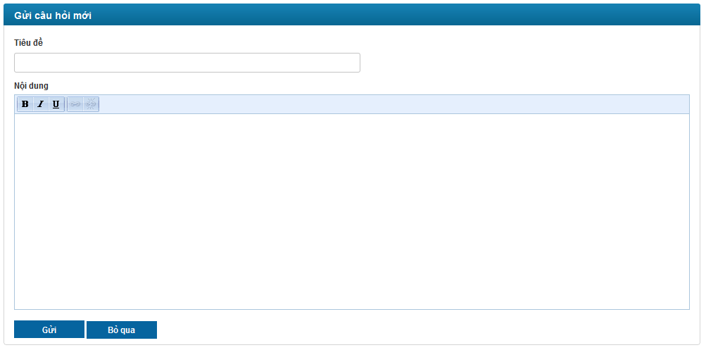**

**Data Fields Definition – Create A New Question Screen**

|  |  |  |  |  |  |  |
| --- | --- | --- | --- | --- | --- | --- |
| **Field name** | **Description** | **Read**  **Only** | **Mandatory** | **Control Type** | **Data Type** | **Length** |
| header | A label with content “Tạo câu hỏi mới” | Y | - | label | string | 30 |
| Title label | A label with content “Tiêu đề:” | Y | - | label | string | 10 |
| Title Textbox | This text box for inputting title of the question | N | Y | textbox | string | 50 |
| Content Label | A label with content “Nội dung:” | Y | - | label | string | 10 |
| Content | This text box is for inputting content of the question | N | Y | textbox | string | 500 |

**Buttons / Hyper Links – Create a New Question Screen**

|  |  |  |  |  |
| --- | --- | --- | --- | --- |
| **Function** | **Description** | **Available Criteria** | **Validations** | **Outcome** |
| Post question | Allow user post a new question | Always available. | No validation | Allow user post a new question and redirect the user to question detail page |
| Cancel | Cancel current action | Always available. | No validation | Cancel current action and redirect the user to Q&A page. |

#### Vote a Question

##### Use Case Diagram



##### Use Case Specification

|  |  |  |  |  |
| --- | --- | --- | --- | --- |
| **USE CASE – Vote a question SPECIFICATION** | | | | |
| **Use-case No.** | UC022 | **Use-case Version** | | 1.0 |
| **Use-case Name** | Vote a question | | | |
| **Author** | QuangLM | | | |
| **Date** | 13/01/2011 | **Priority** | Normal | |
| **Actor:**  User  **Summary:**  When the user sees a good/bad question, they want to do something to show that they like it or hate it. The user can do that. They can vote a question by click to button with thumb up symbol if they like it or button with thumb down symbol if they hate it.  **Goal:**  Vote up for question you like or vote down for question you hate.  **Triggers**  Click to button with thumb up symbol or button with thumb down symbol  **Preconditions:**  Successfully logged into the system and open a Question Detail page  **Post Conditions:**  Stay remain at current place page with a question was voted.  **Main Success Scenario:**   |  |  |  | | --- | --- | --- | | Step | Actor Action | System Response | | 1 | Click to thumb up button | Change the color of thumb up button (from white color to green color), vote up number is increased by 1 |   **Alternative Scenario:**   |  |  |  | | --- | --- | --- | | Step | Actor Action | System Response | | 1 | Click to thumb down button | Change the color of thumb down button (from white color to red color), vote down comment is increased by 1 |  |  |  |  | | --- | --- | --- | | Step | Actor Action | System Response | | 1 | Click to thumb up button | Change the color of thumb up button (from white color to green color), vote up number is increased by 1 | | 2 | Click to thumb up button again | Nothing happen |  |  |  |  | | --- | --- | --- | | Step | Actor Action | System Response | | 1 | Click to thumb down button | Change the color of thumb down button (from white color to red color), vote down comment is increased by 1 | | 2 | Click to thumb down button again | Nothing happen |  |  |  |  | | --- | --- | --- | | Step | Actor Action | System Response | | 1 | Click to thumb up button | Change the color of thumb up button (from white color to green color), vote up number is increased by 1 | | 2 | Click to thumb down button | Thumb up symbol turn back into white, thumb down symbol turn into red, vote up number is decreased by 1, vote down number is increased by 1 |  |  |  |  | | --- | --- | --- | | Step | Actor Action | System Response | | 1 | Click to thumb down button | Change the color of thumb down button (from white color to red color), vote down comment is increased by 1 | | 2 | Click to thumb up button | Thumb down symbol turn back into white, thumb up symbol turn into green, vote down number is decreased by 1, vote up number is increased by 1 |   **Exceptions:**  **Relationships:**  Log in use case  **Business Rules:**   |  |  |  | | --- | --- | --- | | **No** | **Rule Description** | **Error Message** | | 1 | Each account can only vote up or vote down and only increased vote number by 1 per question |  | | | | | |
| **Description:**  When the user sees a good/bad question, they want to do something to show that they like it or hate it. The user can do that. They can vote a question by click to thumb up icon if they like it or thumb down icon if they hate it. The last vote count means that the user can change to vote up to vote down or change back to vote up and the system will use your last vote. The vote up is displayed as thumb up icon. The vote down is displayed as thumb down icon. Both icons in white at start. When the icon is clicked, its color will change (green in case of vote up and red in case of vote down). If the user clicks to 1 icon, then clicks other icon too. The last clicked icon will be in blue/red color, the other will be in white. You can’t vote for your own question. When you click to thumb up or thumb down icon at your question, nothing will happen. | | | | |

**Screen**

**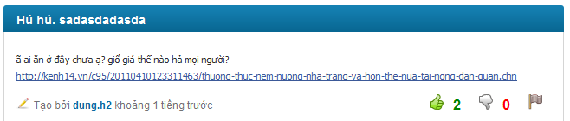**

**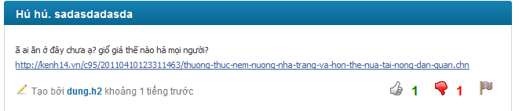**

**Buttons / Hyper Links**

|  |  |  |  |  |
| --- | --- | --- | --- | --- |
| **Function** | **Description** | **Available Criteria** | **Validations** | **Outcome** |
| User link | This hyperlink helps user open User Profile page | Display with each comment | No validation | Redirect user to User Profile page |
| Vote up question | This button is displayed with thumb up symbol and it is used to vote up for a question | Always available | No validation | Vote up number is increased by 1, thumb up symbol turn into green |
| Vote down question | This button is displayed with thumb down symbol and it is used to vote down for a question | Always available | No validation | Vote down number is increased by 1, thumb down symbol turn into red |
| Report a question | This flag symbol is used for report a question as spam/inappropriate | Always available | No validation | Popup a report window |

#### Report a Question

##### Use Case Diagram



##### Use Case Specification

|  |  |  |  |  |
| --- | --- | --- | --- | --- |
| **USE CASE – Report a question SPECIFICATION** | | | | |
| **Use-case No.** | UC023 | **Use-case Version** | | 1.0 |
| **Use-case Name** | Report a question | | | |
| **Author** | QuangLM | | | |
| **Date** | 13/01/2011 | **Priority** | High | |
| **Actor:**  User  **Summary:**  When the user sees someone is spamming by posting many question with nonsense, unrelated inappropriate or advertising content, they can report it. The user need click to button with flag symbol. The question will be deleted manually by admins when they review the question.  **Goal:**  Report a question as spam or inappropriate.  **Triggers**  Click to button with flag symbol  **Preconditions:**  Successfully logged into the system and open a question detail page  **Post Conditions:**  Stay remain at current place page with a question was reported.  **Main Success Scenario:**   |  |  |  | | --- | --- | --- | | Step | Actor Action | System Response | | 1 | Click to flag symbol | Popup a window | | 2 | Click to “Báo cáo” button | Popup a message “Báo cáo vi phạm hoàn tất! Ban quan trị sẽ kiểm tra lại trong thời gian sớm nhất.” | | 3 | Click OK | Popups close |   **Alternative Scenario:**   |  |  |  | | --- | --- | --- | | Step | Actor Action | System Response | | 1 | Click to flag symbol | Popup a window | | 2 | Enter reason |  | | 3 | Click to “Báo cáo” button | Popup a message “Báo cáo vi phạm hoàn tất! Ban quan trị sẽ kiểm tra lại trong thời gian sớm nhất.” | | 4 | Click OK | Popups close |  |  |  |  | | --- | --- | --- | | Step | Actor Action | System Response | | 1 | Click to flag symbol | Popup a window | | 2 | Enter reason with more than 100 characters |  | | 3 | Click to “Báo cáo” button | Popup a message “Lý do không dài quá 100 ký tự.” | | 4 | Click OK | Wanring popup closes, report popup still opens |  |  |  |  | | --- | --- | --- | | Step | Actor Action | System Response | | 1 | Click to flag symbol | Popup a window | | 2 | Enter reason |  | | 3 | Click to “Bỏ qua” button | Popup closes |  |  |  |  | | --- | --- | --- | | Stp | Actor Action | System Response | | 1 | Click to flag symbol | Popup a window | | 2 | Enter reason |  | | 3 | Click to “Báo cáo” button | Popup a message “Báo cáo vi phạm hoàn tất! Ban quan trị sẽ kiểm tra lại trong thời gian sớm nhất.” | | 4 | Click OK | Popups close | | 5 | Click to flag button again | Popup a message “Báo cáo vi phạm hoàn tất! Ban quan trị sẽ kiểm tra lại trong thời gian sớm nhất.” |   **Exceptions: -**  **Relationships:**  Log in use case  **Business Rules:**   |  |  |  | | --- | --- | --- | | **No** | **Rule Description** | **Error Message** | | 1 | Each user can only report 1 question once |  | | 2 | The question can only be deleted manually by admins when they review the question. |  | | | | | |

**Screen**

**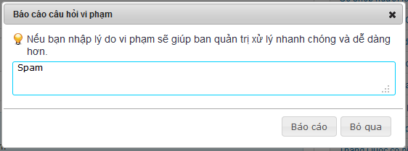**

**Button / Hyper links**

|  |  |  |  |  |
| --- | --- | --- | --- | --- |
| **Function** | **Description** | **Available Criteria** | **Validations** | **Outcome** |
| Report a comment | This button is displayed with flag symbol and it is used to report a comment | Only available when move mouse to other user’s comments | No validation | Popup report window for enter reason |
| Vote up | This button is displayed with thumb up symbol and it is used to vote up for a comment | It will be showed when user move the mouse pointer to a comment | No validation | Vote up number is increased by 1, thumb up symbol turn into green |
| Vote down | This button is displayed with thumb down symbol and it is used to vote down for a comment | It will be showed when user move the mouse pointer to a comment | No validation | Vote down number is increased by 1, thumb down symbol turn into red |
| Post a report | This button is used for post a report to the system | Always available with popup | No validation | Popup a message “Báo cáo vi phạm hoàn tất! Ban quan trị sẽ kiểm tra lại trong thời gian sớm nhất.” |
| Cancel posting a report | This button is used for cancel reporting and close the popup | Always available with popup | No validation | Popup closes |

#### Post an answer

##### Use Case Diagram



##### Use Case Specification

|  |  |  |  |  |
| --- | --- | --- | --- | --- |
| **USE CASE – Post an answer SPECIFICATION** | | | | |
| **Use-case No.** | UC024 | **Use-case Version** | | 1.0 |
| **Use-case Name** | Post an answer | | | |
| **Author** | DungTQ | | | |
| **Date** | 10/01/2011 | **Priority** | Normal | |
| **Actor:**  User  **Summary:**  When open question page, the user can realize a question that he/she knows the answer or a question that propose the same problem with the user problem. The user can post an answer to propose a solution or showing empathy with the asker. Clicking to that question will redirect the user to question detail page. The user need fill in answer content and click to “Trả lời” button to post the reply.  **Goal:**  Allow user posts an anwser  **Triggers**  Click to “Trả lời” button  **Preconditions:**  Successfully logged in to the system and accessed to question detail page.  **Post Conditions:**  Stay remain at question detail page with new answer on top of answer area  **Main Success Scenario:**   |  |  |  | | --- | --- | --- | | Step | Actor Action | System Response | | 1 | Click to the answer text box | “Trả lời” and “Bỏ qua” buttons appear | | 2 | Enter the content in reply box. |  | | 3 | Click to “Trả lời” button | The answer will be added to top of answer area with the content, creator creator’s avatar and created time. |   **Alternative Scenario:**   |  |  |  | | --- | --- | --- | | Step | Actor Actio | System Respons | | 1 | Click to the answer text box | “Trả lời” and “Bỏ qua” buttons appear | | 2 | Enter the content in reply box. |  | | 3 | Click to “Bỏ qua” button | Clear the content, 2 buttns are hidden |   **Exceptions:**   |  |  |  | | --- | --- | --- | | Step | Actor Action | System Response | | 1 | Click to th answer text bo | “Trả lời” and “Bỏ qua” buttons appear | | 2 | Click to “Trả lời” button | Nothing happen |   **Relationships:**  Login use case and question page use case  **Business Rules:**   |  |  |  | | --- | --- | --- | | **o** | **Rule Description** | **Error Message** | | 1 | Blank answer won’t be posted |  | | 2 | Each usr can only pos1 reply per 1 minutes |  | | | | | |
| **Description**  When user want to express his/her opinion or answer a question, the user can do it by enter whatever he/she would like to in answer box and click to “Trả lời” button to post it on Question Detail page. The answer cannot be blank and must be less then 4000 characters because the maximum length that can be inserted into database is 4000. The “Trả lời” and “Bỏ qua” buttons will be showed only after the user click to the answer box. The user can easily cancel posting an answer by click to “Bỏ qua” button. After successfully posting an answer, the answer will be displayed on top of answer area.  Answer area is an area which displayed answers posted by users. The latest answer will be put on top. By default, only 10 latest answers are displayed at Question Detail page, user need click to “Xem thêm” at the end of answer area to see more answers. | | | | |

**Screen**

**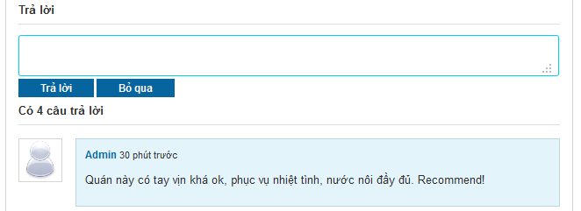**

**Buttons / Hyper Links – Reply Question Screen**

|  |  |  |  |  |
| --- | --- | --- | --- | --- |
| **Function** | **Description** | **Available Criteria** | **Validations** | **Outcome** |
| Post an answer | This button allow user post an answer | Displayed when user click to answer text area | No validation | Post a new answer on top of answer area |
| Cancel Hyperlink | Cancel reply. | Displayed when user click to answer text area | No validation | Clear answer content, 2 buttons are hidden |

#### Vote an answer

##### Use Case Diagram



##### Use Case Specification

|  |  |  |  |  |
| --- | --- | --- | --- | --- |
| **USE CASE – Vote an answer SPECIFICATION** | | | | |
| **Use-case No.** | UC025 | **Use-case Version** | | 1.0 |
| **Use-case Name** | Vote an answer | | | |
| **Author** | DungTQ | | | |
| **Date** | 11/01/2011 | **Priority** | Normal | |
| **Actor:**  User  **Summary:**  When visiting a place, user can realize that there is an answer which resembles his/her thinking or that it is just so good. It’s very convenient if he/she can click to thumb up symbol (which will appear when he/she move mouse to any answer) and doesn’t have to write same content as existed answer. But the user can also realize that there is an answer which is different with his/her thinking or that it is just so lame. So it’s very convenient if they can click thumb down symbol which also will appear when he/she move mouse to any answer.  **Goal:**  Allow users vote for an answer  **Triggers**  Click to thumb up or thumb down symbol  **Preconditions:**  Successfully logged into the system and accessed to question’s details page which has at least one answer.  **Post Conditions:**  Stay remain at question detail page with a reply get voted  **Main Success Scenario:**   |  |  |  | | --- | --- | --- | | Step | Actor Action | System Response | | 1 | Move mouse to a comment which user wants to vote | thumb up symbol and thumb down symbol appear | | 2 | Click to thumb up | Thumb up symbol turn into green, vote up number is increased by 1 |   **Alternative Scenario:**   |  |  |  | | --- | --- | --- | | Step | Actor Action | System Response | | 1 | Move mouse to a comment which user wants to vote | thumb up symbol and thumb down symbol appear | | 2 | Click to thumb down | Thumb down symbol turn into red, vote down number is increased by 1 |  |  |  |  | | --- | --- | --- | | Step | Actor Action | System Response | | 1 | Move mouse to a comment which user wants to vote | thumb up symbol and thumb down symbol appear | | 2 | Click to thumb up | Thumb up symbol turn into green, vote up number is increased by 1 | | 3 | Click to thumb up again | Nothing happen |  |  |  |  | | --- | --- | --- | | Step | Actor Action | System Response | | 1 | Move mouse to a comment which user wants to vote | thumb up symbol and thumb down symbol appear | | 2 | Click to thumb down | Thumb down symbol turn into red, vote down number is increased by 1 | | 3 | Click to thumb down again | Nothing happen |  |  |  |  | | --- | --- | --- | | Step | Actor Action | System Response | | 1 | Move mouse to a comment which user wants to vote | thumb up symbol and thumb down symbol appear | | 2 | Click to thumb up | Thumb up symbol turn into green, vote up number is increased by 1 | | 3 | Click to thumb down | Thumb up symbol turn back into white, thumb down symbol turn into red, vote up number is decreased by 1, vote down number is increased by 1 |  |  |  |  | | --- | --- | --- | | Step | Actor Action | System Response | | 1 | Move mouse to a comment which user wants to vote | thumb up symbol and thumb down symbol appear | | 2 | Click to thumb down | Thumb down symbol turn into red, vote down number is increased by 1 | | 3 | Click to thumb up | Thumb down symbol turn back into white, thumb up symbol turn into green, vote down number is decreased by 1, vote up number is increased by 1 |   **Exceptions:**  **Relationships:**  Login use case, Q&A use case  **Business Rules:**   |  |  |  | | --- | --- | --- | | **No** | **Rule Description** | **Error Message** | | 1 | Each account can only vote up or vote down and only increased vote number by 1 per answer |  | | | | | |
| **Description**  When the user see a good/bad answer, they want to do something to show that they like it or hate it. The user can do that. They can vote an answer by move the mouse to an answer and click to thumb up icon if they like it or thumb down icon if they hate it. The vote will be record and the 2 most voted up answers will be highlighted and put on top of answer area. The last vote count means that the user can change to vote up to vote down or change back to vote up and the system will use your last vote. The vote up is displayed as thumb up icon. The vote down is displayed as thumb down icon. Both icons in white at start. When the icon is clicked, its color will change (green in case of vote up and red in case of vote down). If the user clicks to 1 icon, then clicks other icon too. The last clicked icon will be in blue/red color, the other will be in white. 2 highlighted answers still can be voted like normal answer. Highlight Answer Area is above Answer Area. Each user can only vote for other user’s answers. You can’t vote for your own answer. When you click to thumb up or thumb down icon at your answer, nothing will happen. | | | | |

**Screen**

**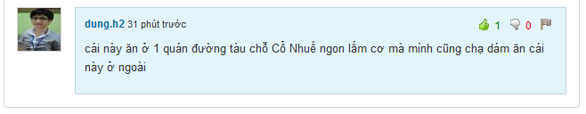**

**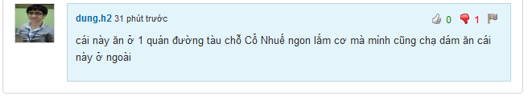**

**Buttons / Hyper Links – Vote Up Screen**

|  |  |  |  |  |
| --- | --- | --- | --- | --- |
| **Function** | **Description** | **Available Criteria** | **Validations** | **Outcome** |
| Vote up an answer | This button will vote up for an answer. It is displayed with thumb up symbol | Default hidden. It will be showed when user move mouse to an answer. | No validation | Thumb up symbol turn into green, vote up number is increased by 1 |
| Vote down an answer | This button will vote down for an answer. It is displayed with thumb down symbol | Default hidden. It will be showed when user move mouse to an answer. | No validation | Thumb down symbol turn into red, vote down number is increased by 1 |

#### Report an answer

##### Use Case Diagram



##### Use Case Specification

|  |  |  |  |  |
| --- | --- | --- | --- | --- |
| **USE CASE –Report an answer SPECIFICATION** | | | | |
| **Use-case No.** | UC026 | **Use-case Version** | | 1.0 |
| **Use-case Name** | Report an answer | | | |
| **Author** | DungTQ | | | |
| **Date** | 11/01/2011 | **Priority** | Normal | |
| **Actor:**  User  **Summary:**  Because website stores a lot of information and replies, admin can’t control all answers which users posted day by day. Report an answer will help admin detect and remove bad answers for a better network. User can use this function by clicking to flag symbol (which will appear when he/she move mouse to other user answer).  **Goal:**  Users can report any answer which they think is spam or has inappropriate content.  **Triggers**  Click to flag symbol  **Preconditions:**  Successfully logged into the system and accessed to question’s details page which has at least one answer.  **Post Conditions:**  Stay remain at question detail page  **Main Success Scenario:**   |  |  |  | | --- | --- | --- | | Step | Actor Action | System Response | | 1 | Move mouse to a comment which user wants to report | X symbol appear | | 2 | Click to X symbol | Popup Report window | | 3 | Click to “Báo cáo” button | Popu a message “Báo cáo vi phạm hoàn tất! Ban quan trị sẽ kiểm tra lại trong thờ gian sớm nhất.” | | 4 | Click OK | Popups close |   **Alternative Scenario:**   |  |  |  | | --- | --- | --- | | Step | Actor Action | System Response | | 1 | Move mouse to a comment which user wants to report | X symbol appar | | 2 | Click to X symbol | Popup Report window | | 3 | Enter reason |  | | 4 | Click to “Báo cáo” button | Popup a message “Báo cáo vi phạm hoàn tất! Ban quan trị sẽ kiểm tra lại trong thời gian sớm nhất.” | | 5 | Click OK | Popups close |  |  |  |  | | --- | --- | --- | | Step | Actor Action | System Response | | 1 | Cick to flag symbol | Popup a window | | 2 | Enter reason with more than 100 characters |  | | 3 | Click to “Báo cáo” button | Popup a message “Lý do không dài quá 100 ký tự.” | | 4 | Click OK | Wanring popup closes, report popup still opens |  |  |  |  | | --- | --- | --- | | Step | Actor Action | System Response | | 1 | Click to flag symbol | Popup a window | | 2 | Enter reason |  | | 3 | Click to “Bỏ qua” button | Popup closes |  |  |  |  | | --- | --- | --- | | Step | Actor Action | System Response | | 1 | Click to flag symbol | Popup a window | | 2 | Enter reason |  | | 3 | Click to “Báo cáo” button | Popup a message “Báo cáo vi phạm hoàn tất! Ban quan trị sẽ kiểm tra lại trong thời gian sớm nhất.” | | 4 | Click OK | Popups close | | 5 | Click to flag button again | Popup a message “Báo cáo vi phạm hoàn tất! Ban quan trị sẽ kiểm tra lại trong thời gian sớm nhất.” |   **Exceptions:**  **Relationships:**  Login use case, view question detail use case  **Business Rules:**   |  |  |  | | --- | --- | --- | | **No** | **Rule Description** | **Error Message** | | 1 | Each account can only report an answer once |  | | | | | |
| **Description**  When the user sees someone is spamming by posting many answers with nonsense, unrelated inappropriate or advertising content, they can report it. The user must move the mouse to spam answer and click to flag icon. A popup will appear and require you to enter your reason. By entering your reason, admin work will be much easier when reviewing spam reports. The reason must be less then 100 character. If you enter more than that, an inform message will popup and required you to shorten your reason down. By clicking to “Báo cáo” button, your spam report will be sent to the system and wait there for admin checking. If you don’t want to send report anymore, just click to “Bỏ qua” button, the report popup will close.  The answer will be deleted manually by admins when they review the answer. The user can’t undo the click. Admin will set the answer back to normal if it isn’t a spam or doesn’t violate any rule. Each user can only report 1 answer once. You can do the report steps many times, but only your 1st report will be saved into the system. | | | | |

**Screen**

**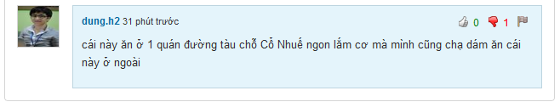**

**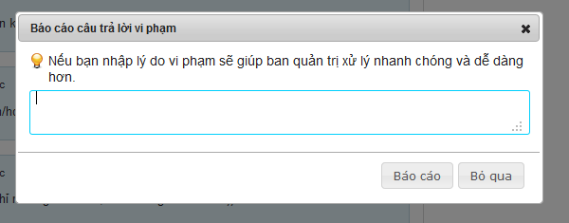**

**Button / Hyper links**

|  |  |  |  |  |
| --- | --- | --- | --- | --- |
| **Function** | **Description** | **Available Criteria** | **Validations** | **Outcome** |
| Report an answer | This button is displayed with flag symbol and it is used to report an answer | Only available when move mouse to other user’s answers | No validation | Popup report window for enter reason |
| Vote up | This button is displayed with thumb up symbol and it is used to vote up for an answer | It will be showed when user move the mouse pointer to an answer | No validation | Vote up number is increased by 1, thumb up symbol turn into green |
| Vote down | This button is displayed with thumb down symbol and it is used to vote down for an answer | It will be showed when user move the mouse pointer to an answer | No validation | Vote down number is increased by 1, thumb down symbol turn into red |
| Post a report | This button is used for post a report to the system | Always available with popup | No validation | Popup a message “Báo cáo vi phạm hoàn tất! Ban quan trị sẽ kiểm tra lại trong thời gian sớm nhất.” |
| Cancel posting a report | This button is used for cancel reporting and close the popup | Always available with popup | No validation | Popup closes |

#### Delete an answer

##### Use Case Diagram



##### Use Case Specification

|  |  |  |  |  |
| --- | --- | --- | --- | --- |
| **USE CASE – Delete an answer SPECIFICATION** | | | | |
| **Use-case No.** | UC027 | **Use-case Version** | | 1.0 |
| **Use-case Name** | Delete an answer | | | |
| **Author** | QuangLM | | | |
| **Date** | 13/01/2011 | **Priority** | High | |
| **Actor:**  User  **Summary:**  When the user post a double answer or post something that he/she regrets later, the user can delete it from answer area so no one can see what he/she just posted or avoid get reported as spam. He/ she can move the mouse to his/her answer then click to a button with X symbol just appear to delete the answer.  **Goal:**  Delete your answer from answer area.  **Triggers**  Click to a button with X symbol  **Preconditions:**  Successfully logged into the system and open a Question Detail page  **Post Conditions:**  Stay remain at current place page with an answer was deleted from answer area.  **Main Success Scenario:**   |  |  |  | | --- | --- | --- | | Step | Actor Action | System Response | | 1 | Move the mouse to your answer | A button with X symbol appear | | 2 | Click to X button | The answer disappear from answer area |   **Alternative Scenario:**  None  **Exceptions: -**  **Relationships:**  Log in use case  **Business Rules:**   |  |  |  | | --- | --- | --- | | **No** | **Rule Description** | **Error Message** | | 1 | You can only delete your own answer |  | | | | | |

**Screen**

****

**Buttons / Hyper Links**

|  |  |  |  |  |
| --- | --- | --- | --- | --- |
| **Function** | **Description** | **Available Criteria** | **Validations** | **Outcome** |
| Delete an answer | This button is displayed with a X symbol and it is used to delete the answer from answer area | It will be showed when user move the mouse pointer to his/her answer | No validation | The answer is deleted from answer area |
| Vote up | This button is displayed with thumb up symbol and it is used to vote up for an answer | It will be showed when user move the mouse pointer to an answer | No validation | Vote up number is increased by 1, thumb up symbol turn into green |
| Vote down | This button is displayed with thumb down symbol and it is used to vote down for an answer | It will be showed when user move the mouse pointer to an answer | No validation | Vote down number is increased by 1, thumb down symbol turn into red |

#### View Favorite List

##### Use Case Diagram



##### Use Case Specification

|  |  |  |  |  |
| --- | --- | --- | --- | --- |
| **USE CASE – View favorite list SPECIFICATION** | | | | |
| **Use-case No.** | UC028 | **Use-case Version** | | 1.0 |
| **Use-case Name** | View Favorite List | | | |
| **Author** | DungTQ | | | |
| **Date** | 13/01/2011 | **Priority** | Normal | |
| **Actor:**  User  **Summary:**  When using website, maybe user will find out some interesting places and they want to save for using later or share for friends. Favorite List will help user to manage favorite places.  **Goal:**  Display list of places which user favor.  **Triggers**  Click to “Địa điểm yêu thích” tab at user profile page  **Preconditions:**  Successfully logged into the system and go to your profile page  **Post Conditions:**  Favorite tab is displayed with all favorite places  **Main Success Scenario:**   |  |  |  | | --- | --- | --- | | Stp | Actor Action | System Response | | 1 | Click to “Địa điểm yêu thích” tab | Favorite tab is displayed with all favorite places |   **Alternative Scenario:**  None  **Exceptions:**  None  **Relationships:**  Login use case  **Business Rules:**   |  |  |  | | --- | --- | --- | | **No** | **Rule Description** | **Error Message** | | 1 | There are 20 places per page |  | | | | | |
| **Description**  When using website, maybe user will find out some interesting places and they want to save for using later or share for friends. Favorite List will help user to manage favorite places. User can go to list by click to "Thêm vào yêu thích" hyperlink at Place Detail page.  To see your favorite list, click to your name at log in area at top right corner of the website then click to “Địa điểm” yêu thích tab. Each place at favorite list is displayed with an avatar, place name, place rating, detail address, com ment number and view number. Favorited places will be divided into pages. Each page contains 20 places. | | | | |

**Screen**

**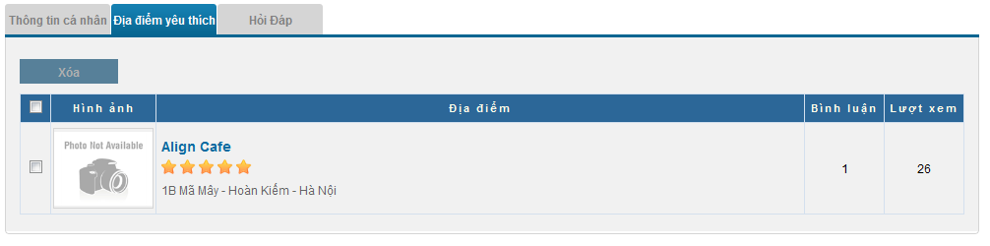**

**Data Fields Definition – Favorite List Screen**

|  |  |  |  |  |  |  |
| --- | --- | --- | --- | --- | --- | --- |
| **Field name** | **Description** | **Read**  **Only** | **Mandatory** | **Control Type** | **Data Type** | **Length** |
| Favorite Title | A label with content: “Địa điểm yêu thích” | Y | - | Label | String | Fixed |
| Place image | Contains place’s main image | Y | - | Image | - | - |
| Place info | Contains place name, its rating and its detail address | Y | - | Label | String | Fixed |
| Comment number | Contains place’s comment number | Y | - | Label | String | Fixed |
| View number | Contains place’s view number | Y | - | Label | String | Fixed |

**Buttons / Hyper Links**

|  |  |  |  |  |
| --- | --- | --- | --- | --- |
| **Function** | **Description** | **Available Criteria** | **Validations** | **Outcome** |
| Remove Button | Remove selected places from favorite list | Only available when atleast 1 place is selected | No validation | Selected places are removed from list |
| Place Name Hyperlink | Name of place | Always available with each place | No validation | Redirect to Place Detail page |

#### Add a Place to Favorite List

##### Use Case Diagram



##### Use Case Specification

|  |  |  |  |  |
| --- | --- | --- | --- | --- |
| **USE CASE – Add a place to favorite list SPECIFICATION** | | | | |
| **Use-case No.** | UC029 | **Use-case Version** | | 1.0 |
| **Use-case Name** | Add Place To Favorite List | | | |
| **Author** | DungTQ | | | |
| **Date** | 11/01/2011 | **Priority** | Normal | |
| **Actor:**  User  **Summary:**  When using website, maybe user will find out some interesting places. Feeling like people will want to know about or going to love that place too, the user want to save for using later or share that place to friends. So this function is really useful for them.  **Goal:**  Users can add any place to their favorite list.  **Triggers**  Click to “Thêm vào yêu thích” button.  **Preconditions:**  Successfully logged into the system and open a place detail page  **Post Conditions:**  Stay remains at Place Detail page  **Main Success Scenario:**   |  |  |  | | --- | --- | --- | | Step | Actor Action | System Response | | 2 | Click to “Thêm vào yêu thích” button | Display message “Địa điểm đã được thêm vào yêu thích.” |   **Alternative Scenario:**  None  **Exceptions:**  None  **Relationships:**  Login use case  **Business Rules:**  None | | | | |

**Screen**

**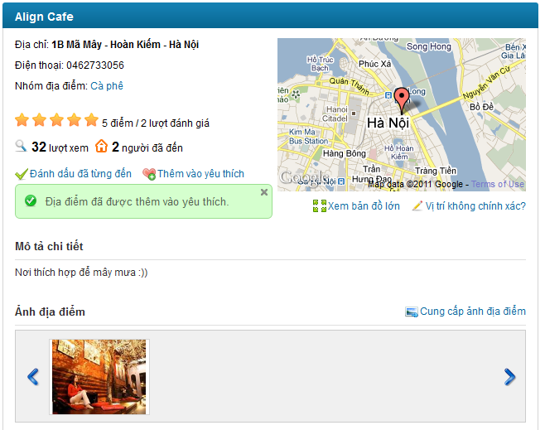**

**Buttons / Hyper Links – Add Place to Favorite List Screen**

|  |  |  |  |  |
| --- | --- | --- | --- | --- |
| **Function** | **Description** | **Available Criteria** | **Validations** | **Outcome** |
| Add To Favorite | This button add current viewing place to favorite list | Default available. | No validation | Display message “Địa điểm đã được thêm vào yêu thích.” |

#### Remove Places from Favorite List

##### Use Case Diagram



##### Use Case Specification

|  |  |  |  |  |
| --- | --- | --- | --- | --- |
| **USE CASE – Remove Places from Favorite List SPECIFICATION** | | | | |
| **Use-case No.** | UC030 | **Use-case Version** | | 1.0 |
| **Use-case Name** | Remove Places From Favorite List | | | |
| **Author** | DungTQ | | | |
| **Date** | 11/01/2011 | **Priority** | Normal | |
| **Actor:**  User  **Summary:**  A place which user liked before, but at the moment user doesn’t like anymore and want to remove it from favorite list. So he/she can use this function. User can click to boxes which beside places he/she wants to remove and click to “Xóa” button. After this function is done, these places will be removed.  **Goal:**  Users can remove any place which existed in their favorite list.  **Triggers**  Click to “Xoá” button  **Preconditions:**  Successfully logged into the system and accessed to favorite list page.  **Post Conditions:**  Selected places will be removed from user’s favorite list.  **Main Success Scenario:**   |  |  |  | | --- | --- | --- | | Step | Actor Action | System Response | | 1 | Select check box besides place A which user want to remove |  | | 2 | Click to “Xóa” button | Selected place is removed and a message is displayed “Địa điểm yêu thích đã được xóa.” |   **Alternative Scenario:**   |  |  |  | | --- | --- | --- | | Step | Actor Action | System Response | | 1 | Select check box besides “Hình ảnh” title | All check boxes in page will be selected. | | 2 | Click to “Xóa” button | All places are removed and a message is displayed “Địa điểm yêu thích đã được xóa.” |   **Exceptions:**  None  **Relationships:**  Login use case, View Favorite List use case.  **Business Rules:**  None | | | | |

**Screen**

**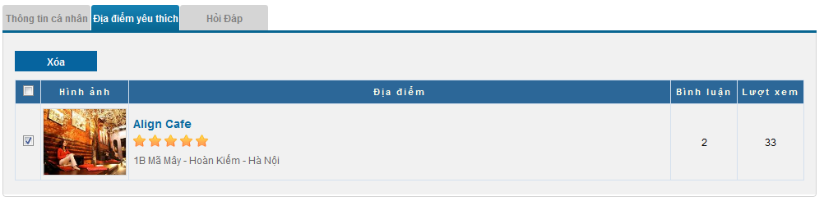**

**Data Fields Definition – Favorite List Screen**

|  |  |  |  |  |  |  |
| --- | --- | --- | --- | --- | --- | --- |
| **Field name** | **Description** | **Read**  **Only** | **Mandatory** | **Control Type** | **Data Type** | **Length** |
| Favorite Title | A label with content: “Địa điểm yêu thích” | Y | - | Label | String | Fixed |
| Place image | Contains place’s main image | Y | - | Image | - | - |
| Place info | Contains place name, its rating and its detail address | Y | - | Label | String | Fixed |
| Comment number | Contains place’s comment number | Y | - | Label | String | Fixed |
| View number | Contains place’s view number | Y | - | Label | String | Fixed |

**Buttons / Hyper Links**

|  |  |  |  |  |
| --- | --- | --- | --- | --- |
| **Function** | **Description** | **Available Criteria** | **Validations** | **Outcome** |
| Remove Button | Remove selected places from favorite list | Only available when atleast 1 place is selected | No validation | Selected places are removed from list |
| Place Name Hyperlink | Name of place | Always available with each place | No validation | Redirect to Place Detail page |

#### List Top Places of Month

##### Use Case Diagram



##### Use Case Specification

|  |  |  |  |  |
| --- | --- | --- | --- | --- |
| **USE CASE – List top places of the month SPECIFICATION** | | | | |
| **Use-case No.** | UC031 | **Use-case Version** | | 1.0 |
| **Use-case Name** | List Top Places of Month | | | |
| **Author** | QuangLM | | | |
| **Date** | 16/01/2011 | **Priority** | Normal | |
| **Actor:**  User  **Summary:**  Each time the user accesses the website, he/she can see a list of top 20 places of the month at home page based on page view, rating and comment number. This list is used for help the user can find a best place to go.  **Goal:**  See top hot places in the website  **Triggers:**  Access the home page  **Preconditions: -**  **Post Conditions:**  Stay remains at home page.  **Main Success Scenario:**   |  |  |  | | --- | --- | --- | | Step | Actor Action | System Response | | 1 | Access home page | Display top 20 hottest places |   **Alternative Scenario: -**  **Exceptions: -**  **Relationships: -**  **Business Rules:**  -   |  |  |  | | --- | --- | --- | | **No** | **Rule Description** | **Error Message** | | 1 | Sorted by page view, rating and comment number |  | | 2 | The list is updated each 10 minutes |  | | | | | |

#### List Newest Places

##### Use Case Diagram



##### Use Case Specification

|  |  |  |  |  |
| --- | --- | --- | --- | --- |
| **USE CASE – List newest places SPECIFICATION** | | | | |
| **Use-case No.** | UC032 | **Use-case Version** | | 1.0 |
| **Use-case Name** | List Newest Places | | | |
| **Author** | QuangLM | | | |
| **Date** | 16/01/2011 | **Priority** | Normal | |
| **Actor:**  User  **Summary:**  Each time the user accesses the home page, he/she can see a list of top 20 newest places which was just added to the system by someone. This list is used to inform user about which place just added to the system.  **Goal:**  See top newest places in the website  **Triggers:**  Access the home page  **Preconditions: -**  **Post Conditions:**  Stay remains at home page.  **Main Success Scenario:**   |  |  |  | | --- | --- | --- | | Step | Actor Action | System Response | | 1 | Access home page | Display top 20 newest place |   **Alternative Scenario: -**  **Exceptions: -**  **Relationships: -**  **Business Rules:**   |  |  |  | | --- | --- | --- | | No | Rule Description | Error Message | | 1 | Sorted by newest to older places |  | | | | | |
| **Description:**  Each time the user accesses the website, he/she can see a list of top 20 most searched categories. The list is display as a tag cloud. Category names in the list are sorted by name. Top 5 most searched categories will be in bold and blue text. The last 15 categories are just in normal plain black text .This list is used to let user know which categories get the most concern on the website. The tag cloud is below newest places list. The result list is based on search queries from users on the system. | | | | |

**Screen**

**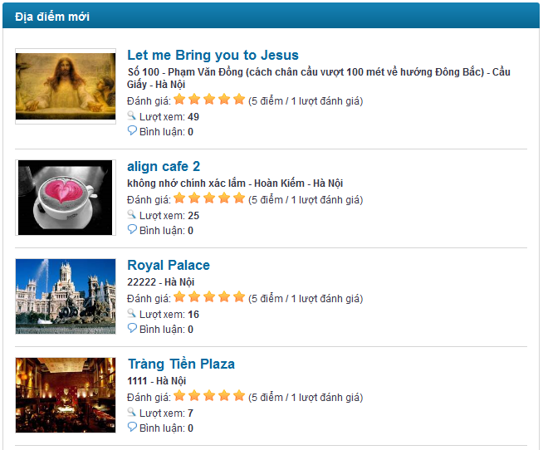**

#### List Most Searched Categories

##### Use Case Diagram



##### Use Case Specification

|  |  |  |  |  |
| --- | --- | --- | --- | --- |
| **USE CASE – List most searched categories SPECIFICATION** | | | | |
| **Use-case No.** | UC033 | **Use-case Version** | | 1.0 |
| **Use-case Name** | List most searched categories | | | |
| **Author** | QuangLM | | | |
| **Date** | 16/01/2011 | **Priority** | Normal | |
| **Actor:**  User  **Summary:**  Each time the user accesses the home page, he/she can see a list of top 20 most searched categories. The list is display as a tag cloud. This list is used to let user know which categories get the most concern on the website.  **Goal:**  See most researched categories in the website  **Triggers:**  Access the home page  **Preconditions: -**  **Post Conditions:**  Stay remains at home page.  **Main Success Scenario:**   |  |  |  | | --- | --- | --- | | Step | Actor Action | System Response | | 1 | Access home page | Display a tag cloud of 20 most searched categories |   **Alternative Scenario: -**  **Exceptions: -**  **Relationships: -**  **Business Rules:**   |  |  |  | | --- | --- | --- | | No | Rule Description | Error Message | | 1 | Category names in the list are sorted by name. |  | | | | | |
| **Description:**  Each time the user accesses the website, he/she can see a list of top 50 most searched categories. The list is display as a tag cloud. Category names in the list are sorted by name. The tag cloud has 2 view modes: short view and detail view. Short view only display 20 most searched categories while detail view display 50 most searched categories. The short view is default. User need click to “Xem thêm” to redirect to new page with Detail view. This list is used to let user know which categories get the most concern on the website. The result list is based on search queries from users on the system. The more the category entered in search box, the bigger size and bolder it has. | | | | |

**Screen**

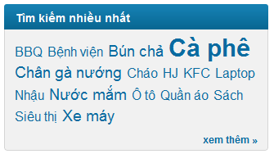

#### List Most Contributors

##### Use Case Diagram



##### Use Case Specification

|  |  |  |  |  |
| --- | --- | --- | --- | --- |
| **USE CASE – List most contributors SPECIFICATION** | | | | |
| **Use-case No.** | UC034 | **Use-case Version** | | 1.0 |
| **Use-case Name** | List most contributors | | | |
| **Author** | QuangLM | | | |
| **Date** | 16/01/2011 | **Priority** | Normal | |
| **Actor:**  User  **Summary:**  Each time the user accesses Q&A page, he/she can see a list of top 10 most contributors. This list is used to let user know who contribute most to the website.  **Goal:**  See most contributors  **Triggers:**  Click to “Hỏi & Đáp” menu at navigator  **Preconditions:**  **Post Conditions:**  Stay remains at Q&A page.  **Main Success Scenario:**   |  |  |  | | --- | --- | --- | | Step | Actor Action | System Response | | 1 | Click to “Hỏi & Đáp” menu at navigator | Display top 10 most contributor on the right side |   **Alternative Scenario: -**  **Exceptions: -**  **Relationships: -**  **Business Rules:**   |  |  |  | | --- | --- | --- | | No | Rule Description | Error Message | | 1 | The mos contributor list is based on number of posted answers |  | | 2 | Sorted by highest point to lesser contributors |  | | | | | |
| **Description:**  Each time the user accesses Q&A page, he/she can see a list of top 10 most contributors. The list is sorted by highest answer number to lesser .This list is used to let user know who contribute most to Q&A page. Each user is displayed with avatar, name and number of answers that user has posted. User name is displayed as link. User can click to these links to open User profile page. | | | | |

**Screen**

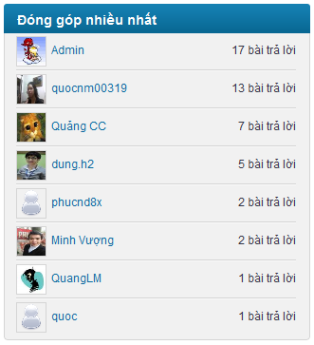

#### Log In

##### Use Case Diagram



##### Use Case Specification

|  |  |  |  |  |
| --- | --- | --- | --- | --- |
| **USE CASE – Log in SPECIFICATION** | | | | |
| **Use-case No.** | UC035 | **Use-case Version** | | 1.0 |
| **Use-case Name** | Log in | | | |
| **Author** | VuongNM | | | |
| **Date** | 10/01/2011 | **Priority** | High | |
| **Actor:**  User  **Summary:**  User must be login to be able to use such functions as create place, edit place, rating... There are 2 ways to login into website; the first way is register one account on system. The second way is logon via third party account: Yahoo or Google. The second way is recommended.  **Goal:**  Allow guest login to website.  **Triggers**  Click to “Đăng nhập” at log in area on top right corner of the website  **Preconditions:**  Access to the website  **Post Conditions:**  User logged to system  **Main Success Scenario:**   |  |  |  | | --- | --- | --- | | **Step** | **Actor Action** | **System Response** | | 1 | Click to “Đăng nhập” at log in area on top right corner of the website | Redirect user to log in page | | 2 | Enter Username, password |  | | 3 | Click to “Đăng nhập” button | Navigate the user back to previous page |   **Alternative Scenario:**   |  |  |  | | --- | --- | --- | | **Step** | **Actor Action** | **System Response** | | 1 | Click to “Đăng nhập” at log in area on top right corner of the website | Redirect user to log in page | | 2 | Select Google or Yahoo image to login | Redirect to log in page belong to Goole or Yahoo | | 3 | Enter third party account’s username & password correctly |  | | 4 | Click to “Đăng nhập” button | notification message will be showed to confirm if the user really want to use this account to login to the system | | 5 | Click to “Có” button | Navigate the user back to previous page |   **Exceptions:**   |  |  |  | | --- | --- | --- | | **Step** | **Actor Action** | **System Response** | | 1 | Click to “Đăng nhập” at log in area on top right corner of the website | Redirect user to log in page | | 2 | Enter wrong user name, password |  | | 3 | Click to “Đăng nhập” button | Show error message “Bạn hãy sửa những lỗi bên dưới và thử lại.   * Incorrect username or password.” |  |  |  |  | | --- | --- | --- | | **Step** | **Actor Action** | **System Response** | | 1 | Click to “Đăng nhập” hyperlink at home page | Redirect user to log in page | | 2 | Select Google or Yahoo image to login | Popup is displayed and require user enter username & password | | 3 | Enter wrong third party account’s username or password |  | | 4 | Click to “Đăng nhập” button | Show error message, require the user re-enter user name and password |   **Relationships:**  **Business Rules:**   |  |  |  | | --- | --- | --- | | **No** | **Rule Description** | **Error Message** | | 1 | In order to log in to the system, user name and password are required. |  | | | | | |
| **Description:**  There are functions that required users log in to the system to be able to use such as create new place, edit a place, post a question, and post a comment or an answer… User need click to “Đăng nhập” button on log in panel at top right corner of the website. The system will navigate user to Log in page. Log in page gives user 3 choices for logging in: using google account, using yahoo account or using PSN account. Click to google icon, the user will log in through Google account system. Click to Yahoo icon, the user will log in through Yahoo account system. To log in through account registerd at our website, user need fill in yout email address and password. If you check “Tự động đăng nhập lần sau”, your account info will be saved into cookie. And next time when you access the website again, you don’t need to log in cause the system will auto recognize you. The user can change his/her password incase he/she forgot it by clicking to “Quên mật khẩu” hyperlink. | | | | |

**Screen**

**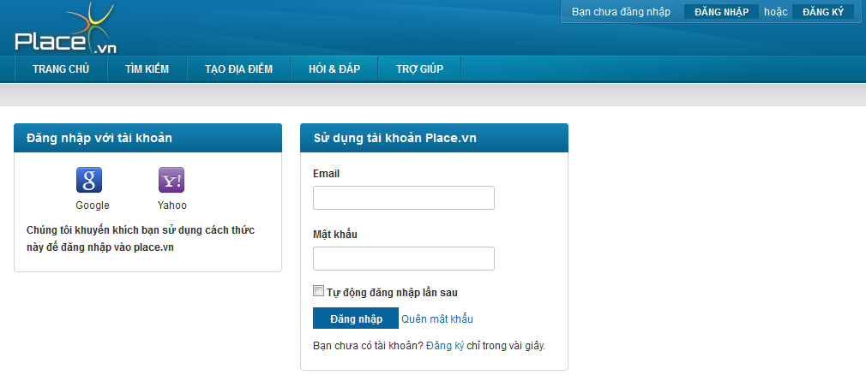**

**Data Fields Definition – Attach Place Page**

|  |  |  |  |  |  |  |
| --- | --- | --- | --- | --- | --- | --- |
| **Field name** | **Description** | **Read**  **Only** | **Mandatory** | **Control Type** | **Data Type** | **Length** |
| **PSN Account Area with title “Sử dụng tài khoản Place.vn”** | | | | | | |
| Email label | A label with content “Email” | - | - | Label | String | Fixed |
| Email | Email address used for registering | - | Y | Textbox | String | 100 |
| Password label | A label with content “Mật khẩu” | - | - | Label | String | Fixed |
| Password | Users enter your password to login into PSN website.  Displayed text is password | - | Y | Textbox | String | 50 |
| Remember me | A check box with content “Tự động đăng nhập lần sau” | - | - | Checkbox | Boolean | fixed |
| Register label | A label with content “Bạn chưa có tài khoản?” + “[Đăng ký](http://place.vn/account/register) “hyperlink + “chỉ trong vài giây.” | - | - | Label | String | Fixed |
| **3rd party account area with title “Đăng nhập với tài khoản”** | | | | | | |
| Google | User click it to logon website by Google account | Y | - | Image | - | - |
| Yahoo | User click it to logon website by Yahoo account | Y | - | Image | - | - |
| Suggestion | A label with content “Chúng tôi khuyến khích bạn sử dụng cách thức này để đăng nhập vào place.vn” | - | - | Label | String | Fixed |

**Buttons / Hyperlinks**

|  |  |  |  |  |
| --- | --- | --- | --- | --- |
| **Function** | **Description** | **Available Criteria** | **Validations** | **Outcome** |
| Log in Button | This button is used for log in into the system | Always available | No validation | Redirected back to previous page with user name appear on log in area instead of “Đăng nhập” and “Đăng kí” button |
| Register hyperlink | When clicked guest is navigated to register page to create new account in website | Always available | No validation | Redirect to register page |
| Forgot password hyperlink | User navigated to forgot password page when clicked | Always available | No validation | navigated the user to forgot password page |

#### Log Out

##### Use Case Diagram



##### Use Case Specification

|  |  |  |  |  |
| --- | --- | --- | --- | --- |
| **USE CASE – Log out SPECIFICATION** | | | | |
| **Use-case No.** | UC036 | **Use-case Version** | | 1.0 |
| **Use-case Name** | Log out | | | |
| **Author** | VuongNM | | | |
| **Date** | 10/01/2011 | **Priority** | High | |
| **Actor:**  User  **Summary:**  After done using the website and plan to leave, the user can log out of the system.  **Goal:**  Allow users log out website  **Triggers**  Click on “Thoát” at log in area on top right corner of the website  **Preconditions:**  Logged into the system  **Post Conditions:**  Display the user as guest  **Main Success Scenario:**   |  |  |  | | --- | --- | --- | | **Step** | **Actor Action** | **System Response** | | 1 | click “Thoát” button | Redirect to home page, “Đăng nhập” and “Đăng kí” button appear instead of user name, user point and “Thoát” button on log in area at top right corner of the website |   **Alternative Scenario:**  None  **Exceptions:**  None  **Relationships:**  Login function  **Business Rules:**  None | | | | |

**Buttons / Hyperlinks**

|  |  |  |  |  |
| --- | --- | --- | --- | --- |
| **Function** | **Description** | **Available Criteria** | **Validations** | **Outcome** |
| Logout hyperlink | By clicking this user will log out of website |  |  | Displayed user as guest |

#### Register an Account

##### Use Case Diagram



##### Use Case Specification

|  |  |  |  |  |
| --- | --- | --- | --- | --- |
| **USE CASE – Register an account SPECIFICATION** | | | | |
| **Use-case No.** | UC037 | **Use-case Version** | | 1.0 |
| **Use-case Name** | Register an account | | | |
| **Author** | VuongNM | | | |
| **Date** | 10/01/2011 | **Priority** | High | |
| **Actor:**  User  **Summary:**  Because of permission of guest is limited. So guest must register an account to be able to create place, rating, or comment …  **Goal:**  Register an account in the system.  **Triggers**  Click to “Đăng kí” button on log in area at top right corner of the website  **Preconditions:**  Access to the website  **Post Conditions:**  Navigate the user back to home page.  **Main Success Scenario:**   |  |  |  | | --- | --- | --- | | **Step** | **Actor Action** | **System Response** | | 1 | Click to “Đăng kí” button on log in area at top right corner of the website | Website navigate the user to register page | | 2 | Type in email address correctly |  | | 3 | Enter password correctly |  | | 4 | Re-enter password into confirm password textbox correctly |  | | 5 | Enter full name |  | | 6 | Click to “Đăng kí” button | Send activation email to registered email address and redirect to Success page |   **Alternative Scenario: -**  **Exceptions:**   |  |  |  | | --- | --- | --- | | **Step** | **Actor Action** | **System Response** | | 1 | Click to “Đăng kí” button on log in area at top right corner of the website | Website navigate the user to register page | | 2 | Type in email address **in wrong format** | Display error message “Địa chỉ Email không đúng.” |  |  |  |  | | --- | --- | --- | | **Step** | **Actor Action** | **System Response** | | 1 | Click to “Đăng kí” button on log in area at top right corner of the website | Website navigate the user to register page | | 2 | Type in email address correctly |  | | 3 | Enter password correctly |  | | 4 | Re-enter password into confirm password textbox **mistakenly** | Display error message “'Nhập lại mật khẩu' và 'Mật khẩu' phải giống nhau.” |  |  |  |  | | --- | --- | --- | | **Step** | **Actor Action** | **System Response** | | 1 | Click to “Đăng kí” button on log in area at top right corner of the website | Website navigate the user to register page | | 2 | Type in **used** email address | check email format | | 3 | Enter password correctly |  | | 4 | Re-enter passwod into confirm password textbox correctly |  | | 5 | Enter full name |  | | 6 | Click to “Đăng kí” button | Display error message” Bạn hãy sửa những lỗi bên dưới và thử lại.   * Địa chỉ email đã tồn tại” |   **Relationships:**  Forget password function  **Business Rules:**   |  |  |  | | --- | --- | --- | | **No** | **Rule Description** | **Error Message** | | 1 | In order to register a new account, email address, password and confirm password is required. |  | | 2 | One email address can only be used for registering once |  | | | | | |
| **Description:**  In order to has full access to our website, user need to log in by using Google account or Yahoo account or register a PSN account. To register an account on our system, user needs to have a vaild email address. This email address must exist to be able to get activation email from the system. Each email can only be used for registering once, you can use it again. After register an account, you must log in to your email to find validation email. In this email, we send to you an activation link. Click to that link will active your account. An unactived account will get limited access on our website | | | | |

**Screen**

**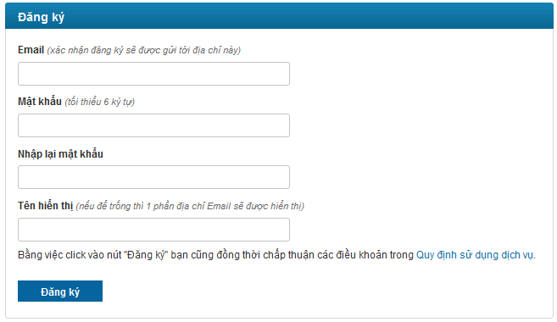**

**Data Fields Definition – Attach Place Page**

|  |  |  |  |  |  |  |
| --- | --- | --- | --- | --- | --- | --- |
| **Field name** | **Description** | **Read**  **Only** | **Mandatory** | **Control Type** | **Data Type** | **Length** |
| Email label | A label with content “Email (xác nhận đăng ký sẽ được gửi tới địa chỉ này) ” | - | - | Label | String | Fixed |
| Email | Email address used for registering | - | Y | Textbox | Text | 50 |
| Password label | A label with content “Mật khẩu (tối thiểu 6 ký tự) ” | - | - | Label | String | Fixed |
| Password | This text box for enter password | - | Y | Textbox | Text | 50 |
| Confirm label | A label with content “Nhập lại mật khẩu” | - | - | Label | String | Fixed |
| Confirm password | This text box for enter confirm password | - | Y | Textbox | Text | 50 |
| Nickname label | A label with content “Tên hiển thị (nếu để trống thì 1 phần địa chỉ Email sẽ được hiển thị) ” | - | - | Label | String | Fixed |
| Nickname | This text box for enter nickname | - | Y | Textbox | Text | 100 |
| Agreement | This label contains: “Bằng việc click vào nút "Đăng ký" bạn cũng đồng thời chấp thuận các điều khoản trong” + “[Quy định sử dụng dịch vụ](http://place.vn/home/termsofservice)” hyperlink | Y | Y | Checkbox | True/False | - |

**Buttons / Hyperlinks**

|  |  |  |  |  |
| --- | --- | --- | --- | --- |
| **Function** | **Description** | **Available Criteria** | **Validations** | **Outcome** |
| Register button | When clicked all information which entered by user is submitted to website to create new account. | Always available | Enter valid information | Send activation email to registered email address and redirect to Success page |
| Policies hyperlink | This link will open policies page | Always available | No validation | Redirect user to Terms of Service page |

#### Reset Forgot Password

##### Use Case Diagram



##### Use Case Specification

|  |  |  |  |  |
| --- | --- | --- | --- | --- |
| **USE CASE – Reset forgot password SPECIFICATION** | | | | |
| **Use-case No.** | UC038 | **Use-case Version** | | 1.0 |
| **Use-case Name** | Reset Forgot Password | | | |
| **Author** | VuongNM | | | |
| **Date** | 10/01/2011 | **Priority** | High | |
| **Actor:**  User  **Summary:**  By some reasons, registered user forgot their password and wanted to recovery this. When user report forgot password, website send confirm email to the user. The user clicks confirm reset password in email, after that system will reset user password and sent new password in email to user.  **Goal:**  Reset user’s password.  **Triggers**  Click to “Quên mật khẩu” hyperlink  **Preconditions:**  Access to the website and open log in page  **Post Conditions:**  Stay remains at forgot pass page with notification ask user check for new email with new password  **Main Success Scenario:**   |  |  |  | | --- | --- | --- | | **Step** | **Actor Action** | **System Response** | | 1 | Click to “Quên mật khẩu” hyperlink | navigate user to forgot password page | | 2 | Type email address into email address textbox |  | | 3 | Click to “Quên mật khẩu” button | Confirm email sent to user. Website show message to inform the user check email to confirm resetting his/her password | | 4 | User click confirm hyperlink in email | Redirect the user to reset password page | | 5 | Enter new password and confirm password |  | | 5 | Click to “Thay đổi” button | New password is saved |   **Alternative Scenario:**  **Exceptions:**   |  |  |  | | --- | --- | --- | | **Step** | **Actor Action** | **System Response** | | 1 | Click to “Quên mật khẩu” hyperlink | navigate user to forgot password page | | 2 | Type invalida email address into email address textbox |  | | 3 | Click to “Tạo mật khẩu mới” button | Display error message, inform the user that he/she justentered an invalid email address |     **Relationships:**  **Business Rules:**   |  |  |  | | --- | --- | --- | | **No** | **Rule Description** | **Error Message** | | 1 | Email address is required to be able to reset pasword |  | | 2 | Confirm link will be sent through email |  | | | | | |
| **Description:**  The system allows user change password when they forgot it. User goes to log in page at PSN website and click “Quên mật khẩu” hyperlink to get redirected to Forgot Password page. Users need enter their email address, system will check this email is registered or not. If valid, one email is sent to user with reset password link. Follow this link, user is navigated to reset password page. In here, user selects “Tạo mật khẩu mới” button, the system will replace your password with the new one. | | | | |

**Screen**

**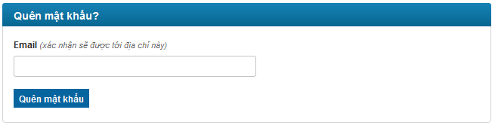**

**oOo**

**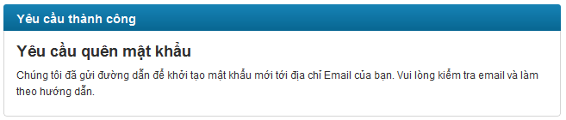**

**oOo**

**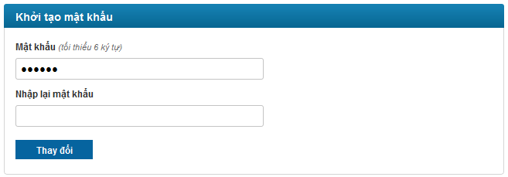**

**Data Fields Definition – Attach Place Page**

|  |  |  |  |  |  |  |
| --- | --- | --- | --- | --- | --- | --- |
| **Field name** | **Description** | **Read**  **Only** | **Mandatory** | **Control Type** | **Data Type** | **Length** |
| **Forgot password area with title “Quên mật khẩu?”** | | | | | | |
| Email label | A label with content “Email (xác nhận sẽ được tới địa chỉ này) ” | - | - | Label | String | Fixed |
| Email | Email address used for get reset password link | - | Y | Textbox | String | 254 |
| **Reset password area with title “Khởi tạo mật khẩu”** | | | | | | |
| New password label | A label with content “Mật khẩu (tối thiểu 6 ký tự) ” | - | - | Label | String | Fixed |
| New password | password that will replace old password | - | Y | Textbox | String | 100 |
| Confirm password label | A label with content “Nhập lại mật khẩu” | - | - | Label | String | Fixed |
| Confirm password | Confirm password | - | Y | Button | String | 100 |

**Buttons / Hyperlinks**

|  |  |  |  |  |
| --- | --- | --- | --- | --- |
| **Function** | **Description** | **Available Criteria** | **Validations** | **Outcome** |
| forgot password | When clicked a mail with link used for resetting will be sent to user email address | Always available | Email can’t be blank | Notification message is displayed to inform that user check email and follow hyperlink to generate new password |
| Reset password | Using button will save new password instead of the old one | Always available | Password and confirm password can’t be blank | Notification message is displayed to inform that new password is generated and is sent to user’s email. |

#### Edit Your Profile

##### Use Case Diagram



##### Use Case Specification

|  |  |  |  |  |
| --- | --- | --- | --- | --- |
| **USE CASE – Edit your profile SPECIFICATION** | | | | |
| **Use-case No.** | UC039 | **Use-case Version** | | 1.0 |
| **Use-case Name** | Edit your profile | | | |
| **Author** | VuongNM | | | |
| **Date** | 10/01/2011 | **Priority** | High | |
| **Actor:**  User  **Summary:**  When viewing his/her profile, user can change his/her nickname and avatar.  **Goal:**  Allow user edit and complete their profile  **Triggers**  Click on “Sửa đổi” button  **Preconditions:**  Logged into the system and open your profile page  **Post Conditions:**  None  **Main Success Scenario:**   |  |  |  | | --- | --- | --- | | **Step** | **Actor Action** | **System Response** | | 1 | Change nickname |  | | 2 | Click to “Sửa đổi” button | Display message “Thông tin cá nhân đã được cập nhật.” |   **Alternative Scenario:**   |  |  |  | | --- | --- | --- | | **Step** | **Actor Action** | **System Response** | | 1 | Click uploader | Popup a window for choosing image | | 2 | Choose an image | Display image url | | 3 | Click to “Sửa đổi” button | Display message “Thông tin cá nhân đã được cập nhật.” |   **Exceptions:**   |  |  |  | | --- | --- | --- | | **Step** | **Actor Action** | **System Response** | | 1 | Change nickname to more than 50 characters |  | | 2 | Click to “Sửa đổi” button | Display message “Thông tin cập nhập lỗi” |  |  |  |  | | --- | --- | --- | | **Step** | **Actor Action** | **System Response** | | 1 | Click uploader | Popup a window for choosing image | | 2 | Choose an image with any extension except JPG, PNG | Display image url | | 3 | Click to “Sửa đổi” button | Display message “Cập nhật ảnh đại diện không thành công. Chỉ hỗ trợ ảnh định dạng JPG và PNG. Kích thước ảnh không được vượt quá 2Mb. Nếu lỗi vẫn xảy ra bạn hãy thử lại vào lúc khác.” |  |  |  |  | | --- | --- | --- | | **Step** | **Actor Action** | **System Response** | | 1 | Click uploader | Popup a window for choosing image | | 2 | Choose an image with size bigger then 2MB | Display image url | | 3 | Click to “Sửa đổi” button | Display message “Cập nhật ảnh đại diện không thành công. Chỉ hỗ trợ ảnh định dạng JPG và PNG. Kích thước ảnh không được vượt quá 2Mb. Nếu lỗi vẫn xảy ra bạn hãy thử lại vào lúc khác.” |   **Relationships:**  View user profile  **Business Rules:**   |  |  |  | | --- | --- | --- | | **No** | **Rule Description** | **Error Message** | | 1 | In order to change password, old password, new password and retype new password are required |  | | 2 | Avatar’s size can’t be exceed than 1M |  | | 3 | Email address can’t be changed because this used as username in logging in |  | | 4 | View permission combo box has default value is “Everyone” |  | | | | | |
| **Description:**  User can update his/her profile. He/she can change Display name, change avatar or click to “Đổi mật khẩu” hyperlink to chage password. User need click to “Sửa đổi” button to save changes. Display Name can not has more than 50 characters, if not, there will be an error message require user to reenter. About user’s avatar, it must be JPG or PNG and must be smaller than 4Mb. The changing in user profile will be update right away as you click “Sửa đổi” button on the whole system. | | | | |

**Screen**

**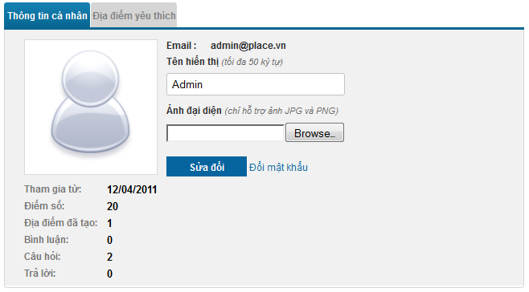**

**Data Fields Definition – Attach Place Page**

|  |  |  |  |  |  |  |
| --- | --- | --- | --- | --- | --- | --- |
| **Field name** | **Description** | **Read**  **Only** | **Mandatory** | **Control Type** | **Data Type** | **Length** |
| Email label | A label with content “Email:” | Y | - | Label | String | Fixed |
| Email | Contain your email address | N | Y | Textbox | String | 254 |
| Nickname label | A label with content “Tên hiển thị (tối đa 50 ký tự) ” | Y | - | Label | String | Fixed |
| Nick name | Contain your nickname | N | Y | Text box | String | 50 |
| Avatar label | A label with content “Ảnh đại diện (chỉ hỗ trợ ảnh JPG và PNG)” | Y | - | Label | String | Fixed |
| Avatar uploader | Uploader used for upload your image to server | Y | - | Uploader | - | - |
| Avatar | Your current avatar | Y | - | Image | - | - |
| Created date label | “Tham gia từ:” label | Y | - | Label | String | Fixed |
| Created date | Contains created date of current viewing profile | Y | - | Label | String | Fixed |
| Point label | “Điểm số:” label | Y | - | Label | String | Fixed |
| Point | Contains your point | Y | - | Label | String | Fixed |
| Created place label | “Địa điểm đã tạo:” label | Y | - | Label | String | Fixed |
| Create place number | Contains number of places you created | Y | - | Label | String | Fixed |
| Comment posted label | “Bình luận:” label | Y | - | Label | String | Fixed |
| Comment posted number | Contains number of comments you posted | Y | - | Label | String | Fixed |
| Question posted label | “Câu hỏi:” label | Y | - | Label | String | Fixed |
| Question posted number | Contains number of questions you posted | Y | - | Label | String | Fixed |
| Answer posted label | “Trả lời:” label | Y | - | Label | String | Fixed |
| Answer posted number | Contains number of answers you posted | Y | - | Label | String | Fixed |

**Buttons / Hyperlinks**

|  |  |  |  |  |
| --- | --- | --- | --- | --- |
| **Function** | **Description** | **Available Criteria** | **Validations** | **Outcome** |
| Edit your profile | This button is used for edit your profile | Only available when open your own profile |  | Display message “Thông tin cá nhân đã được cập nhật.” |
| “Đổi mật khẩu” hyperlink | This link will open change password page | Only available when open your own profile |  | Redirect to Change Password page |

#### Change Password

##### Use Case Diagram



##### Use Case Specification

|  |  |  |  |  |
| --- | --- | --- | --- | --- |
| **USE CASE – Change password SPECIFICATION** | | | | |
| **Use-case No.** | UC040 | **Use-case Version** | | 1.0 |
| **Use-case Name** | Change Password | | | |
| **Author** | QuangLM | | | |
| **Date** | 10/01/2011 | **Priority** | High | |
| **Actor:**  User  **Summary:**  For security, many users often change their account password each 2-3 months. User can change their password by go to their user profile and click to “Đổi mật khẩu” hyperlink  **Goal:**  Allow user change his/her account password.  **Triggers**  Click to “Đổi mật khẩu” hyperlink  **Preconditions:**  Access to the website and open your profile  **Post Conditions:**  Stay remains at forgot pass page  **Main Success Scenario:**   |  |  |  | | --- | --- | --- | | **Step** | **Actor Action** | **System Response** | | 1 | Click to “Quên mật khẩu” hyperlink | navigate user to forgot password page | | 2 | Enter old password |  | | 3 | Enter new password |  | | 4 | Enter confirm password |  | | 5 | Click to “Thay đổi” button | Display message “Thay đổi mật khẩu thành công” |   **Alternative Scenario:**  **Exceptions:**   |  |  |  | | --- | --- | --- | | **Step** | **Actor Action** | **System Response** | | 1 | Click to “Quên mật khẩu” hyperlink | navigate user to forgot password page | | 2 | Enter not matched old password |  | | 3 | Enter new password |  | | 4 | Enter confirm password |  | | 5 | Click to “Thay đổi” button | Display message “Mật khẩu cũ không đúng” |  |  |  |  | | --- | --- | --- | | **Step** | **Actor Action** | **System Response** | | 1 | Click to “Quên mật khẩu” hyperlink | navigate user to forgot password page | | 2 | Enter old password |  | | 3 | Enter new password |  | | 4 | Enter not matched confirm password |  | | 5 | Click to “Thay đổi” button | Display message “Nhập lại mật khẩu mới' và 'Mật khẩu mới' phải giống nhau.” |   **Relationships:**  **Business Rules:**   |  |  |  | | --- | --- | --- | | **No** | **Rule Description** | **Error Message** | | 1 | Old password, new password and confirm password are required to change password |  | | | | | |

**Screen**

**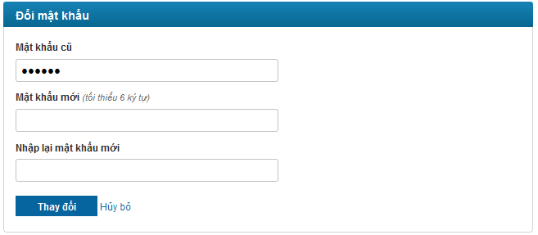**

**Data Fields Definition – Attach Place Page**

|  |  |  |  |  |  |  |
| --- | --- | --- | --- | --- | --- | --- |
| **Field name** | **Description** | **Read**  **Only** | **Mandatory** | **Control Type** | **Data Type** | **Length** |
| Old password label | A label with content “Mật khẩu cũ ” | - | - | Label | String | Fixed |
| Old password | Your old password | - | Y | Textbox | String | 100 |
| New password label | A label with content “Mật khẩu mới (tối thiểu 6 ký tự) ” | - | - | Label | String | Fixed |
| New password | password that will replace old password | - | Y | Textbox | String | 100 |
| Confirm password label | A label with content “Nhập lại mật khẩu mới” | - | - | Label | String | Fixed |
| Confirm password | Confirm password | - | Y | Button | String | 100 |

**Buttons / Hyperlinks**

|  |  |  |  |  |
| --- | --- | --- | --- | --- |
| **Function** | **Description** | **Available Criteria** | **Validations** | **Outcome** |
| Change password | This button is used to change user password | Always available | Old password, new password and confirm password can’t be blank | Display message “Thay đổi mật khẩu thành công” |
| Cancel changing password | This hyperlink will navigate user back to his/her profile | Always available | No validation | Redirect back to user profile |

#### View an User’s Profile

##### Use Case Diagram



##### Use Case Specification

|  |  |  |  |  |
| --- | --- | --- | --- | --- |
| **USE CASE – View an user’s profile SPECIFICATION** | | | | |
| **Use-case No.** | UC041 | **Use-case Version** | | 1.0 |
| **Use-case Name** | View an user’s profile | | | |
| **Author** | VuongNM | | | |
| **Date** | 10/01/2011 | **Priority** | High | |
| **Actor:**  User  **Summary:**  Website is as bridge connects people with people, so user can view other user’s profile to know more information about him or her. The user can see his own/ her own profile.  **Goal:**  Allow user view his/her of other user profile.  **Triggers**  User clicks on username hyperlink to navigate to their personal page.  **Preconditions:**  Access the website  **Post Conditions:**  Redirect the user to profile page  **Main Success Scenario:**   |  |  |  | | --- | --- | --- | | **Step** | **Actor Action** | **System Response** | | 1 | Click to other user’s name link | Navigated to correspond profile page |   **Alternative Scenario:**   |  |  |  | | --- | --- | --- | | **Step** | **Actor Action** | **System Response** | | 1 | Log in to website |  | | 1 | Click to your name on log in area at top right corner of website | Navigated to your profile page |   **Exceptions:**  None  **Relationships:**  Log in use case  **Business Rules:** | | | | |
| **Description:**  User Profile page will be opened as user click to a user link on anywhere on the website. This page contains all information about a user. There will be a litte different when open your own profile and open other user’s profile. At your profile, there are textbox, uploader and hyperlink for changing information. At other user’s profile there won’t be. you can’t know other user’s email address but you can know the user name, the day that user registered on the system, how many point that user have, how many places that user created, how many comments, questions and answers that user posted on the system. | | | | |

**Screen**

****

**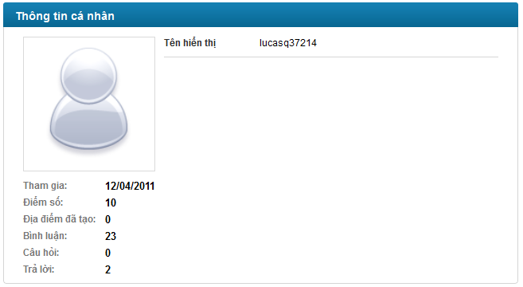**

**Data Fields Definition – Attach Place Page**

|  |  |  |  |  |  |  |
| --- | --- | --- | --- | --- | --- | --- |
| **Field name** | **Description** | **Read**  **Only** | **Mandatory** | **Control Type** | **Data Type** | **Length** |
| **Your profile** | | | | | | |
| Email label | A label with content “Email:” | Y | - | Label | String | Fixed |
| Email | Contain your email address | N | Y | Textbox | String | 254 |
| Nickname label | A label with content “Tên hiển thị (tối đa 50 ký tự) ” | Y | - | Label | String | Fixed |
| Nick name | Contain your nickname | N | Y | Text box | String | 50 |
| Avatar label | A label with content “Ảnh đại diện (chỉ hỗ trợ ảnh JPG và PNG)” | Y | - | Label | String | Fixed |
| Avatar uploader | Uploader used for upload your image to server | Y | - | Uploader | - | - |
| Avatar | Your current avatar | Y | - | Image | - | - |
| Created date label | “Tham gia từ:” label | Y | - | Label | String | Fixed |
| Created date | Contains created date of current viewing profile | Y | - | Label | String | Fixed |
| Point label | “Điểm số:” label | Y | - | Label | String | Fixed |
| Point | Contains your point | Y | - | Label | String | Fixed |
| Created place label | “Địa điểm đã tạo:” label | Y | - | Label | String | Fixed |
| Create place number | Contains number of places you created | Y | - | Label | String | Fixed |
| Comment posted label | “Bình luận:” label | Y | - | Label | String | Fixed |
| Comment posted number | Contains number of comments you posted | Y | - | Label | String | Fixed |
| Question posted label | “Câu hỏi:” label | Y | - | Label | String | Fixed |
| Question posted number | Contains number of questions you posted | Y | - | Label | String | Fixed |
| Answer posted label | “Trả lời:” label | Y | - | Label | String | Fixed |
| Answer posted number | Contains number of answers you posted | Y | - | Label | String | Fixed |
| **Other user profile** | | | | | | |
| Nickname label | A label with content “Tên hiển thị” | Y | - | Label | String | Fixed |
| Nick name | Contain other user’s nickname | N | Y | Text box | String | 50 |
| Avatar | Other user’s avatar | Y | - | Image | - | - |
| Created date label | “Tham gia từ:” label | Y | - | Label | String | Fixed |
| Created date | Contains created date of current viewing profile | Y | - | Label | String | Fixed |
| Point label | “Điểm số:” label | Y | - | Label | String | Fixed |
| Point | Contains other user’s point | Y | - | Label | String | Fixed |
| Created place label | “Địa điểm đã tạo:” label | Y | - | Label | String | Fixed |
| Create place number | Contains number of places other user created | Y | - | Label | String | Fixed |
| Comment posted label | “Bình luận:” label | Y | - | Label | String | Fixed |
| Comment posted number | Contains number of comments other user posted | Y | - | Label | String | Fixed |
| Question posted label | “Câu hỏi:” label | Y | - | Label | String | Fixed |
| Question posted number | Contains number of questions other user posted | Y | - | Label | String | Fixed |
| Answer posted label | “Trả lời:” label | Y | - | Label | String | Fixed |
| Answer posted number | Contains number of answers other user posted | Y | - | Label | String | Fixed |

**Buttons / Hyperlinks**

|  |  |  |  |  |
| --- | --- | --- | --- | --- |
| **Function** | **Description** | **Available Criteria** | **Validations** | **Outcome** |
| Edit your profile | This button is used for edit your profile | Only available when open your own profile |  | Display message “Thông tin cá nhân đã được cập nhật.” |
| “Đổi mật khẩu” hyperlink | This link will open change password page | Only available when open your own profile |  | Redirect to Change Password page |

#### <Admin> List all Users

##### Use Case Diagram



##### Use Case Specification

|  |  |  |  |  |
| --- | --- | --- | --- | --- |
| **USE CASE – List all users SPECIFICATION** | | | | |
| **Use-case No.** | UC042 | **Use-case Version** | | 1.0 |
| **Use-case Name** | List all users | | | |
| **Author** | VuongNM | | | |
| **Date** | 10/01/2011 | **Priority** | High | |
| **Actor:**  Administrator  **Summary:**  Administrator can view all member of website  **Goal:**  Allow administrator list all users in website  **Triggers**  Click to “Users” menu then click to “Manage Users” sub menu  **Preconditions:**  Logged into the system with admin role and go to Admin page  **Post Conditions:**  Open manage user page  **Main Success Scenario:**   |  |  |  | | --- | --- | --- | | **Step** | **Actor Action** | **System Response** | | 1 | Click to “Users” menu then click to “Manage Users” sub menu | Display Manage User page with all user in the system |   **Alternative Scenario:**  **Exceptions:**  **Relationships:**  **Business Rules:** | | | | |

**Screen**

**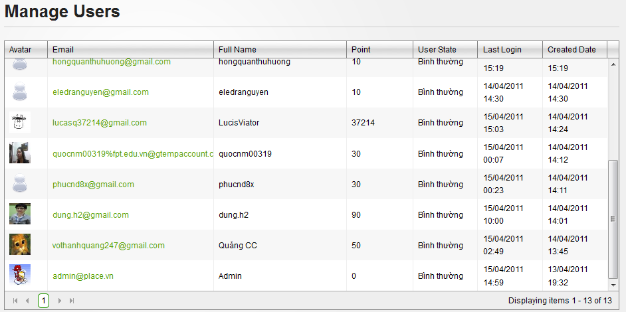**

**Data Fields Definition – Attach Place Page**

|  |  |  |  |  |  |  |
| --- | --- | --- | --- | --- | --- | --- |
| **Field name** | **Description** | **Read**  **Only** | **Mandatory** | **Control Type** | **Data Type** | **Length** |
| Avatar | Avatar of user | Y | Y | Image | Image | - |
| Full name | Full name or nickname of user | Y | Y | Label | String | Fixed |
| Posts | User’s point | Y | Y | Label | String | Fixed |
| User State | User’s state | Y | Y | Label | String | Fixed |
| Last login | User’s last login time | Y | Y | Label | String | Fixed |
| Created date | User’s created date | Y | Y | Label | String | Fixed |

**Buttons / Hyperlinks**

|  |  |  |  |  |
| --- | --- | --- | --- | --- |
| **Function** | **Description** | **Available Criteria** | **Validations** | **Outcome** |
| Email link | This link will redirect to User Detail page |  |  | Redirect to User Detail page |

#### <Admin> View User Detail

##### Use Case Diagram



##### Use Case Specification

|  |  |  |  |  |
| --- | --- | --- | --- | --- |
| **USE CASE – View user detail SPECIFICATION** | | | | |
| **Use-case No.** | UC043 | **Use-case Version** | | 1.0 |
| **Use-case Name** | View user detail | | | |
| **Author** | QuangLM | | | |
| **Date** | 10/01/2011 | **Priority** | High | |
| **Actor:**  Administrator  **Summary:**  Administrator view detail information of users by click to email link at Manage User page  **Goal:**  Administrator can view detail information of users  **Triggers**  Click to email link at Manage User page  **Preconditions:**  Logged into the system with admin role and open manager user page  **Post Conditions:**  Display User Detail page  **Main Success Scenario:**   |  |  |  | | --- | --- | --- | | **Step** | **Actor Action** | **System Response** | | 1 | Click to email link at Manage User page | Redirect to User Detail page |   **Alternative Scenario:**  **Exceptions:**  **Relationships:**  List all users use case  **Business Rules:** | | | | |

**Screen**

**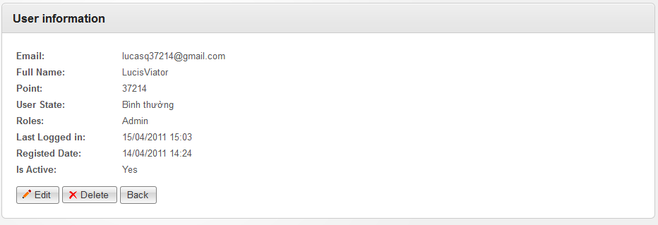**

**Data Fields Definition – Attach Place Page**

|  |  |  |  |  |  |  |
| --- | --- | --- | --- | --- | --- | --- |
| **Field name** | **Description** | **Read**  **Only** | **Mandatory** | **Control Type** | **Data Type** | **Length** |
| Email | Contains user email address | Y | Y | Label | String | Fixed |
| Full name | Contains user full name or nick name | Y | Y | Label | String | Fixed |
| Point | Contains user point | Y | Y | Label | String | Fixed |
| User state | Contains user state | Y | Y | Label | String | Fixed |
| Role | Contains user role | Y | Y | Label | String | Fixed |
| Last log in | Contains the last time user logged into the system | Y | Y | Label | String | Fixed |
| Registered date | Contains the time user registered on the system | Y | Y | Label | String | Fixed |
| Active status | Contains user activation status | Y | Y | Label | String | Fixed |

**Buttons / Hyperlinks**

|  |  |  |  |  |
| --- | --- | --- | --- | --- |
| **Function** | **Description** | **Available Criteria** | **Validations** | **Outcome** |
| Edit user information | This button is used to open edit user page | Always available | No validation | Redirect to Edit User page |
| Delete current viewing user | This button is used to delete current viewing user | Always available | No validation | Popup confirm |
| Back to manage user page | This button will navigate admin back to manage user page | Always available | No validation | Redirect back to Manage User page |

#### <Admin> Edit an User

##### Use Case Diagram



##### Use Case Specification

|  |  |  |  |  |
| --- | --- | --- | --- | --- |
| **USE CASE – Edit an user SPECIFICATION** | | | | |
| **Use-case No.** | UC044 | **Use-case Version** | | 1.0 |
| **Use-case Name** | Edit an user | | | |
| **Author** | VuongNM | | | |
| **Date** | 10/01/2011 | **Priority** | High | |
| **Actor:**  Administrator  **Summary:**  Administrator can edit existing member in system such as change email address, edit full name, point, change user state or assign role.  **Goal:**  Allow administrator update user profile.  **Triggers**  Click to “Edit” button  **Preconditions:**  Logged into the system with admin role and open User Detail page  **Post Conditions:**  Redirect back to manage user page  **Main Success Scenario:**   |  |  |  | | --- | --- | --- | | **Step** | **Actor Action** | **System Response** | | 1 | Click to “Edit” button | Redirect to Edit User page | | 2 | Change some information |  | | 3 | Click to “Save” button | Redirect to Manage User page and display message “User has been updated successfully” |   **Alternative Scenario:**  **Exceptions:**   |  |  |  | | --- | --- | --- | | **Step** | **Actor Action** | **System Response** | | 1 | Click to “Edit” button | Redirect to Edit User page | | 2 | Leave required fields blank |  | | 3 | Click to “Save” button | Displayed error message inform admin can’t leave required fields blank |   **Relationships:**  View user detail use case  **Business Rules:** | | | | |

**Screen**

**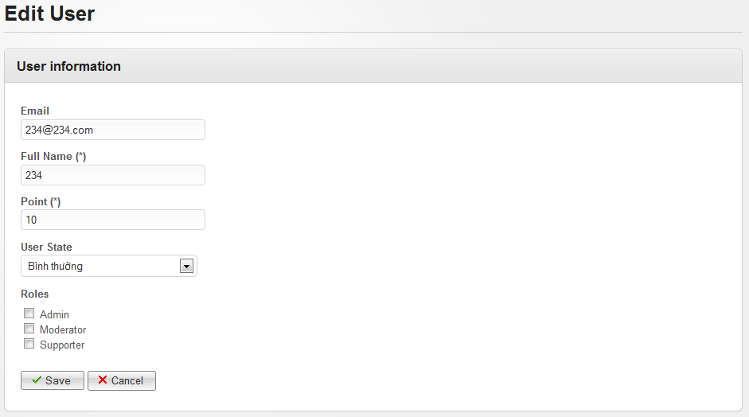**

**Data Fields Definition – Attach Place Page**

|  |  |  |  |  |  |  |
| --- | --- | --- | --- | --- | --- | --- |
| **Field name** | **Description** | **Read**  **Only** | **Mandatory** | **Control Type** | **Data Type** | **Length** |
| Email label | “Email” label | Y | Y | Label | String | Fixed |
| Email | Contains user email address | Y | Y | Label | String | Fixed |
| Full name label | “Full name (\*)” label | Y | Y | Label | String | Fixed |
| Full name | Contains user full name or nick name | Y | Y | Label | String | Fixed |
| Point label | “Point (\*)” label |  |  |  |  |  |
| Point | Contains user point | Y | Y | Label | String | Fixed |
| User state label | “User State” label | Y | Y | Label | String | Fixed |
| User state | A commbox contains all states | Y | Y | Combobox | String | Fixed |
| Role label | “Roles” label | Y | Y | Label | String | Fixed |
| Role | Contains all roles, each row displayed with a check box | Y | Y | Checkbox | String | Fixed |

**Buttons / Hyperlinks**

|  |  |  |  |  |
| --- | --- | --- | --- | --- |
| **Function** | **Description** | **Available Criteria** | **Validations** | **Outcome** |
| Save | This button will save all edited information | Always available | All required fields can’t be blank | Redirect to Manage User page and display message “User has been updated successfully” |
| cancel | This button will navigate admin back to Manage User page | Always available | No validation | Redirect to Manage User page |

#### <Admin> Delete Users

##### Use Case Diagram



##### Use Case Specification

|  |  |  |  |  |
| --- | --- | --- | --- | --- |
| **USE CASE – Delete users SPECIFICATION** | | | | |
| **Use-case No.** | UC045 | **Use-case Version** | | 1.0 |
| **Use-case Name** | Delete users | | | |
| **Author** | VuongNM | | | |
| **Date** | 10/01/2011 | **Priority** | High | |
| **Actor:**  Administrator  **Summary:**  Administrator can delete an user  **Goal:**  Allow administrator delete spam user or who have bad behavior in website  **Triggers**  Click to “Delete” button  **Preconditions:**  Logged into the system with admin role and open User Detail page  **Post Conditions:**  Redirect back to Manage User page  **Main Success Scenario:**   |  |  |  | | --- | --- | --- | | **Step** | **Actor Action** | **System Response** | | 1 | Click to “Delete” button | Pop up confirm message “Are you sure you want to delete this User?” | | 2 | Click to “Ok” button | Popup close, redirect back to Manage User page, display message “User has been deleted successfully” |   **Alternative Scenario:**   |  |  |  | | --- | --- | --- | | **Step** | **Actor Action** | **System Response** | | 1 | Click to “Delete” button | Pop up confirm message “Are you sure you want to delete this User?” | | 2 | Click to “Cancel” button | Popup closes |   **Exceptions:**  None  **Relationships:**  List of user use case  **Business Rules:** | | | | |

**Screen**

**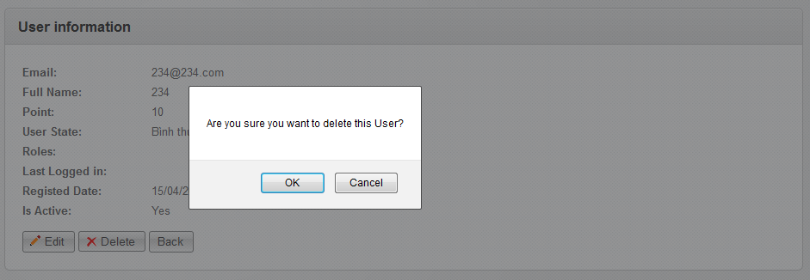**

#### <Admin> List All Categories

##### Use Case Diagram



##### Use Case Specification

|  |  |  |  |  |
| --- | --- | --- | --- | --- |
| **USE CASE – List all Categories SPECIFICATION** | | | | |
| **Use-case No.** | UC046 | **Use-case Version** | | 1.0 |
| **Use-case Name** | List all categories | | | |
| **Author** | DungTQ | | | |
| **Date** | 19/01/2011 | **Priority** | Normal | |
| **Actor:**  Admin  **Summary:**  Category is only be managed by admins. A list of all categories in the system will be listed.  **Goal:**  Admin can view existed category list.  **Triggers**  Click to “Categories” menu then click to “Manage Categories” sub menu  **Preconditions:**  Successfully logged into the system with Admin role and go to Admin page  **Post Conditions:**  Categories List page will be displayed with all existed categories  **Main Success Scenario:**   |  |  |  | | --- | --- | --- | | Step | Actor Action | System Response | | 1 | Click to “Categories” menu then click to “Manage Categories” sub menu | Categories List page will be displayed with all existed categories |   **Alternative Scenario:**  None  **Exceptions:**  None  **Relationships:**  Login use case  **Business Rules:**   |  |  |  | | --- | --- | --- | | **No** | **Rule Description** | **Error Message** | | 1 | Each page display 20 categories |  | | | | | |

**Screen**

**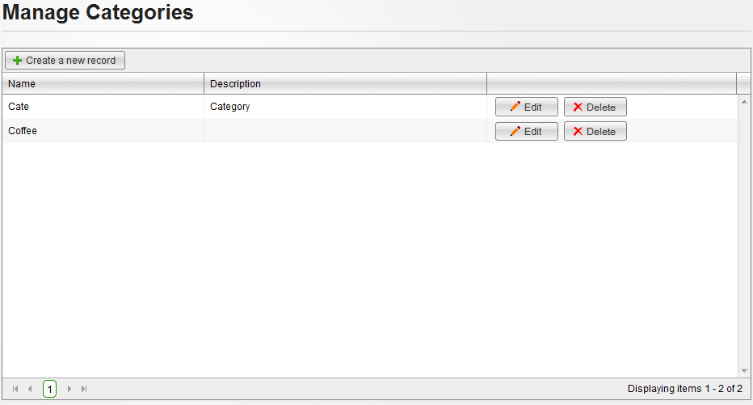**

**Data Fields Definition – Category List Screen**

|  |  |  |  |  |  |  |
| --- | --- | --- | --- | --- | --- | --- |
| **Field name** | **Description** | **Read**  **Only** | **Mandatory** | **Control Type** | **Data Type** | **Length** |
| Category name | Contains category name | Y | - | Label | String | Fixed |
| Category description | Contains category description | Y | - | label | string | 50 |

**Buttons / Hyper Links – Category List Screen**

|  |  |  |  |  |
| --- | --- | --- | --- | --- |
| **Function** | **Description** | **Available Criteria** | **Validations** | **Outcome** |
| Create new category | This button is used for adding a new category | Always available | No validation | Redirect to Create Category page |
| Edit category | This button is used to edit a category | Always available with each category | No validation | Redirect to Edit Category page |
| Delete category | This button is used to delete a category | Always available with each category | No validation | Popup confirm |

#### <Admin> Create a New Category

##### Use Case Diagram



##### Use Case Specification

|  |  |  |  |  |
| --- | --- | --- | --- | --- |
| **USE CASE – Create a new category SPECIFICATION** | | | | |
| **Use-case No.** | UC047 | **Use-case Version** | | 1.0 |
| **Use-case Name** | Create A New Category | | | |
| **Author** | DungTQ | | | |
| **Date** | 19/01/2011 | **Priority** | Normal | |
| **Actor:**  Admin  **Summary:**  Admin can create a new category in the system  **Goal:**  Create a new category in database.  **Triggers**  Click to “Categories” menu then click to “Create a new category” sub menu  **Preconditions:**  Successfully logged into the system with Admin role and go to admin page.  **Post Conditions:**  New category will be added to database and displayed in Manage Category page.  **Main Success Scenario:**   |  |  |  | | --- | --- | --- | | Step | Actor Action | System Response | | 1 | Click to “Categories” menu then click to “Create a new category” sub menu | Redirect to Create Category page | | 2 | Enter needed infomration |  | | 3 | Click to “Save” button | Redirect to Manage Category page with new category was added and display message “Category has been inserted successfully” |   **Alternative Scenario:**   |  |  |  | | --- | --- | --- | | Step | Actor Action | System Response | | 1 | Click to “Categories” menu then click to “Manage Categories” sub menu | Redirect to Manage Category page | | 2 | Click to “Create a new record” | Redirect to Create Category page | | 3 | Enter needed infomration |  | | 4 | Click to “Save” button | Redirect to Manage Category page with new category was added and display message “Category has been inserted successfully” | | Step | Actor Action | System Response | | 1 | Click to “Categories” menu then click to “Create a new category” sub menu | Redirect to Create Category page | | 2 | Enter needed infomration |  | | 3 | Click to “Cancel” button | Redirect to Manage Category page |   **Exceptions:**   |  |  |  | | --- | --- | --- | | Step | Actor Action | System Response | | 1 | Click to “Categories” menu then click to “Create a new category” sub menu | Redirect to Create Category page | | 2 | Leave Category name blank |  | | 3 | Click to “Save” button | Display message “Name is required.” |   **Relationships:**  Login use case  **Business Rules:**   |  |  |  | | --- | --- | --- | | **No** | **Rule Description** | **Error Message** | | 1 | Can’t create new category without enter its name |  | | | | | |

**Screen**

**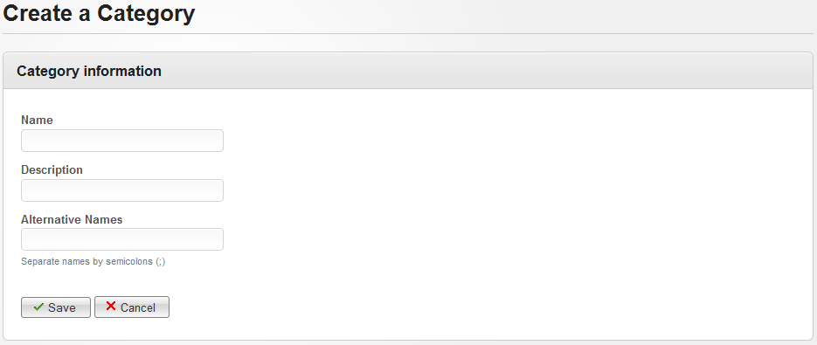**

**Data Fields Definition – Create A New Category Screen**

|  |  |  |  |  |  |  |
| --- | --- | --- | --- | --- | --- | --- |
| **Field name** | **Description** | **Read**  **Only** | **Mandatory** | **Control Type** | **Data Type** | **Length** |
| Name label | “Name” label | Y | Y | Label | String | Fixed |
| Category name | A text box for enter category name | N | Y | Textbox | String | 100 |
| Desciprtion label | “Description” label | Y | Y | Label | String | Fixed |
| Category description | A textbox for enter description for new category | N | N | Textbox | String | 1000 |
| Alter name label | “Alternative Names” label | Y | Y | Label | String | Fixed |
| Alternative name | A textbox for enter other name of new category | N | N | Textbox | String | 100 |

**Buttons / Hyper Links – Create A New Category Screen**

|  |  |  |  |  |
| --- | --- | --- | --- | --- |
| **Function** | **Description** | **Available Criteria** | **Validations** | **Outcome** |
| Add new category | Allow admin create new category | Always available. | Validate textbox whether it’s filled or not. | Redirect to Manage Category page with new category was added and display message “Category has been inserted successfully” |
| Cancel | Cancel current action | Always available. | No validation | Redirect back to Manage Category page |

#### <Admin> Edit a Category

##### Use Case Diagram



##### Use Case Specification

|  |  |  |  |  |
| --- | --- | --- | --- | --- |
| **USE CASE – Edit a category SPECIFICATION** | | | | |
| **Use-case No.** | UC048 | **Use-case Version** | | 1.0 |
| **Use-case Name** | Edit A Category | | | |
| **Author** | DungTQ | | | |
| **Date** | 19/01/2011 | **Priority** | Normal | |
| **Actor:**  Admin  **Summary:**  The admin can make a mistake when creating a new category. So he/she want to correct it. The admin can edit a category.  **Goal:**  Edit a category  **Triggers**  Click to “Edit” button  **Preconditions:**  Successfully logged into the system with Admin role and accessed to Manage Category page.  **Post Conditions:**  Redirect back to Manage Category page  **Main Success Scenario:**   |  |  |  | | --- | --- | --- | | Step | Actor Action | System Response | | 1 | Click to “Edit” button | Redirect to Edit Category page | | 2 | Edit information |  | | 3 | Click to “Save” button | Redirect back to Manage Category page and display message “Category has been updated successfully” |   **Alternative Scenario:**   |  |  |  | | --- | --- | --- | | Step | Actor Action | System Response | | 1 | Click to “Edit” button | Redirect to Edit Category page | | 2 | Edit information |  | | 3 | Click to “Cancel” button | Redirect back to Manage Category page |   **Exceptions:**     |  |  |  | | --- | --- | --- | | Step | Actor Action | System Response | | 1 | Click to “Edit” button | Redirect to Edit Category page | | 2 | Leave Name blank |  | | 3 | Click to “Save” button | Display message “Name is required.” |   **Relationships:**  Login use case, List all category use case  **Business Rules:**  None | | | | |

**Screen**

**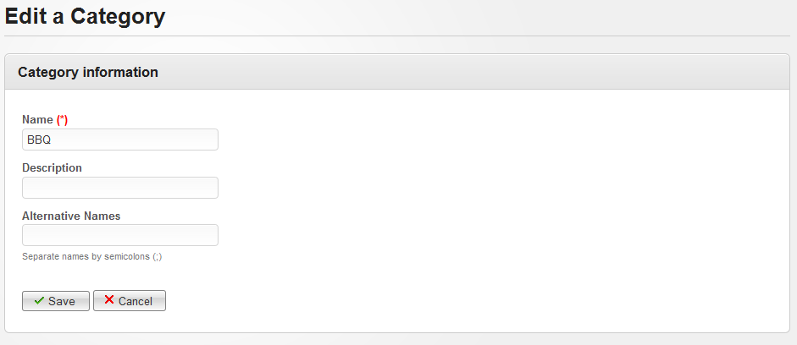**

**Data Fields Definition – Edit A Category Screen**

|  |  |  |  |  |  |  |
| --- | --- | --- | --- | --- | --- | --- |
| **Field name** | **Description** | **Read**  **Only** | **Mandatory** | **Control Type** | **Data Type** | **Length** |
| Name label | “Name” label | Y | Y | Label | String | Fixed |
| Category name | A text box for enter category name | N | Y | Textbox | String | 100 |
| Desciprtion label | “Description” label | Y | Y | Label | String | Fixed |
| Category description | A textbox for enter description for new category | N | N | Textbox | String | 1000 |
| Alter name label | “Alternative Names” label | Y | Y | Label | String | Fixed |
| Alternative name | A textbox for enter other name of new category | N | N | Textbox | String | 100 |

**Buttons / Hyper Links – Edit a Category Screen**

|  |  |  |  |  |
| --- | --- | --- | --- | --- |
| **Function** | **Description** | **Available Criteria** | **Validations** | **Outcome** |
| Save Button | Allow admin save updated category | Always available. | Validate textbox whether it’s filled or not. | Redirect to Manage Category page with category was updated and display message “Category has been updated successfully” |
| Cancel Button | Cancel current action | Always available. | No validation | Redirect back to Manage Category page |

#### <Admin> Delete Categories

##### Use Case Diagram



##### Use Case Specification

|  |  |  |  |  |
| --- | --- | --- | --- | --- |
| **USE CASE – Delete Categories SPECIFICATION** | | | | |
| **Use-case No.** | UC049 | **Use-case Version** | | 1.0 |
| **Use-case Name** | Delete Categories | | | |
| **Author** | DungTQ | | | |
| **Date** | 19/01/2011 | **Priority** | Normal | |
| **Actor:**  Admin  **Summary:**  When the admin see a category which places belong to it is a few or mostly closed, they can want to delete it.  **Goal:**  Delete categories in database.  **Triggers**  Click to “Delete” button  **Preconditions:**  Successfully logged into the system with Admin role and accessed to Manage Category page.  **Post Conditions:**  stay remains at Manage Category page and selected category will be deleted from category list,  **Main Success Scenario:**   |  |  |  | | --- | --- | --- | | Step | Actor Action | System Response | | 1 | Click to “Delete” button | Pop up a window to confirm if the admin really want to delete the category. | | 3 | Click to “OK” button | Close pop up, remove selected category from the list, display message “Category has been deleted successfully” |   **Alternative Scenario:**   |  |  |  | | --- | --- | --- | | Step | Actor Action | System Response | | 1 | Click to “Delete” button | Pop up a window to confirm if the admin really want to delete the category. | | 3 | Click to “Cancel” button | Close pop up |   **Exceptions:**  None  **Relationships:**  Login use case  **Business Rules:**  None. | | | | |

**Screen**

**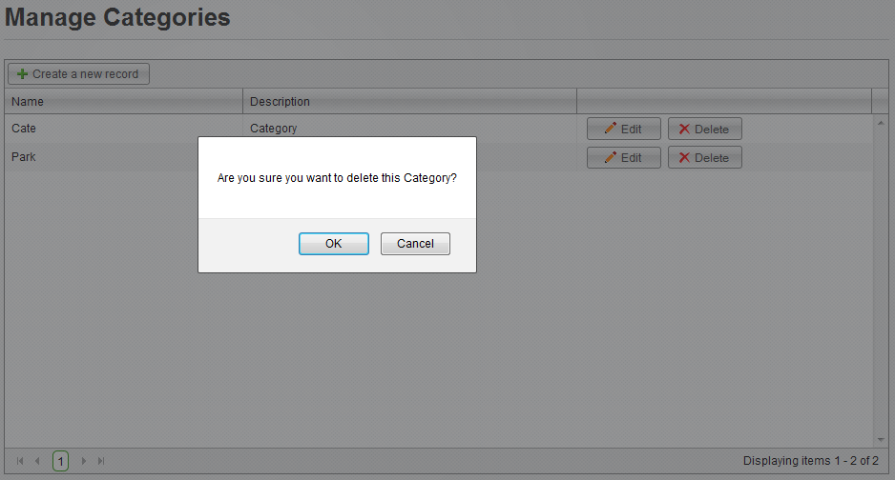**

**Buttons / Hyper Links – Delete Categories Screen**

|  |  |  |  |  |
| --- | --- | --- | --- | --- |
| **Function** | **Description** | **Available Criteria** | **Validations** | **Outcome** |
| Delelte category | This button will remove selected category from the list | Always available with each category | No validation | Pop up a window to confirm if the admin really want to delete the category. |
| Edit category | This button is used to go to Edit page of selected category | Always available with each category | No validation | Redirect to Edit Category page |

#### <Admin> List All Advertises

##### Use Case Diagram



##### Use Case Specification

|  |  |  |  |  |
| --- | --- | --- | --- | --- |
| **USE CASE- List all advertises SPECIFICATION** | | | | |
| **Use-case No.** | UC050 | **Use-case Version** | | 1.0 |
| **Use-case Name** | List all advertises | | | |
| **Author** | QuocNM | | | |
| **Date** | 15/01/2011 | **Priority** | Normal | |
| **Actor:**  Administrator  **Summary:**  This is a page where displays all ads of the website. All ads are displayed in this page will be displayed with the owner name, rank... In default, there are 20 items per page.  **Goal:**  This use case allows the actor view all ads of the website.  **Triggers**  Click to “Advertises” menu then click to “Manage Advertises” sub menu.  **Preconditions:**  Successfully logged into the system with Admin role and go to Admin page  **Post Conditions:**  Manage Advertises page will be displayed with all existed ads in database.  **Main Success Scenario:**   |  |  |  | | --- | --- | --- | | Step | Actor Action | System Response | | 1 | Click to “Advertises” menu then click to “Manage Advertises” sub menu. | Manage Advertises page will be displayed with all existed Ads in database. |   **Exceptions:**  None  **Relationships:**  Login use case  **Business Rules:**   |  |  |  | | --- | --- | --- | | No | Business Rule | Error Message | | 1 | There are 20 items per page. |  | | | | | |

**Data Fields Definition – Attach Place Page**

|  |  |  |  |  |  |  |
| --- | --- | --- | --- | --- | --- | --- |
| **Field name** | **Description** | **Read**  **Only** | **Mandatory** | **Control Type** | **Data Type** | **Length** |
| Advertise | This is image/gif/flash which will be used for advertise | N/A | N/A | Image | - | - |
| Company name | Name of company/group/person who will used this advertise to promote on the system | N/A | N/A | Label | Text | Fixed |
| Created date | Date time that the advertise was added to the system | N/A | N/A | Label | Text | Fixed |
| Effective time | Duration which the advertise will be displayed on the website | N/A | N/A | Label | Text | Fixed |
| Ads location | Location the advertise will be located | N/A | N/A | Label | Text | Fixed |

**Buttons / Hyper Links – Attach Place Page**

|  |  |  |  |  |
| --- | --- | --- | --- | --- |
| **Function** | **Description** | **Available Criteria** | **Validations** | **Outcome** |
| Edit advertise | This button is used to edit selected advertise | Always available wich each advertise | No validation | Redirect to Edit Advertise page |
| Delete advertise | The button will delete chosen advertise | Always available wich each advertise | No validation | Pop up confirm |
| Create new advertise | This button is used to add new advertise into the system | Always available | No validation | Redirect to Create Advertise page |

#### <Admin> Create New Advertise

##### Use Case Diagram



##### Use Case Specification

|  |  |  |  |  |
| --- | --- | --- | --- | --- |
| **USE CASE- Create new advertise SPECIFICATION** | | | | |
| **Use-case No.** | UC051 | **Use-case Version** | | 1.0 |
| **Use-case Name** | Create new advertise | | | |
| **Author** | QuocNM | | | |
| **Date** | 15/01/2011 | **Priority** | Normal | |
| **Actor:**  Administrator  **Summary:**  Administrator can add new advertise on the system.  **Goal:**  This use case allows admin create new advertise  **Triggers**  Click to “Create a new record” button.  **Preconditions:**  Successfully logged into the system with Admin role and go to Manage Advertises page  **Post Conditions:**  Redirect back to Manage Advertises page  **Main Success Scenario:**   |  |  |  | | --- | --- | --- | | Step | Actor Action | System Response | | 1 | Click to “Create a new record” button. | Redirect to Create Advertise page | | 2 | User enter data for all data fields |  | | 3 | Click to “Save” button | Redirect back to Manage Advertises page with new Advertise, display message inform success adding new advertise |   **Alternative Scenario:**   |  |  |  | | --- | --- | --- | | Step | Actor Action | System Response | | 1 | Click to “Advertises” menu then click to “Create new advertise” sub menu | Redirect to Create Advertise page | | 2 | User enter data for all data fields |  | | 3 | Click to “Save” button | Redirect back to Manage Advertises page with new Advertise, display message inform success adding new advertise |  |  |  |  | | --- | --- | --- | | Step | Actor Action | System Response | | 1 | Click to “Create a new record” button. | Redirect to Create Advertise page | | 2 | User enter data for all data fields |  | | 3 | Click to “Cancel” button | Redirect back to Manage Advertises page |   **Exceptions:**   |  |  |  | | --- | --- | --- | | Step | Actor Action | System Response | | 1 | Click to “Create a new record” button. | Redirect to Create Advertise page | | 2 | Leave required fields blank |  | | 3 | Click to “Save” button | Display error message, required admin fill in data for required fields |   **Relationships:**  Login use case, List all advertises use case  **Business Rules:**  None | | | | |

**Data Fields Definition**

|  |  |  |  |  |  |  |
| --- | --- | --- | --- | --- | --- | --- |
| **Field name** | **Description** | **Read**  **Only** | **Mandatory** | **Control Type** | **Data Type** | **Length** |
| Advertise label | “Advertise” label | N/A | N/A | Label | Text | Fixed |
| Advertise | This is an uploader which will upload image/gif/flash which will be used for advertise | N/A | Y | Uploader | - | - |
| Company label | “Company Name” label | N/A | N/A | Label | Text | Fixed |
| Company name | A text box for enter name of company which hire an ads slot on the website | N | Y | Text box | Text | Fixed |
| Effective time label | “Effective Time” label | N/A | N/A | Label | Text | Fixed |
| Effective from | A calendar for choosing the date which the advertise will be used | N | Y | Calendar | - | - |
| Effective to | A calendar for choosing the date which the advertise will be used until | N | Y | Calendar | - | - |
| Ads location label | “Advertise Location” label | N/A | N/A | Label | Text | Fixed |
| Ads location | A combobox for chosing location of the advertise | N/A | Y | Combobox | Text | Fixed |

**Buttons / Hyper Links – Attach Place Page**

|  |  |  |  |  |
| --- | --- | --- | --- | --- |
| **Function** | **Description** | **Available Criteria** | **Validations** | **Outcome** |
| Create new ads | The button will allow the admin to save the ads. | Always available | Data must be entered in all mandatory data fields | The record will be saved and user will be navigated back to Manage Advertises page and a success message will be displayed |
| Cancel | The button will allow the admin to go back to Manage Advertises page | Always available | No | User will be navigated to Manage Advertises page |

#### <Admin> Edit an Advertise

##### Use Case Diagram



##### Use Case Specification

|  |  |  |  |  |
| --- | --- | --- | --- | --- |
| **USE CASE- Edit an advertise SPECIFICATION** | | | | |
| **Use-case No.** | UC052 | **Use-case Version** | | 1.0 |
| **Use-case Name** | Edit an advertise | | | |
| **Author** | QuocNM | | | |
| **Date** | 15/01/2011 | **Priority** | Normal | |
| **Actor:**  Administrator  **Summary:**  When partners change their advertise, admin can edit their advertise on the system to the newest version.  **Goal:**  This use case allows admin edit an advertise.  **Triggers**  Click to “Edit” button  **Preconditions:**  Successfully logged into the system with Admin role and go to Manage Advertises page  **Post Conditions:**  Redirect back to Manage Advertises page  **Main Success Scenario:**   |  |  |  | | --- | --- | --- | | Step | Actor Action | System Response | | 1 | Click to “Edit” button | Redirect to Edit Advertise page | | 2 | Update information |  | | 3 | Click to “Save” button | Redirect back to ManageAdvertises page with success message |   **Alternative Scenario:**   |  |  |  | | --- | --- | --- | | Step | Actor Action | System Response | | 1 | Click to “Edit” button | Redirect to Edit Advertise page | | 2 | Update information |  | | 3 | Click to “Cancel” button | Redirect back to ManageAdvertises page |   **Exceptions:**   |  |  |  | | --- | --- | --- | | Step | Actor Action | System Response | | 1 | Click to “Edit” button | Redirect to Edit Advertise page | | 2 | Update information, leave required field blank |  | | 3 | Click to “Save” button | Display error message, require admin fill in data for required fields |   **Relationships:**  Login use case, List All Advertises use case  **Business Rules:**  None | | | | |

**Data Fields Definition**

|  |  |  |  |  |  |  |
| --- | --- | --- | --- | --- | --- | --- |
| **Field name** | **Description** | **Read**  **Only** | **Mandatory** | **Control Type** | **Data Type** | **Length** |
| Advertise label | “Advertise” label | N/A | N/A | Label | Text | Fixed |
| Advertise | This is an uploader which will upload image/gif/flash which will be used for advertise | N/A | Y | Uploader | - | - |
| Company label | “Company Name” label | N/A | N/A | Label | Text | Fixed |
| Company name | A text box for enter name of company which hire an ads slot on the website | N | Y | Text box | Text | Fixed |
| Effective time label | “Effective Time” label | N/A | N/A | Label | Text | Fixed |
| Effective from | A calendar for choosing the date which the advertise will be used | N | Y | Calendar | - | - |
| Effective to | A calendar for choosing the date which the advertise will be used until | N | Y | Calendar | - | - |
| Ads location label | “Advertise Location” label | N/A | N/A | Label | Text | Fixed |
| Ads location | A combobox for chosing location of the advertise | N/A | Y | Combobox | Text | Fixed |

**Buttons / Hyper Links – Attach Place Page**

|  |  |  |  |  |
| --- | --- | --- | --- | --- |
| **Function** | **Description** | **Available Criteria** | **Validations** | **Outcome** |
| edit new ads | The button will allow the admin to save the ads. | Always available | Data must be entered in all mandatory data fields | The record will be saved and user will be navigated back to Manage Advertises page and a success message will be displayed |
| Cancel | The button will allow the admin to go back to Manage Advertises page | Always available | No | Admin will be navigated to Manage Advertises page |

#### <Admin> Delete Advertise

##### Use Case Diagram



##### Use Case Specification

|  |  |  |  |  |
| --- | --- | --- | --- | --- |
| **USE CASE- Delete advertise SPECIFICATION** | | | | |
| **Use-case No.** | UC053 | **Use-case Version** | | 1.0 |
| **Use-case Name** | Delete advertise | | | |
| **Author** | QuocNM | | | |
| **Date** | 15/01/2011 | **Priority** | Normal | |
| **Actor:**  Administrator  **Summary:**  When hired time of an advertise is over, it will be deleted and leave the spot for other ads  **Goal:**  This use case allows admin remove an advertise from advertise list.  **Triggers**  Click to “Delete” button.  **Preconditions:**  Successfully logged into the system with Admin role and go to Manage Advertises page  **Post Conditions:**  Selected advertise will be removed from the list  **Main Success Scenario:**   |  |  |  | | --- | --- | --- | | Step | Actor Action | System Response | | 1 | Click to “Detele” button | Popup confirm | | 2 | Click to “Ok” button | Advertise will be removed, a success message will be displayed |   **Alternative Scenario:**   |  |  |  | | --- | --- | --- | | Step | Actor Action | System Response | | 1 | Click to “Detele” button | Popup confirm | | 2 | Click to “Cancel” button | Popup close |   **Exceptions:**  None  **Relationships:**  Login use case, list all advertises use case  **Business Rules:**  None | | | | |

**Data Fields Definition – Attach Place Page**

|  |  |  |  |  |  |  |
| --- | --- | --- | --- | --- | --- | --- |
| **Field name** | **Description** | **Read**  **Only** | **Mandatory** | **Control Type** | **Data Type** | **Length** |
| Advertise | This is image/gif/flash which will be used for advertise | N/A | N/A | Image | - | - |
| Company name | Name of company/group/person who will used this advertise to promote on the system | N/A | N/A | Label | Text | Fixed |
| Created date | Date time that the advertise was added to the system | N/A | N/A | Label | Text | Fixed |
| Effective time | Duration which the advertise will be displayed on the website | N/A | N/A | Label | Text | Fixed |
| Ads location | Location the advertise will be located | N/A | N/A | Label | Text | Fixed |

**Buttons / Hyper Links – Attach Place Page**

|  |  |  |  |  |
| --- | --- | --- | --- | --- |
| **Function** | **Description** | **Available Criteria** | **Validations** | **Outcome** |
| Edit advertise | This button is used to edit selected advertise | Always available wich each advertise | No validation | Redirect to Edit Advertise page |
| Delete advertise | The button will delete chosen advertise | Always available wich each advertise | No validation | Pop up confirm |
| Create new advertise | This button is used to add new advertise into the system | Always available | No validation | Redirect to Create Advertise page |

#### <Admin> Manage Reported Places

##### Use Case Diagram



##### Use Case Specification

|  |  |  |  |  |
| --- | --- | --- | --- | --- |
| **USE CASE – Manage reported places SPECIFICATION** | | | | |
| **Use-case No.** | UC054 | **Use-case Version** | | 1.0 |
| **Use-case Name** | Manage Reported Places | | | |
| **Author** | QuangLM | | | |
| **Date** | 19/01/2011 | **Priority** | Normal | |
| **Actor:**  Admin  **Summary:**  Because all information posted in our website are public, and spam is a big problem we must solve. Similar to other website, we use Report Spam function which allows users report to us about any information what they think it’s spam. And place is one thing which users can report. After that, admin teams will review these reports and approve or reject it.  **Goal:**  View reported place list and delete it cause of spam or confirm it as not spam.  **Triggers**  Click to “Spam” menu then click to “Reported Places” sub menu  **Preconditions:**  Successfully logged into the system with Admin role and accessed to Admin page  **Post Conditions:**  Stay remain at Manage Reported Places page  **Main Success Scenario:**   |  |  |  | | --- | --- | --- | | Step | Actor Action | System Response | | 1 | Click to “Spam” menu then click to “Reported Places” sub menu | Redirect to Manage Reported Places page | | 2 | Click to “Not Spam” button | Reported place will be removed from the list, and system display message “Reports attached to chosen Place has been deleted successfully” |   **Alternative Scenario:**   |  |  |  | | --- | --- | --- | | Step | Actor Action | System Response | | 1 | Click to “Spam” menu then click to “Reported Places” sub menu | Redirect to Manage Reported Places page | | 2 | Click to “Delete” button | Popup confirm | | 3 | Click to “OK” button | Close popup, Remove reported place and display success message |  |  |  |  | | --- | --- | --- | | Step | Actor Action | System Response | | 1 | Click to “Spam” menu then click to “Reported Places” sub menu | Redirect to Manage Reported Places page | | 2 | Click to “Delete” button | Popup confirm | | 3 | Click to “Cancel” button | Close popup |   **Exceptions:**  **Relationships:**  Login use case  **Business Rules:**   |  |  |  | | --- | --- | --- | | **No** | **Rule Description** | **Error Message** | | 1 | Each page display 20 reports |  | | | | | |

**Screen**

**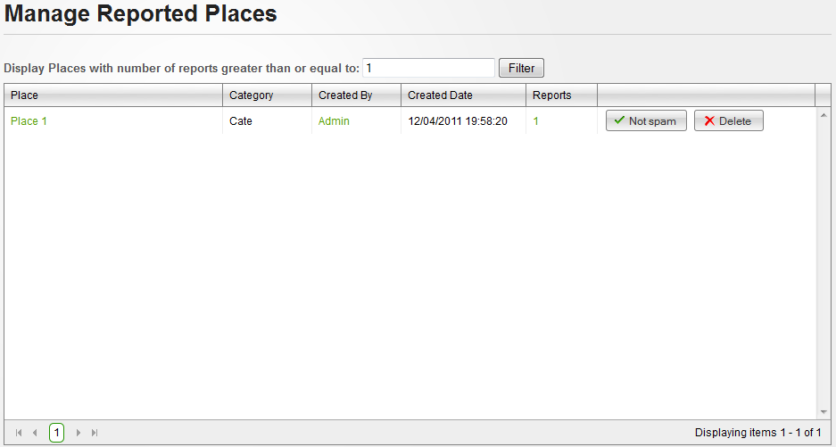**

**Data Fields Definition – Manage Places Marked Spam/fake Screen**

|  |  |  |  |  |  |  |
| --- | --- | --- | --- | --- | --- | --- |
| **Field name** | **Description** | **Read**  **Only** | **Mandatory** | **Control Type** | **Data Type** | **Length** |
| Category | Contains place’s category | Y | - | Label | String | Fixed |
| Created date | Contains place’s created date | Y | - | Label | String | Fixed |
| Filter label | A label with content: “Display Places with number of reports greater than or equal to:” | Y | - | Label | String | Fixed |
| Filter | A textbox for enter minimum report number | N | Y | Textbox | Numeric | - |

**Buttons / Hyper Links – Manage Places Marked Spam/fake Screen**

|  |  |  |  |  |
| --- | --- | --- | --- | --- |
| **Function** | **Description** | **Available Criteria** | **Validations** | **Outcome** |
| Place link | This link will open Place Detail place | Available with each reported place | No validation | Redirect to Place Detail page |
| User link | This linkwill open user profile | Available with each reported place | No validation | Redirect to User Profile page |
| Filter | This button will filter all reported places in the list | Always available | Filter value must be numeric and larger than or equal to 1 | Displayed all reported places with report number larger or equal with filter value |
| Remove from report list | This button will remove chosen place from report list cause it isn’t spam | Available with each reported place | No validation | Reported place will be removed from the list, and system display message “Reports attached to chosen Place has been deleted successfully” |
| Delete a place | This button will delete chosen place cause of spam | Available with each reported place | No validation | Popup confirm |

#### <Admin> Manage Reported Comments

##### Use Case Diagram



##### Use Case Specification

|  |  |  |  |  |
| --- | --- | --- | --- | --- |
| **USE CASE – Manage reported comments SPECIFICATION** | | | | |
| **Use-case No.** | UC055 | **Use-case Version** | | 1.0 |
| **Use-case Name** | Manage Reported comments | | | |
| **Author** | QuangLM | | | |
| **Date** | 19/01/2011 | **Priority** | Normal | |
| **Actor:**  Admin  **Summary:**  Because all information posted in our website are public, and spam is a big problem we must solve. Similar to other website, we use Report Spam function which allows users report to us about any information what they think it’s spam. And place is one thing which users can report. After that, admin teams will review these reports and approve or reject it.  **Goal:**  View reported comment list and delete it cause of spam or confirm it as not spam.  **Triggers**  Click to “Spam” menu then click to “Reported Comments” sub menu  **Preconditions:**  Successfully logged into the system with Admin role and accessed to Admin page  **Post Conditions:**  Stay remain at Manage Reported Comments page  **Main Success Scenario:**   |  |  |  | | --- | --- | --- | | Step | Actor Action | System Response | | 1 | Click to “Spam” menu then click to “Reported Comments” sub menu | Redirect to Manage Reported Comments page | | 2 | Click to “Not Spam” button | Reported comment will be removed from the list, and system display message “Reports attached to chosen Comment has been deleted successfully” |   **Alternative Scenario:**   |  |  |  | | --- | --- | --- | | Step | Actor Action | System Response | | 1 | Click to “Spam” menu then click to “Reported Comments” sub menu | Redirect to Manage Reported Comments page | | 2 | Click to “Delete” button | Popup confirm | | 3 | Click to “OK” button | Close popup, Remove reported comment and display success message |  |  |  |  | | --- | --- | --- | | Step | Actor Action | System Response | | 1 | Click to “Spam” menu then click to “Reported Comments” sub menu | Redirect to Manage Reported Comments page | | 2 | Click to “Delete” button | Popup confirm | | 3 | Click to “Cancel” button | Close popup |   **Exceptions:**  **Relationships:**  Login use case  **Business Rules:**   |  |  |  | | --- | --- | --- | | **No** | **Rule Description** | **Error Message** | | 1 | Each page display 20 reports |  | | | | | |

**Screen**

**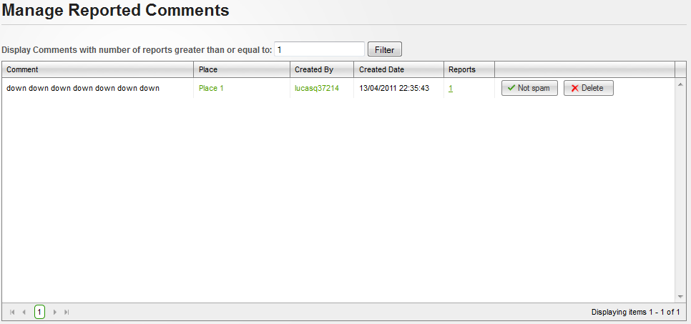**

**Data Fields Definition – Manage Places Marked Spam/fake Screen**

|  |  |  |  |  |  |  |
| --- | --- | --- | --- | --- | --- | --- |
| **Field name** | **Description** | **Read**  **Only** | **Mandatory** | **Control Type** | **Data Type** | **Length** |
| Content | Contains comment’s content | Y | - | Label | String | Fixed |
| Created date | Contains place’s created date | Y | - | Label | String | Fixed |
| Filter label | A label with content: “Display Comments with number of reports greater than or equal to:” | Y | - | Label | String | Fixed |
| Filter | A textbox for enter minimum report number | N | Y | Textbox | Numeric | - |

**Buttons / Hyper Links – Manage Places Marked Spam/fake Screen**

|  |  |  |  |  |
| --- | --- | --- | --- | --- |
| **Function** | **Description** | **Available Criteria** | **Validations** | **Outcome** |
| Place link | This link will open Place Detail place | Available with each reported comment | No validation | Redirect to Place Detail page |
| User link | This linkwill open user profile | Available with each reported comment | No validation | Redirect to User Profile page |
| Filter | This button will filter all reported comments in the list | Always available | Filter value must be numeric and larger than or equal to 1 | Displayed all reported comments with report number larger or equal with filter value |
| Remove from report list | This button will remove chosen comment from report list cause it isn’t spam | Available with each reported comment | No validation | Reported comment will be removed from the list, and system display message “Reports attached to chosen Comment has been deleted successfully” |
| Delete a comment | This button will delete chosen comment cause of spam | Available with each reported comment | No validation | Popup confirm |

#### <Admin> Manage Reported Questions

##### Use Case Diagram



##### Use Case Specification

|  |  |  |  |  |
| --- | --- | --- | --- | --- |
| **USE CASE – Manage reported questions SPECIFICATION** | | | | |
| **Use-case No.** | UC056 | **Use-case Version** | | 1.0 |
| **Use-case Name** | Manage Reported Questions | | | |
| **Author** | QuangLM | | | |
| **Date** | 19/01/2011 | **Priority** | Normal | |
| **Actor:**  Admin  **Summary:**  Because all information posted in our website are public, and spam is a big problem we must solve. Similar to other website, we use Report Spam function which allows users report to us about any information what they think it’s spam. And place is one thing which users can report. After that, admin teams will review these reports and approve or reject it.  **Goal:**  View reported question list and delete it cause of spam or confirm it as not spam.  **Triggers**  Click to “Spam” menu then click to “Reported Questions” sub menu  **Preconditions:**  Successfully logged into the system with Admin role and accessed to Admin page  **Post Conditions:**  Stay remain at Manage Reported Questions page  **Main Success Scenario:**   |  |  |  | | --- | --- | --- | | Step | Actor Action | System Response | | 1 | Click to “Spam” menu then click to “Reported Questions” sub menu | Redirect to Manage Reported Questions page | | 2 | Click to “Not Spam” button | Reported question will be removed from the list, and system display message “Reports attached to chosen Question has been deleted successfully” |   **Alternative Scenario:**   |  |  |  | | --- | --- | --- | | Step | Actor Action | System Response | | 1 | Click to “Spam” menu then click to “Reported Questions” sub menu | Redirect to Manage Reported Questions page | | 2 | Click to “Delete” button | Popup confirm | | 3 | Click to “OK” button | Close popup, Remove reported question and display success message |  |  |  |  | | --- | --- | --- | | Step | Actor Action | System Response | | 1 | Click to “Spam” menu then click to “Reported Questions” sub menu | Redirect to Manage Reported Question page | | 2 | Click to “Delete” button | Popup confirm | | 3 | Click to “Cancel” button | Close popup |   **Exceptions:**  **Relationships:**  Login use case  **Business Rules:**   |  |  |  | | --- | --- | --- | | **No** | **Rule Description** | **Error Message** | | 1 | Each page display 20 reports |  | | | | | |

**Screen**

**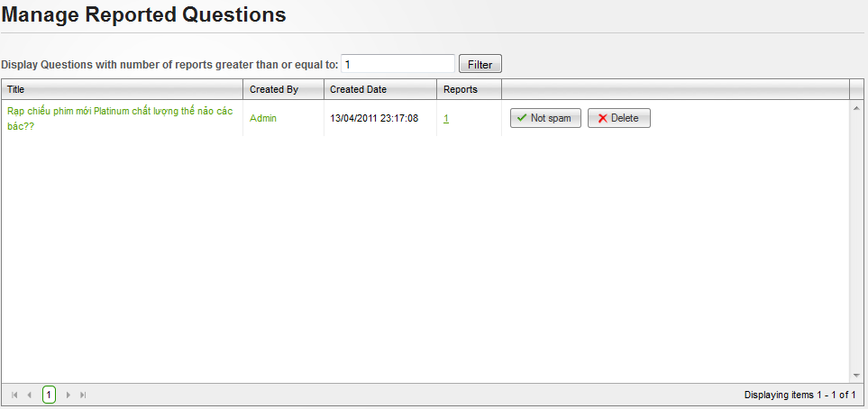**

**Data Fields Definition – Manage Places Marked Spam/fake Screen**

|  |  |  |  |  |  |  |
| --- | --- | --- | --- | --- | --- | --- |
| **Field name** | **Description** | **Read**  **Only** | **Mandatory** | **Control Type** | **Data Type** | **Length** |
| Created date | Contains place’s created date | Y | - | Label | String | Fixed |
| Filter label | A label with content: “Display Comments with number of reports greater than or equal to:” | Y | - | Label | String | Fixed |
| Filter | A textbox for enter minimum report number | N | Y | Textbox | Numeric | - |

**Buttons / Hyper Links – Manage Places Marked Spam/fake Screen**

|  |  |  |  |  |
| --- | --- | --- | --- | --- |
| **Function** | **Description** | **Available Criteria** | **Validations** | **Outcome** |
| Question link | This link will open Question Detail page | Available with each reported question | No validation | Redirect to Question Detail page |
| User link | This linkwill open user profile | Available with each reported question | No validation | Redirect to User Profile page |
| Filter | This button will filter all reported questions in the list | Always available | Filter value must be numeric and larger than or equal to 1 | Displayed all reported questions with report number larger or equal with filter value |
| Remove from report list | This button will remove chosen question from report list cause it isn’t spam | Available with each reported question | No validation | Reported question will be removed from the list, and system display message “Reports attached to chosen Question has been deleted successfully” |
| Delete a question | This button will delete chosen question cause of spam | Available with each reported question | No validation | Popup confirm |

#### <Admin> Manage Reported Answers

##### Use Case Diagram



##### Use Case Specification

|  |  |  |  |  |
| --- | --- | --- | --- | --- |
| **USE CASE – Manage reported answers SPECIFICATION** | | | | |
| **Use-case No.** | UC057 | **Use-case Version** | | 1.0 |
| **Use-case Name** | Manage Reported answers | | | |
| **Author** | QuangLM | | | |
| **Date** | 19/01/2011 | **Priority** | Normal | |
| **Actor:**  Admin  **Summary:**  Because all information posted in our website are public, and spam is a big problem we must solve. Similar to other website, we use Report Spam function which allows users report to us about any information what they think it’s spam. And place is one thing which users can report. After that, admin teams will review these reports and approve or reject it.  **Goal:**  View reported answer list and delete it cause of spam or confirm it as not spam.  **Triggers**  Click to “Spam” menu then click to “Reported Answers” sub menu  **Preconditions:**  Successfully logged into the system with Admin role and accessed to Admin page  **Post Conditions:**  Stay remain at Manage Reported Comments page  **Main Success Scenario:**   |  |  |  | | --- | --- | --- | | Step | Actor Action | System Response | | 1 | Click to “Spam” menu then click to “Reported Answers” sub menu | Redirect to Manage Reported Answers page | | 2 | Click to “Not Spam” button | Reported answer will be removed from the list, and system display message “Reports attached to chosen Answer has been deleted successfully” |   **Alternative Scenario:**   |  |  |  | | --- | --- | --- | | Step | Actor Action | System Response | | 1 | Click to “Spam” menu then click to “Reported Answers” sub menu | Redirect to Manage Reported Answers page | | 2 | Click to “Delete” button | Popup confirm | | 3 | Click to “OK” button | Close popup, Remove reported answer and display success message |  |  |  |  | | --- | --- | --- | | Step | Actor Action | System Response | | 1 | Click to “Spam” menu then click to “Reported Answers” sub menu | Redirect to Manage Reported Answers page | | 2 | Click to “Delete” button | Popup confirm | | 3 | Click to “Cancel” button | Close popup |   **Exceptions:**  **Relationships:**  Login use case  **Business Rules:**   |  |  |  | | --- | --- | --- | | **No** | **Rule Description** | **Error Message** | | 1 | Each page display 20 reports |  | | | | | |

**Screen**

**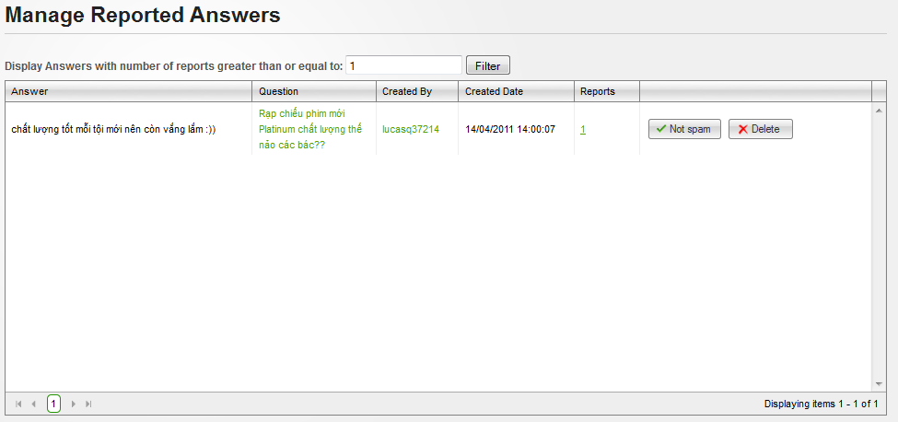**

**Data Fields Definition – Manage Places Marked Spam/fake Screen**

|  |  |  |  |  |  |  |
| --- | --- | --- | --- | --- | --- | --- |
| **Field name** | **Description** | **Read**  **Only** | **Mandatory** | **Control Type** | **Data Type** | **Length** |
| Content | Contains answer’s content | Y | - | Label | String | Fixed |
| Created date | Contains place’s created date | Y | - | Label | String | Fixed |
| Filter label | A label with content: “Display Comments with number of reports greater than or equal to:” | Y | - | Label | String | Fixed |
| Filter | A textbox for enter minimum report number | N | Y | Textbox | Numeric | - |

**Buttons / Hyper Links – Manage Places Marked Spam/fake Screen**

|  |  |  |  |  |
| --- | --- | --- | --- | --- |
| **Function** | **Description** | **Available Criteria** | **Validations** | **Outcome** |
| Question link | This link will open Question Detail place | Available with each reported answer | No validation | Redirect to Question Detail page |
| User link | This linkwill open user profile | Available with each reported answer | No validation | Redirect to User Profile page |
| Filter | This button will filter all reported answers in the list | Always available | Filter value must be numeric and larger than or equal to 1 | Displayed all reported answers with report number larger or equal with filter value |
| Remove from report list | This button will remove chosen answer from report list cause it isn’t spam | Available with each reported answer | No validation | Reported answer will be removed from the list, and system display message “Reports attached to chosen Answer has been deleted successfully” |
| Delete a place | This button will delete chosen answer cause of spam | Available with each reported answer | No validation | Popup confirm |

### Software System Attributes

#### Usability

**GUI**

* All the text, image text and help documents should be in Vietnamese.
* The interface should be elegant, simple and out-standing.
* All images must also provide alt attribute.

**Usability for end-users**

* Searching tool should be easy to use.
* The website must provide a help page to support novice users.
* Users can use main functionality of the system without logging in to the system.
* The system should remember information (but not confidential) that users have to provide regularly. For example: name, address…

**Usability for admin and staff**

* Website admin and shop’s staff should need no more than one day of training to be productive with the system.
* Detailed help must be available for the admin and staff, both in web pages and separate documentations.

**Installation**

* The system must be easy to deploy. Customer can deploy successfully and learn to configure, maintain the system within one day of training.
* The documentation for installation must be included. It describes detailed steps for installing or deploying the system. The customer can follow the steps without direct help from the developing team.

#### Reliability

* Initial data must be collected carefully and correctly
* The database must be backed up regularly and can be recovered if necessary
* Have a good spam filter
* Rating system must be reliable
* Not conflict with other software
* Rate of fault occurrence (ROFO): a number of 0.005 is acceptable. It means that it is acceptable to have 5 failures happen in each 1000 operational time units (e.g. 5 failures per 1000 hours of operation).
* Mean Time Between Failures (MTBF): 1 month
* Mean Time To Repair (MTTR): immediately when admin finds out problem or website is attacked by someone. Average 1 day.
* Accuracy: precision of floating number should be rounded to 0.01. All currency units must be displayed (e.g. $, VND…)
* Maximum Bugs or Defect Rate: 5 bugs / KLOC.
* Bugs or Defect Rate
  + Minor bugs: bugs related to GUI
  + Significant bugs: bugs related to minor business logic
  + Critical *bugs: function can’t execute correctly, completely loss of data, disconnect to the server*

#### Availability

* Systems have to run 24 hours 7 days
* Can be turned off when upgrading and must display an alternative maintenance page in such occasions
* Percentage of time available is about 95-97%. Because the system uses client/server protocol through Internet network, we cannot control cases of force majeure such as power failure, disconnected network…

#### Security

* Privacy: the system should provide protection method for protecting user information from outside or from other users. All the information of users must not be available for anyone or software that is not part of the system. User password is also invisible for the system administrator.
* The system must provide methods to prevent common security attacks. E.g. SQL injection, D-Dos…
* Transformation of confidential information must be encrypted.
* The system must provide secure methods for users to recovery their password, including the interference of system’s admin.
* Secure information of customers should not be stored on customer’s machine.
* Utilize certain cryptographic techniques for database
* Provide options for users to choose whether to share private information
* Restrict communications between some areas of the program
* Check data integrity for critical variables
* Must use secure connection (SSL) for transferring sensitive data

#### Maintainability

**Coding standards and naming conventions**

* Output of the project must include coding standards and naming conventions documentations. Implementation code must be easy to maintain.
* All code must be clearly commented, including class, method documentations.
* If some components are reused, the documentations of those components must also be included.

**Design**

* The design of the system must be loosely coupled that chances on some module will not affect others.

**Logging**

* All the errors should be logged, supporting for bug fixing and maintenance.
* All strange or sensitive situations should also be logged.

**Email**

* The system must provide an email address to receive customer feedback or send emails.

#### Portability

* Website can be used by any people with a browser and an Internet connection.

#### Performance

**Load time**

* Every page should be completely displayed within: average 1.5 second and maximum 5 seconds.
* Searching should return and display the result within 2 seconds.
* Comments and rating and the like should affect immediately, without reloading the web page.
* Frequently accessed data must be cached
* Reference *data must be cached*

**Mailing system**

* Mail server should send emails within 1 minute after associated events happen.

**Capacity**

* The system should serve correctly and reasonably with at least 1000 online users at a moment.
* The system can store at least 100000 places and 10000 users without affecting the loading speed.
* If the system is busy, it has to inform users about that.

**Compatibility**

* The system should provide elegant responses for nowadays common screen resolutions: 1024\*768, 1280\*800.
* The output must be compatible with all common browsers: Mozilla Firefox, Internet Explorer, Google Chrome, Apple Safari, and Opera.
* Information of the system can be accessed by searching bots

# Software Design Description

## Design Overview

This document describes the technical and UI design of the PSN system. It includes the architectural design and the detailed design of common functions and business functions. It also includes the design of database model, and overall design of user interface.

The architectural design describes the overall architecture of the system, and the architecture of each main component and subsystem. It will describe the patterns being used, the role of each component and the role of the system in the working environment.

The detailed design describes static and dynamic structure for each component and function. It includes class diagrams, class explanations, and sequence diagrams of the main use cases. The detailed design uses notations of .NET framework 4.0 and C# 4.0 as they are the framework and language for developing the system.

The database design describes the relationship between entities, and details of each entity. It uses notations of SQL Server 2008 as it is the database server for developing the system.

The user interface design describes the layout of the system, and some design for the screens.

## System Architectural Design

### Overall System Architecture



The system will use the Client-Server and SOA architectural patterns as the main architecture. It makes use of the Internet and common web protocols to deliver its services to the users.

The main entities of the above diagram will be described as following:

* **Database store:** this is the central data storage for the system. It may be running on a separate server to the Application Server, or in the same machine.
* **Application Server:** this is the server of the system running on IIS web server. It includes two main components: Web Application and Web Services. Web Application is responsible for creating web pages. It is developed using **ASP.NET MVC 3** framework. Web Services provides the system’s API to the world and some parts of the application. The services are consumed by some mobile applications. It is noted that this component will not be included in this project’s scope. However the system architecture must be extensible for adding such a component in the future.
* **Service Providers:** these are third party service providers that the application may need services from. For example the application may need Google Map services from Google, or some API from Facebook and OpenID…
* **Clients:** these include internet browsers running on personal computers, or mobile applications targeting mobile devices. The web browsers will interact with the web application via normal protocols (HTTP, HTTPS…). The mobile applications use SOA pattern to interact with the system via web services. However it is also noted that they are not included in this project’s scope.

### Web Application Architecture

The architecture for the PSN web application will be depicted as the following diagram:



#### Psn.Common Component

This component contains common logic that can be used throughout the application. It includes for example mechanism for logging, caching, cryptography, and other utilities.



#### Psn.Resources Component

This component contains static resources for the system. It includes localized strings and messages.

#### Psn.Business Component

This component contains all business logic for the system. It includes ORM classes, business classes, data access layer, business interface…

The aim and challenge for the design is that this component will be application type independent. That is this component is not tied only to web application but can be used for other .NET application types if necessary.

All the services of this component will be used by dependent components via its interfaces.



#### Psn.Web Component

This component is responsible for delivering the front end to the users and accepting their inputs. It will be developed using ASP.NET MVC 3 framework. An MVC Application is designed and implemented using the following three attributes:



* **Model:** The model contains the core information for an application. This includes the data and validation rules as well as data access and aggregation logic.
* **View:** The view encapsulates the presentation of the application, and in ASP.NET this is typically the HTML markup.
* **Controller:** The controller contains the control-flow logic. It interacts with the Model and Views to control the flow of information and execution of the application.

The **PSN** application will make use another attribute: **View Model**. The view model encapsulates all the data properties that the view needs or provides. It is the view model that the view depends directly on, not the model. The model will be implemented by **Psn.Business** components, except those not related to business logics.



The overall architecture of Psn.Web component will be depicted as the following diagram:



* **Helpers:** These are utilities classes specific for this component
* **Framework:** Contain the core framework to build web application

## Detailed Design

### Comment

This part is the detailed design for the following use cases:

* Post a comment
* Edit a comment
* Delete a comment
* Report a comment
* Vote a comment

#### Class Diagram



#### Class Explanations

##### **IPlaceCommentRepository interface**

###### **Attributes**

N/A

###### **Operations**

Feedback DeleteComment(PlaceComment pc)

Delete comment

**Parameters and Return**

|  |  |  |
| --- | --- | --- |
| Parameter | Type | Description |
| pc | PlaceComment | Comment to be deleted |
| return | Feedback | Feedback object containing result of deleting |

Feedback ReportComment(ReportedComment rc)

Report comment

**Parameters and Return**

|  |  |  |
| --- | --- | --- |
| Parameter | Type | Description |
| rc | ReportedComment | Comment to be reported |
| return | Feedback | Feedback object containing result of reporting |

Feedback<IList<PlaceComment>> GetHighlightPlaceComments(int placeId, int number)

Get highlight comments

**Parameters and Return**

|  |  |  |
| --- | --- | --- |
| Parameter | Type | Description |
| placeID | int | Place’s id |
| number | int | Number of comments |
| return | Feedback<IList<PlaceComment>> | Feedback<IList<PlaceComment>> object containing highlight comments |

Feedback<IList<PlaceComment>> GetPlaceComments(int placeId, PageInfo pageInfo)

Get comments

**Parameters and Return**

|  |  |  |
| --- | --- | --- |
| Parameter | Type | Description |
| placeID | int | Place’s id |
| pageInfo | PageInfo | PageInfo object containing page number and item per page |
| return | Feedback<IList<PlaceComment>> | Feedback<IList<PlaceComment>> object containing list of comments |

Feedback<PlaceComment> InsertComment(PlaceComment pc)

Insert a new comment

**Parameters and Return**

|  |  |  |
| --- | --- | --- |
| Parameter | Type | Description |
| pc | PlaceComment | Comment to be inserted |
| return | Feedback<PlaceComment> | Feedback<PlaceComment> object containing new comment |

Feedback<PlaceComment> VoteComment(VotedComment vc)

Update vote status of a comment

**Parameters and Return**

|  |  |  |
| --- | --- | --- |
| Parameter | Type | Description |
| vc | VotedComment | Voted comment |
| return | Feedback<PlaceComment> | Feedback<PlaceComment> object containing voted comment |

##### **PlaceComment Repository class**

Default implementation of IPlaceCommentRepository interface

##### **PlaceCommentsController class**

###### **Attributes**

|  |  |  |  |
| --- | --- | --- | --- |
| Attribute | Type | Visibility | Description |
| \_placeCommentRepo | IPlaceCommentRepository | Private | PlaceCommentRepository object to perform operations related to comments |

###### **Operations**

ActionResult Comment(PlaceComment pc)

Comment

ActionResult DeleteComment(int id)

Delete comment

ActionResult List(int placeId=0, int total=0)

View comments

ActionResult ListMore(int placeId=0, int total=0, int page=1)

View more comments

ActionResult ReportComment(ReportedComment rc)

Report comment

ActionResult VoteComment(int id, bool isUpVote)

Vote comment

##### **ListView class**

Contain HTML markup and .NET code to render View Comments screen

##### **ListMoreView class**

Contain HTML markup and .NET code to render View Comments More screen

##### **CommentView class**

Contain HTML markup and .NET code to render Comment screen

##### **ListPlaceCommentViewModel class**

Model type of ListView, ListMoreView and CommentView

#### Sequence Diagrams



##### **Create Comment**



##### **Delete Comment**



##### **Report Comment**



##### **View Comment List**



##### **Vote Comment**



##### **Highlight Best Comment**



### Search Place

This part is the detailed design for the following use cases:

* Search Place

#### Class Diagram



#### Class Explanations

##### **IPlaceRepository interface**

###### **Attributes**

N/A

###### **Operations**

SearchPlacesFeedback SearchPlaces(PlaceSearchCriteria criteria)

Search place in basic mode (based on place’s category and place’s address part)

**Parameters and Return**

|  |  |  |
| --- | --- | --- |
| Parameter | Type | Description |
| criteria | PlaceSearchCriteria | Place Search Criteria |
| return | SearchPlacesFeedback | SearchPlacesFeedback object containing list of all matched places |

##### **PlaceRepository class**

Default implementation of IPlaceRepository interface

##### **ICategoryRepository interface**

###### **Attributes**

N/A

###### **Operations**

Feedback<int> IncreaseSearchTimes(int id)

Increase search times

**Parameters and Return**

|  |  |  |
| --- | --- | --- |
| Parameter | Type | Description |
| id | int | Place’s id |
| return | Feedback<int> | Feedback object containing search times |

##### **CategoryRepository class**

Default implementation of ICategoryRepository interface

##### **PlacesController class**

###### **Attributes**

|  |  |  |  |
| --- | --- | --- | --- |
| Attribute | Type | Visibility | Description |
| \_categoryRepo | ICategoryRepository | Private | PlaceRepository object to perform operations related to categories |
| \_placeRepo | IPlaceRepository | Private | PlaceRepository object to perform operations related to places |

###### **Operations**

ActionResult GetMatchedAddressParts(string query)

Get matched address parts

ActionResult GetMatchedCategories(string query)

Get matched categories

ActionResult Index()

Index

ActionResult QuickSearchParser(PlaceSearchInput input)

Quick Search parser

ActionResult Result(PlaceSearchInput input)

Render result view for basic search function

ActionResult ResultMore(PlaceSearchInput input)

Render more result view for basic search function

##### **ResultView class**

Contain HTML markup and .NET code to render result view

##### **ResultMoreView class**

Contain HTML markup and .NET code to render more result view

##### **SearchResultViewModel class**

Model type of ResultView and ResultMoreView

#### Sequence Diagrams

##### **Result**



### Statistics

This part is the detailed design for the following use cases:

* Hot Questions In Month
* View Most Searched Category (Tag Cloud)
* Top Answer Contributors

#### Class Diagram



#### Class Explanations

##### **IQuestionRepository interface**

###### **Attributes**

N/A

###### **Operations**

Feedback<IList<Question>> GetHotQuestionsInMonth(int top)

Get list of hot questions in month

**Parameters and Return**

|  |  |  |
| --- | --- | --- |
| Parameter | Type | Description |
| top | int | Number of hot questions |
| return | Feedback<IList<Question>> | Feedback object containing list of hot questions |

Feedback<IList<User>> GetTopAnswerContributors(int top)

Get list of most contributors from database based on number of answers

**Parameters and Return**

|  |  |  |
| --- | --- | --- |
| Parameter | Type | Description |
| top | int | Number of contributors |
| return | Feedback<IList<User>> | Feedback object containing list of top contributors |

##### **QuestionRepository class**

Default implementation of IQuestionRepository inferface

##### **StatisticsController class**

###### **Attributes**

|  |  |  |  |
| --- | --- | --- | --- |
| Attribute | Type | Visibility | Description |
| \_questionRepo | IQuestionRepository | Private | QuestionRepository object to perform operations related to statistics |

###### **Operations**

ActionResult HotQuestionsInMonth()

Render hot questions in month

ActionResult TagCloud()

Render most searched categories tag cloud

ActionResult TagCloudFull()

Render all searched categories

ActionResult TopAnswerContributors()

Render top answer contributors list

##### **HotQuestionsInMonthView class**

Contain HTML markup and .NET code to render hot questions in month list

##### **TopAnswerContributorsView class**

Contain HTML markup and .NET code to render top answer contributors list

##### **TagCloudView class**

Contain HTML markup and .NET code to render most searched category (Tag Cloud)

##### **TagCloudFullView class**

Contain HTML markup and .NET code to render all categories list

#### Sequence Diagrams

##### **Hot Questions In Month**



##### **Newest Places**



##### **Tag Cloud.**



##### **Tag Cloud Full**



##### **Top Answer Contributors**



### Question

This part is the detailed design for the following use cases:

* Get Question List
* Get question’s details
* Insert question
* Update question
* Report question

#### Class Diagram



#### Class Explanations

##### **IQuestionRepository interface**

###### **Attributes**

N/A

###### **Operations**

Feedback ReportQuestion(ReportedQuestion rq)

Report question

**Parameters and Return**

|  |  |  |
| --- | --- | --- |
| Parameter | Type | Description |
| rq | ReportedQuestion | Report Question |
| return | Feedback | General feedback object |

Feedback<Question> GetQuestionDetails(int id)

Get question’s details data

**Parameters and Return**

|  |  |  |
| --- | --- | --- |
| Parameter | Type | Description |
| id | int | Question’s id |
| return | Feedback<Question> | Feedback object containing question’s details data |

Feedback<Question> GetQuestionForEditing(int id)

Get question’s details for editing

**Parameters and Return**

|  |  |  |
| --- | --- | --- |
| Parameter | Type | Description |
| id | int | Question’s id |
| return | Feedback<Question> | Feedback object containing question’s details for editing |

Feedback<Question> InsertQuestion(Question q)

Insert a new question

**Parameters and Return**

|  |  |  |
| --- | --- | --- |
| Parameter | Type | Description |
| q | Question | Question typed by user |
| return | Feedback<Question> | Feedback object containing new question data |

Feedback<Question> UpdateQuestion(Question q)

Update question

**Parameters and Return**

|  |  |  |
| --- | --- | --- |
| Parameter | Type | Description |
| q | Question | Question typed by user |
| return | Feedback<Question> | Feedback object containing question data |

Feedback<Question> VoteQuestion(VoteQuestion q)

Vote question

**Parameters and Return**

|  |  |  |
| --- | --- | --- |
| Parameter | Type | Description |
| q | VoteQuestion | Vote Question |
| Return | Feedback<Question> | Feedback object containing question data |

ListQuestionFeedback GetAllQuestions(PageInfo pageInfo)

Get all questions.

**Parameters and Return**

|  |  |  |
| --- | --- | --- |
| Parameter | Type | Description |
| pageInfo | PageInfo | PageInfo object containing page number and item per page |
| return | ListQuestionFeedback | ListQuestionFeedback object |

##### **QuestionRepository class**

Default implementation of IQuestionRepository interface

##### **QuestionController class**

###### **Attributes**

|  |  |  |  |
| --- | --- | --- | --- |
| Attribute | Type | Visibility | Description |
| \_questionRepo | IQuestionRepository | Private | QuestionRepository object to perform question operations |

###### **Operations**

ActionResult IndexMore(int page=1)

Render Index screen with more question

ActionResult Create(InsertQuestionViewModel vm)

Create a new question

ActionResult Details(int id)

Render View Question Detail screen.

ActionResult Edit(InsertQuestionViewModel vm)

Edit question

ActionResult Index(int page=1)

Render Index screen

ActionResult ReportQuestion(ReportedQuestion rq)

Report question

ActionResult VoteQuestion(int id, bool isUpVote)

Vote question

ViewResult Create()

Render Create a new Question screen

ViewResult Edit(int id)

Render Edit Question screen

##### **IndexView class**

Contain HTML markup and .NET code to render Index screen

##### **IndexMoreView class**

Contain HTML markup and .NET code to render Index More screen

##### **ListQuestionViewModel class**

Model type of InsertView and InsertMoreView

##### **CreateView class**

Contain HTML markup and .NET code to render Create a new Question screen

##### **EditView class**

Contain HTML markup and .NET code to render Edit Question screen

##### **ReportQuestionView class**

Contain HTML markup and .NET code to render Report Question screen

##### **InsertQuestionViewModel class**

Model type of CreateView, EditView and ReportQuestionView

##### **DetailsView class**

Contain HTML markup and .NET code to render View Question Details screen

##### **ViewQuestionDetailsViewModel class**

Model type of DetailsView

#### Sequence Diagrams

##### **Create**



##### **Edit**



##### **Get All Questions**



##### **Get Question Details**



##### **Report Question**



##### **Vote Question**



### Answer

This part is the detailed design for the following use cases:

* Get Answer list
* Reply Question

#### Class Diagram



#### Class Explanations

##### **IAnswerRepository interface**

###### **Attributes**

N/A

###### **Operations**

Feedback DeleteAnswer(Answer a)

Delete answer

**Parameters and Return**

|  |  |  |
| --- | --- | --- |
| Parameter | Type | Description |
| a | Answer | Answer to be deleted |
| return | Feedback | General feedback object |

Feedback ReportAnswer(ReportedAnswer ra)

Report answer as spam

**Parameters and Return**

|  |  |  |
| --- | --- | --- |
| Parameter | Type | Description |
| ra | ReportedAnswer | Answer to be reported |
| return | Feedback | General feedback object |

Feedback<Answer> InsertAnswer(Answer a)

Create a new answer

**Parameters and Return**

|  |  |  |
| --- | --- | --- |
| Parameter | Type | Description |
| a | Answer | Answer to be created |
| return | Feedback<Answer> | Feedback object containing an answer |

Feedback<Answer> VoteAnswer(VotedAnswer va)

Vote answer

**Parameters and Return**

|  |  |  |
| --- | --- | --- |
| Parameter | Type | Description |
| ra | VotedAnswer | Answer to be voted |
| return | Feedback<Answer> | Feedback object containing an answer |

Feedback<IList<Answer>> GetHighlightAnswers(int id, int number)

Get highlight answers

**Parameters and Return**

|  |  |  |
| --- | --- | --- |
| Parameter | Type | Description |
| id | int | Answer’s ID |
| number | int |  |
| return | Feedback<IList<Answer>> | Feedback object containing all highlight answers |

ListAnswerFeedback GetAllAnswers(int id, PageInfo pageInfo)

Get all answers

**Parameters and Return**

|  |  |  |
| --- | --- | --- |
| Parameter | Type | Description |
| id | int | Reply’s ID |
| pageInfo | PageInfo | PageInfo object containing page number and item per page |
| return | ListAnswerFeedback | ListAnswerFeedback object |

##### **IAnswerRepository class**

Default implementation of IAnswerRepository interface

##### **AnswersController class**

###### **Attributes**

|  |  |  |  |
| --- | --- | --- | --- |
| Attribute | Type | Visibility | Description |
| \_answerRepo | IAnswerRepository | Private | AnswerRepository object to perform answer operations |

###### **Operations**

ActionResult Create(Answer vm)

Create a new answer

##### **QuestionsController class**

###### **Attributes**

|  |  |  |  |
| --- | --- | --- | --- |
| Attribute | Type | Visibility | Description |
| \_questionRepo | IQuestionRepository | Private | QuestionRepository object to perform question operations |

###### **Operations**

ActionResult DeleteAnswer(int id)

Delete answer

ActionResult DetailsMore(int id, int page=1)

View answer’s details

ActionResult Reply(Answer answer)

Reply an answer

ActionResult ReportAnswer(ReportedAnswer ra)

Report an answer

ActionResult VoteAnswer(int id, bool isUpVote)

Vote an answer

##### **GetAnswerListView class**

Contain HTML markup and .NET code to render Answer list screen

##### **ReplyView class**

Contain HTML markup and .NET code to render Reply Answer screen

##### **ListAnswerViewModel class**

Model type of GetAnswerListView and ReplyView

#### Sequence Diagrams

##### **Get Answer List**



##### **Reply**



##### **Report**



##### **Vote**



### Favorite

This part is the detailed design for the following use cases:

* Get Favorite List
* Insert Place To Favorite List
* Delete Place From Favorite List

#### Class Diagram



#### Class Explanations

##### **IUserRepository interface**

###### **Attributes**

N/A

###### **Operations**

Feedback DeleteUserFavoritePlaces(List<int> idList, int userId)

Delete favorite places from Favorite list

**Parameters and Return**

|  |  |  |
| --- | --- | --- |
| Parameter | Type | Description |
| idList | List<int> | List ID’s favorite places |
| userId | int | User’s ID |
| return | Feedback | General feedback object |

Feedback<IList<Place>> GetUserFavoritePlaces(int userid)

Get all places of favorite list

**Parameters and Return**

|  |  |  |
| --- | --- | --- |
| Parameter | Type | Description |
| userId | int | User’s ID |
| return | Feedback<IList<Place>> | General feedback object |

##### **UserRepository class**

Default implementation of IUserRepository interface

##### **IPlaceRepository interface**

###### **Attributes**

N/A

###### **Operations**

Feedback<int> AddToFavorite(FavoritePlace favoritePlace)

Insert place to favorite list

**Parameters and Return**

|  |  |  |
| --- | --- | --- |
| Parameter | Type | Description |
| favoritePlace | FavoritePlace | Favorite Place |
| return | Feedback <int> | Feedback object containing list of int |

##### **PlaceRepository class**

Default implementation of IPlaceRepository interface

##### **AccountController class**

###### **Attributes**

|  |  |  |  |
| --- | --- | --- | --- |
| Attribute | Type | Visibility | Description |
| \_userRepo | IUserRepository | Private | UserRepository object to perform favorite place operations |

###### **Operations**

ActionResult DeleteUserFavoritePlace(List<int> selectedIds)

Delete places from favorite list

GetUserFavoritePlaces(int userId)

Get user’s favorite list

##### **PlacesController class**

###### **Attributes**

|  |  |  |  |
| --- | --- | --- | --- |
| Attribute | Type | Visibility | Description |
| \_placeRepo | IPlaceRepository | Private | PlaceRepository object to perform favorite place operations |

###### **Operations**

ActionResult AddToFavorite(FavoritePlace favoritePlace)

Insert place to favorite list

##### **\_UserFavoritePlacesView class**

Contain HTML markup and .NET code to render Favorite List screen

##### **UserFavoritePlacesViewModel class**

Model type of \_UserFavoritePlacesView

##### **DetailsView class**

Contain HTML markup and .NET code to render View Favorite Details screen

##### **PlaceDetailsViewModel class**

Model type of DetailsView

#### Sequence Diagrams

##### **Add To Favorite**



##### **Delete User Favorite Place**



##### **Get User Favorite Places**



### Manage Categories

This part is the detailed design for the following use cases:

* View Categories list
* View Category ‘s details
* Create a new category
* Edit category
* Delete category

#### Class Diagram



#### Class Explanations

##### **ICategoryRepository interface**

###### **Attributes**

N/A

###### **Operations**

Feedback DeleteCategory(int id)

Delete category

**Parameters and Return**

|  |  |  |
| --- | --- | --- |
| Parameter | Type | Description |
| id | int | Id of category to be deleted |
| return | Feedback | General feedback object |

Feedback<Category> GetCategoryDetails(int id)

Get a category’s details

**Parameters and Return**

|  |  |  |
| --- | --- | --- |
| Parameter | Type | Description |
| id | int | Id of category to be deleted |
| return | Feedback<Category> | Feedback object containing details of category |

Feedback<Category> InsertCategory (Category c)

Insert a new category

**Parameters and Return**

|  |  |  |
| --- | --- | --- |
| Parameter | Type | Description |
| c | Category | Category to be created |
| return | Feedback<Category> | Feedback object containing a category |

Feedback<Category> UpdateCategory(Category c)

Update/edit a category

**Parameters and Return**

|  |  |  |
| --- | --- | --- |
| Parameter | Type | Description |
| c | Category | Category to be updated |
| return | Feedback<Category> | Feedback object containing a category |

Feedback<IList<Category>> GetAllCategories()

Get all categories

**Parameters and Return**

|  |  |  |
| --- | --- | --- |
| Parameter | Type | Description |
| return | Feedback<IList<Category>> | Feedback object containing all categories |

##### **CategoryRepository class**

Default implementation of ICategoryRepository interface

##### **ManageCategoriesController class**

###### **Attributes**

|  |  |  |  |
| --- | --- | --- | --- |
| Attribute | Type | Visibility | Description |
| \_categoryRepo | ICategoryRepository | Private | CategoryRepository object to perform category operations |

###### **Operations**

ActionResult Create(InsertCategoryViewModel vm)

Insert category

ActionResult Delete(int id)

Delete category

ActionResult Edit(int id=0)

Render Edit Category screen

ActionResult Edit(InsertCategoryViewModel vm)

Edit category

ViewResult Create()

Render Create a new Category screen

ViewResult Index()

Render Manage Categories screen

##### **IndexView class**

Contain HTML markup and .NET code to render Manage Categories screen

##### **ListCategoryViewModel class**

Model type of IndexView

##### **CreateView class**

Contain HTML markup and .NET code to render Insert a new Category screen

##### **EditView class**

Contain HTML markup and .NET code to render Edit Category screen

##### **InsertCategoryViewModel class**

Model type of CreateView and EditView

#### Sequence Diagrams

##### **Delete Category**



##### **Get All Categories**



##### **Insert Category**



##### **Update Category**



### Manage Spam Places

This part is the detailed design for the following use cases:

* Delete False Place Reports
* Delete Reported Place
* Manage Reported Place

#### Class Diagram



#### Class Explanations

##### **IPlaceRepository interface**

###### **Attributes**

N/A

###### **Operations**

Feedback DeleteFalseReports(int id)

Delete false reports

**Parameters and Return**

|  |  |  |
| --- | --- | --- |
| Parameter | Type | Description |
| id | int | Id of false report to be deleted |
| return | Feedback | General feedback object |

Feedback DeleteReportedPlace(int id)

Delete reported place

**Parameters and Return**

|  |  |  |
| --- | --- | --- |
| Parameter | Type | Description |
| id | int | Id of reported comment to be deleted |
| return | Feedback | General feedback object |

Feedback<IList<Place>> GetAllReportedPlaces(int minReportNumber)

Get the min report number of reported places

**Parameters and Return**

|  |  |  |
| --- | --- | --- |
| Parameter | Type | Description |
| minReportNumber | int | Number of shown report |
| return | Feedback<List<Place>> | Feedback object containing list of places |

Feedback<IList<ReportedPlace>> GetReportedPlaceDetails(int id)

Get the reported details of place

**Parameters and Return**

|  |  |  |
| --- | --- | --- |
| Parameter | Type | Description |
| id | int | Id of place which its reported to be viewed |
| return | Feedback<IList<ReportedPlace>> | Feedback object containing list of reported place |

##### **PlaceRepository class**

Default implementation of IPlaceRepository interface

##### **ManageSpamController class**

###### **Attributes**

|  |  |  |  |
| --- | --- | --- | --- |
| Attribute | Type | Visibility | Description |
| \_placeRepo | IPlaceRepository | Private | PlaceRepository object to perform place spam operations |

###### **Operations**

ActionResult DeleteFalsePlaceReports(int id)

Delete false reports

ActionResult DeleteReportedPlace(int id)

Delete reported place

ViewResult ManageReportedPlace(int? minReportNumber)

Render Manage Spam Place screen

##### **ManageReportedPlaceView class**

Contain HTML markup and .NET code to render Manage Spam Places screen

##### **ListReportedPlaceViewModel class**

Model type of ManageReportedPlaceView

#### Sequence Diagrams

##### **Delete False Place Reports**



##### **Delete Reported Place**



##### **Manage Reported Place**



### Manage Spam Comments

This part is the detailed design for the following use cases:

* Delete False Comment Reports
* Delete Reported Comment
* Manage Reported Comment

#### Class Diagram



#### Class Explanations

##### **IPlaceCommentRepository interface**

###### **Attributes**

N/A

###### **Operations**

Feedback DeleteFalseReports(int id)

Delete false reports

**Parameters and Return**

|  |  |  |
| --- | --- | --- |
| Parameter | Type | Description |
| id | int | Id of false report to be deleted |
| return | Feedback | General feedback object |

Feedback DeleteReportedComment(int id)

Delete reported comment

**Parameters and Return**

|  |  |  |
| --- | --- | --- |
| Parameter | Type | Description |
| id | int | Id of reported comment to be deleted |
| return | Feedback | General feedback object |

Feedback<IList<PlaceComment>> GetAllReportedComments(int minReportNumber)

Get the min report number of reported comments

**Parameters and Return**

|  |  |  |
| --- | --- | --- |
| Parameter | Type | Description |
| minReportNumber | int | Number of shown report |
| return | Feedback<IList<PlaceComment>> | Feedback object containing list of comment |

Feedback<IList<ReportedComment>> GetReportedCommentDetails(int id)

Get the reported details of comment

**Parameters and Return**

|  |  |  |
| --- | --- | --- |
| Parameter | Type | Description |
| id | int | Id of comment which its reported to be viewed |
| return | Feedback<IList<ReportedComment>> | Feedback object containing list of reported comment |

##### **PlaceCommentRepository class**

Default implementation of IPlaceCommentRepository interface

##### **ManageSpamController class**

###### **Attributes**

|  |  |  |  |
| --- | --- | --- | --- |
| Attribute | Type | Visibility | Description |
| \_placeCommentRepo | IPlaceCommentRepository | Private | PlaceCommentRepository object to perform place comment spam operations |

###### **Operations**

ActionResult DeleteFalseCommentReports(int id)

Delete false comment report

ActionResult DeleteReportedComment(int id)

Delete reported comment

ViewResult ManageReportedComment(int? minReportNumber)

Render Manage Spam Comments screen

##### **ManageReportedCommentView class**

Contain HTML markup and .NET code to render Manage Spam Comments screen

##### **ListReportedCommentViewModel class**

Model type of ManageReportedCommentView

#### Sequence Diagrams

##### **Delete False Comment Reports**



##### **Delete Reported Comment**



##### **Manage Reported Comment**



### Manage Spam Answers

This part is the detailed design for the following use cases:

* Delete False Answer Reports
* Delete Reported Answer
* Manage Reported Answer

#### Class Diagram



#### Class Explanations

##### **IAnswerRepository interface**

###### **Attributes**

N/A

###### **Operations**

Feedback DeleteReportedAnswer(int id)

Delete reported answer

**Parameters and Return**

|  |  |  |
| --- | --- | --- |
| Parameter | Type | Description |
| id | int | Id of reported answer to be deleted |
| return | Feedback | General feedback object |

Feedback DeleteFalseReports(int id)

Delete false reports

**Parameters and Return**

|  |  |  |
| --- | --- | --- |
| Parameter | Type | Description |
| id | int | Id of false reported to be deleted |
| return | Feedback | General feedback object |

Feedback<IList<Answer>> GetAllReportedAnswers(int minReportNumber)

Get the min report number of reported answers

**Parameters and Return**

|  |  |  |
| --- | --- | --- |
| Parameter | Type | Description |
| minReportNumber | Int | Number of shown report |
| return | Feedback<IList<Answer>> | Feedback object containing list of answer |

Feedback<IList<ReportedAnswer>> GetReportedAnswerDetails(int id)

Get the reported details of answer

**Parameters and Return**

|  |  |  |
| --- | --- | --- |
| Parameter | Type | Description |
| id | Int | Id of answer which its reported to be viewed |
| return | Feedback<IList<ReportedAnswer>> | Feedback object containing list of reported answer |

##### **AnswerRepository class**

Default implementation of IAnswerRepository interface

##### **ManageSpamController class**

###### **Attributes**

|  |  |  |  |
| --- | --- | --- | --- |
| Attribute | Type | Visibility | Description |
| \_answerRepo | IAnswerRepository | Private | AnswerRepository object to perform answer spam operations |

###### **Operations**

ActionResult DeleteFalseAnswerReports(int id)

Delete false reported

ActionResult DeleteReportedAnswer(int id)

Delete reported answer

ManageReportedAnswer(int? minReportNumber)

Render min report number of report answers from Manage Spam Answers screen

##### **ManageReportedAnswerView class**

Contain HTML markup and .NET code to render Manage Spam Answers screen

##### **ListReportedAnswerViewModel class**

Model type of ManageReportedAnswerView

#### Sequence Diagrams

##### **Delete False Answer Reports**



##### **Delete Reported Answer**



##### **Manage Reported Answer**



### Login/Logout/Register

This part is the detailed design for the following use cases:

* Login
* Logout
* Register an Account

#### Class Diagram



#### Class Explanations

##### **ISecurityRepository interface**

###### **Attributes**

N/A

###### **Operations**

Feedback Login(string email, string password)

Check whether the provided username and password are correct

**Parameters and Return**

|  |  |  |
| --- | --- | --- |
| Parameter | Type | Description |
| email | string | Email to validate |
| password | string | Password to validate |
| return | Feedback | General feedback object |

Feedback<User> ActivateUser(string key)

Activate user

**Parameters and Return**

|  |  |  |
| --- | --- | --- |
| Parameter | Type | Description |
| key | string | Key used to activate |
| return | Feedback<User> | Feedback object containing user data |

Feedback<User> LoginByOpenId(User user)

Login by OpenId

**Parameters and Return**

|  |  |  |
| --- | --- | --- |
| Parameter | Type | Description |
| user | User | User |
| return | Feedback<User> | Feedback object containing user data |

Feedback<User> Register(User user)

Register

**Parameters and Return**

|  |  |  |
| --- | --- | --- |
| Parameter | Type | Description |
| user | User | User |
| return | Feedback<User> | Feedback object containing user data |

##### **SecurityRepository class**

Default implementation of ISecurityRepository interface

##### **AccountController class**

###### **Attributes**

|  |  |  |  |
| --- | --- | --- | --- |
| Attribute | Type | Visibility | Description |
| \_securityRepo | ISecurityRepository | Private | SecurityRepository object to perform security operations |

###### **Operations**

ActionResult ActivateUser()

Activate user

ActionResult Login(string returnUrl)

Render Login screen

ActionResult Login(LoginViewModel model, string returnUrl)

Accept login data and validate it

ActionResult Logout()

Render Logout screen and log the user out of the system

ActionResult OpenIdLogOn(string returnUrl)

Log in by OpenId account

ActionResult Register(RegisterViewModel model, RegisterVerificationEmailViewModel vm)

Accept register info and create a new user

ViewResult Register()

Render Register screen

##### **LoginView class**

Contain HTML markup and .NET code to render Login screen

##### **LoginViewModel class**

Model type of LoginView

##### **RegisterView class**

Contain HTML markup and .NET code to render Register screen

##### **RegisterViewModel class**

Model type of RegisterView

#### Sequence Diagrams

##### **Login**



##### **Register new Account**



### Forgot Password

This part is the detailed design for the following use cases:

* Forgot password

#### Class Diagram



#### Class Explanations

##### **ISecurityRepository Class**

###### **Attributes**

N/A

###### **Operations**

Feedback ResetPassword(string email, string newPassword)

Reset password

**Parameters and Return**

|  |  |  |
| --- | --- | --- |
| Parameter | Type | Description |
| email | string | User’s email |
| newPassword | string | New password |
| return | Feedback | General feedback object |

Feedback<User> CheckResetPasswordKey(string resetPasswordKey)

Check reset password key

**Parameters and Return**

|  |  |  |
| --- | --- | --- |
| Parameter | Type | Description |
| resetPasswordKey | string | Reset password key |
| return | Feedback<User> | Feedback object containing user data |

Feedback<User> RequestResetPassword(string email, string resetPasswordKey)

Request reset password

**Parameters and Return**

|  |  |  |
| --- | --- | --- |
| Parameter | Type | Description |
| email | string | User’s email |
| resetPasswordKey | string | Reset password key |
| return | Feedback<User> | Feedback object containing user data |

##### **SecurityRepository class**

Default implementation of ISecurityRepository interface

##### **MailController Class**

###### **Attributes**

N/A

###### **Operations**

EmailResult ResetPasswordVerificationEmail(RequestResetPasswordViewModel vm)

Reset password verification email

##### **AccountController Class**

###### **Attributes**

|  |  |  |  |
| --- | --- | --- | --- |
| Attribute | Type | Visibility | Description |
| \_securityRepo | ISecurityRepository | Private | SecurityRepository object to perform security operations |

###### **Operations**

ActionResult RequestResetPassword()

Render Request Reset Password screen

ActionResult RequestResetPassword(RequestResetPasswordViewModel vm)

Request reset password

ActionResult ResetPassword(ResetPasswordViewModel vm)

Reset password

ActionResult ResetPassword()

Render Reset Password screen



##### **ResetPasswordVerificationEmailView Class**

Contain HTML markup and .NET code to render Reset password verification email

##### **RequestResetPasswordView Class**

Contain HTML markup and .NET code to render Request reset password screen

##### **RequestResetPasswordViewModel Class**

Model type of RequestResetPasswordView

##### **ResetPasswordView Class**

Contain HTML markup and .NET code to render Reset password screen

##### **ResetPasswordViewModel Class**

Model type of ResetPasswordView

#### Sequence Diagrams

##### **Forgot Password**



##### **Verification Email**



### Change Password

This part is the detailed design for the following use cases:

* Change password

#### Class Diagram



#### Class Explanations

##### **ISecurityRepository Class**

###### **Attributes**

N/A

###### **Operations**

Feedback ChangePassword(string oldPassword, string newPassword, int userId)

Change user’s password

**Parameters and Return**

|  |  |  |
| --- | --- | --- |
| Parameter | Type | Description |
| oldPwd | oldPassword | Old password in user want to change password case |
| pwd | newPasswor | new password |
| userId | int | User’s id |
| return | Feedback | General feedback object |

##### **SecurityRepositoryClass**

Default implementation of ISecurityRepository interface

##### **AccountController Class**

###### **Attributes**

|  |  |  |  |
| --- | --- | --- | --- |
| Attribute | Type | Visibility | Description |
| \_securityRepo | ISecurityRepository | Private | SecurityRepository object to perform security operations |

###### **Operations**

ActionResult CancelChangePassword()

Cancel change password

ActionResult ChangePassword(ChangePasswordViewModel vm)

Change password

ActionResult ChangePassword()

Render Change Password screen

##### **ChangePasswordView Class**

Contain HTML markup and .NET code to render change password screen

##### **ChangePasswordViewModel Class**

Model type of ChangePasswordView

#### Sequence Diagrams



### Update User Profile

This part is the detailed design for the following use cases:

* Update user profile

#### Class Diagram



#### Class Explanations

##### **IUserRepository Class**

###### **Attributes**

N/A

###### **Operations**

Feedback<string> RemoveAvatar(int id)

Remove avatar

**Parameters and Return**

|  |  |  |
| --- | --- | --- |
| Parameter | Type | Description |
| id | Int | User’s id |
| return | Feedback<string> | Feedback<string> object containing avatar |

Feedback<string> UpdateUserProfile(User currentUser)

Update user’s profile

**Parameters and Return**

|  |  |  |
| --- | --- | --- |
| Parameter | Type | Description |
| currentUser | User | Current user |
| return | Feedback<string> | Feedback<string> object containing user profile |

Feedback<User> GetMyInfo(int id)

Get user’s information details by user id

**Parameters and Return**

|  |  |  |
| --- | --- | --- |
| Parameter | Type | Description |
| id | Int | User’s id |
| return | Feedback<User> | Feedback<User> object containing user data |

##### **UserRepository Class**

Default implementation of IUserRepository interface

##### **AccountController Class**

###### **Attributes**

|  |  |  |  |
| --- | --- | --- | --- |
| Attribute | Type | Visibility | Description |
| \_userRepo | IUserRepository | Private | UserRepository object to perform user operations |

###### **Operations**

ActionResult GetTabDetails(int id=0)

Get tab details

ActionResult My()

Render View User Profile screen

ActionResult My(UpdateUserProfileViewModel vm)

Edit user profile

JsonResult RemoveUserAvatar()

Remove user avatar

##### **\_UserDetailsInformationView Class**

Contain HTML markup and .NET code to render Edit user profile screen

##### **UpdateUserProfileViewModel Class**

Model type of \_UserDetailsInformationView

#### Sequence Diagrams



### View other user's profile

This part is the detailed design for the following use cases:

* View other user’s profile

#### Class Diagram



#### Class Explanations

##### **IUserRepository Class**

###### **Attributes**

N/A

###### **Operations**

Feedback<User> ViewOtherUserInformaton(int id)

View other user information

**Parameters and Return**

|  |  |  |
| --- | --- | --- |
| Parameter | Type | Description |
| id | int | Id of user which to view |
| return | Feedback<User> | Feedback<User> object containing user data |

##### **UserRepository Class**

Default implementation of IUserRepository interface

##### **AccountController Class**

###### **Attributes**

|  |  |  |  |
| --- | --- | --- | --- |
| Attribute | Type | Visibility | Description |
| \_userRepo | IUserRepository | Private | UserRepository object to perform user operations |

###### **Operations**

ActionResult Details(int id=0)

View Other User Profile

##### **ViewOtherUserInformationView Class**

Contain HTML markup and .NET code to render edit user profile screen

##### **ViewOtherUserInformationViewModel Class**

Model type of ViewOtherUserInformationView

#### Sequence Diagrams



### Manager Users

This part is the detailed design for the following use cases:

* Create new user
* Update user
* Ban user
* View user list



#### Class Diagram



#### Class Explanations

##### **IUserRepository Class**

###### **Attributes**

N/A

###### **Operations**

Feedback<IList<User>> GetAllUsers()

Get list all of users in system

**Parameters and Return**

|  |  |  |
| --- | --- | --- |
| Parameter | Type | Description |
| return | Feedback<IList<User>> | Feedback<IList<User>>object containing all users data |

Feedback<IList<UserState>> GetAllUserStates()

Get all user states

**Parameters and Return**

|  |  |  |
| --- | --- | --- |
| Parameter | Type | Description |
| User | User | User object |
| return | Feedback<IList<UserState>> | Feedback<IList<UserState>> object containing user states data |

Feedback<User> DeleteUser(int id)

Delete user

**Parameters and Return**

|  |  |  |
| --- | --- | --- |
| Parameter | Type | Description |
| id | int | User’s id |
| return | Feedback<User> | Feedback<User> object containing user data |

Feedback<User> GetUserDetails(int id)

Get user’s details by user id

**Parameters and Return**

|  |  |  |
| --- | --- | --- |
| Parameter | Type | Description |
| id | int | User’s id |
| return | Feedback<User> | Feedback<User> object containing user data |

Feedback<User> UpdateUser(User c, IList<int> roleIds)

Update user

**Parameters and Return**

|  |  |  |
| --- | --- | --- |
| Parameter | Type | Description |
| c | User | User object |
| roleIds | IList<int> | List of roleId of selected user |
| return | Feedback<User> | Feedback<User> object containing user data |

##### **UserRepository Class**

Default implementation of IUserRepository interface

##### **ManageUserController Class**

###### **Attributes**

|  |  |  |  |
| --- | --- | --- | --- |
| Attribute | Type | Visibility | Description |
| \_userRepo | IUserRepository | Private | UserRepository object to perform user operations |

###### **Operations**

ActionResult Delete(int id)

Delete user

ActionResult Details(int id=0)

Render User details page

ActionResult Edit(int id=0)

Render Edit user page

ActionResult Edit(EditUserViewModel vm)

Edit user

ViewResult Index()

Render Index page

##### **DetailsView Class**

Contain HTML markup and .NET code to render details screen

##### **UserDetailsViewModel Class**

Model type of DetailsView

##### **IndexView Class**

Contain HTML markup and .NET code to render view list screen

##### **ListUserViewModel Class**

Model type IndexView

##### **EditView Class**

Contain HTML markup and .NET code to render Edit user screen

##### **EditUserViewModel Class**

Model type of EditView

#### Sequence Diagrams

##### **Edit User**



##### **View User Details**



##### **View User List**



### Place

This part is the detailed design for the following use cases:

* View place’s details
* Create new place
* Edit place’s location
* Mark place as visited
* Report place as spam

#### Class Diagram



#### Class Explanations

##### **IPlaceRepository interface**

###### **Attributes**

N/A

###### **Operations**

Feedback InsertPlaceImage(PlaceImage placeImage)

Insert place image

**Parameters and Return**

|  |  |  |
| --- | --- | --- |
| Parameter | Type | Description |
| placeImage | PlaceImage | Image to be inserted |
| return | Feedback | General feedback object |

Feedback ReportPlace(ReportedPlace rp)

Create a report of a place

**Parameters and Return**

|  |  |  |
| --- | --- | --- |
| Parameter | Type | Description |
| rp | ReportedPlace | Reported place |
| return | Feedback | General feedback object |

Feedback UpdateLocation(ChangeLocationInput input)

Save location of an existed place

**Parameters and Return**

|  |  |  |
| --- | --- | --- |
| Parameter | Type | Description |
| input | ChangeLocationInput | Location |
| return | Feedback | General feedback object |

Feedback<IEnumerable<Place>> GetAllPlaces(PageInfo pageInfo)

Get location of an existed place

**Parameters and Return**

|  |  |  |
| --- | --- | --- |
| Parameter | Type | Description |
| pageInfo | PageInfo | PageInfo object containing page number and item per page |
| return | Feedback<IEnumerable<Place>> | Feedback object containing enumerable of place |

Feedback<int> IncreasePageViews(int id)

Increase page views

**Parameters and Return**

|  |  |  |
| --- | --- | --- |
| Parameter | Type | Description |
| id | int | Place’s id |
| Feedback<int> | Feedback<int> | Feedback int object |

Feedback<int> MarkAsVisited(VisitedPlace visitedPlace)

Mark a place as visited

**Parameters and Return**

|  |  |  |
| --- | --- | --- |
| Parameter | Type | Description |
| visitedPlace | VisitedPlace | Visited Place |
| return | Feedback<int> | Feedback int object |

Feedback<Place> RatePlace(RatedPlace ratedPlace)

Rate place

**Parameters and Return**

|  |  |  |
| --- | --- | --- |
| Parameter | Type | Description |
| ratedPlace | RatedPlace | Place to be rated |
| return | Feedback<Place> | Feedback object containing rated place data |

InsertPlaceFeedback InsertPlace(Place place)

Create a new place

**Parameters and Return**

|  |  |  |
| --- | --- | --- |
| Parameter | Type | Description |
| place | Place | Place to be created |
| return | InsertPlaceFeedback | InsertPlaceFeedback object containing new place data |

PlaceDetailsFeedback GetPlaceDetails(int id)

Get place’s details data

**Parameters and Return**

|  |  |  |
| --- | --- | --- |
| Parameter | Type | Description |
| id | int | Id of place to be get |
| return | PlaceDetailsFeedback | PlaceDetailsFeedback object containing place detail data |

##### **PlaceRepository class**

Default implementation of IPlaceRepository interface

##### **PlacesController class**

###### **Attributes**

|  |  |  |  |
| --- | --- | --- | --- |
| Attribute | Type | Visibility | Description |
| \_placeRepo | IPlaceRepository | Private | IPlaceRepository object to perform place operations |

###### **Operations**

ActionResult Create(InsertPlaceViewModel viewModel)

Create a new place

ActionResult Details(int id=0)

View place details

ActionResult Edit(InsertPlaceViewModel viewModel)

Edit place

ActionResult EditMap(int placeId, Location location)

Edit map.

ActionResult GetChildren(int parentId, bool isParent)

Get children of an address part

ActionResult MarkAsVisit(VisitedPlace visitedPlace)

Mark a place as visited

ActionResult Rate(RatedPlace ratedPlace)

Rate place

ActionResult ReportPlace(ReportedPlace rp)

Report place

ActionResult UploadImage(UploadImageViewModel vm)

Upload image

ViewResult Create()

Render Create a new Place screen

ViewResult Edit(int id=0)

Render Edit Place screen

##### **AddressPartViewModel**

##### **GetChildrenViewModel**

##### **UploadImageViewModel**

##### **DetailsView class**

Contain HTML markup and .NET code to render View Place Details screen

##### **PlaceDetailsViewModel class**

Model type of DetailsView

##### **SuggestEditView class**

Contain HTML markup and .NET code to render Suggest Edit screen

##### **SuggestedEditViewModel class**

Model type of SuggestEditView

##### **CreateView class**

Contain HTML markup and .NET code to render Create a new Place screen

##### **EditView class**

Contain HTML markup and .NET code to render Edit Place screen

##### **InsertPlaceViewModel class**

Model type of CreateView and EditView

#### Sequence Diagrams

##### **Create**



##### **Edit**



##### **Edit Location**



##### **Mark As Visited**



##### **Report Place**



##### **Rate**



##### **View Place Details**



### Revision

This part is the detailed design for the following use cases:

* View edit history of a place
* View an edit revision of a place
* Compare 2 edit revisions of a place
* Report an edit version of a place

#### Class Diagram



#### Class Explanations

##### **IPlaceRevisionRepository interface**

###### **Attributes**

N/A

###### **Operations**

Feedback ApproveRevision(PlaceRevision ar)

Approve Revision

**Parameters and Return**

|  |  |  |
| --- | --- | --- |
| Parameter | Type | Description |
| ar | PlaceRevision | Revision to be approved |
| return | Feedback | Feedback object containing approved revision |

Feedback SetCurrentRevision(int revisionId)

Set current revision

**Parameters and Return**

|  |  |  |
| --- | --- | --- |
| Parameter | Type | Description |
| revisionId | int | Id of revision to be set current |
| return | Feedback | General feedback object |

Feedback<IList<PlaceRevision>> GetListRevisionDetails(IList<int> revisionIds)

Get details of list revision

**Parameters and Return**

|  |  |  |
| --- | --- | --- |
| Parameter | Type | Description |
| revisionIds | IList<int> | List of revision Ids |
| return | Feedback<IList<PlaceRevision>> | Feedback<IList<PlaceRevision>> object containing a list of Revision details |

Feedback<IList<PlaceRevision>> GetListRevisions(int placeId)

Get list of revision

**Parameters and Return**

|  |  |  |
| --- | --- | --- |
| Parameter | Type | Description |
| placeId | int | Place’s id |
| return | Feedback<IList<PlaceRevision>> | Feedback<IList<PlaceRevision>> object containing a list of Revision |

Feedback<PlaceRevision> GetCurrentRevisionDetails(int placeId)

Get current revision details

**Parameters and Return**

|  |  |  |
| --- | --- | --- |
| Parameter | Type | Description |
| placeId | int | Place’s id |
| return | Feedback<PlaceRevision> | Feedback<PlaceRevision> object containing revision details data |

Feedback<PlaceRevision> InsertPlaceRevision(PlaceRevision placeRevision)

Create a new revision of place

**Parameters and Return**

|  |  |  |
| --- | --- | --- |
| Parameter | Type | Description |
| placeRevision | PlaceRevision | Revision to be created |
| return | Feedback<PlaceRevision> | Feedback<PlaceRevision> object containing new revision |

##### **PlaceRevisionRepository class**

Default implementation of IPlaceRevisionRepository interface

##### **PlacesController class**

###### **Attributes**

|  |  |  |  |
| --- | --- | --- | --- |
| Attribute | Type | Visibility | Description |
| \_placeRevisionRepo | IPlaceRevisionRepository | Private | IPlaceRevisionRepository object to perform revision of place operations |

###### **Operations**

ActionResult ApproveRevision(int id, bool isApproved=false)

Approve revision

ActionResult GetRevisionDetails(int id1=0, int id2=0)

Get revision details

ActionResult History(PlaceRevisionHistoryViewModel vm)

View history

ViewResult History(int id=0)

Render History screen

##### **GetRevisionDetailsViewModel class**

##### **HistoryView class**

Contain HTML markup and .NET code to render History screen

##### **PlaceRevisionHistoryViewModel class**

Model type of HistoryView

#### Sequence Diagrams

##### **Get Revision List**



##### **View Revision Details**



##### **Approve Revision**



##### **Set Current Revision**



##### **Compare 2 Revisions**



### Management Ads

This part is the detailed design for the following use cases:

* View Ad list
* View Ad’s details
* Create new Ad
* Update an Ad
* Delete an Ad

#### Class Diagram

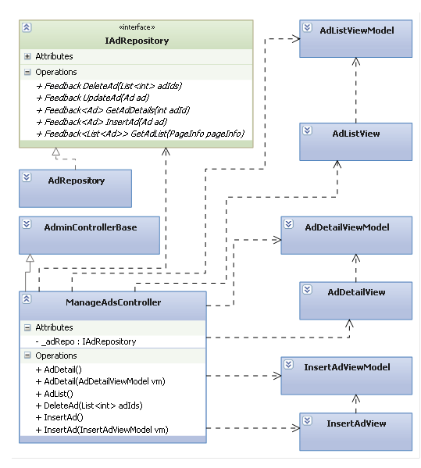

#### Class Explanations

##### **IAdRepository interface**

###### **Attributes**

N/A

###### **Operations**

Feedback DeleteAd(int adId)

Delete an advertisement

**Parameters and Return**

|  |  |  |
| --- | --- | --- |
| Parameter | Type | Description |
| adId | int | Id of advertisement to be deleted |
| return | Feedback | General feedback object |

Feedback UpdateAd(Ad ad)

Update/edit an advertisement

**Parameters and Return**

|  |  |  |
| --- | --- | --- |
| Parameter | Type | Description |
| ad | Ad | Advertisement to update |
| return | Feedback | General feedback object |

Feedback<Ad> GetAdDetails(int adId)

Get an advertisement’s details

**Parameters and Return**

|  |  |  |
| --- | --- | --- |
| Parameter | Type | Description |
| adId | int | Id of advertisement to get data |
| return | Feedback<Ad> | Feedback object containing Advertisement data |

Feedback<Ad> InsertAd(Ad ad)

Create a new advertisement

**Parameters and Return**

|  |  |  |
| --- | --- | --- |
| Parameter | Type | Description |
| ad | Ad | Advertisement to be created |
| return | Feedback<Ad > | Feedback object containing Advertisement data |

Feedback<List<Ad>> GetAdList(PageInfo pageInfo)

Get the list of Advertisement

**Parameters and Return**

|  |  |  |
| --- | --- | --- |
| Parameter | Type | Description |
| pageInfo | PageInfo | PageInfo object containing page number and item per page |
| return | Feedback<List<Ad>> | Feedback object containing a list of Advertisement data |

##### **AdRepository class**

Default implementation of IAdRepository interface

##### **ManageAdsController class**

###### **Attributes**

|  |  |  |  |
| --- | --- | --- | --- |
| Attribute | Type | Visibility | Description |
| \_adRepo | IAdRepository | Private | IAdRepository object to perform advertisements and banners operations |

###### **Operations**

AdDetail()

Render Advertisement’s details screen

AdList()

Render Advertisement’s list screen

InsertAd()

Render Create new Advertisement screen

InsertAd(InsertAdViewModel vm)

Create a new advertisement

DeleteAd(List<int> adIds)

Delete an advertisement

AdDetail(AdDetailViewModel vm)

Edit an advertisement

##### **AdListView class**

Contain HTML markup and .NET code to render Advertisement’s list screen

##### **AdListView Model class**

Model type of AdListView

##### **AdDetailView class**

Contain HTML markup and .NET code to render Advertisement’s details screen

##### **AdDetailViewModel class**

Model type of AdDetailView

##### **InsertAdView class**

Contain HTML markup and .NET code to render Create new Advertisement screen

##### **InsertAdViewModel class**

Model type of InsertAdView

#### Sequence Diagrams

##### **View Ad list**



##### **View Ad’s details**



##### **Create new Ad**



##### **Update an Ad**



##### **Delete an Ad**



### Manage Spam Questions

#### Class Diagram



#### Class Explanations

##### **IQuestionRepository interface**

###### **Attributes**

N/A

###### **Operations**

Feedback DeleteReportedQuestion(int id)

Delete reported question

**Parameters and Return**

|  |  |  |
| --- | --- | --- |
| Parameter | Type | Description |
| id | int | Id of reported question to be deleted |
| return | Feedback | General feedback object |

Feedback DeleteFalseReports(int id)

Delete false reports

**Parameters and Return**

|  |  |  |
| --- | --- | --- |
| Parameter | Type | Description |
| id | int | Id of false reported to be deleted |
| return | Feedback | General feedback object |

Feedback<IList<Question>> GetAllReportedQuestions(int minReportNumber)

Get the min report number of reported questions

**Parameters and Return**

|  |  |  |
| --- | --- | --- |
| Parameter | Type | Description |
| minReportNumber | Int | Number of shown report |
| return | Feedback<IList<Question>> | Feedback object containing list of question |

Feedback<IList<ReportedQuestion>> GetReportedQuestionDetails(int id)

Get the reported details of question

**Parameters and Return**

|  |  |  |
| --- | --- | --- |
| Parameter | Type | Description |
| id | Int | Id of question which its reported to be viewed |
| return | Feedback<IList<ReportedAnswer>> | Feedback object containing list of reported question |

##### **QuestionRepository class**

Default implementation of IQuestionRepository interface

##### **ManageSpamController class**

###### **Attributes**

|  |  |  |  |
| --- | --- | --- | --- |
| Attribute | Type | Visibility | Description |
| \_questionRepo | IQuestionRepository | Private | QuestionRepository object to perform question spam operations |

###### **Operations**

ActionResult DeleteFalseQuestionReports(int id)

Delete false reported

ActionResult DeleteReportedQuestion (int id)

Delete reported question

ManageReportedQuestion (int? minReportNumber)

Render min report number of report question s from Manage Spam Questions screen

##### **ManageReportedQuestionView class**

Contain HTML markup and .NET code to render Manage Spam Questions screen

##### **ListReportedQuestionViewModel class**

Model type of ManageReportedQuestionView

#### Sequence Diagrams

##### **Delete False Question Reports**



##### **Delete Reported Question**



##### **Manage Reported Question**



## Database Design

### ERDs

Refer to attached ERD design

### Tables

|  |  |
| --- | --- |
| Table Name | Description |
| Addresses | Stores address detailed information of a place |
| Address­Part­Prefixes | Stores address level names, like “District”, “Province”… |
| Address­Parts | Stores province names, district names |
| Answers | Stores answers of questions |
| [Categories](#Tables/Categories) | Stores place categories |
| [Category­Alternatives](#Tables/CategoryAlternatives) | Stores alternative names of place categories |
| Contacts | Stores contacts |
| [Favorite­Places](#Tables/FavoritePlaces) | Stores favorite places of users |
| [Featured­Places](#Tables/FavoritePlaces) | Stores featured places |
| [Locations](#Tables/Locations) | Stores geological information of a location |
| [Permissions](#Tables/Permissions) | Stores permissions in the system |
| [Place­Comments](#Tables/PlaceComments) | Stores comments on places |
| [Place­Images](#Tables/PlaceComments) | Stores images on places |
| [Place­Responses](#Tables/PlaceResponses) | Stores response relationship between places |
| [Place­Revisions](#Tables/PlaceRevisions) | Stores revisions of places |
| [Places](#Tables/Places) | Stores general information of places |
| PointConfigs | Stores configs of point |
| Questions | Stores questions |
| Rated­Places | Stores who has rated a place |
| Reported­Answers | Stores who has reported an answer as spam/inappropriate |
| Reported­Comments | Stores who has reported a comment as spam/inappropriate |
| Reported­Images | Stores who has reported a image as spam/inappropriate |
| Reported­Places | Stores who has reported a place as spam/inappropriate |
| Reported­Questions | Stores who has reported a question as spam/inappropriate |
| Reported­Revisions | Stores who has reported a revision as spam/inappropriate |
| Revision­States | Stores revision states |
| Role­Permissions | Resolves n-n relationship between roles and permissions |
| Roles | Stores roles in the system |
| User­Roles | Resolves n-n relationship between users and roles |
| Users | Stores information of users |
| User­States | Stores user account states |
| Visited­Places | Stores who has marked a place as visited |
| VisitorNumbers | Stores the number of visitors for each day |
| Voted­Answers | Stores who has voted an answer |
| Voted­Comments | Stores who has voted a comment |
| Voted­Images | Stores who has voted an image |
| Voted­Questions | Stores who has voted a question |

### Addresses table

|  |  |  |  |  |  |  |
| --- | --- | --- | --- | --- | --- | --- |
| Table Name | Type | Null | Unique | P/F Key | Default | Description |
| Id | int |  |  | PK |  | Id of Addresses  Identity 1 -1 |
| Details | nvarchar(1000) |  |  |  |  | Address details |
| Address­Part­Id | int |  |  | FK |  | Most specified part of this address  FK to Address­Parts.Id |
| Location­Id | int | x |  | FK |  | Location of this address on the map  FK to Locations.Id |

### Address­Part­Prefixes table

|  |  |  |  |  |  |  |
| --- | --- | --- | --- | --- | --- | --- |
| Table Name | Type | Null | Unique | P/F Key | Default | Description |
| Id | int |  |  | PK |  | Id of Address­Part­Prefixes  Identity 1 -1 |
| Name | nvarchar(100) |  |  |  |  | Name of Address­Part­Prefixes |

### Address­Parts table

|  |  |  |  |  |  |  |
| --- | --- | --- | --- | --- | --- | --- |
| Table Name | Type | Null | Unique | P/F Key | Default | Description |
| Id | int |  |  | PK |  | Id of Address­Parts  Identity 1 -1 |
| Name | nvarchar(100) |  |  |  |  | Name of Address­Parts |
| NameURL | nvarchar(100) |  |  |  |  | Name of the address part to appear in the URL |
| NameSearch | nvarchar(100) |  |  |  |  | Name of the address part to search |
| NameIncludeParent | nvarchar(500) |  |  |  |  | Full name of the address part including parents |
| Parent­Id | int | x |  | FK |  | Parent address part  FK to Address­Parts.Id |
| Prefix­Id | int |  |  | FK |  | What is this part called  FK to Address­Part­Prefixes.Id |
| Location­Id | int |  |  | FK |  | Location of this address part on the map  FK to Locations.Id |

### Answers table

|  |  |  |  |  |  |  |
| --- | --- | --- | --- | --- | --- | --- |
| Table Name | Type | Null | Unique | P/F Key | Default | Description |
| Id | int |  |  | PK |  | Id of Answers  Identity 1 -1 |
| QuestionId | int |  |  | FK |  | Question that this answer belongs to  FK to Questions.Id |
| ContentHtml | nvarchar(max) |  |  |  |  | Content of Answers in HTML mode |
| ContentText | nvarchar(max) |  |  |  |  | Content of Answers in text mode |
| UpVotes | int |  |  |  |  | Vote up times of Answers |
| DownVotes | int |  |  |  |  | Vote down times of Answers |
| Reports | int |  |  |  |  | Report times of Answers |
| CreatedBy | int |  |  | FK |  | User created Answers  FK to Users.Id |
| CreatedDate | datetime |  |  |  |  | The created date of Answers |
| UpdatedBy | int | x |  | FK |  | User updated Answers  FK to Users.Id |
| LastUpdate | datetime | x |  |  |  | The last update date of Answers |
| IsDeleted | bit |  |  |  |  | Flag to delete Answers |

### Categories table

|  |  |  |  |  |  |  |
| --- | --- | --- | --- | --- | --- | --- |
| Table Name | Type | Null | Unique | P/F Key | Default | Description |
| Id | int |  |  | PK |  | Id of Categories  Identity 1 -1 |
| Name | nvarchar(100) |  |  |  |  | Name of Categories |
| NameURL | nvarchar(100) |  |  |  |  | Name of the category to appear on URL |
| NameSearch | nvarchar(100) |  |  |  |  | Name of the category to search |
| Description | nvarchar(1000) | x |  |  |  | Description of Categories |
| Searches | int |  |  |  |  | Searched times of Categories |
| IsDeleted | bit |  |  |  |  | Flag to delete Categories |

### Category­Alternatives table

|  |  |  |  |  |  |  |
| --- | --- | --- | --- | --- | --- | --- |
| Table Name | Type | Null | Unique | P/F Key | Default | Description |
| Id | int |  |  | PK |  | Id of Category­Alternatives  Identity 1 -1 |
| CategoryId | int |  |  | FK |  | Category of Category­Alternatives  FK to Categories.Id |
| Name | nvarchar(100) |  |  |  |  | Other name of the category |

### Contacts table

|  |  |  |  |  |  |  |
| --- | --- | --- | --- | --- | --- | --- |
| Table Name | Type | Null | Unique | P/F Key | Default | Description |
| Id | int |  |  | PK |  | Id of Contacts  Identity 1 -1 |
| Email | nvarchar(254) |  |  |  |  | Email of the user |
| Subject | nvarchar(100) |  |  |  |  | Subject of the message |
| Message | nvarchar(2000) |  |  |  |  | Content of the message |
| CreatedDate | datetime |  |  |  |  | Contacted date |
| IsChecked | bit |  |  |  |  | Indicate if this contact is checked |
| IsDeleted | bit |  |  |  |  | Indicate this contact is deleted |

### Favorite­Places table

|  |  |  |  |  |  |  |
| --- | --- | --- | --- | --- | --- | --- |
| Table Name | Type | Null | Unique | P/F Key | Default | Description |
| Id | int |  |  | PK |  | Id of Favorite­Places  Identity 1 -1 |
| UserId | int |  |  | FK |  | User add place to Favorite  FK to Users.Id |
| PlaceId | int |  |  | FK |  | Place in Favorite  FK to Favotites.Id |
| AddedDate | datetime |  |  |  |  | The date that place is added |

### Featured Places table

|  |  |  |  |  |  |  |
| --- | --- | --- | --- | --- | --- | --- |
| Table Name | Type | Null | Unique | P/F Key | Default | Description |
| Id | int |  |  | PK |  | Id of Locations  Identity 1 -1 |
| PlaceId | int |  |  | FK |  | Place in Featured Places  FK to Places.Id |
| CategoryId | int |  |  | FK |  | Category of Featured Places  FK to Categories.Id |
| Rank | int |  |  |  |  | Position of the place |
| ValidFrom | datetime |  |  |  |  | Start date |
| ValidTo | datetime |  |  |  |  | End date |
| CreatedDate | datetime |  |  |  |  | Created date of the record |
| IsDeleted | bit |  |  |  |  | Indicate this record is deleted |

### Locations table

|  |  |  |  |  |  |  |
| --- | --- | --- | --- | --- | --- | --- |
| Table Name | Type | Null | Unique | P/F Key | Default | Description |
| Id | int |  |  | PK |  | Id of Locations  Identity 1 -1 |
| Longitude | float |  |  |  |  | Longitude of Place |
| Latitude | float |  |  |  |  | Latitude of Place |

### Permissions table

|  |  |  |  |  |  |  |
| --- | --- | --- | --- | --- | --- | --- |
| Table Name | Type | Null | Unique | P/F Key | Default | Description |
| Id | int |  |  | PK |  | Id of Permissions  Identity 1 -1 |
| Name | nvarchar(100) |  |  |  |  | Name of Permissions |
| Description | nvarchar(1000) | x |  |  |  | Description of Permissions |

### Place­Comments table

|  |  |  |  |  |  |  |
| --- | --- | --- | --- | --- | --- | --- |
| Table Name | Type | Null | Unique | P/F Key | Default | Description |
| Id | int |  |  | PK |  | Id of Place­Comments  Identity 1 -1 |
| PlaceId | int |  |  | FK |  | Place that comment belongs to  FK to Places.Id |
| ContentHtml | nvarchar(max) |  |  |  |  | Content of Comment in HTML mode |
| ContentText | nvarchar(max) |  |  |  |  | Content of Comment in text mode |
| UpVotes | int |  |  |  |  | Vote up times of Comment |
| DownVotes | int |  |  |  |  | Vote down times of Comment |
| Reports | int |  |  |  |  | Report times of Comment |
| CreatedBy | int |  |  | FK |  | User created Comment  FK to Users.Id |
| CreatedDate | datetime |  |  |  |  | The created date of Comment |
| UpdatedBy | int | x |  | FK |  | User updated Comment  FK to Users.Id |
| LastUpdate | datetime | x |  |  |  | The last update date of Comment |
| IsDeleted | bit |  |  |  |  | Flag to delete Comment |

### Place­Images table

|  |  |  |  |  |  |  |
| --- | --- | --- | --- | --- | --- | --- |
| Table Name | Type | Null | Unique | P/F Key | Default | Description |
| Id | int |  |  | PK |  | Id of Place­Images  Identity 1 -1 |
| PlaceId | int |  |  | FK |  | Place that image belongs to  FK to Places.Id |
| ImageUrl | nvarchar(1000) |  |  |  |  | Url of the image |
| Description | nvarchar(200) |  |  |  |  | Description of the image |
| UpVotes | int |  |  |  |  | Vote up times of Image |
| DownVotes | int |  |  |  |  | Vote down times of Image |
| Reports | int |  |  |  |  | Report times of Image |
| AddedBy | int |  |  | FK |  | User created Image  FK to Users.Id |
| AddedDate | datetime |  |  |  |  | The added date of Image |
| IsApproved | bit |  |  |  |  |  |
| IsDeleted | bit |  |  |  |  | Flag to delete Image |

### Place­Responses table

|  |  |  |  |  |  |  |
| --- | --- | --- | --- | --- | --- | --- |
| Table Name | Type | Null | Unique | P/F Key | Default | Description |
| Id | int |  |  | PK |  | Id of Place­Responses  Identity 1 -1 |
| PlaceId | int |  |  | FK |  | Place responds to  FK to |
| ResponseToId | int |  |  | FK |  | Place is responded to |
| CreatedBy | int |  |  | FK |  | User created response |
| CreatedDate | datetime |  |  |  |  | The created date of response |

### [Place­Revisions](#Tables/PlaceRevisions) table

|  |  |  |  |  |  |  |
| --- | --- | --- | --- | --- | --- | --- |
| Table Name | Type | Null | Unique | P/F Key | Default | Description |
| Id | int |  |  | PK |  | Id of [Place­Revisions](#Tables/PlaceRevisions)  Identity 1 -1 |
| PlaceId | int |  |  | FK |  | Place that revision belongs to  FK to Places.Id |
| RevisionStateId | int |  |  | FK |  | State of Revision  FK to RevisionStates.Id |
| Name | nvarchar(200) |  |  |  |  | Name of Revision |
| DescriptionHtml | nvarchar(max) | x |  |  |  | Description of Revision in HTML mode |
| DescriptionText | nvarchar(max) | x |  |  |  | Description of Revision in text mode |
| CategoryId | int |  |  | FK |  | Category of Revision  FK to Categories.Id |
| AddressId | int |  |  | FK |  | Adress of Revision  FK to Addresses.Id |
| Phone | nvarchar(20) | x |  |  |  | Phone number |
| CreatedBy | int |  |  | FK |  | User created Revision  FK to Users.Id |
| CreatedDate | datetime |  |  |  |  | The created date of Revision |
| ApprovedBy | int | x |  | FK |  | User approved Revision  FK to Users.Id |
| ApprovedDate | datetime | x |  |  |  | The approved date of Revision |
| IsDeleted | bit |  |  |  |  | Flag to delete Revision |

### [Places](#Tables/Places) table

|  |  |  |  |  |  |  |
| --- | --- | --- | --- | --- | --- | --- |
| Table Name | Type | Null | Unique | P/F Key | Default | Description |
| Id | int |  |  | PK |  | Id of [Places](#Tables/Places)  Identity 1 -1 |
| NameURL | nvarchar(200) |  |  |  |  | Name of place to appear on the URL |
| IsLocated | bit |  |  |  |  | Number of views |
| Views | int |  |  |  |  | Paged view of Place |
| RateTimes | int |  |  |  |  | Rate times of Place |
| TotalRates | int |  |  |  |  | Rate mark of Place |
| Reports | int |  |  |  |  | Reported times of Place |
| Visits | int |  |  |  |  | Visited times of Place |
| CurrentRevision | int |  |  | FK |  | Current revision ID |
| Avatar | int |  |  | FK |  | Current avatar id |
| Comments | int |  |  |  |  | Number of comments |
| CreatedDate | datetime |  |  |  |  | Created date |
| CreatedBy | int |  |  | FK |  | Creator ID |
| IsDeleted | bit |  |  |  |  | Flag to delete Place |

### PointConfigs table

|  |  |  |  |  |  |  |
| --- | --- | --- | --- | --- | --- | --- |
| Table Name | Type | Null | Unique | P/F Key | Default | Description |
| Id | int |  |  | PK |  | Id of PointConfigs  Identity 1 -1 |
| Key | nvarchar(100) |  |  |  |  | Key name |
| Value | int |  |  |  |  | Config value |
| Description | nvarchar(1000) |  |  |  |  | Description of the record |

### Questions table

|  |  |  |  |  |  |  |
| --- | --- | --- | --- | --- | --- | --- |
| Table Name | Type | Null | Unique | P/F Key | Default | Description |
| Id | int |  |  | PK |  | Id of Questions  Identity 1 -1 |
| Title | nvarchar(100) |  |  |  |  | Title of Question |
| TitileUrl | nvarchar(100) |  |  |  |  | Title to appear on the URL |
| ContentHtml | nvarchar(max) |  |  |  |  | Content of Question in HTML mode |
| ContentText | nvarchar(max) |  |  |  |  | Content of Question in text mode |
| UpVotes | int |  |  |  |  | Vote up times of Question |
| DownVotes | int |  |  |  |  | Vote down times of Question |
| Views | int |  |  |  |  | Paged view of Question |
| Reports | int |  |  |  |  | Report times of Question |
| CreatedBy | int |  |  | FK |  | User created Question  FK to Users.Id |
| CreatedDate | datetime |  |  |  |  | The created date of Question |
| UpdatedBy | int | x |  | FK |  | User approved Question  FK to Users.Id |
| LastUpdate | datetime | x |  |  |  | The approved date of Question |
| IsDeleted | bit |  |  |  |  | Flag to delete Question |

### Rated­Places table

|  |  |  |  |  |  |  |
| --- | --- | --- | --- | --- | --- | --- |
| Table Name | Type | Null | Unique | P/F Key | Default | Description |
| Id | int |  |  | PK |  | Id of Rated­Places  Identity 1 -1 |
| PlaceId | int |  |  | FK |  | Place is rated  FK to Places.Id |
| Rate | int |  |  |  |  | Rate mark |
| RatedBy | int |  |  | FK |  | User rated Place  FK to Users.Id |
| RatedDate | datetime |  |  |  |  | The rated date |

### Reported­Answers table

|  |  |  |  |  |  |  |
| --- | --- | --- | --- | --- | --- | --- |
| Table Name | Type | Null | Unique | P/F Key | Default | Description |
| Id | int |  |  | PK |  | Id of Reported­Answers  Identity 1 -1 |
| AnswerId | int |  |  | FK |  | Answer is reported  FK to Answers.Id |
| ReportedBy | int |  |  | FK |  | User reported  FK to Users.Id |
| ReportedDate | datetime |  |  |  |  | The reported date |
| Reason | nvarchar(100) | x |  |  |  | The reason why user reported |
| IsIgnored | bit |  |  |  |  | Indicate this report is ignored |

### Reported­Comments table

|  |  |  |  |  |  |  |
| --- | --- | --- | --- | --- | --- | --- |
| Table Name | Type | Null | Unique | P/F Key | Default | Description |
| Id | int |  |  | PK |  | Id of Reported­Comments  Identity 1 -1 |
| PlaceCommentId | int |  |  | FK |  | Comment is reported  FK to PlaceComment s.Id |
| ReportedBy | int |  |  | FK |  | User reported  FK to Users.Id |
| ReportedDate | datetime |  |  |  |  | The reported date |
| Reason | nvarchar(100) | x |  |  |  | The reason why user reported |
| IsIgnored | bit |  |  |  |  | Indicate this report is ignored |

### Reported­Images table

|  |  |  |  |  |  |  |
| --- | --- | --- | --- | --- | --- | --- |
| Table Name | Type | Null | Unique | P/F Key | Default | Description |
| Id | int |  |  | PK |  | Id of Reported­Images  Identity 1 -1 |
| ImageId | int |  |  | FK |  |  |
| ReportedBy | int |  |  | FK |  | User reported  FK to Users.Id |
| ReportedDate | datetime |  |  |  |  | The reported date |
| Reason | nvarchar(100) | x |  |  |  | The reason why user reported |
| IsIgnored | bit |  |  |  |  | Indicate this report is ignored |

### Reported­Places table

|  |  |  |  |  |  |  |
| --- | --- | --- | --- | --- | --- | --- |
| Table Name | Type | Null | Unique | P/F Key | Default | Description |
| Id | int |  |  | PK |  | Id of Reported­Places  Identity 1 -1 |
| PlaceId | int |  |  | FK |  | Place is reported  FK to Places.Id |
| ReportedBy | int |  |  | FK |  | User reported  FK to Users.Id |
| ReportedDate | datetime |  |  |  |  | The reported date |
| Reason | nvarchar(100) | x |  |  |  | The reason why user reported |
| IsIgnored | bit |  |  |  |  | Indicate this report is ignored |

### Reported­Questions table

|  |  |  |  |  |  |  |
| --- | --- | --- | --- | --- | --- | --- |
| Table Name | Type | Null | Unique | P/F Key | Default | Description |
| Id | int |  |  | PK |  | Id of Reported­Questions  Identity 1 -1 |
| QuestionId | int |  |  | FK |  | Question is reported  FK to Questions.Id |
| ReportedBy | int |  |  | FK |  | User reported  FK to Users.Id |
| ReportedDate | datetime |  |  |  |  | The reported date |
| Reason | nvarchar(100) | x |  |  |  | The reason why user reported |
| IsIgnored | bit |  |  |  |  | Indicate this report is ignored |

### Reported­Revisions table

|  |  |  |  |  |  |  |
| --- | --- | --- | --- | --- | --- | --- |
| Table Name | Type | Null | Unique | P/F Key | Default | Description |
| Id | int |  |  | PK |  | Id of Reported­Revisions  Identity 1 -1 |
| RevisionId | int |  |  | FK |  | Revision is reported  FK to PlaceRevisions.Id |
| ReportedBy | int |  |  | FK |  | User reported  FK to Users.Id |
| ReportedDate | datetime |  |  |  |  | The reported date |
| Reason | nvarchar(100) | x |  |  |  | The reason why user reported |
| IsIgnored | bit |  |  |  |  | Indicate this report is ignored |

### Revision­States table

|  |  |  |  |  |  |  |
| --- | --- | --- | --- | --- | --- | --- |
| Table Name | Type | Null | Unique | P/F Key | Default | Description |
| Id | int |  |  | PK |  | Id of Revision­States  Identity 1 -1 |
| Name | nvarchar(100) |  |  |  |  | Name of Revision­State |
| Description | nvarchar(1000) | x |  |  |  | Description of Revision­State |

### Role­Permissions table

|  |  |  |  |  |  |  |
| --- | --- | --- | --- | --- | --- | --- |
| Table Name | Type | Null | Unique | P/F Key | Default | Description |
| Id | int |  |  | PK |  | Id of Role­Permissions  Identity 1 -1 |
| PermissionId | int |  |  | FK |  | Permission matches with role  FK to Permissions.Id |
| RoleId | int |  |  | FK |  | Role matches with permission  FK to Users.Id |

### Roles table

|  |  |  |  |  |  |  |
| --- | --- | --- | --- | --- | --- | --- |
| Table Name | Type | Null | Unique | P/F Key | Default | Description |
| Id | int |  |  | PK |  | Id of Roles  Identity 1 -1 |
| Name | nvarchar(100) |  |  |  |  | Name of Role |
| Description | nvarchar(1000) | x |  |  |  | Description of Role |

### User­Roles table

|  |  |  |  |  |  |  |
| --- | --- | --- | --- | --- | --- | --- |
| Table Name | Type | Null | Unique | P/F Key | Default | Description |
| Id | int |  |  | PK |  | Id of User­Roles  Identity 1 -1 |
| UserId | int |  |  | FK |  | User matches with role  FK to Users.Id |
| RoleId | int |  |  | FK |  | Role matches with user  FK to Roles.Id |

### Users table

|  |  |  |  |  |  |  |
| --- | --- | --- | --- | --- | --- | --- |
| Table Name | Type | Null | Unique | P/F Key | Default | Description |
| Id | int |  |  | PK |  | Id of Users  Identity 1 -1 |
| OpenIdUrl | nvarchar(1000) | x |  |  |  | Extended Url to go to the User’s page |
| Password | nvarchar(100) |  |  |  |  | Password of User |
| Email | nvarchar(254) |  |  |  |  | Email of User |
| AvatarUrl | nvarchar(1000) | x |  |  |  | Url of avatar |
| Fullname | nvarchar(50) |  |  |  |  | Fullname of User |
| Point | int |  |  |  |  | Point of User |
| TodayPoint | int | x |  |  |  | Point that the user earns to day |
| TodayDate | datetime | x |  |  |  | Today date |
| UserStateId | int |  |  | FK |  | State of User  FK to UserStates.Id |
| LocationId | int | x |  | FK |  | Location of User  FK to Locations.Id |
| ActivationKey | nvarchar(100) | x |  |  |  | Activation Key of User |
| IsActivated | bit |  |  |  |  | Flag to active User |
| ResetPasswordKey | nvarchar(100) | x |  |  |  | Reset password key of User |
| LastLogin | datetime | x |  |  |  | Last login of User |
| FailedLoginAttempts | int |  |  |  |  | Failed Login times of User |
| LastLoginAttempted | datetime | x |  |  |  | Last Login Attempted of User |
| CreatedDate | datetime |  |  |  |  | The created date of User |
| LastUpdate | datetime | x |  |  |  | The last update date of User |
| IsDeleted | bit |  |  |  |  | Flag to delete User |

### User­States table

|  |  |  |  |  |  |  |
| --- | --- | --- | --- | --- | --- | --- |
| Table Name | Type | Null | Unique | P/F Key | Default | Description |
| Id | int |  |  | PK |  | Id of User­States  Identity 1 -1 |
| Name | nvarchar(100) |  |  |  |  | Name of User­State |
| Description | nvarchar(1000) | x |  |  |  | Description of User­State |

### Visited­Places table

|  |  |  |  |  |  |  |
| --- | --- | --- | --- | --- | --- | --- |
| Table Name | Type | Null | Unique | P/F Key | Default | Description |
| Id | int |  |  | PK |  | Id of Visited­Places  Identity 1 -1 |
| PlaceId | int |  |  | FK |  | Place is visited  FK to Places.Id |
| MarkedBy | int |  |  | FK |  | User mark place as visited  FK to Users.Id |
| MarkedDate | datetime |  |  |  |  | The marked date |

### VisitorNumbers table

|  |  |  |  |  |  |  |
| --- | --- | --- | --- | --- | --- | --- |
| Table Name | Type | Null | Unique | P/F Key | Default | Description |
| Id | int |  |  | PK |  | Id of Visited­Places  Identity 1 -1 |
| Date | datetime |  |  |  |  | Date of the record |
| VisitorNumber | int |  |  |  |  | Number of visitors on that date |

### Voted­Answers table

|  |  |  |  |  |  |  |
| --- | --- | --- | --- | --- | --- | --- |
| Table Name | Type | Null | Unique | P/F Key | Default | Description |
| Id | int |  |  | PK |  | Id of Voted­Answers  Identity 1 -1 |
| AnswerId | int |  |  | FK |  | Answer is voted  FK to Answers.Id |
| VotedBy | int |  |  | FK |  | User voted  FK to Users.Id |
| VotedDate | datetime |  |  |  |  | The voted date |
| IsUpVote | bit |  |  |  |  | Flag to vote up or vote down |

### Voted­Comments table

|  |  |  |  |  |  |  |
| --- | --- | --- | --- | --- | --- | --- |
| Table Name | Type | Null | Unique | P/F Key | Default | Description |
| Id | int |  |  | PK |  | Id of Voted­Comments  Identity 1 -1 |
| PlaceCommentId | int |  |  | FK |  | Place comment is voted  FK to PlaceComments.Id |
| VotedBy | int |  |  | FK |  | User voted  FK to Users.Id |
| VotedDate | datetime |  |  |  |  | The voted date |
| IsUpVote | bit |  |  |  |  | Flag to vote up or vote down |

### Voted­Images table

|  |  |  |  |  |  |  |
| --- | --- | --- | --- | --- | --- | --- |
| Table Name | Type | Null | Unique | P/F Key | Default | Description |
| Id | int |  |  | PK |  | Id of Voted­Images  Identity 1 -1 |
| ImageId | int |  |  | FK |  | Image Id |
| VotedBy | int |  |  | FK |  | User voted  FK to Users.Id |
| VotedDate | datetime |  |  |  |  | The voted date |
| IsUpVote | bit |  |  |  |  | Flag to vote up or vote down |

### Voted­Questions table

|  |  |  |  |  |  |  |
| --- | --- | --- | --- | --- | --- | --- |
| Table Name | Type | Null | Unique | P/F Key | Default | Description |
| Id | int |  |  | PK |  | Id of Voted­Questions  Identity 1 -1 |
| QuestionId | int |  |  | FK |  | Question is voted  FK to Questions.Id |
| VotedBy | int |  |  | FK |  | User voted  FK to Users.Id |
| VotedDate | datetime |  |  |  |  | The voted date |
| IsUpVote | bit |  |  |  |  | Flag to vote up or vote down |

# Software Test Documentation

## Introduction

### System Overview

This document describes the approach and methodologies used by the testing group to plan, organize and manage the testing of this system. It describes implementation details of test cases or technical details of how the product features should work.

The system will be tested is also the system our team are currently developing. This system is developed based on MVC3 framework. It is a website using for sharing places between internet users. The system has similarities with other social network.

### Test Approach

The testing for this project will consist of Unit, System/Integration (combined) and Acceptance test levels. It is hoped that there will be at least one full time independent test person for system/integration testing. Most testing will be done by the test manager with the development team’s participation.

Unit Testing will be done by the developers and will be approved by the implementing team leader. All unit test information (sample, output, data printouts, and defect information…) will be managed by developers and it must be showed when team required.

System/Integration Testing will be performed by the test manager and implementing team leader with assistance from the individual developers as required.

Acceptance Testing will be performed by the test manager and development team leader. The acceptance test will be done for a period of 2 weeks after completion of the System/Integration test process. Programs will enter into Acceptance test after all critical and major defects have been corrected. A program may have one major defect as long as it does not obstruct testing of the program (There is a work around for the error). Prior to final completion of acceptance testing all open critical and major defects must be corrected.

## Test Plan

### Features to be tested

The following is a list of areas to be focus on during testing of website

#### Admin – Roles

Test all functions in Manage Roles page includes: List, create a new Role, edit and update roles.

#### Admin – Users

Test all functions in Manage Users page includes: List, create a new user, edit and update users.

#### Admin – Featured Places

Test all functions in Manage Featured Places page includes: List, create a new featured place, edit and update featured places.

#### Admin – Unlocated Places

Test all functions in Manage Unlocated Places page includes: List, create a new unlocated place, edit and update unlocated places.

#### Admin – Categories

Test all functions in Manage Categories page includes: List, create a new category, edit and update categories.

#### Admin – Contacts

Test all functions in Manage Contacts page includes: List, create a new contact, edit and update contacts.

#### Admin – Address Paths

Test all functions in Manage Address Paths page includes: List, create a new address, edit and update addresses.

#### Admin – Manage Reported Places

Test all functions in Manage Spam - Manage Reported Places includes: list all spam reports, confirm false report, delete spam entity, view spam report detail

#### Admin – Manage Reported Comments

Test all functions in Manage Spam - Manage Reported Comments includes: list all spam reports, confirm false report, delete spam entity, view spam report detail

#### Admin – Manage Reported Questions

Test all functions in Manage Spam - Manage Reported Questions includes: list all spam reports, confirm false report, delete spam entity, view spam report detail

#### Admin – Manage Reported Answers

Test all functions in Manage Spam - Manage Reported Answers includes: list all spam reports, confirm false report, delete spam entity, view spam report detail

#### Users

Test all functions in Users includes: Login, Logout, Register, User info, Change user info, Change password.

#### Search

Test all functions in Search page includes: Quick Search, Tag Cloud

#### Place Details

Test view place detail function

#### Create Place

Test create place function

#### Edit Place

Test edit place function

#### Q&A

Test all functions in Question & Answer includes: list all question, view question detail, create new question, post an answer, vote question, report question, vote answer, report answer, edit question, delete answer.

#### Revisions

Test all functions relate to revisions includes: list all revisions, compare 2 revisions, view detail information of a revision

### Features not to be tested

The following is a list of the areas that will not be tested in this system:



#### Admin – Manage Places

Test all functions in Manage Roles page includes: List, create a new Role, edit and update roles.

#### Admin – Manage Place Images

Test all functions in Manage Roles page includes: List, create a new Role, edit and update roles.

#### Admin – Manage Reported Images

Test all functions in Manage Roles page includes: List, create a new Role, edit and update roles.

#### Admin – Statistics

Test all functions in Manage Roles page includes: List, create a new Role, edit and update roles.

#### Network Connection & Security

With each user, it will be different. We only ensure that this system will affect to network.

#### Performance

There wasn’t enough time so we can’t optimize source code and improve performance. We can only ensure the system work well but not at its best performance.

### Test Cases



#### Admin – Roles

|  |  |  |  |  |  |  |  |
| --- | --- | --- | --- | --- | --- | --- | --- |
| **ID** | **Test Case Description** | **Test Case Procedure** | **Expected Output** | **Inter-test case Dependence** | **Result** | **Test date** | **Note** |
|  | **List roles** |  |  |  |  |  |  |
|  | Steps 1. Login the system with Admin role. 2. Click "**Users**" tab in the left menu. | | | | | | |
| [Roles-1] | Test **Manage Roles** page | Click "**Manage Roles**" tab | **"Manage Roles"** is highlighted by white color**. Manage Roles** page is displayed with the folowing informations: - Title: Manage Roles  - "Create a new record" button - A table with 3 columns: + Name: contains role's name + Description: contains role's description + Blank column: contains Edit and Delete button with each row - Buttons: refresh, first page, last page, previous page, next page - List of page - A label: Displaying items ... of ... |  | Pass | 3/29/2011 |  |
| [Roles-2] | Test Refresh button | Click to "Refresh" button | Current page will be displayed again with same content |  | Pass | 3/29/2011 |  |
| [Roles-3] | Test First page button | Click to "First page" button when current displayed page is larger than 1 | First page will be displayed with content |  | Pass | 3/29/2011 |  |
| [Roles-4] | Test Previous page button | Click to "Previous page" button when current displayed page is larger than 1 | Previous page of current page will be displayed with content |  | Pass | 3/29/2011 |  |
| [Roles-5] | Test Next page button | Click to "Next page" button when current displayed page is smaller than max page | Next page of current page will be displayed with content |  | Pass | 3/29/2011 |  |
| [Roles-6] | Test Last page button | Click to "Last page" button when current displayed page is smaller than max page | Last page will be displayed with content |  | Pass | 3/29/2011 |  |
| [Roles-7] | Test index of page | Click to index page at the bottom | Index page will be displayed with content |  | Pass | 3/29/2011 |  |
|  | **Create a new role** |  |  |  |  |  |  |
|  | Steps 1. Go to **Manage Roles** page 2. Click "Create a new record" button Or 1. Click **Create a new Role** tab in the left | | | | | | |
| [Roles-8] | Test "**Create a Role**" page | Click to "Create a new record" button at **Manage Roles** page.  Or: click **Create a new Role** tab in the left | **Create a Role** page will be displayed with the following informations: - Titile: Create a Role - Labels: Role information, Name (\*), Description, Permission - Textfields: Name, Description - Checkboxes and Permission values - 2 buttons: Save and Cancel Check in DB: all permissions are resemble values in Permissions table |  | Pass | 3/29/2011 |  |
| [Roles-9] | Create new role successful | 1. Input valid information in 2 textfields and check some checkboxes in Permission 2. Click to "Save" button | Redirect to **Manage Roles** page and Notification "Role has been inserted successfully" will be displayed at the below of title page. Check in DB:  - RoleId and PermissionIDs are created in RolePermissions table - All inputed informations are created in Roles table |  | Pass | 3/29/2011 |  |
| [Roles-10] | 1.Input valid information in 2 textfields and don’t check any checkbox in Permission 2. Click to "Save" button |  | Pass | 3/29/2011 |  |
| [Roles-11] | 1. Input valid information in Name textfield and check some checkboxes in Permission 2. Click to "Save" button |  | Pass | 3/29/2011 |  |
| [Roles-12] | 1. Input valid information in Name textfield and don't check any checkboxes in Permission 2. Click to "Save" button |  | Pass | 3/29/2011 |  |
| [Roles-13] | Create new role unsuccessful | 1. Input more 100 characters in Name textfield 2. Click to "Save" button | Notification "Please enter no more than 100 characters." with red color will be displayed beside Name textfield |  | Pass | 3/29/2011 |  |
| [Roles-14] | 1. Input more 1000 characters in Description textfield 2. Click to "Save" button | Notification "Please enter no more than 1000 characters." with red color will be displayed beside Description textfield |  | Pass | 3/29/2011 |  |
| [Roles-15] | 1. Input valid information in either Description textfields or check any checkbox in Permissions and don't input Name textfiled 2. Click to "Save" button | Notification "The Name field is required" with red color will be displayed beside Name textfield |  | Pass | 3/29/2011 |  |
| [Roles-16] | 1. Input valid information in either Description textfields or check any checkbox in Permissions and input existed name in DB into Name textfiled 2. Click to "Save" button | Notification "There is already a role with the same name" will be displayed at the below of title page. |  | Pass | 3/29/2011 |  |
| [Roles-17] | Cancel action | Click to "Cancel" button | Redirect to **Manage Roles** page |  | Pass | 3/29/2011 |  |
|  | **Edit role** |  |  |  |  |  |  |
|  | Steps 1. Go to **Manage Roles** page | | | | | | |
| [Roles-18] | Test **Edit Role** page | Click to "Edit" button in any row at **Manage Roles** page | **Edit Role** page will be displayed with the following informations: - Titile: Edit a Role - Labels: Role information, Name (\*), Description, Permission - Textfields: Name, Description are filled information - Checkboxes and Permission values - 2 buttons: Save and Cancel Check in DB:  - All informations are resemble values in Roles and RolePermissions table  - All permissions are resemble values in Permissions table |  | Pass | 3/29/2011 |  |
| [Roles-19] | Edit role successful | 1. Edit valid information in 2 textfields (Name mustn't existed in DB) and check some checkboxes in Permissions 2. Click to "Save" button | Redirect to **Manage Roles** page and Notification "Role has been updated successfully" will be displayed at the below of title page. Check in DB:  - RoleId and PermissionIDs are updated in RolePermissions table - All edited informations are resemble values in Roles table |  | Pass | 3/29/2011 |  |
| [Roles-20] | 1. Edit valid information in Name textfield (Name mustn't existed in DB) and check some checkboxes in Permissions 2. Click to "Save" button |  | Pass | 3/29/2011 |  |
| [Roles-21] | 1. Edit valid information in both textfields (Name mustn't existed in DB) and don’t check any checkbox in Permissions 2. Click to "Save" button |  | Pass | 3/29/2011 |  |
| [Roles-22] | 1. Edit valid information in Name textfield (Name mustn't existed in DB), remove Description and don’t check any checkbox in Permissions 2. Click to "Save" button |  | Pass | 3/29/2011 |  |
| [Roles-23] | Edit role unsuccessful | 1. Edit more 100 characters in Name textfield 2. Click to "Save" button | Notification "Please enter no more than 100 characters." with red color will be displayed beside Name textfield |  | Pass | 3/29/2011 |  |
| [Roles-24] | 1. Edit more 1000 characters in Description textfield 2. Click to "Save" button | Notification "Please enter no more than 1000 characters." with red color will be displayed beside Description textfield |  | Pass | 3/29/2011 |  |
| [Roles-25] | 1. Edit valid information in either Description textfields or check any checkbox in Permissions and Name textfiled is blank 2. Click to "Save" button | Notification "The Name field is required" with red color will be displayed beside Name textfield |  | Pass | 3/29/2011 |  |
| [Roles-26] | 1. Edit valid information in either Description textfields or check any checkbox in Permissions and edit Name to be existed name in DB into Name textfiled 2. Click to "Save" button | Notification "There is already a role with the same name" will be displayed at the below of title page. |  | Pass | 3/29/2011 |  |
| [Roles-27] | Cancel action | Click to "Cancel" button | Redirect to **Manage Roles** page |  | Pass | 3/29/2011 |  |
|  | **Delete role** |  |  |  |  |  |  |
|  | Steps 1. Go to **Manage Roles** page | | | | | | |
| [Roles-28] | Delete role successful | 1. Click to "Delete" button in any row at **Manage Roles** page 2. Click to "OK" button | 1. Popup will appear with content: "Are you sure you want to delete this Role?" 2. This role will be deleted.   Notification "Role has been deleted successfully" will be displayed at the below of title page Check in DB:  - All rows which contain RoleId are deleted in RolePermissions and UserRoles table - Role is deleted from Roles table |  | Pass | 3/29/2011 |  |
| [Roles-29] | Delete role unsuccessful | 1. Click to "Delete" button in any row at **Manage Roles** page 2. Click to "Cancel" button | 1. Popup will appear with content: "Are you sure you want to delete this Role?" 2. Popup will be closed. |  | Pass | 3/29/2011 |  |

#### Admin – Users

|  |  |  |  |  |  |  |  |
| --- | --- | --- | --- | --- | --- | --- | --- |
| **ID** | **Test Case Description** | **Test Case Procedure** | **Expected Output** | **Inter-test case Dependence** | **Result** | **Test date** | **Note** |
|  | **List users** |  |  |  |  |  |  |
|  | Steps 1. Login the system with Admin role. 2. Click "**Users**" tab in the left menu. | | | | | | |
| [Users-1] | Test **Manage Users** page | Click "**Manage Users**" tab | **"Manage Users"** is highlighted by white color**. Manage Users** page is displayed with the folowing informations: - Title: Manage Users  - A table with 6 columns: + Email + Full Name + Point + User State + Last Login + Created Date - Buttons: refresh, first page, last page, previous page, next page - List of page - A label: Displaying items ... of ... |  | Pass | 3/30/2011 |  |
| [Users-2] | Test Refresh button | Click to "Refresh" button | Current page will be displayed again with same content |  | Pass | 3/30/2011 |  |
| [Users-3] | Test First page button | Click to "First page" button when current displayed page is larger than 1 | First page will be displayed with content |  | Pass | 3/30/2011 |  |
| [Users-4] | Test Previous page button | Click to "Previous page" button when current displayed page is larger than 1 | Previous page of current page will be displayed with content |  | Pass | 3/30/2011 |  |
| [Users-5] | Test Next page button | Click to "Next page" button when current displayed page is smaller than max page | Next page of current page will be displayed with content |  | Pass | 3/30/2011 |  |
| [Users-6] | Test Last page button | Click to "Last page" button when current displayed page is smaller than max page | Last page will be displayed with content |  | Pass | 3/30/2011 |  |
| [Users-7] | Test index of page | Click to index page at the bottom | Index page will be displayed with content |  | Pass | 3/30/2011 |  |
|  | **View user's details** |  |  |  |  |  |  |
|  | Steps 1. Go to **Manage Users** page | | | | | | |
| [Users-8] | Test "**View User Details**" page | Click to an email's hyperlink at **Manage Users** page | **View User Details** page will be displayed with the following informations: - Titile: View User Details - Labels and values: User Information, Full Name, Point, User State, Roles, Last Logined, Registed Date, Avatar - 3 buttons: Edit, Delete and Back Check in DB: all informations are resemble values in Users, UserRoles and UserStates table |  | Pass | 3/30/2011 |  |
| [Users-9] | Back action | Click to "Back" button | Redirect to **Manage Users** page |  | Pass | 3/30/2011 |  |
|  | **Edit user** |  |  |  |  |  |  |
|  | Steps 1. Go to **Manage Users** page 2. Click to an email's hyperlink at **Manage Users** page | | | | | | |
| [Users-10] | Test "**Edit user**" page | Click to "Edit" button at **View User Details** page. | **Edit User** page will be displayed with the following informations: - Titile: Edit User - Labels: User Information, Email, Full Name (\*), Point (\*), User State, Roles - Textfields: Email (is disabled), Full Name, Point - DropDown List: User State - Checkboxes and Role values - 2 buttons: Save and Cancel Check in DB: all informations are resemble values in Users, UserRoles and UserStates table |  | Pass | 3/30/2011 |  |
| [Users-11] | Edit user successful | 1. Edit valid information 2. Click to "Save" button | Redirect to **Manage Users** page and Notification "User has been updated successfully" will be displayed at the below of title page. Check in DB: all edited informations are updated to Users, UserRoles and UserStates tables |  | Pass | 3/30/2011 |  |
| [Users-12] | Edit user unsuccessful | 1. Remove Full Name value 2. Click to "Save" button | Notification "Full Name is required" with red color will be displayed beside Full Name textfield |  | Pass | 3/30/2011 |  |
| [Users-13] | 1. Edit more 100 characters in Full Name textfield 2. Click to "Save" button | Notification "Please enter no more than 100 characters." with red color will be displayed beside Full Name textfield |  | Pass | 3/30/2011 |  |
| [Users-14] | 1. Remove Point value 2. Click to "Save" button | Notification "Point is required" with red color will be displayed beside Point textfield |  | Pass | 3/30/2011 |  |
| [Users-15] | Remove Point value and input some characters to this textbox | Notification "The field Point must be a number." with red color will be displayed beside Point textfield |  | Pass | 3/30/2011 |  |
| [Users-16] | Cancel action | Click to "Cancel" button | Redirect to **View User Details** page |  | Pass | 3/30/2011 |  |
|  | **Delete users** |  |  |  |  |  |  |
|  | Steps 1. Go to **Manage Users** page 2. Click to an email's hyperlink at **Manage Users** page | | | | | | |
| [Users-17] | Delete user successful | 1. Click to "Delete" button at **View User Details** page 2. Click "OK" | 1. Popup will appear with content: "Are you sure you want to delete this User?" 2. This user will be deleted.   Redirect to **Manage Users** page and Notification "User has been deleted successfully" will be displayed at the below of title page  Check in DB: IsDeleted attribute of this user is True |  | Pass | 3/30/2011 |  |
| [Users-18] | Delete user unsuccessful | 1. Click to "Delete" button at **View User Details** page 2. Click "Cancel" | 1. Popup will appear with content: "Are you sure you want to delete this User?" 2. Popup will be closed.  Check in DB: IsDeleted attribute of this user is False |  | Pass | 3/30/2011 |  |

#### Admin - Featured Places

|  |  |  |  |  |  |  |  |
| --- | --- | --- | --- | --- | --- | --- | --- |
| **ID** | **Test Case Description** | **Test Case Procedure** | **Expected Output** | **Inter-test case Dependence** | **Result** | **Test date** | **Note** |
|  | **List featured places** |  |  |  |  |  |  |
|  | Steps 1. Login the system with Admin role. 2. Click "**Places**" tab in the left menu. | | | | | | |
| [Featured Places-1] | Test **Manage Featured Places** page | Click "Manage Featured Places" tab | **"Manage Featured Places"** is highlighted by white color**. Manage Featured Places** page is displayed with the folowing informations: - Title: Manage Featured Places  - Add new record button - A table with 6 columns: + Place Name: contains place's name + Category: contains category where place belongs + Rank: place's rank + Valid From + Valid To + Blank column: contains Edit and Delete button with each row - Buttons: refresh, first page, last page, previous page, next page - List of page - A label: Displaying items ... of ... |  | Pass | 3/30/2011 |  |
| [Featured Places-2] | Test Refresh button | Click to "Refresh" button | Current page will be displayed again with same content |  | Pass | 3/30/2011 |  |
| [Featured Places-3] | Test First page button | Click to "First page" button when current displayed page is larger than 1 | First page will be displayed with content |  | Pass | 3/30/2011 |  |
| [Featured Places-4] | Test Previous page button | Click to "Previous page" button when current displayed page is larger than 1 | Previous page of current page will be displayed with content |  | Pass | 3/30/2011 |  |
| [Featured Places-5] | Test Next page button | Click to "Next page" button when current displayed page is smaller than max page | Next page of current page will be displayed with content |  | Pass | 3/30/2011 |  |
| [Featured Places-6] | Test Last page button | Click to "Last page" button when current displayed page is smaller than max page | Last page will be displayed with content |  | Pass | 3/30/2011 |  |
| [Featured Places-7] | Test index of page | Click to index page at the bottom | Index page will be displayed with content |  | Pass | 3/30/2011 |  |
|  | **Create a new featured place** | |  |  |  |  |  |
|  | Steps 1. Go to **Manage Featured Places** page 2. Click "Create a new record" button | | | | | | |
| [Featured Places-8] | Test "Create a featured place" page | Click to "Create a new record" button at **Manage Featured Places** page. | **Create a Featured Place** page will be displayed with the following informations: - Titile: Create a Featured Place - Labels: Featured Place information, PlaceID, Place Name, Category Name, Rank, Valid From, Valid To - Textfields: PlaceID, Place Name (is disabled) - Numeric Box: Rank - Dropdown List: Category - 2 DateTimePickers: Valid From and Valid To - 2 buttons: Save and Cancel |  | Pass | 3/30/2011 |  |
| [Featured Places-9] | Create new featured place successful | 1. Input valid information 2. Click to "Save" button | 1. Place Name textfiled will be named automatically which corresponds to PlaceId 2. Redirect to **Manage Featured Places** page and Notification "Featured Place has been inserted successfully" will be displayed at the below of title page. Check in DB:  - All inputed information are created in Featured Places table |  | Pass | 3/30/2011 |  |
| [Featured Places-10] | Create new featured place unsuccessful | 1. Don't input PlaceId and input other valid information 2. Click to "Save" button | Notification "PlaceId is required" with red color will be displayed beside PlaceId textfield |  | Pass | 3/30/2011 |  |
| [Featured Places-11] | 1. Input PlaceId which doesn’t existed in DB 2. Click to "Save" button | Place Name read-on textfiled will display: "Not existed" |  | Pass | 3/30/2011 |  |
| [Featured Places-12] | 1. Input some characters to PlaceId field 2. Click to "Save" button | Notification "The field PlaceId must be a number" with red color will be displayed beside PlaceId textfield |  | Pass | 3/30/2011 |  |
| [Featured Places-13] | 1. Input a number larger than 3 in Rank numeric box 2. Click to "Save" button | Value of numeric box is changed to 3 automatically |  | Pass | 3/30/2011 |  |
| [Featured Places-14] | 1. Don't input ValidFrom and input other valid information 2. Click to "Save" button | Notification "ValidFrom is required" with red color will be displayed beside ValidFrom textfield |  | Pass | 3/30/2011 |  |
| [Featured Places-15] | 1. Don't input ValidTo and input other valid information 2. Click to "Save" button | Notification "ValidTo is required" with red color will be displayed beside ValidTo textfield |  | Pass | 3/30/2011 |  |
| [Featured Places-16] | 1. Input ValidFrom larger than ValidTo 2. Click to "Save" button | Notification "ValidTo must be larger than ValidFrom" with red color will be displayed beside ValidTo textfield |  | Pass | 3/30/2011 |  |
| [Featured Places-17] | Cancel action | Click to "Cancel" button | Redirect to **Manage Featured Places** page |  | Pass | 3/30/2011 |  |
|  | **Edit featured place** |  |  |  |  |  |  |
|  | Steps 1. Go to **Manage Featured Places** page | | | | | | |
| [Featured Places-18] | Test **Edit Featured Place** page | Click to "Edit" button in any row at **Manage Featured Places** page | **Edit Featured Place** page will be displayed with the following informations: - Titile: Create a Featured Place - Labels: Featured Place information, PlaceID, Place Name, Category Name, Rank, Valid From, Valid To - Textfields: PlaceID, Place Name (is disabled) - Numeric Box: Rank - Dropdown List: Category - 2 DateTimePickers: Valid From and Valid To - 2 buttons: Save and Cancel Check in DB:  - All informations are resemble values in Featured Places table |  | Pass | 3/30/2011 |  |
| [Featured Places-19] | Edit featured place successful | 1. Edit valid information 2. Click to "Save" button | 1. Place Name textfiled will be named automatically which corresponds to PlaceId 2. Redirect to **Manage Featured Places** page and Notification "Featured Place has been edited successfully" will be displayed at the below of title page. Check in DB:  - All edited information are updated in Featured Places table |  | Pass | 3/30/2011 |  |
| [Featured Places-20] | Edit featured place unsuccessful | 1. Remove PlaceId and edit other valid information 2. Click to "Save" button | Notification "PlaceId is required" with red color will be displayed beside PlaceId textfield |  | Pass | 3/30/2011 |  |
| [Featured Places-21] | 1. Edit PlaceId which doesn’t existed in DB 2. Click to "Save" button | Place Name read-on textfiled will display: "Not existed" |  | Pass | 3/30/2011 |  |
| [Featured Places-22] | 1. Remove PlaceId and input some characters to this field 2. Click to "Save" button | Notification "The field PlaceId must be a number" with red color will be displayed beside PlaceId textfield |  | Pass | 3/30/2011 |  |
| [Featured Places-23] | 1. Edit a number larger than 3 in Rank numeric box 2. Click to "Save" button | Value of numeric box is changed to 3 automatically |  | Pass | 3/30/2011 |  |
| [Featured Places-24] | 1. Remove ValidFrom and edit other valid information 2. Click to "Save" button | Notification "ValidFrom is required" with red color will be displayed beside ValidFrom textfield |  | Pass | 3/30/2011 |  |
| [Featured Places-25] | 1. Remove ValidTo and edit other valid information 2. Click to "Save" button | Notification "ValidTo is required" with red color will be displayed beside ValidTo textfield |  | Pass | 3/30/2011 |  |
| [Featured Places-26] | 1. Edit ValidFrom larger than ValidTo 2. Click to "Save" button | Notification "ValidTo must be larger than ValidFrom" with red color will be displayed beside ValidTo textfield |  | Pass | 3/30/2011 |  |
| [Featured Places-27] | Cancel action | Click to "Cancel" button | Redirect to **Manage Featured Places** page |  | Pass | 3/30/2011 |  |
|  | **Delete featured place** |  |  |  |  |  |  |
|  | Steps 1. Go to **Manage Featured Places** page | | | | | | |
| [Featured Places-28] | Delete featured place successful | 1. Click to "Delete" button in any row 2. Click "OK" | 1. Popup will appear with content: "Are you sure you want to delete this Featured Place?" 2. This featured place will be deleted.   Notification "Featured Place has been deleted successfully" will be displayed at the below of title page  Check in DB: IsDeleted attribute of this category is True |  | Pass | 3/30/2011 |  |
| [Featured Places-29] | Delete featured place unsuccessful | 1. Click to "Delete" button in any row 2. Click "Cancel" | 1. Popup will appear with content: "Are you sure you want to delete this Featured Place?" 2. Popup will be closed.  Check in DB: IsDeleted attribute of this category is False |  | Pass | 3/30/2011 |  |

#### Admin - Unlocated Places

|  |  |  |  |  |  |  |  |
| --- | --- | --- | --- | --- | --- | --- | --- |
| **ID** | **Test Case Description** | **Test Case Procedure** | **Expected Output** | **Inter-test case Dependence** | **Result** | **Test date** | **Note** |
|  | **List Contacts** |  |  |  |  |  |  |
|  | Steps 1. Login the system with Admin role. 2. Click "**Contacts**" tab in the left menu. | | | | | | |
| [Contacts-1] | Test **Manage Contacts** page | Click "**Manage Contacts**" tab | "**Manage Contacts**" is highlighted by white color. **Manage Contacts** page is displayed with the folowing informations: - Title: Manage Contacts  - A table with 6 columns: + Email + Subject + Created Date - Combox Box: Checked, Not Checked, All - Buttons: refresh, first page, last page, previous page, next page, Filter - List of page - A label: Displaying items ... of ... |  | Pass | 4/1/2011 |  |
| [Contacts-2] | Test Refresh button | Click to "Refresh" button | Current page will be displayed again with same content |  | Pass | 4/1/2011 |  |
| [Contacts-3] | Test First page button | Click to "First page" button when current displayed page is larger than 1 | First page will be displayed with content |  | Pass | 4/1/2011 |  |
| [Contacts-4] | Test Previous page button | Click to "Previous page" button when current displayed page is larger than 1 | Previous page of current page will be displayed with content |  | Pass | 4/1/2011 |  |
| [Contacts-5] | Test Next page button | Click to "Next page" button when current displayed page is smaller than max page | Next page of current page will be displayed with content |  | Pass | 4/1/2011 |  |
| [Contacts-6] | Test Last page button | Click to "Last page" button when current displayed page is smaller than max page | Last page will be displayed with content |  | Pass | 4/1/2011 |  |
| [Contacts-7] | Test index of page | Click to index page at the bottom | Index page will be displayed with content |  | Pass | 4/1/2011 |  |
| [Contacts-8] | View checked contacts | 1. Choose "Checked" in combo box 2. Click to Filter button | All checked contacts will be displayed |  | Pass | 4/1/2011 |  |
| [Contacts-9] | View unchecked contacts | 1. Choose "Unchecked" in combo box 2. Click to Filter button | All unchecked contacts will be displayed |  | Pass | 4/1/2011 |  |
| [Contacts-10] | View all contacts | 1. Choose "All" in combo box 2. Click to Filter button | All contacts will be displayed |  | Pass | 4/1/2011 |  |
|  | **View Contact's details** |  |  |  |  |  |  |
|  | Steps 1. Go to **Manage Contacts** page | | | | | | |
| [Contacts-11] | Test "**View Contact Details**" page with checked contact | 1. Choose "Checked" in combo box 2. Click to Filter button 3. Click to a subject's hyperlink | **View Contact Details** page will be displayed with the following informations: - Titile: View Contact Details - Label: Contact Information, Email, Subject, Message, Created Date - Textboxes (are disabled) - 2 buttons: Delete and Back Check in DB: all informations are resemble values in Contacts table |  | Pass | 4/1/2011 |  |
| [Contacts-12] | Test "**View Contact Details**" page with unchecked contact | 1. Choose "Unchecked" in combo box 2. Click to Filter button 3. Click to a subject's hyperlink | **View Contact Details** page will be displayed with the following informations: - Titile: View Contact Details - Label: Contact Information, Email, Subject, Message, Created Date - Textboxes (are disabled) - 3 buttons: Mark As Checked, Delete and Back Check in DB: all informations are resemble values in Contacts table |  | Pass | 4/1/2011 |  |
| [Contacts-13] | Mark contact as checked | 1. Choose "Unchecked" in combo box 2. Click to Filter button 3. Click to a subject's hyperlink 4. Click "Mark As Checked" button | This contact will be checked Check in DB: IsChecked attribute of this contact is True |  | Pass | 4/1/2011 |  |
| [Contacts-14] | Cancel action | Click to "Cancel" button | Redirect to **Manage Contacts** page |  | Pass | 4/1/2011 |  |
|  | **Delete Contacts** |  |  |  |  |  |  |
|  | Steps 1. Go to **Manage Contacts** page 2. Click to a subject's hyperlink | | | | | | |
| [Contacts-15] | Delete Contact successful | 1. Click to "Delete" button at **View Contact Details** page 2. Click to "OK" button | 1. Popup will appear with content: "Are you sure you want to delete this Contact?" 2. This Contact will be deleted.   Redirect to Manage Contacts page and Notification "Contact has been deleted successfully" will be displayed at the below of title page  Check in DB: IsDeleted attribute of this contact is True |  | Pass | 4/1/2011 |  |
| [Contacts-16] | Delete Contact unsuccessful | 1. Click to "Delete" button at **View Contact Details** page 2. Click to "Cancel" button | 1. Popup will appear with content: "Are you sure you want to delete this Contact?" 2. Popup will be closed.  Check in DB: IsDeleted attribute of this contact is False |  | Pass | 4/1/2011 |  |

#### Admin – Categories

|  |  |  |  |  |  |  |  |
| --- | --- | --- | --- | --- | --- | --- | --- |
| **ID** | **Test Case Description** | **Test Case Procedure** | **Expected Output** | **Inter-test case Dependence** | **Result** | **Test date** | **Note** |
|  | **List categories** |  |  |  |  |  |  |
|  | Steps 1. Login the system with Admin role. 2. Click "**Categories**" tab in the left menu. | | | | | | |
| [Categories-1] | Test **Manage Categories** page | Click "**Manage Categories**" tab | **"Manage Categories"** is highlighted by white color**. Manage Categories** page is displayed with the folowing informations: - Title: Manage Categories  - Add new record button - A table with 3 columns: + Name: contains category's name + Description: contains category's description + Blank column: contains Edit and Delete button with each row - Buttons: refresh, first page, last page, previous page, next page - List of page - A label: Displaying items ... of ... |  | Pass | 3/31/2011 |  |
| [Categories-2] | Test Refresh button | Click to "Refresh" button | Current page will be displayed again with same content |  | Pass | 3/31/2011 |  |
| [Categories-3] | Test First page button | Click to "First page" button when current displayed page is larger than 1 | First page will be displayed with content |  | Pass | 3/31/2011 |  |
| [Categories-4] | Test Previous page button | Click to "Previous page" button when current displayed page is larger than 1 | Previous page of current page will be displayed with content |  | Pass | 3/31/2011 |  |
| [Categories-5] | Test Next page button | Click to "Next page" button when current displayed page is smaller than max page | Next page of current page will be displayed with content |  | Pass | 3/31/2011 |  |
| [Categories-6] | Test Last page button | Click to "Last page" button when current displayed page is smaller than max page | Last page will be displayed with content |  | Pass | 3/31/2011 |  |
| [Categories-7] | Test index of page | Click to index page at the bottom | Index page will be displayed with content |  | Pass | 3/31/2011 |  |
|  | **Create a new category** | |  |  |  |  |  |
|  | Steps 1. Go to **Manage Categories** page 2. Click "Create a new record" button Or 1. Click "**Create a new category**" tab in the left | | | | | | |
| [Categories-8] | Test "**Create a category**" page | Click to "Create a new record" button at **Manage Categories** page.  Or click "**Create a new Category**" tab in the left | **Create a Category** page will be displayed with the following informations: - Titile: Create a category - Labels: Category information, Name, Description, Alternative Names - Textfields: Name, Description, Alternative Names - 2 buttons: Save and Cancel |  | Pass | 3/31/2011 |  |
| [Categories-9] | Create new category successful | 1. Input valid information in 3 textfields 2. Click to "Save" button | Redirect to **Manage Categorie**s page and Notification "Category has been inserted successfully" will be displayed at the below of title page. Check in DB:  - All inputed information are created in Categories table |  | Pass | 3/31/2011 |  |
| [Categories-10] | 1. Input valid information in Name textfield 2. Click to "Save" button |  | Pass | 3/31/2011 |  |
| [Categories-11] | Create new category unsuccessful | 1. Don't input Name textfiled 2. Click to "Save" button | Notification "The Name field is required" with red color will be displayed beside Name textfield |  | Pass | 3/31/2011 |  |
| [Categories-12] | 1. Input existed name in DB into Name textfiled 2. Click to "Save" button | Notification "There is already a category with the same name" will be displayed at the below of title page. |  | Pass | 3/31/2011 |  |
| [Categories-13] | Cancel action | Click to "Cancel" button | Redirect to **Manage Categories** page |  | Pass | 3/31/2011 |  |
|  | **Edit category** |  |  |  |  |  |  |
|  | Steps 1. Go to **Manage Categories** page | | | | | | |
| [Categories-14] | Test **Edit Category** page | Click to "Edit" button in any row at **Manage Categories** page | **Edit Category** page will be displayed with the following informations: - Titile: Edit a category - Labels: Category information, Name, Description, Alternative Names - Textfields: Name, Description, Alternative Names are filled information - 2 buttons: Save and Cancel |  | Pass | 3/31/2011 |  |
| [Categories-15] | Edit category successful | 1. Edit valid information in 3 textfields (Name mustn't existed in DB) 2. Click to "Save" button | Redirect to **Manage Categories** page and Notification "Category has been updated successfully" will be displayed at the below of title page. Check in DB:  - All edited information are updated in Categories table |  | Pass | 3/31/2011 |  |
| [Categories-16] | 1. Edit valid information in Name textfield (Name mustn't existed in DB) and remove others textfield 2. Click to "Save" button |  | Pass | 3/31/2011 |  |
| [Categories-17] | Edit category unsuccessful | 1. Remove value in Name textfiled 2. Click "Save" button | Notification "The Name field is required" with red color will be displayed beside Name textfield |  | Pass | 3/31/2011 |  |
| [Categories-18] | 1. Edit Name to be existed name in DB into Name textfiled 2. Click to "Save" button | Notification "There is already a Category with the same name" will be displayed at the below of title page. |  | Pass | 3/31/2011 |  |
| [Categories-19] | Cancel action | Click to "Cancel" button | Redirect to **Manage Categories** page |  | Pass | 3/31/2011 |  |
|  | **Delete category** |  |  |  |  |  |  |
|  | Steps 1. Go to **Manage Categories** page | | | | | | |
| [Categories-20] | Delete category successful | 1. Click to "Delete" button in any row 2. Click to "OK" button | 1. Popup will appear with content: "Are you sure you want to delete this Category?" 2. This category will be deleted.   Notification "Category has been deleted successfully" will be displayed at the below of title page  Check in DB: IsDeleted attribute of this category is True |  | Pass | 3/31/2011 |  |
| [Categories-21] | Delete category unsuccessful | 1. Click to "Delete" button in any row 2. Click to "Cancel" button | 1. Popup will appear with content: "Are you sure you want to delete this Category?" 2. Popup will be closed.  Check in DB: IsDeleted attribute of this category is False |  | Pass | 3/31/2011 |  |

#### Admin – Contacts

|  |  |  |  |  |  |  |  |
| --- | --- | --- | --- | --- | --- | --- | --- |
| **ID** | **Test Case Description** | **Test Case Procedure** | **Expected Output** | **Inter-test case Dependence** | **Result** | **Test date** | **Note** |
|  | **List Contacts** |  |  |  |  |  |  |
|  | Steps 1. Login the system with Admin role. 2. Click "**Contacts**" tab in the left menu. | | | | | | |
| [Contacts-1] | Test **Manage Contacts** page | Click "**Manage Contacts**" tab | "**Manage Contacts**" is highlighted by white color. **Manage Contacts** page is displayed with the folowing informations: - Title: Manage Contacts  - A table with 6 columns: + Email + Subject + Created Date - Combox Box: Checked, Not Checked, All - Buttons: refresh, first page, last page, previous page, next page, Filter - List of page - A label: Displaying items ... of ... |  | Pass | 4/1/2011 |  |
| [Contacts-2] | Test Refresh button | Click to "Refresh" button | Current page will be displayed again with same content |  | Pass | 4/1/2011 |  |
| [Contacts-3] | Test First page button | Click to "First page" button when current displayed page is larger than 1 | First page will be displayed with content |  | Pass | 4/1/2011 |  |
| [Contacts-4] | Test Previous page button | Click to "Previous page" button when current displayed page is larger than 1 | Previous page of current page will be displayed with content |  | Pass | 4/1/2011 |  |
| [Contacts-5] | Test Next page button | Click to "Next page" button when current displayed page is smaller than max page | Next page of current page will be displayed with content |  | Pass | 4/1/2011 |  |
| [Contacts-6] | Test Last page button | Click to "Last page" button when current displayed page is smaller than max page | Last page will be displayed with content |  | Pass | 4/1/2011 |  |
| [Contacts-7] | Test index of page | Click to index page at the bottom | Index page will be displayed with content |  | Pass | 4/1/2011 |  |
| [Contacts-8] | View checked contacts | 1. Choose "Checked" in combo box 2. Click to Filter button | All checked contacts will be displayed |  | Pass | 4/1/2011 |  |
| [Contacts-9] | View unchecked contacts | 1. Choose "Unchecked" in combo box 2. Click to Filter button | All unchecked contacts will be displayed |  | Pass | 4/1/2011 |  |
| [Contacts-10] | View all contacts | 1. Choose "All" in combo box 2. Click to Filter button | All contacts will be displayed |  | Pass | 4/1/2011 |  |
|  | **View Contact's details** |  |  |  |  |  |  |
|  | Steps 1. Go to **Manage Contacts** page | | | | | | |
| [Contacts-11] | Test "**View Contact Details**" page with checked contact | 1. Choose "Checked" in combo box 2. Click to Filter button 3. Click to a subject's hyperlink | **View Contact Details** page will be displayed with the following informations: - Titile: View Contact Details - Label: Contact Information, Email, Subject, Message, Created Date - Textboxes (are disabled) - 2 buttons: Delete and Back Check in DB: all informations are resemble values in Contacts table |  | Pass | 4/1/2011 |  |
| [Contacts-12] | Test "**View Contact Details**" page with unchecked contact | 1. Choose "Unchecked" in combo box 2. Click to Filter button 3. Click to a subject's hyperlink | **View Contact Details** page will be displayed with the following informations: - Titile: View Contact Details - Label: Contact Information, Email, Subject, Message, Created Date - Textboxes (are disabled) - 3 buttons: Mark As Checked, Delete and Back Check in DB: all informations are resemble values in Contacts table |  | Pass | 4/1/2011 |  |
| [Contacts-13] | Mark contact as checked | 1. Choose "Unchecked" in combo box 2. Click to Filter button 3. Click to a subject's hyperlink 4. Click "Mark As Checked" button | This contact will be checked Check in DB: IsChecked attribute of this contact is True |  | Pass | 4/1/2011 |  |
| [Contacts-14] | Cancel action | Click to "Cancel" button | Redirect to **Manage Contacts** page |  | Pass | 4/1/2011 |  |
|  | **Delete Contacts** |  |  |  |  |  |  |
|  | Steps 1. Go to **Manage Contacts** page 2. Click to a subject's hyperlink | | | | | | |
| [Contacts-15] | Delete Contact successful | 1. Click to "Delete" button at **View Contact Details** page 2. Click to "OK" button | 1. Popup will appear with content: "Are you sure you want to delete this Contact?" 2. This Contact will be deleted.   Redirect to Manage Contacts page and Notification "Contact has been deleted successfully" will be displayed at the below of title page  Check in DB: IsDeleted attribute of this contact is True |  | Pass | 4/1/2011 |  |
| [Contacts-16] | Delete Contact unsuccessful | 1. Click to "Delete" button at **View Contact Details** page 2. Click to "Cancel" button | 1. Popup will appear with content: "Are you sure you want to delete this Contact?" 2. Popup will be closed.  Check in DB: IsDeleted attribute of this contact is False |  | Pass | 4/1/2011 |  |

#### Admin – Address Parts

|  |  |  |  |  |  |  |  |
| --- | --- | --- | --- | --- | --- | --- | --- |
| **ID** | **Test Case Description** | **Test Case Procedure** | **Expected Output** | **Inter-test case Dependence** | **Result** | **Test date** | **Note** |
|  | **List Address Paths** |  |  |  |  |  |  |
|  | Steps 1. Login the system with Admin role. 2. Click "**Address Paths**" tab in the left menu. | | | | | | |
| [Address Paths-1] | Test **Manage Address Paths** page | Click "**Manage Address Paths**" tab | "**Manage Address Paths**" is highlighted by white color. **Manage Address Paths** page is displayed with the folowing informations: - Title: Manage Address Paths  - A tree view with root is Việt Nam. It can include "Tỉnh", "Thành phố", "Quận", 'Huyện", "Thị xã", "Phường" - 3 buttons: Add a child, Edit, Delete |  | Pass | 4/1/2011 |  |
|  | **Create a new Address Path** | |  |  |  |  |  |
|  | Steps 1. Go to **Manage Address Paths** page 2. Click "Add new child" button Or 1. Click "**Create an Address Path**" tab in the left | | | | | | |
| [Address Paths-2] | Test "**Create an Address Path**" page | 1. Click to address which will be parent 2. Click to "Add new child" button at **Manage Address Paths** page.  Or click "**Create an Address Path**" tab in the left | **Create an Address Path** page will be displayed with the following informations: - Titile: Create an Address Path - Labels: Address Path information, Parent, Name, Prefix - Textfields: Parent (read-only, is name choosen), Name - DropDownList: Tỉnh, Thành phố, Quận, Huyện, Thị xã, Phường - 2 buttons: Save and Cancel - Address Path Map Check in DB: all prefixes are resemble values in AddressPartPrefixes table |  | Pass | 4/1/2011 |  |
| [Address Paths-3] | Create new Address Path successful | 1. Input Name textfield and locate the address on the map 2. Click to "Save" button | Redirect to **Manage Address Paths**  page and Notification "Address Path has been inserted successfully" will be displayed at the below of title page. Check in DB:  - All inputed informations are created in AddressParts table |  | Pass | 4/1/2011 |  |
| [Address Paths-4] | Create new Address Path unsuccessful | 1. Don't locate the address on the map 2. Click to "Save" button | Warning message "Please locate the address on the map" will be displayed. |  | Pass | 4/1/2011 |  |
| [Address Paths-5] | 1. Input more 100 characters in Name textfield 2. Click to "Save" button | Notification "Please enter no more than 100 characters." with red color will be displayed beside Name textfield |  | Pass | 4/1/2011 |  |
| [Address Paths-6] | 1. Don’t input Name textfield and locate the address on the map 2. Click to "Save" button | Notification "Name is required" will be displayed beside Name textfield |  | Pass | 4/1/2011 |  |
| [Address Paths-7] | Cancel action | Click to "Cancel" button | Redirect to **Manage Address Paths** page |  | Pass | 4/1/2011 |  |
|  | **Edit Address Path** |  |  |  |  |  |  |
|  | Steps 1. Go to **Manage Address Paths** page | | | | | | |
| [Address Paths-8] | Test **Edit Address Path** page | 1. Choose an address at tree view 2. Click to "Edit" button | **Edit Address Path** page will be displayed with the following informations: - Titile: Edit Address Path - Labels: Address Path information, Parent, Name, Prefix - Textfields: Parent (read-only, is parent name's address choosen), Name - DropDownList: Tỉnh, Thành phố, Quận, Huyện, Thị xã, Phường - 2 buttons: Save and Cancel - Address Path Map Check in DB: all prefixes are resemble values in AddressPartPrefixes table |  | Pass | 4/1/2011 |  |
| [Address Paths-9] | Edit Address Path successful | 1. Edit Name textfield and locate the address on the map 2. Click "Save" button | Redirect to **Manage Address Paths**  page and Notification "Address Path has been updated successfully" will be displayed at the below of title page. Check in DB:  - All edited informations are updated in AddressParts table |  | Pass | 4/1/2011 |  |
| [Address Paths-10] | Edit Address Path unsuccessful | 1. Click to "Edit" button | Warning message "You must select an Address Part to edit" will be displayed. |  | Pass | 4/1/2011 |  |
| [Address Paths-11] | 1. Edit more 100 characters in Name textfield 2. Click to "Save" button | Notification "Please enter no more than 100 characters." with red color will be displayed beside Name textfield |  | Pass | 4/1/2011 |  |
| [Address Paths-12] | 1. Remove value in Name textfiled 2. Click to "Save" button | Notification "Name is required" will be displayed beside Name textfield |  | Pass | 4/1/2011 |  |
| [Address Paths-13] | Cancel action | Click to "Cancel" button | Redirect to **Manage Address Paths** page |  | Pass | 4/1/2011 |  |
|  | **Delete Address Path** |  |  |  |  |  |  |
|  | Steps 1. Go to **Manage Address Paths** page | | | | | | |
| [Address Paths-14] | Delete Address Path successful | 1. Choose an address at tree view 2. Click to "Delete" button 2. Click to "OK" button | 1. Popup will appear with content: "Are you sure you want to delete this Address Path and its all children?" 2. This Address Path will be deleted.   Notification "Address Path has been deleted successfully" will be displayed at the below of title page  Check in DB:  - Address Path is deleted from Address Parts table |  | Pass | 4/1/2011 |  |
| [Address Paths-15] | Delete Address Path unsuccessful | 1. Click to "Delete" button in any row 2. Click to "Cancel" button | 1. Popup will appear with content: "Are you sure you want to delete this Address Path and its all children?" 2. Popup will be closed. |  | Pass | 4/1/2011 |  |

#### Admin – Manage Reported Places

|  |  |  |  |  |  |  |  |
| --- | --- | --- | --- | --- | --- | --- | --- |
| **ID** | **Test Case Description** | **Test Case Procedure** | **Expected Output** | **Inter-test case Dependence** | **Result** | **Test date** | **Note** |
|  | **List Reported Places** |  |  |  |  |  |  |
|  | Steps 1. Login the system with Admin role. 2. Click "Spam" tab in the left menu. | | | | | | |
| [Reported Places-1] | Test **Manage Reported Place** page | Click "Reported Places" tab | **"Reported Places"** tab is highlighted by white color**. Manage Reported Place** page is displayed with the folowing informations: - Title: Manage Reported Places  - A label with content: "Display Places with number of reports greater than or equal to:" - A text box with default value is "1" - A "Filter" button - A table with below columns:  + Place: contains place name displayed as hyperlink  + Category: contains place's category  + Created By: contains place's creator name displayed as hyperlink  + Created Date: contain place's created date  + Reports: contains number of spam reports belong to each place, displayed as hyperlink  + Blank column 1: contains "False Report" button  + Blank column 2: contains "Delete" button - At the end of table  + Buttons: first page, last page, previous page, next page  + List of page  + A label: Displaying items ... of ... |  | Pass | 3/30/2011 |  |
| [Reported Places-2] | Test Created Date format | Click "Reported Places" tab | Created Date was displayed with format "dd/MM/yyyy" |  | Pass | 3/30/2011 |  |
|  | **Paging (Reported Places)** | |  |  |  |  |  |
|  | Steps 1. Login the system with Admin role. 2. Click "Spam" tab in the left menu. 3. Click "Reported Places" tab | | | | | | |
| [Reported Places-3] | Test Page Size | Number of report places < page size Click "Reported Places" tab | List of plage has 1 page Label content in case there are 19 reported places: "Displaying items 1 - 19 of 19" |  | Pass | 3/30/2011 |  |
| [Reported Places-4] | Number of report places = page size Click "Reported Places" tab | List of plage has 1 page Label content in case there are 20 reported places: "Displaying items 1 - 20 of 20" |  | Pass | 3/30/2011 |  |
| [Reported Places-5] | Number of report places > page size Click "Reported Places" tab | List of plage has 2 page Label content in case there are 21 reported places: "Displaying items 21 - 21 of 21" |  | Pass | 3/30/2011 |  |
| [Reported Places-6] | Test index of page | Number of reports > page size Click "2" in list of page | "2" is selected in page list reported places belong to page 2 was displayed |  | Pass | 3/30/2011 |  |
| [Reported Places-7] | Test First Page button | Number of reports > page size 1. Click "2" in list of page 2. Click First Page button | "1" is selected in page list reported places belong to page 1 was displayed |  | Pass | 3/30/2011 |  |
| [Reported Places-8] | Test Last page button | Number of reports > page size Click Last Page button | "2" is selected in page list reported places belong to page 2 was displayed |  | Pass | 3/30/2011 |  |
| [Reported Places-9] | Test Next Page button | Number of reports > page size Click Next Page button | "2" is selected in page list reported places belong to page 2 was displayed |  | Pass | 3/30/2011 |  |
| [Reported Places-10] | Test Previous Page button | Number of reports > page size 1. Click "2" in list of page 2. Click Previous Page button | "1" is selected in page list reported places belong to page 1 was displayed |  | Pass | 3/30/2011 |  |
|  | **Filter (Reported Places)** | |  |  |  |  |  |
|  | Steps 1. Login the system with Admin role. 2. Click "Spam" tab in the left menu. 3. Click "Reported Places" tab | | | | | | |
| [Reported Places-11] | Test Filter Default Value | Click "Reported Places" tab | "1" is displayed in textbox all report places has report number greater or equal 1 |  | Pass | 3/30/2011 |  |
| [Reported Places-12] | Test Filter Button | Filter give valid result 1. Enter report number, which many places has, into textbox 2. Click "Filter" button | all report places was displayed has report number greater or equal than enter value |  | Pass | 3/30/2011 |  |
| [Reported Places-13] | Filter give invalid result 1. Enter report number, which no place has, into textbox 2. Click "Filter" button | Display message "No records to display." |  | Pass | 3/30/2011 |  |
| [Reported Places-14] | Filter give only 1 result 1. Enter report number, which only 1 place has, into textbox 2. Click "Filter" button | only 1 place is displayed and has report number equal entered value |  | Pass | 3/30/2011 |  |
| [Reported Places-15] | Test Client Validation | Enter negative value into textbox | Error Message: "Minimum Reports must be greater than or equal to [Entered Value]. " |  | Pass | 3/30/2011 |  |
| [Reported Places-16] | Entered value isn't numeric | Error Message: "Minimum Reports must be an integer." |  | Pass | 3/30/2011 |  |
| [Reported Places-17] | Test Server Validation | turn off javascript in browser 1. Enter negative value into textbox 2. Click "Filter" button | Error Message: "Minimum Reports must be greater than or equal to [Entered Value]. " |  | Pass | 3/30/2011 |  |
| [Reported Places-18] | turn off javascript in browser 1. Entered value isn't numeric 2. Click "Filter" button | Error Message: "Minimum Reports must be an integer." |  | Pass | 3/30/2011 |  |
|  | **View Report Detail (Reported Places)** | |  |  |  |  |  |
|  | Steps 1. Login the system with Admin role. 2. Click "Spam" tab in the left menu. 3. Click "Reported Places" tab | | | | | | |
| [Reported Places-19] | View Report Detail | report number > 0 Click to report number hyperlink at column Reports | 1. Popup will appear with a table contains detail of all reports, has following columns: + Reported By: contains full name of the user who reported the place + Reported Date: contains date which the place got reported + Reason: contains report reason |  | Pass | 3/30/2011 |  |
| [Reported Places-20] | report number = 0 Click to report number hyperlink at column Reports | Display message "No records to display." |  | Pass | 3/30/2011 |  |
|  | **Delete Reported Place** | |  |  |  |  |  |
|  | Steps 1. Login the system with Admin role. 2. Click "Spam" tab in the left menu. 3. Click "Reported Places" tab | | | | | | |
| [Reported Places-21] | Delete Reported Place | 1. Click to "Delete" button in any row 2. Click "OK" | 1. Popup will appear with content: "Are you sure you want to delete this Place?" 2. Chosen Place will be disappear from Reported List.  3. Notification "Spam Place and attached Reports has been deleted successfully " will be displayed |  | Pass | 3/30/2011 |  |
| [Reported Places-22] | Cancel | 1. Click to "Delete" button in any row 2. Click "Cancel" | 1. Popup will appear with content: "Are you sure you want to delete this Place?" 2. Popup will be closed. |  | Pass | 3/30/2011 |  |
|  | **Confirm False Report (Reported Places)** | |  |  |  |  |  |
|  | Steps 1. Login the system with Admin role. 2. Click "Spam" tab in the left menu. 3. Click "Reported Places" tab | | | | | | |
| [Reported Places-23] | confirm False Report | 1. Click to "False Report" button in any row 2. Click "OK" | 1. Popup will appear with content: "Are you sure you want to delete all reports belong to this place?" 2. Chosen Place will be disappear from Reported List.  3. Notification "Reports attached to chosen Place has been deleted successfully" will be displayed |  | Pass | 3/30/2011 |  |
| [Reported Places-24] | Cancel | 1. Click to "False Report" button in any row 2. Click "Cancel" | 1. Popup will appear with content: "Are you sure you want to delete all reports belong to this place?" 2. Popup will be closed. |  | Pass | 3/30/2011 |  |
|  | **Sort (Reported Places)** | |  |  |  |  |  |
|  | Steps 1. Login the system with Admin role. 2. Click "Spam" tab in the left menu. 3. Click "Reported Places" tab | | | | | | |
| [Reported Places-25] | Sort by Category | Increase Sort 1. Click "Reported Places" tab 2. Click to Category title column | Reported Places in table got sorted by its category in alphabet, increase |  | Pass | 3/30/2011 |  |
| [Reported Places-26] | Decrease Sort 1. Click "Reported Places" tab 2. Click to Category title column 3. Click to Category title column 2nd time | Reported Places in table got sorted by its category in alphabet, decrease |  | Pass | 3/30/2011 |  |
| [Reported Places-27] | Sort by Created Date | Increase Sort 1. Click "Reported Places" tab 2. Click to Category title column | Reported Places in table got sorted, older date then newer one |  | Pass | 3/30/2011 |  |
| [Reported Places-28] | Decrease Sort 1. Click "Reported Places" tab 2. Click to Category title column 3. Click to Category title column 2nd time | Reported Places in table got sorted, newer date then older one |  | Pass | 3/30/2011 |  |

#### Admin – Manage Reported Comments

|  |  |  |  |  |  |  |  |
| --- | --- | --- | --- | --- | --- | --- | --- |
| **ID** | **Test Case Description** | **Test Case Procedure** | **Expected Output** | **Inter-test case Dependence** | **Result** | **Test date** | **Note** |
|  | **List Reported Comments** | |  |  |  |  |  |
|  | Steps 1. Login the system with Admin role. 2. Click "Spam" tab in the left menu. | | | | | | |
| [Reported Comments-1] | Test **Manage Reported Comment** page | Click "Reported Comments" tab | **"Reported Comments"** tab is highlighted by white color**. Manage Reported Comment** page is displayed with the folowing informations: - Title: Manage Reported Comments  - A label with content: "Display Comments with number of reports greater than or equal to:" - A text box with default value is "1" - A "Filter" button - A table with below columns:  + Content: contains comment's content  + Place: contains name of the place the comment belong to  + Created By: contains comment's creator name displayed as hyperlink  + Created Date: contain comment's created date  + Reports: contains number of spam reports belong to each comment, displayed as hyperlink  + Blank column 1: contains "False Report" button  + Blank column 2: contains "Delete" button - At the end of table  + Buttons: first page, last page, previous page, next page  + List of page  + A label: Displaying items ... of ... |  | Pass | 3/30/2011 |  |
| [Reported Comments-2] | Test Created Date format | Click "Reported Comments" tab | Created Date was displayed with format "dd/MM/yyyy" |  | Pass | 3/30/2011 |  |
|  | **Paging (Reported Comments)** | |  |  |  |  |  |
|  | Steps 1. Login the system with Admin role. 2. Click "Spam" tab in the left menu. 3. Click "Reported Comments tab | | | | | | |
| [Reported Comments-3] | Test Page Size | Number of reported Comments < page size Click "Reported Comments tab | List of plage has 1 page Label content in case there are 19 reported Comments "Displaying items 1 - 19 of 19" |  | Pass | 3/30/2011 |  |
| [Reported Comments-4] | Number of report Comments = page size Click "Reported Comments tab | List of plage has 1 page Label content in case there are 20 reported Comments "Displaying items 1 - 20 of 20" |  | Pass | 3/30/2011 |  |
| [Reported Comments-5] | Number of report Comments > page size Click "Reported Comments tab | List of plage has 2 page Label content in case there are 21 reported Comments "Displaying items 21 - 21 of 21" |  | Pass | 3/30/2011 |  |
| [Reported Comments-6] | Test index of page | Number of reports > page size Click "2" in list of page | "2" is selected in page list reported places belong to page 2 was displayed |  | Pass | 3/30/2011 |  |
| [Reported Comments-7] | Test First Page button | Number of reports > page size 1. Click "2" in list of page 2. Click First Page button | "1" is selected in page list reported places belong to page 1 was displayed |  | Pass | 3/30/2011 |  |
| [Reported Comments-8] | Test Last page button | Number of reports > page size Click Last Page button | "2" is selected in page list reported places belong to page 2 was displayed |  | Pass | 3/30/2011 |  |
| [Reported Comments-9] | Test Next Page button | Number of reports > page size Click Next Page button | "2" is selected in page list reported places belong to page 2 was displayed |  | Pass | 3/30/2011 |  |
| [Reported Comments-10] | Test Previous Page button | Number of reports > page size 1. Click "2" in list of page 2. Click Previous Page button | "1" is selected in page list reported places belong to page 1 was displayed |  | Pass | 3/30/2011 |  |
|  | **Filter (Reported Comments)** | |  |  |  |  |  |
|  | Steps 1. Login the system with Admin role. 2. Click "Spam" tab in the left menu. 3. Click "Reported Comments tab | | | | | | |
| [Reported Comments-11] | Test Filter Default Value | Click "Reported Comments tab | "1" is displayed in textbox all report Comments has report number greater or equal 1 |  | Pass | 3/30/2011 |  |
| [Reported Comments-12] | Test Filter Button | Filter give valid result 1. Enter report number, which many places has, into textbox 2. Click "Filter" button | all report comments was displayed has report number greater or equal than enter value |  | Pass | 3/30/2011 |  |
| [Reported Comments-13] | Filter give invalid result 1. Enter report number, which no place has, into textbox 2. Click "Filter" button | Display message "No records to display." |  | Pass | 3/30/2011 |  |
| [Reported Comments-14] | Filter give only 1 result 1. Enter report number, which only 1 place has, into textbox 2. Click "Filter" button | only 1 comment is displayed and has report number equal entered value |  | Pass | 3/30/2011 |  |
| [Reported Comments-15] | Test Client Validation | Enter negative value into textbox | Error Message: "Minimum Reports must be greater than or equal to [Entered Value]. " |  | Pass | 3/30/2011 |  |
| [Reported Comments-16] | Entered value isn't numeric | Error Message: "Minimum Reports must be an integer." |  | Pass | 3/30/2011 |  |
| [Reported Comments-17] | Test Server Validation | turn off javascript in browser 1. Enter negative value into textbox 2. Click "Filter" button | Error Message: "Minimum Reports must be greater than or equal to [Entered Value]. " |  | Pass | 3/30/2011 |  |
| [Reported Comments-18] | turn off javascript in browser 1. Entered value isn't numeric 2. Click "Filter" button | Error Message: "Minimum Reports must be an integer." |  | Pass | 3/30/2011 |  |
|  | **View Report Detail (Reported Comments)** | |  |  |  |  |  |
|  | Steps 1. Login the system with Admin role. 2. Click "Spam" tab in the left menu. 3. Click "Reported Comments tab | | | | | | |
| [Reported Comments-19] | View Report Detail | report number > 0 Click to report number hyperlink at column Reports | 1. Popup will appear with a table contains detail of all reports, has following columns: + Reported By: contains full name of the user who reported the comment + Reported Date: contains date which the comment got reported + Reason: contains report reason |  | Pass | 3/30/2011 |  |
| [Reported Comments-20] | report number = 0 Click to report number hyperlink at column Reports | Display message "No records to display." |  | Pass | 3/30/2011 |  |
|  | **Delete Reported Comment** | |  |  |  |  |  |
|  | Steps 1. Login the system with Admin role. 2. Click "Spam" tab in the left menu. 3. Click "Reported Comments" tab | | | | | | |
| [Reported Comments-21] | Delete Reported Comment | 1. Click to "Delete" button in any row 2. Click "OK" | 1. Popup will appear with content: "Are you sure you want to delete this Comment?" 2. Chosen Comment will be disappear from Reported List.  3. Notification "Spam Comment and attached Reports has been deleted successfully " will be displayed |  | Pass | 3/30/2011 |  |
| [Reported Comments-22] | Cancel | 1. Click to "Delete" button in any row 2. Click "Cancel" | 1. Popup will appear with content: "Are you sure you want to delete this Comment?" 2. Popup will be closed. |  | Pass | 3/30/2011 |  |
|  | **Confirm False Report (Reported Comments)** | |  |  |  |  |  |
|  | Steps 1. Login the system with Admin role. 2. Click "Spam" tab in the left menu. 3. Click "Reported Comments" tab | | | | | | |
| [Reported Comments-23] | confirm False Report | 1. Click to "False Report" button in any row 2. Click "OK" | 1. Popup will appear with content: "Are you sure you want to delete all reports belong to this comment?" 2. Chosen Place will be disappear from Reported List.  3. Notification "Reports attached to chosen Comment has been deleted successfully" will be displayed |  | Pass | 3/30/2011 |  |
| [Reported Comments-24] | Cancel | 1. Click to "False Report" button in any row 2. Click "Cancel" | 1. Popup will appear with content: "Are you sure you want to delete all reports belong to this comment?" 2. Popup will be closed. |  | Pass | 3/30/2011 |  |
|  | **Sort (Reported Comments)** | |  |  |  |  |  |
|  | Steps 1. Login the system with Admin role. 2. Click "Spam" tab in the left menu. 3. Click "Reported Comments" tab | | | | | | |
| [Reported Comments-25] | Sort by Created Date | Increase Sort 1. Click "Reported Places" tab 2. Click to Category title column | Reported Comments in table got sorted, older date then newer one |  | Pass | 3/30/2011 |  |
| [Reported Comments-26] | Decrease Sort 1. Click "Reported Places" tab 2. Click to Category title column 3. Click to Category title column 2nd time | Reported Comments in table got sorted, newer date then older one |  | Pass | 3/30/2011 |  |

#### Admin – Manage Reported Questions

|  |  |  |  |  |  |  |  |
| --- | --- | --- | --- | --- | --- | --- | --- |
| **ID** | **Test Case Description** | **Test Case Procedure** | **Expected Output** | **Inter-test case Dependence** | **Result** | **Test date** | **Note** |
|  | **List Reported Questions** | |  |  |  |  |  |
|  | Steps 1. Login the system with Admin role. 2. Click "Spam" tab in the left menu. | | | | | | |
| [Reported Questions-1] | Test **Manage Reported Question** page | Click "Reported Questions" tab | **"Reported Questions"** tab is highlighted by white color**. Manage Reported Question** page is displayed with the folowing informations: - Title: Manage Reported Questions  - A label with content: "Display Questions with number of reports greater than or equal to:" - A text box with default value is "1" - A "Filter" button - A table with below columns:  + Title: contains title of the question  + Content: contains question's content  + Created By: contains question's creator name displayed as hyperlink  + Created Date: contain question's created date  + Reports: contains number of spam reports belong to each question, displayed as hyperlink  + Blank column 1: contains "False Report" button  + Blank column 2: contains "Delete" button - At the end of table  + Buttons: first page, last page, previous page, next page  + List of page  + A label: Displaying items ... of ... |  | Pass | 3/30/2011 |  |
| [Reported Questions-2] | Test Created Date format | Click "Reported Questions" tab | Created Date was displayed with format "dd/MM/yyyy" |  | Pass | 3/30/2011 |  |
|  | **Paging (Reported Questions)** | |  |  |  |  |  |
|  | Steps 1. Login the system with Admin role. 2. Click "Spam" tab in the left menu. 3. Click "Reported Questions" tab | | | | | | |
| [Reported Questions-3] | Test Page Size | Number of report questions < page size Click "Reported Questions" tab | List of plage has 1 page Label content in case there are 19 reported questions: "Displaying items 1 - 19 of 19" |  | Pass | 3/30/2011 |  |
| [Reported Questions-4] | Number of report questions = page size Click "Reported Questions" tab | List of plage has 1 page Label content in case there are 20 reported questions: "Displaying items 1 - 20 of 20" |  | Pass | 3/30/2011 |  |
| [Reported Questions-5] | Number of report questions > page size Click "Reported Questions" tab | List of plage has 2 page Label content in case there are 21 reported questions: "Displaying items 21 - 21 of 21" |  | Pass | 3/30/2011 |  |
| [Reported Questions-6] | Test index of page | Number of reports > page size Click "2" in list of page | "2" is selected in page list reported questions belong to page 2 was displayed |  | Pass | 3/30/2011 |  |
| [Reported Questions-7] | Test First Page button | Number of reports > page size 1. Click "2" in list of page 2. Click First Page button | "1" is selected in page list reported questions belong to page 1 was displayed |  | Pass | 3/30/2011 |  |
| [Reported Questions-8] | Test Last page button | Number of reports > page size Click Last Page button | "2" is selected in page list reported questions belong to page 2 was displayed |  | Pass | 3/30/2011 |  |
| [Reported Questions-9] | Test Next Page button | Number of reports > page size Click Next Page button | "2" is selected in page list reported questions belong to page 2 was displayed |  | Pass | 3/30/2011 |  |
| [Reported Questions-10] | Test Previous Page button | Number of reports > page size 1. Click "2" in list of page 2. Click Previous Page button | "1" is selected in page list reported questions belong to page 1 was displayed |  | Pass | 3/30/2011 |  |
|  | **Filter (Reported Questions)** | |  |  |  |  |  |
|  | Steps 1. Login the system with Admin role. 2. Click "Spam" tab in the left menu. 3. Click "Reported Questions" tab | | | | | | |
| [Reported Questions-11] | Test Filter Default Value | Click "Reported Questions" tab | "1" is displayed in textbox all report questions has report number greater or equal 1 |  | Pass | 3/30/2011 |  |
| [Reported Questions-12] | Test Filter Button | Filter give valid result 1. Enter report number, which many places has, into textbox 2. Click "Filter" button | all report questions was displayed has report number greater or equal than enter value |  | Pass | 3/30/2011 |  |
| [Reported Questions-13] | Filter give invalid result 1. Enter report number, which no place has, into textbox 2. Click "Filter" button | Display message "No records to display." |  | Pass | 3/30/2011 |  |
| [Reported Questions-14] | Filter give only 1 result 1. Enter report number, which only 1 place has, into textbox 2. Click "Filter" button | only 1 question is displayed and has report number equal entered value |  | Pass | 3/30/2011 |  |
| [Reported Questions-15] | Test Client Validation | Enter negative value into textbox | Error Message: "Minimum Reports must be greater than or equal to [Entered Value]. " |  | Pass | 3/30/2011 |  |
| [Reported Questions-16] | Entered value isn't numeric | Error Message: "Minimum Reports must be an integer." |  | Pass | 3/30/2011 |  |
| [Reported Questions-17] | Test Server Validation | turn off javascript in browser 1. Enter negative value into textbox 2. Click "Filter" button | Error Message: "Minimum Reports must be greater than or equal to [Entered Value]. " |  | Pass | 3/30/2011 |  |
| [Reported Questions-18] | turn off javascript in browser 1. Entered value isn't numeric 2. Click "Filter" button | Error Message: "Minimum Reports must be an integer." |  | Pass | 3/30/2011 |  |
|  | **View Report Detail (Reported Questions)** | |  |  |  |  |  |
|  | Steps 1. Login the system with Admin role. 2. Click "Spam" tab in the left menu. 3. Click "Reported Questions" tab | | | | | | |
| [Reported Questions-19] | View Report Detail | report number > 0 Click to report number hyperlink at column Reports | 1. Popup will appear with a table contains detail of all reports, has following columns: + Reported By: contains full name of the user who reported the question + Reported Date: contains date which the question got reported + Reason: contains report reason |  | Pass | 3/30/2011 |  |
| [Reported Questions-20] | report number = 0 Click to report number hyperlink at column Reports | Display message "No records to display." |  | Pass | 3/30/2011 |  |
|  | **Delete Reported Questions** | |  |  |  |  |  |
|  | Steps 1. Login the system with Admin role. 2. Click "Spam" tab in the left menu. 3. Click "Reported Places" tab | | | | | | |
| [Reported Questions-21] | Delete Reported Place | 1. Click to "Delete" button in any row 2. Click "OK" | 1. Popup will appear with content: "Are you sure you want to delete this Place?" 2. Chosen Place will be disappear from Reported List.  3. Notification "Spam Place and attached Reports has been deleted successfully " will be displayed |  | Pass | 3/30/2011 |  |
| [Reported Questions-22] | Cancel | 1. Click to "Delete" button in any row 2. Click "Cancel" | 1. Popup will appear with content: "Are you sure you want to delete this Place?" 2. Popup will be closed. |  | Pass | 3/30/2011 |  |
|  | **Confirm False Report (Reported Questions)** | |  |  |  |  |  |
|  | Steps 1. Login the system with Admin role. 2. Click "Spam" tab in the left menu. 3. Click "Reported Questions" tab | | | | | | |
| [Reported Questions-23] | confirm False Report | 1. Click to "False Report" button in any row 2. Click "OK" | 1. Popup will appear with content: "Are you sure you want to delete all reports belong to this question?" 2. Chosen Question will be disappear from Reported List.  3. Notification "Reports attached to chosen Question has been deleted successfully" will be displayed |  | Pass | 3/30/2011 |  |
| [Reported Questions-24] | Cancel | 1. Click to "False Report" button in any row 2. Click "Cancel" | 1. Popup will appear with content: "Are you sure you want to delete all reports belong to this question?" 2. Popup will be closed. |  | Pass | 3/30/2011 |  |
|  | **Sort (Reported Questions)** | |  |  |  |  |  |
|  | Steps 1. Login the system with Admin role. 2. Click "Spam" tab in the left menu. 3. Click "Reported Questions" tab | | | | | | |
| [Reported Questions-25] | Sort by Title | Increase Sort 1. Click "Reported Places" tab 2. Click to Title column | Reported Questions in table got sorted by its title in alphabet, increase |  | Pass | 3/30/2011 |  |
| [Reported Questions-26] | Decrease Sort 1. Click "Reported Places" tab 2. Click to Title column 3. Click to Title column 2nd time | Reported Questions in table got sorted by its title in alphabet, decrease |  | Pass | 3/30/2011 |  |
| [Reported Questions-27] | Sort by Created Date | Increase Sort 1. Click "Reported Places" tab 2. Click to Category title column | Reported Questions in table got sorted, older date then newer one |  | Pass | 3/30/2011 |  |
| [Reported Questions-28] | Decrease Sort 1. Click "Reported Places" tab 2. Click to Category title column 3. Click to Category title column 2nd time | Reported Questions in table got sorted, newer date then older one |  | Pass | 3/30/2011 |  |

#### Admin – Manage Reported Answers

|  |  |  |  |  |  |  |  |
| --- | --- | --- | --- | --- | --- | --- | --- |
| **ID** | **Test Case Description** | **Test Case Procedure** | **Expected Output** | **Inter-test case Dependence** | **Result** | **Test date** | **Note** |
|  | **List Reported Answers** | |  |  |  |  |  |
|  | Steps 1. Login the system with Admin role. 2. Click "Spam" tab in the left menu. | | | | | | |
| [Reported Answers-1] | Test **Manage Reported Answer** page | Click "Reported Answers" tab | **"Reported Answers"** tab is highlighted by white color**. Manage Reported Answer** page is displayed with the folowing informations: - Title: Manage Reported Answers  - A label with content: "Display Answers with number of reports greater than or equal to:" - A text box with default value is "1" - A "Filter" button - A table with below columns:  + Question: contains the question's content  + Answer: contains answer's content  + Created By: contains answer's creator name displayed as hyperlink  + Created Date: contain answer's created date  + Reports: contains number of spam reports belong to each place, displayed as hyperlink  + Blank column 1: contains "False Report" button  + Blank column 2: contains "Delete" button - At the end of table  + Buttons: first page, last page, previous page, next page  + List of page  + A label: Displaying items ... of ... |  | Pass | 3/30/2011 |  |
| [Reported Answers-2] | Test Created Date format | Click "Reported Answers" tab | Created Date was displayed with format "dd/MM/yyyy" |  | Pass | 3/30/2011 |  |
|  | **Paging (Reported Answers)** | |  |  |  |  |  |
|  | Steps 1. Login the system with Admin role. 2. Click "Spam" tab in the left menu. 3. Click "Reported Places" tab | | | | | | |
| [Reported Answers-3] | Test Page Size | Number of report Answers < page size Click "Reported Places" tab | List of plage has 1 page Label content in case there are 19 reported Answers: "Displaying items 1 - 19 of 19" |  | Pass | 3/30/2011 |  |
| [Reported Answers-4] | Number of report Answers = page size Click "Reported Places" tab | List of plage has 1 page Label content in case there are 20 reported Answers: "Displaying items 1 - 20 of 20" |  | Pass | 3/30/2011 |  |
| [Reported Answers-5] | Number of report Answers > page size Click "Reported Places" tab | List of plage has 2 page Label content in case there are 21 reported Answers: "Displaying items 21 - 21 of 21" |  | Pass | 3/30/2011 |  |
| [Reported Answers-6] | Test index of page | Number of reports > page size Click "2" in list of page | "2" is selected in page list reported Answers belong to page 2 was displayed |  | Pass | 3/30/2011 |  |
| [Reported Answers-7] | Test First Page button | Number of reports > page size 1. Click "2" in list of page 2. Click First Page button | "1" is selected in page list reported Answers belong to page 1 was displayed |  | Pass | 3/30/2011 |  |
| [Reported Answers-8] | Test Last page button | Number of reports > page size Click Last Page button | "2" is selected in page list reported Answers belong to page 2 was displayed |  | Pass | 3/30/2011 |  |
| [Reported Answers-9] | Test Next Page button | Number of reports > page size Click Next Page button | "2" is selected in page list reported Answers belong to page 2 was displayed |  | Pass | 3/30/2011 |  |
| [Reported Answers-10] | Test Previous Page button | Number of reports > page size 1. Click "2" in list of page 2. Click Previous Page button | "1" is selected in page list reported Answers belong to page 1 was displayed |  | Pass | 3/30/2011 |  |
|  | **Filter (Reported Answers)** | |  |  |  |  |  |
|  | Steps 1. Login the system with Admin role. 2. Click "Spam" tab in the left menu. 3. Click "Reported Answers" tab | | | | | | |
| [Reported Answers-11] | Test Filter Default Value | Click "Reported Answers" tab | "1" is displayed in textbox all report Answers has report number greater or equal 1 |  | Pass | 3/30/2011 |  |
| [Reported Answers-12] | Test Filter Button | Filter give valid result 1. Enter report number, which many places has, into textbox 2. Click "Filter" button | all report answers was displayed has report number greater or equal than enter value |  | Pass | 3/30/2011 |  |
| [Reported Answers-13] | Filter give invalid result 1. Enter report number, which no place has, into textbox 2. Click "Filter" button | Display message "No records to display." |  | Pass | 3/30/2011 |  |
| [Reported Answers-14] | Filter give only 1 result 1. Enter report number, which only 1 place has, into textbox 2. Click "Filter" button | only 1 answer is displayed and has report number equal entered value |  | Pass | 3/30/2011 |  |
| [Reported Answers-15] | Test Client Validation | Enter negative value into textbox | Error Message: "Minimum Reports must be greater than or equal to [Entered Value]. " |  | Pass | 3/30/2011 |  |
| [Reported Answers-16] | Entered value isn't numeric | Error Message: "Minimum Reports must be an integer." |  | Pass | 3/30/2011 |  |
| [Reported Answers-17] | Test Server Validation | turn off javascript in browser 1. Enter negative value into textbox 2. Click "Filter" button | Error Message: "Minimum Reports must be greater than or equal to [Entered Value]. " |  | Pass | 3/30/2011 |  |
| [Reported Answers-18] | turn off javascript in browser 1. Entered value isn't numeric 2. Click "Filter" button | Error Message: "Minimum Reports must be an integer." |  | Pass | 3/30/2011 |  |
|  | **View Report Detail (Reported Answers)** | |  |  |  |  |  |
|  | Steps 1. Login the system with Admin role. 2. Click "Spam" tab in the left menu. 3. Click "Reported Answers" tab | | | | | | |
| [Reported Answers-19] | View Report Detail | report number > 0 Click to report number hyperlink at column Reports | 1. Popup will appear with a table contains detail of all reports, has following columns: + Reported By: contains full name of the user who reported the place + Reported Date: contains date which the placed got reported + Reason: contains report reason |  | Pass | 3/30/2011 |  |
| [Reported Answers-20] | report number = 0 Click to report number hyperlink at column Reports | Display message "No records to display." |  | Pass | 3/30/2011 |  |
|  | **Delete Reported Answers** | |  |  |  |  |  |
|  | Steps 1. Login the system with Admin role. 2. Click "Spam" tab in the left menu. 3. Click "Reported Places" tab | | | | | | |
| [Reported Answers-21] | Delete Reported Place | 1. Click to "Delete" button in any row 2. Click "OK" | 1. Popup will appear with content: "Are you sure you want to delete this Answer?" 2. Chosen Place will be disappear from Reported List.  3. Notification "Spam Answer and attached Reports has been deleted successfully " will be displayed |  | Pass | 3/30/2011 |  |
| [Reported Answers-22] | Cancel | 1. Click to "Delete" button in any row 2. Click "Cancel" | 1. Popup will appear with content: "Are you sure you want to delete this Answer?" 2. Popup will be closed. |  | Pass | 3/30/2011 |  |
|  | **Confirm False Report (Reported Answers)** | |  |  |  |  |  |
|  | Steps 1. Login the system with Admin role. 2. Click "Spam" tab in the left menu. 3. Click "Reported Answers" tab | | | | | | |
| [Reported Answers-23] | confirm False Report | 1. Click to "False Report" button in any row 2. Click "OK" | 1. Popup will appear with content: "Are you sure you want to delete all reports belong to this answer?" 2. Chosen Place will be disappear from Reported List.  3. Notification "Reports attached to chosen Answer has been deleted successfully" will be displayed |  | Pass | 3/30/2011 |  |
| [Reported Answers-24] | Cancel | 1. Click to "False Report" button in any row 2. Click "Cancel" | 1. Popup will appear with content: "Are you sure you want to delete all reports belong to this answer?" 2. Popup will be closed. |  | Pass | 3/30/2011 |  |
|  | **Sort (Reported Answers)** | |  |  |  |  |  |
|  | Steps 1. Login the system with Admin role. 2. Click "Spam" tab in the left menu. 3. Click "Reported Places" tab | | | | | | |
| [Reported Answers-25] | Sort by Created Date | Increase Sort 1. Click "Reported Places" tab 2. Click to Category title column | Reported Answers in table got sorted, older date then newer one |  | Pass | 3/30/2011 |  |
| [Reported Answers-26] | Decrease Sort 1. Click "Reported Places" tab 2. Click to Category title column 3. Click to Category title column 2nd time | Reported Answers in table got sorted, newer date then older one |  | Pass | 3/30/2011 |  |

#### Users

|  |  |  |  |  |  |  |  |
| --- | --- | --- | --- | --- | --- | --- | --- |
| **ID** | **Test Case Description** | **Test Case Procedure** | **Expected Output** | **Inter-test case Dependence** | **Result** | **Test date** | **Note** |
|  | **Login** |  |  |  |  |  |  |
|  | Steps: 1. Go to website | | | | | | |
| [Users-1] | Test **Login** page | Click to "Đăng nhập" button at the top of page | First panel includes: - Titile: "Đăng nhập với tài khoản" - Icon Google and Yahoo - Text: "Chúng tôi khuyến khích bạn sử dụng cách thức này để đăng nhập vào place.vn" Second panel includes: - Labels: Email, "Mật khẩu" - 2 textfields - Checkbox : "Tự động đăng nhập lần sau" - Button "Đăng nhập" - Hyperlink "Quên mật khẩu", "Đăng ký" - Text "Bạn chưa có tài khoản? Đăng ký nhanh chóng dễ dàng" |  | Pass | 4/2/2011 |  |
| [Users-2] | Login with Google account successfully | 1. Click to "Đăng nhập" button 2. Click to Google button 3. Input valid email and password and click to "Sign in" button | 1. Display **Login** page 2. Display Google Account page, require user to input email and password 3. Redirect to Home page. In the top of page, display "Tài khoản đăng nhập:" + characters before @gmail.com |  | Pass | 4/2/2011 |  |
| [Users-3] | Login with Google account unsuccessfully | 1. Click to "Đăng nhập" button 2. Click to Google button 3. Input either unvalid email or password and click to "Sign in" button | 1. Display **Login** page 2. Display Google Account page, require user to input email and password 3. Display error message: "The username or password you entered is incorrect" |  | Pass | 4/2/2011 |  |
| [Users-4] | Login with Yahoo account successfully | 1. Click to "Đăng nhập" button 2. Click to Yahoo button 3. Input valid email and password and click to "Sign in" button 4. Click to Agree to sign in to allow sharing of Yahoo! info. | 1. Display **Login** page 2. Display Sign in to Yahoo page, require user to input email and password 3. Redirect to OpenID Yahoo page 4. Redirect to Home page. In the top of page, display "Tài khoản đăng nhập:" + Yahoo account's name |  | Pass | 4/2/2011 |  |
| [Users-5] | Login with Yahoo account unsuccessfully | 1. Click to "Đăng nhập" button 2. Click to Yahoo button 3. Input either unvalid email or password and click to "Sign in" button | 1. Display **Login** page 2. Display Sign in to Yahoo page, require user to input email and password 3. Display error message: "Invalid ID or password. Please try again using your full Yahoo! ID." |  | Pass | 4/2/2011 |  |
| [Users-6] | Login with PSN account successfully | 1. Click to "Đăng nhập" button 2. Input valid email and password 3. Click to "Đăng nhập" button | 1. Display **Login** page 3. Redirect to Home page. In the top of page, display "Tài khoản đăng nhập:" + PSN account's name |  | Pass | 4/2/2011 |  |
| [Users-7] | Login with PSN account unsuccessfully | 1. Click to "Đăng nhập" button 2. Input either unvalid email or password 3. Click to "Đăng nhập" button | 1. Display **Login** page 3. Display error message: "Bạn hãy sửa những lỗi bên dưới và thử lại. •Incorrect username or password." |  | Pass | 4/2/2011 |  |
| [Users-8] | 1. Click to "Đăng nhập" button 2. Input an email 3. Click to "Đăng nhập" button | 1. Display Login page 3. Display error message: "Mật khẩu là bắt buộc." |  | Pass | 4/2/2011 |  |
| [Users-9] | 1. Click to "Đăng nhập" button 2. Input a password 3. Click to "Đăng nhập" button | 1. Display Login page 3. Display error message: "Email là bắt buộc." |  | Pass | 4/2/2011 |  |
| [Users-10] | Remember password | 1. Click to "Đăng nhập" button 2. Input valid email and password 3. Check on box "Nhớ đăng nhập lần sau" 4. Click to "Đăng nhập" button 5. Restart browser and go to Home page | 1. Display **Login** page 4. Redirect to Home page. In the top of page, display "Tài khoản đăng nhập:" + PSN account's name 5. Account is logined automatically. |  | Pass | 4/2/2011 |  |
| [Users-11] | Test **Forgot password** page | 1. Click to "Đăng nhập" button 2. Click to "Quên mật khẩu" hyperlink | 1. Display **Login** page 2. Display "Quên mật khẩu" page includes: - Title: Quên mật khẩu - Label: "Email (xác nhận sẽ được tới địa chỉ này)" - Textfield - Button: "Quên mật khẩu" |  | Pass | 4/2/2011 |  |
| [Users-12] | Test Forgot password email | 1. Go to "Quên mật khẩu" page  2. Input email and click to "Quên mật khẩu" button | An email is sent to email includes: - From: no-reply@place.vn - To: email - Subject: Xác nhận quên mật khẩu - Place.vn - Content: "Xin chào" + Full Name + "Hãy nhấn vào đây (hyperlink) để thay đổi lại mật khẩu của bạn" |  | Pass | 4/2/2011 |  |
| [Users-13] | Test **Reset password** page | Click to hyperlink in Forgot password email | Go to **Reset password** page includes: - Title: Tạo mật khẩu mới - Place.vn - A panel including: + Title: Khởi tạo mật khẩu + Labels: "Mật khẩu (tối đa 6 ký tự)", "Nhập lại mật khẩu" + 2 textfields + Button: "Thay đổi" |  | Pass | 4/2/2011 |  |
| [Users-14] | Reset password successfully | 1. Input valid password and re-password 2. Click to "Thay đổi" button 3. Log in with new password | 2. A panel will display including: - Title: "Tạo mật khẩu thành công" - Message: "Hãy đăng nhập bằng mật khẩu bạn vừa khởi tạo" 3. Log in successfully |  | Pass | 4/2/2011 |  |
| [Users-15] | Reset password unsuccessfully | Input password less than 6 characters | Display error message: "Mật khẩu phải từ 6 đến 50 ký tự." |  | Pass | 4/2/2011 |  |
| [Users-16] | Input password more than 6 characters | Display error message: "Mật khẩu phải từ 6 đến 50 ký tự." |  | Pass | 4/2/2011 |  |
| [Users-17] | Input password and re-password differently | Display error message:'Nhập lại mật khẩu' và 'Mật khẩu' phải giống nhau." |  | Pass | 4/2/2011 |  |
|  | **Logout** |  |  |  |  |  |  |
|  | Steps: 1. Go to website | | | | | | |
| [Users-18] | Log out successfully | Click to "Thoát" button at the top of page | Redirect to Home page, require user to log in or register |  | Pass | 4/2/2011 |  |
|  | **Register** |  |  |  |  |  |  |
|  | Steps: 1. Go to website | | | | | | |
| [Users-19] | Test **Register** page | Click to "Đăng ký" button at the top of page | A panel including: - Title: "Đăng ký" - Labels: "Email (xác nhận đăng ký sẽ được gửi tới địa chỉ này)", "Mật khẩu (tối thiểu 6 ký tự)", "Nhập lại mật khẩu", "Tên hiển thị (nếu để tróng thì 1 phần địa chỉ Email sẽ được hiển thị) - 4 textfields - Hyperlink "Quy định sử dụng dịch vụ" - Text "Bằng việc click vào nút Đăng ký bạn cũng đồng thời chấp thuận các điều khoản trong Quy định sử dụng dịch vụ" - Button "Đăng ký" |  | Pass | 4/3/2011 |  |
| [Users-20] | Register successfully | 1. Go to **Register** page 2. Input valid information 3. Click to "Đăng ký" button | Display **Register Successfully** page. And email which contains hyperlink to activate account will be send immediately |  | Pass | 4/3/2011 |  |
| [Users-21] | Register unsuccessfully | 1. Go to **Register** page 2. Don't input email and input other valid information 3. Click to "Đăng ký" button | Notification "Email là bắt buộc." with red color will be displayed beside Email textfield |  | Pass | 4/3/2011 |  |
| [Users-22] | 1. Go to **Register** page 2. Input invalid email and input other valid information 3. Click to "Đăng ký" button | Notification "Địa chỉ Email không đúng." with red color will be displayed beside Email textfield |  | Pass | 4/3/2011 |  |
| [Users-23] | 1. Go to **Register** page 2. Input valid email 3. Click to "Đăng ký" button | Notification "Mật khẩu là bắt buộc." and "Nhập lại mật khẩu là bắt buộc." with red color will be displayed beside "Mật khẩu" and "Nhập lại mật khẩu" textfields |  | Pass | 4/3/2011 |  |
| [Users-24] | 1. Go to **Register** page 2. Input valid email and pasword less than 6 characters 3. Click to "Đăng ký" button | Notification "Mật khẩu phải từ 6 đến 30 ký tự." with red color will be displayed beside "Mật khẩu" textfield |  | Pass | 4/3/2011 |  |
| [Users-25] | 1. Go to **Register** page 2. Input valid email and pasword more than 30 characters 3. Click to "Đăng ký" button | Notification "Mật khẩu phải từ 6 đến 30 ký tự." with red color will be displayed beside "Mật khẩu" textfield |  | Pass | 4/3/2011 |  |
| [Users-26] | 1. Go to **Register** page 2. Input valid email, pasword and re-password are different 3. Click to "Đăng ký" button | Notification "'Nhập lại mật khẩu' và 'Mật khẩu' phải giống nhau." with red color will be displayed beside "Nhập lại mật khẩu" textfields |  | Pass | 4/3/2011 |  |
| [Users-27] | Test **Term Of Service** hyperlink | 1. Go to **Register** page 2. Click to "Quy định sử dụng dịch vụ" hyperlink | Display **Term Of Service** page |  | Pass | 4/3/2011 |  |
| [Users-28] | Test email which contains hyperlink to activate account | View email | Content: "Xin chào ... Cảm ơn bạn đã đăng ký tài khoản tại place.vn. Trước khi sử dụng tài khoản bạn cần thực kích hoạt để hoàn thành việc đăng ký. Chú ý - Bạn phải hoàn thành bước này để trở thành thành viên của place.vn. Bạn chỉ cần nhấn vào đường dẫn bên dưới để kích hoạt tài khoản. Để hoàn thành việc đăng ký, hãy nhấn vào đường dẫn dưới đây:" + hyperlink |  | Pass | 4/3/2011 |  |
| [Users-29] | Login after registering successfully | 1. Click to hyperlink in mailbox 2. Login with account activated below | 1. Browser is opened, go to website.  And a message will be displayed: "Đăng ký hoàn tất Tài khoản đã được kích hoạt thành công. Xin hãy đăng nhập" 2. Login successfully | Register successfully | Pass | 4/3/2011 |  |
| [Users-30] | Login with account registered successfully but unactivated | Display error message: "Bạn hãy sửa những lỗi bên dưới và thử lại. •Tài khoản chưa được kích hoạt" | Register successfully | Pass | 4/3/2011 |  |
|  | **User Profile** |  |  |  |  |  |  |
|  | Steps: 1. Logined to website successfully | | | | | | |
| [Users-31] | Test **User Info** page | Click to username hyperlink at the top of page | Page is displayed with 2 tabs "Thông tin cá nhân" and "Địa chỉ yêu thích" In the default, "Thông tin cá nhân" tab will be displayed. |  | Pass | 4/4/2011 |  |
| [Users-32] | Test User Info tab | Go to **User Info** page | Tab is displayed including information: - Labels: Email, "Tên hiển thị(nếu để trống thì 1 phần địa chỉ Email sẽ được hiển thị)", "Ảnh đại diện(chỉ hỗ trợ ảnh JPG, JPEG và PNG. Cỡ file phải nhỏ hơn 2MB)" - 2 textfields - Avatar - User's info: Tham gia, Điểm số, Địa điểm đã tạo, Bình luận, Câu hỏi, Trả lời - "Đổi mật khẩu" hyperlink - Buttons: Browse, "Sửa đổi" |  | Pass | 4/4/2011 |  |
| [Users-33] | Test Favorite Place tab | 1. Go to **User Info** page 2. Click to "Địa chỉ yêu thích" tab | Tab is displayed including information: - Button: "Xóa" - Gridview has 5 columns: + Checkbox + Hình ảnh + Địa điểm + Bình luận + Lượt xem |  | Pass | 4/4/2011 |  |
|  | **Change user info** |  |  |  |  |  |  |
|  | Steps: 1. Go to **User Info** page | | | | | | |
| [Users-34] | Edit Full Name successfully | Input valid full name | Display message |  | Pass | 4/4/2011 |  |
| [Users-35] | Edit Full Name unsuccessfully | Remove Full Name | Display error message |  | Pass | 4/4/2011 |  |
| [Users-36] | Edit Full Name with name has more than 50 characters | Display error message |  | Pass | 4/4/2011 |  |
| [Users-37] | Edit avatar successfully | Upload valid picture | Display message |  | Pass | 4/4/2011 |  |
| [Users-38] | Edit avatar unsuccessfully | Upload picture which size is larger than 2MB | Display error message "Dung lượng file phải nhỏ hơn 2MB" |  | Pass | 4/4/2011 |  |
| [Users-39] | Upload picture which has extension type different than JPG, JPEG, PNG | Display error message "Chỉ hỗ trợ ảnh JPG, JPEG, PNG" |  | Pass | 4/4/2011 |  |
| [Users-40] | Change password | Click to "Đổi mật khẩu" hyperlink | Display **Change Password** page |  | Pass | 4/4/2011 |  |
|  | **Change password** |  |  |  |  |  |  |
|  | Steps: 1. Go to **Change Password** page | | | | | | |
| [Users-41] | Change password successfully | Input valid info | Display message "Thay đổi mật khẩu thành công" |  | Pass | 4/4/2011 |  |
| [Users-42] | Change password unsuccessfully | 1. Don't input anything 2. Click to "Thay đổi" button | Notification "Mật khẩu cũ là bắt buộc", Mật khẩu mới là bắt buộc.", "Nhắc lại mật khẩu mới là bắt buộc." with red color will be displayed beside each textfield |  | Pass | 4/4/2011 |  |
| [Users-43] | 1. Input old password 2. Click to "Thay đổi" button | Notification "Mật khẩu mới là bắt buộc. ", "Nhắc lại mật khẩu mới là bắt buộc." with red color will be displayed beside "Mật khẩu mới" and "Nhập lại mật khẩu" textfields |  | Pass | 4/4/2011 |  |
| [Users-44] | 1. Input old password and new password is less than 6 characters 2. Click to "Thay đổi" button | Notification "Mật khẩu mới phải từ 6 đến 30 ký tự.", "Nhắc lại mật khẩu mới là bắt buộc." with red color will be displayed beside "Mật khẩu mới" and "Nhập lại mật khẩu" textfields |  | Pass | 4/4/2011 |  |
| [Users-45] | 1. Input old password and new password is more than 30 characters 2. Click to "Thay đổi" button | Notification "Mật khẩu mới phải từ 6 đến 30 ký tự.", "Nhắc lại mật khẩu mới là bắt buộc." with red color will be displayed beside "Mật khẩu mới" and "Nhập lại mật khẩu" textfields |  | Pass | 4/4/2011 |  |
| [Users-46] | 1. Input old password, new password and re-new password is less than 30 characters 2. Click to "Thay đổi" button | Notification "Nhắc lại mật khẩu mới phải từ 6 đến 30 ký tự." with red color will be displayed beside "Nhập lại mật khẩu" textfields |  | Pass | 4/4/2011 |  |
| [Users-47] | 1. Input old password, new password and re-new password is more than 30 characters 2. Click to "Thay đổi" button | Notification "Nhắc lại mật khẩu mới phải từ 6 đến 30 ký tự." with red color will be displayed beside "Nhập lại mật khẩu" textfields |  | Pass | 4/4/2011 |  |
| [Users-48] | 1. Input old password, and new password and re-new password are different 2. Click to "Thay đổi" button | Notification "'Nhắc lại mật khẩu mới' và 'Mật khẩu mới' phải giống nhau." with red color will be displayed beside "Nhập lại mật khẩu" textfields |  | Pass | 4/4/2011 |  |
| [Users-49] |  | 1. Input wrong old password, new password and re-new password are valid and different 2. Click to "Thay đổi" button | Display error message "Mật khẩu cũ không đúng" |  | Pass | 4/4/2011 |  |
| [Users-50] | Cancel action | Input valid full name | Redirect to **User Profile** page |  | Pass | 4/4/2011 |  |

#### Search

|  |  |  |  |  |  |  |  |
| --- | --- | --- | --- | --- | --- | --- | --- |
| **ID** | **Test Case Description** | **Test Case Procedure** | **Expected Output** | **Inter-test case Dependence** | **Result** | **Test date** | **Note** |
|  | **Quick Search** |  |  |  |  |  |  |
|  | Steps: 1. Go to website | | | | | | |
| [Search-1] | Test **Quick Search** page | 1. Click to "Tìm kiếm" button at the top of page | Quick Search page is displayed with the folowing informations: - First panel contains : + Title: Tìm kiếm + Tips show how to input and use information + Labels: "Tìm gì, mua gì", "Ở đâu" + 2 textfields + Button: "Tìm kiếm" - Second panel contains: + Title: Tìm kiếm nhiều nhất + Name of most searched category + Hyperlink: "Xem thêm" |  | Pass | 4/5/2011 |  |
| [Search-2] | Test Suggest Search function | Input some characters which is contained in existed categories into "Tìm gì, mua gì" textfield | Suggest categories which contains inputed characters |  | Pass | 4/5/2011 |  |
| [Search-3] | Input some characters which isn't contained in any existed category into "Tìm gì, mua gì" textfield | Don't display any suggestion |  | Pass | 4/5/2011 |  |
| [Search-4] | Input some characters which is contained in existed addresses into "Ở đâu" textfield | Suggest addresses which contains inputed characters |  | Pass | 4/5/2011 |  |
| [Search-5] | Input some characters which isn't contained in any existed address into "Ở đâu" textfield | Don't display any suggestion |  | Pass | 4/5/2011 |  |
| [Search-6] | Quick Search successful | 1. Don't input any information 2. Click to "Tìm kiếm" button |  |  | Pass | 4/5/2011 |  |
| [Search-7] | 1. Input existed category and existed address 2. Click to "Tìm kiếm" button | Search by inputed category and address Display panel contains: - Title: "Có tất cả ... địa điểm" - Label: "Sắp xếp" - SortBy hyperlinks: "Đánh giá", "Lượt xem", "Bình luận" - Result includes: + Photo + Title (hyperlink) + Details address and address part + Rate (by stars) + Viewes + Comments |  | Pass | 4/5/2011 |  |
| [Search-8] | 1. Input existed category and unexisted address 2. Click to "Tìm kiếm" button | Search by Category with all existed addresses Display panel contains: - Title: "Có tất cả ... địa điểm" - Label: "Sắp xếp" - SortBy hyperlinks: "Đánh giá", "Lượt xem", "Bình luận" - Result includes: + Photo + Title (hyperlink) + Details address and address part + Rate (by stars) + Viewes + Comments |  | Pass | 4/5/2011 |  |
| [Search-9] | 1. Click to "Xem thêm" button at the bottom of page | Page will display 10 results more. | 1. Input existed category and existed address 2. Click to "Tìm kiếm" button Number of results must more than 10 | Pass | 4/5/2011 |  |
| [Search-10] | Quick Search unsuccessful | 1. Don't input any information 2. Click to "Tìm kiếm" button | Nothing happen |  | Pass | 4/5/2011 |  |
| [Search-11] | 1. Input HTML or javascript query to textfield 2. Click to "Tìm kiếm" button | Display an error page |  | Pass | 4/5/2011 |  |
| [Search-12] | 1. Input unexisted category and existed address 2. Click to "Tìm kiếm" button | All inputed information still remain. Display panel contains: - Title: "Có tất cả 0 địa điểm" - Message: "Không tìm thấy địa điểm nào!" |  | Pass | 4/5/2011 |  |
| [Search-13] | 1. Input unexisted category and unexisted address 2. Click to "Tìm kiếm" button | All inputed information still remain. Display panel contains: - Title: "Có tất cả 0 địa điểm" - Message: "Không tìm thấy địa điểm nào!" |  | Pass | 4/5/2011 |  |
|  | **View place's details** |  |  |  |  |  |  |
|  | 1. Go to **Quick Search** page | | | | | | |
| [Search-14] | Test **View Place Details** page |  |  |  | Pass | 4/5/2011 |  |
|  | **Tag Cloud** |  |  |  |  |  |  |
|  | 1. Go to **Quick Search** page | | | | | | |
| [Search-15] | Test **Most Searched Category** page | 1. Go to **Quick Search** page | 40 most searched category will be displayed with other font-size.  There are 5 font-sizes, so after each 8 categories, font-size will be smaller. Compare with DB to check whether displayed categories are correct |  | Pass | 4/5/2011 |  |
| [Search-16] | Test **All Category** page | 1. Click to "Xem thêm" hyperlink at **Quick Search** page | All categories are displayed with other font-size. There are 5 font-sizes, so after each (max-min)/5 categories, font-size will be smaller. Compare with DB to check whether displayed categories are correct |  | Pass | 4/5/2011 |  |

#### Place Details

|  |  |  |  |  |  |  |  |
| --- | --- | --- | --- | --- | --- | --- | --- |
| **ID** | **Test Case Description** | **Test Case Procedure** | **Expected Output** | **Inter-test case Dependence** | **Result** | **Test date** | **Note** |
|  | **Create Place Page** |  |  |  |  |  |  |
|  | Steps 1. Log in 2. Click to plane name hyperlink | | | | | | |
| [Place Detail-1] | Test **Place Detail** page | Click to plane name hyperlink | **Detail Place** page is displayed with 2 areas: - Place Detail Area: with title is place name and contains:  + Label "Địa chỉ" and place's detail address, place's city/providence and place's district/street  + Label "Điện thoại" and place's phone number  + Label "Nhóm địa điểm" and place's category (displayed as hyperlink)  + Rating bar and label in format: place's rating + "điểm / 1 lượt đánh giá"  + mini map display place's location  + view number is displayed in format: view number + "lượt xem"  + "Đánh dấu đã từng đến" hyperlink   + "Thêm vào ưa thích" hyperlink  + "Xem bản đồ lớn" hyperlink  + "Vị trí không chính xác?" hyperlink  + label "Mô tả chi tiết" and place's description  + label "Ảnh địa điểm" and place's image  + "Cung cấp ảnh địa điểm" hyperlink  + "Đóng góp" hyperlink  + "Chỉnh sửa thông tin" hyperlink  + "Xem lịch sử sửa đổi" hyperlink  + "Báo cáo vi phạm" hyperlink  + comment number is displayed in format "Có" + comment number + "bình luận"  + text area for comment and comments  + label "Xem thêm" if there are more than 20 comments  - Relate Place Area: with title "Các địa điểm tương tự", contains places related with current viewing place. Each place is displayed with name as hyperlink, rating, view number and comment number. |  | Pass | 4/3/2011 |  |
| [Place Detail-2] | Test **Place Detail** page | 1. log out 2. Click to plane name hyperlink | **Detail Place** page is displayed with 2 areas: - Place Detail Area: with title is place name and contains:  + Label "Địa chỉ" and place's detail address, place's city/providence and place's district/street  + Label "Điện thoại" and place's phone number  + Label "Nhóm địa điểm" and place's category (displayed as hyperlink)  + Rating bar and label in format: place's rating + "điểm / 1 lượt đánh giá"  + mini map display place's location  + view number is displayed in format: view number + "lượt xem"  + "Đánh dấu đã từng đến" hyperlink   + "Thêm vào ưa thích" hyperlink  + "Xem bản đồ lớn" hyperlink  + "Vị trí không chính xác?" hyperlink  + label "Mô tả chi tiết" and place's description  + label "Ảnh địa điểm" and place's image  + "Cung cấp ảnh địa điểm" hyperlink  + "Đóng góp" hyperlink  + "Chỉnh sửa thông tin" hyperlink  + "Xem lịch sử sửa đổi" hyperlink  + "Báo cáo vi phạm" hyperlink  + comment number is displayed in format "Có" + comment number + "bình luận"  + text area for comment and comments  + label "Xem thêm" if there are more than 20 comments  - Relate Place Area: with title "Các địa điểm tương tự", contains places related with current viewing place. Each place is displayed with name as hyperlink, rating, view number and comment number. |  | Pass | 4/3/2011 |  |
| [Place Detail-3] | Test "Đóng góp" hyperlink | 1. Click to "Tạo địa điểm" tab in main menu 2. fill valid information to all field except phone number 3. Click to "Tạo" button | redỉrect to place detail page and phone number is displayed "chưa có thông tin - " + "đóng góp" hyperlink |  | Pass | 4/3/2011 |  |
| [Place Detail-4] | 1. Click to "Tạo địa điểm" tab in main menu 2. fill valid information to all field except place's description 3. Click to "Tạo" button | redỉrect to place detail page and description is displayed "chưa có thông tin - " + "đóng góp" hyperlink |  | Pass | 4/3/2011 |  |
| [Place Detail-5] | 1. Click to "Tạo địa điểm" tab in main menu 2. fill valid information to all field  3. Click to "Tạo" button | place's image is displayed "Địa điểm chưa có hình ảnh nào. Bạn có ảnh về địa điểm này?" + "Đóng góp" hyperlink |  | Pass | 4/3/2011 |  |
| [Place Detail-6] | Click to "đóng góp" hyperlink at phone information | redirect to edit place |  | Pass | 4/3/2011 |  |
| [Place Detail-7] | Click to "đóng góp" hyperlink at description information | redirect to edit place |  | Pass | 4/3/2011 |  |
| [Place Detail-8] | Click to "đóng góp" hyperlink at image information | pop up uploading image window: - label "Chọn ảnh" and an uploader - label "Mô tả ảnh" and text area - "Tải ảnh" button - "Bỏ qua" button |  | Pass | 4/3/2011 |  |
| [Place Detail-9] | 1. log out 2. open place detait page 3. Click to "đóng góp" hyperlink at image information | pop up window with title "Bạn chưa đăng nhập" and notification "Bạn cần đăng nhập để sử dụng chức năng này.  Click vào đây để đăng nhập. Đăng nhập dễ dàng với tài khoản của Yahoo, Google hoặc Place.vn" |  | Pass | 4/3/2011 |  |
| [Place Detail-10] | 1. log out 2. open place detait page 3. Click to "đóng góp" hyperlink at phone information | redirect to Log in page |  | Pass | 4/3/2011 |  |
| [Place Detail-11] | 1. log out 2. open place detait page 3. Click to "đóng góp" hyperlink at description information | redirect to Log in page |  | Pass | 4/3/2011 |  |
| [Place Detail-12] | Test "Cung cấp ảnh địa điểm" hyperlink | Click to "Cung cấp ảnh địa điểm" hyperlink | pop up uploading image window: - label "Chọn ảnh" and an uploader - label "Mô tả ảnh" and text area - "Tải ảnh" button - "Bỏ qua" button |  | Pass | 4/3/2011 |  |
| [Place Detail-13] | 1. log out 2. open place detait page 3. Click to "Cung cấp ảnh địa điểm" hyperlink | pop up window with title "Bạn chưa đăng nhập" and notification "Bạn cần đăng nhập để sử dụng chức năng này.  Click vào đây để đăng nhập. Đăng nhập dễ dàng với tài khoản của Yahoo, Google hoặc Place.vn" |  | Pass | 4/3/2011 |  |
| [Place Detail-14] | Test category hyperlink | Click to category hyperplink | redirect to search place with search results of searching for selected category |  | Pass | 4/3/2011 |  |
| [Place Detail-15] | Test "Xem bản đồ lớn" hyperlink | Click to "Xem bản đồ lớn" hyperplink | pop up window contains bigger map for display place's location in big area |  | Pass | 4/3/2011 |  |
| [Place Detail-16] | Test "Vị trí không chính xác?" hyperlink | Click to "Vị trí không chính xác?" hyperplink | pop up window contains  - title in format "Sửa vị trí địa điểm:" + place name + place detail address + place district/street + place city/providence  - label "Chọn vị trí khác chính xác hơn cho địa điểm trên bản đồ. Tìm đến vị trí và nhấn chuột trái để chọn." - big map for select location |  | Pass | 4/3/2011 |  |
| [Place Detail-17] | 1. log out 2. open place detait page 3. Click to "Vị trí không chính xác?" hyperplink | pop up window with title "Bạn chưa đăng nhập" and notification "Bạn cần đăng nhập để sử dụng chức năng này.  Click vào đây để đăng nhập. Đăng nhập dễ dàng với tài khoản của Yahoo, Google hoặc Place.vn" |  | Pass | 4/3/2011 |  |
| [Place Detail-18] | Test "Đánh dấu đã từng đến" hyperlink | Click to "Đánh dấu đã từng đến" hyperplink | Display message "Địa điểm đã được đánh dấu." |  | Pass | 4/3/2011 |  |
| [Place Detail-19] | 1. log out 2. open place detait page 3. Click to "Đánh dấu đã từng đến" hyperplink | pop up window with title "Bạn chưa đăng nhập" and notification "Bạn cần đăng nhập để sử dụng chức năng này.  Click vào đây để đăng nhập. Đăng nhập dễ dàng với tài khoản của Yahoo, Google hoặc Place.vn" |  | Pass | 4/3/2011 |  |
| [Place Detail-20] | Test "Thêm vào ưa thích" hyperlink | Click to "Thêm vào ưa thích" hyperplink | Display message "Địa điểm đã được thêm vào ưa thích." |  | Pass | 4/3/2011 |  |
| [Place Detail-21] | 1. log out 2. open place detait page 3. Click to "Thêm vào ưa thích" hyperplink | pop up window with title "Bạn chưa đăng nhập" and notification "Bạn cần đăng nhập để sử dụng chức năng này.  Click vào đây để đăng nhập. Đăng nhập dễ dàng với tài khoản của Yahoo, Google hoặc Place.vn" |  | Pass | 4/3/2011 |  |
| [Place Detail-22] | Test "Chỉnh sửa thông tin" hyerplink | Click to "Chỉnh sửa thông tin" hyerplink | redirect to edit place |  | Pass | 4/3/2011 |  |
| [Place Detail-23] | 1. log out 2. open place detait page 3. Click to "Chỉnh sửa thông tin" hyerplink | redirect to Log in page |  | Pass | 4/3/2011 |  |
| [Place Detail-24] | Test "Xem Lịch sử sửa đổi" hyerplink | Click to "Xem Lịch sử sửa đổi" hyerplink | redirect to revision page |  | Pass | 4/3/2011 |  |
| [Place Detail-25] | 1. log out 2. open place detait page 3. Click to "Xem Lịch sử sửa đổi" hyerplink | redirect to revision page |  | Pass | 4/3/2011 |  |
| [Place Detail-26] | Test Comment text area | Click to Comment text area | display 2 buttons "Bình luận" and "Bỏ qua" |  | Pass | 4/3/2011 |  |
| [Place Detail-27] | 1. log out 2. open place detait page 3. Click to Comment text area | display message: "Bạn phải" + "đăng nhập" hyperlink + "để sử dụng chức năng này. Nếu bạn chưa có tài khoản, hãy đăng ký" + "tại đây" hyperlink |  | Pass | 4/3/2011 |  |
| [Place Detail-28] | Test place name hyperlink at "Các địa điểm liên quan" | Click to plane name hyperlink | redirect to place detail page |  | Pass | 4/3/2011 |  |
| [Place Detail-29] | Test Display "Xem thêm" label | answer number < 20 | label is hidden |  | Pass | 4/3/2011 |  |
| [Place Detail-30] | answer number = 20 | label is hidden |  | Pass | 4/3/2011 |  |
| [Place Detail-31] | answer number > 20 | label is displayed |  | Pass | 4/3/2011 |  |
| [Place Detail-32] | Test Display More comments | Click to "xem thêm" label | Display maximum 20 more comments below current comments |  | Pass | 4/3/2011 |  |
|  | **Edit Place Location** |  |  |  |  |  |  |
|  | Steps 1. Click to plane name hyperlink | | | | | | |
| [Place Detail-33] | Change to new location | 1. Click to "Vị trí không chính xác?" hyerplink 2. Click to new location 3. Click to "Cập nhật" button | 1. pop up new window display current location 2. new location is marked 3. pop up close, mini map display new location |  | Pass | 4/3/2011 |  |
| [Place Detail-34] | 1. Click to "Vị trí không chính xác?" hyerplink 2. Click to "Cập nhật" button | 1. pop up new window display current location 2. display a notification "Vị trí mới quá gần vị trí hiện tại" |  | Pass | 4/3/2011 |  |
| [Place Detail-35] | 1. Click to "Vị trí không chính xác?" hyerplink 2. Click to new location 3. Click to "Bỏ qua" button | 1. pop up new window display current location 2. new location is marked 3. pop up close, mini map display old location |  | Pass | 4/3/2011 |  |
|  | **Upload place image** |  |  |  |  |  |  |
|  | Steps 1. Click to plane name hyperlink | | | | | | |
| [Place Detail-36] | Upload place image | 1. Click to "Cung cấp ảnh địa điểm" hyerplink 2.Choose an image has any extension excep "PNG" and "JPG" 3. Click to "Tải ảnh" button | Display message "Có lỗi xảy ra, tải ảnh không thành công! Chỉ hỗ trợ ảnh định dạng JPG và PNG. Kích thước ảnh tối thiểu phải là 400x400. Nếu lỗi vẫn xảy ra bạn hãy thử lại vào lúc khác." |  | Pass | 4/3/2011 |  |
| [Place Detail-37] | 1. Click to "Cung cấp ảnh địa điểm" hyerplink 2.Choose an image with extension excep "PNG" or "JPG" and has more than 400x400 pixel 3. Click to "Tải ảnh" button | Display message "Ảnh của bạn đã được tải lên thành công." and new image is displayed at detail page |  | Pass | 4/3/2011 |  |
| [Place Detail-38] | 1. Click to "Cung cấp ảnh địa điểm" hyerplink 2.Choose an image which has less than 400x400 pixel 3. Click to "Tải ảnh" button | Display message "Có lỗi xảy ra, tải ảnh không thành công! Chỉ hỗ trợ ảnh định dạng JPG và PNG. Kích thước ảnh tối thiểu phải là 400x400. Nếu lỗi vẫn xảy ra bạn hãy thử lại vào lúc khác." |  | Pass | 4/3/2011 |  |
| [Place Detail-39] | 1. Click to "Đóng góp" hyerplink at place image area 2.Choose an image has any extension excep "PNG" and "JPG" 3. Click to "Tải ảnh" button | Display message "Có lỗi xảy ra, tải ảnh không thành công! Chỉ hỗ trợ ảnh định dạng JPG và PNG. Kích thước ảnh tối thiểu phải là 400x400. Nếu lỗi vẫn xảy ra bạn hãy thử lại vào lúc khác." |  | Pass | 4/3/2011 |  |
| [Place Detail-40] | 1. Click to "Đóng góp" hyerplink at place image area 2.Choose an image with extension excep "PNG" or "JPG" and has more than 400x400 pixel 3. Click to "Tải ảnh" button | Display message "Ảnh của bạn đã được tải lên thành công." and new image is displayed at detail page |  | Pass | 4/3/2011 |  |
| [Place Detail-41] | 1. Click to "Đóng góp" hyerplink at place image area 2.Choose an image which has less than 400x400 pixel 3. Click to "Tải ảnh" button | Display message "Có lỗi xảy ra, tải ảnh không thành công! Chỉ hỗ trợ ảnh định dạng JPG và PNG. Kích thước ảnh tối thiểu phải là 400x400. Nếu lỗi vẫn xảy ra bạn hãy thử lại vào lúc khác." |  | Pass | 4/3/2011 |  |
|  | **Report a place** |  |  |  |  |  |  |
|  | Steps 1. Click to plane name hyperlink | | | | | | |
| [Place Detail-42] | Test report a place | 1. Click to "Báo cáo vi phạm" hyperlink 2. leave reason blank 3. Click to "Báo cáo" button 4. Click Ok | 1. a window pop up 3. A notification is displayed with content: "Báo cáo vi phạm hoàn tất! Ban quản trị sẽ kiểm tra lại trong thời gian sớm nhất." |  | Pass | 4/3/2011 |  |
| [Place Detail-43] | 1. Click to "Báo cáo vi phạm" hyperlink 2. Enter reason < 100 characters 3. Click to "Báo cáo" button 4. Click Ok | 1. a window pop up 3. A notification is displayed with content: "Báo cáo vi phạm hoàn tất! Ban quản trị sẽ kiểm tra lại trong thời gian sớm nhất." |  | Pass | 4/3/2011 |  |
| [Place Detail-44] | 1. Click to "Báo cáo vi phạm" hyperlink 2. Enter reason = 100 characters 3. Click to "Báo cáo" button 4. Click Ok | 1. a window pop up 3. A notification is displayed with content: "Báo cáo vi phạm hoàn tất! Ban quản trị sẽ kiểm tra lại trong thời gian sớm nhất." |  | Pass | 4/3/2011 |  |
| [Place Detail-45] | 1. Click to "Báo cáo vi phạm" hyperlink 2. Enter reason > 100 characters 3. Click to "Báo cáo" button 4. Click Ok | Display message "Nhập không quá 100 ký tự." |  | Pass | 4/3/2011 |  |
| [Place Detail-46] | 1. Click to "Báo cáo vi phạm" hyperlink 2. Enter valid reason 3. Click to "Huỷ" button | 1. a window pop up 3. popup close |  | Pass | 4/3/2011 |  |
|  | **Post a comment** |  |  |  |  |  |  |
|  | Steps 1. Log in 2. Click place name hyperlink | | | | | | |
| [Place Detail-47] | Test Post a comment | 1. Click to comment text area 2. leave content blank 3. click "Bình luận" button | 1. "Trả lời" and "Huỷ" buttons are displayed below 3. Display message "Nội dung là bắt buộc" |  | Pass | 4/3/2011 |  |
| [Place Detail-48] | 1. Click to comment text area 2. Enter valid content 3. click "Bình luận" button | 1. "Trả lời" and "Huỷ" buttons are displayed below 3. new answer is post and put on top of answer list, created date is display as "vừa mới đây" |  | Pass | 4/3/2011 |  |
| [Place Detail-49] | 1. Click to comment text area 2. Enter valid content 3. click "Bỏ qua" button | 1. "Trả lời" and "Huỷ" buttons are displayed below 3. content is cleared, 2 buttons are hidden |  | Pass | 4/3/2011 |  |
|  | **Display comments (with logged in)** | |  |  |  |  |  |
|  | Steps 1. Log in 2. Click place name hyperlink | | | | | | |
| [Place Detail-50] | Test Display Comment | Click place name hyperlink | each comment contains creator avatar, creator full name, created date, comment's content answers are sorted by created date, from newer to older |  | Pass | 4/3/2011 |  |
| [Place Detail-51] | Test display comment's buttons | Move mouse to an answer of your own | vote up, vote down and "x" symbol are displayed |  | Pass | 4/3/2011 |  |
| [Place Detail-52] | Move mouse to an answer of other users | vote up, vote down and flag symbol are displayed |  | Pass | 4/3/2011 |  |
| [Place Detail-53] | Test vote comment | 1.Click to thumb up symbol | thumb up symbol turn into green, vote up number is increased by 1 |  | Pass | 4/3/2011 |  |
| [Place Detail-54] | 1. Click to thumb up symbol 2 .Click to thumb up symbol again | thumb up symbol turn into green, vote up number is increased by 1 after 1st click then stay remain |  | Pass | 4/3/2011 |  |
| [Place Detail-55] | 1.Click to thumb down symbol | thumb down symbol turn into red, vote down number is increased by 1 |  | Pass | 4/3/2011 |  |
| [Place Detail-56] | 1.Click to thumb down symbol 2.Click to thumb down symbol again | thumb down symbol turn into red, vote down number is increased by 1 after 1st click then stay remain |  | Pass | 4/3/2011 |  |
| [Place Detail-57] | 1. Click to thumb up symbol 2. Click to thumb down symbol | 1. thumb up symbol turn into green, vote up number is increased by 1 2. thumb up symbol turn back into gray, vote down symbol turn into red, vote up number is decreased by 1, vote down number is increased by 1. |  | Pass | 4/3/2011 |  |
| [Place Detail-58] | 1. Click to thumb down symbol 2. Click to thumb up symbol | 1. thumb down symbol turn into red, vote down number is increased by 1 2. thumb down symbol turn back into gray, vote up symbol turn into green, vote down number is decreased by 1, vote up number is increased by 1. |  | Pass | 4/3/2011 |  |
| [Place Detail-59] | Test display popup for report question | 1. Click to flag symbol | popup a window contains:  - label with content "Lý do báo cáo vi phạm không bắt buộc phải nhập nhưng nếu bạn nêu rõ lý do vi phạm, Ban Quản Trị sẽ xử lý vi phạm dễ dàng và nhanh chóng hơn."  - a text area for user enter report reason  - "Báo cáo" button  - "Huỷ" button |  | Pass | 4/3/2011 |  |
| [Place Detail-60] | Test report comment | 1. Click to flag symbol 2. leave reason blank 3. Click to "Báo cáo" button 4. Click Ok | 1. a window pop up 3. A notification is displayed with content: "Báo cáo vi phạm hoàn tất! Ban quản trị sẽ kiểm tra lại trong thời gian sớm nhất." |  | Pass | 4/3/2011 |  |
| [Place Detail-61] | 1. Click to flag symbol 2. Enter reason < 100 characters 3. Click to "Báo cáo" button 4. Click Ok | 1. a window pop up 3. A notification is displayed with content: "Báo cáo vi phạm hoàn tất! Ban quản trị sẽ kiểm tra lại trong thời gian sớm nhất." |  | Pass | 4/3/2011 |  |
| [Place Detail-62] | 1. Click to flag symbol 2. Enter reason = 100 characters 3. Click to "Báo cáo" button 4. Click Ok | 1. a window pop up 3. A notification is displayed with content: "Báo cáo vi phạm hoàn tất! Ban quản trị sẽ kiểm tra lại trong thời gian sớm nhất." |  | Pass | 4/3/2011 |  |
| [Place Detail-63] | 1. Click to flag symbol 2. Enter reason > 100 characters 3. Click to "Báo cáo" button 4. Click Ok | pop up message "Lý do không dài quá 100 ký tự." |  | Pass | 4/3/2011 |  |
| [Place Detail-64] | 1. Click to flag symbol 2. Enter valid reason 3. Click to "Huỷ" button | 1. a window pop up 3. popup close |  | Pass | 4/3/2011 |  |
|  | **Display comment (without logged in)** | |  |  |  |  |  |
|  | Steps 1. Log in 2. Click place name hyperlink | | | | | | |
| [Place Detail-65] | Test vote comment | 1.Click to thumb up symbol 2. Click "Ok" button | 1. display popup with content:  "Bạn cần đăng nhập để sử dụng chức năng này.  Click vào đây để đăng nhập. Đăng nhập dễ dàng với tài khoản của Yahoo, Google hoặc Place.vn" 2. popup close |  | Pass | 4/3/2011 |  |
| [Place Detail-66] | 1.Click to thumb down symbol 2. Click "Ok" button | 1. display popup with content:  "Bạn cần đăng nhập để sử dụng chức năng này.  Click vào đây để đăng nhập. Đăng nhập dễ dàng với tài khoản của Yahoo, Google hoặc Place.vn" 2. popup close |  | Pass | 4/3/2011 |  |
| [Place Detail-67] | Test report comment | 1. Click to flag symbol 2. Click "Ok" button | 1. display popup with content:  "Bạn cần đăng nhập để sử dụng chức năng này.  Click vào đây để đăng nhập. Đăng nhập dễ dàng với tài khoản của Yahoo, Google hoặc Place.vn" 2. popup close |  | Pass | 4/3/2011 |  |

#### Create Place

|  |  |  |  |  |  |  |  |
| --- | --- | --- | --- | --- | --- | --- | --- |
| **ID** | **Test Case Description** | **Test Case Procedure** | **Expected Output** | **Inter-test case Dependence** | **Result** | **Test date** | **Note** |
|  | **Create Place Page** |  |  |  |  |  |  |
|  | Steps 1. Click "Tạo Địa Điểm" tab in the main menu. | | | | | | |
| [Create Place-1] | Test **Create Place** page | Click "Tạo Địa Điểm" tab in the main menu | **"Tạo Địa Điểm"** tab is selected**. Create Place** page is displayed with 2 areas: - "Hướng Dẫn" Area: contains some helpful information for creating a new place  - "Thông tin địa điểm" Area which was splitted into 2 small areas and a "Tạo địa điểm" button:  + "Thông tin cơ bản" area (left side):  \* Label "Tên địa điểm" and following text box  \*Label "Nhóm địa điểm", small label: "Nhập vài ký tự và chọn 1 nhóm từ danh sách gợi ý" and following text box  \*Label "Tỉnh/Thành Phố" and following combo box with default value "- Chọn Tỉnh/Thành Phố -"  \*Label "Khu vực nhỏ hơn", small label "Chọn Quận/Huyện/Thị xã/Phường" and following combo box with default value "- Chọn khu vực nhỏ hơn -"  \*Label "Điện thoại" and following text box  \*Label "Địa chỉ chi tiết", small label "Phần còn lại của địa chỉ cụ thể ngoài thông tin đã nhập ở trên" and text area  + "Thông tin cơ bản" area (right side):  \*Label "Chọn vị trí của địa điểm trên bản đồ", small label "Nếu bạn ko thể xác định vị trí chính xác, người khác sẽ giúp bạn hoàn thiện sau" and a mini map below   + "Mô tả chi tiết" area: contain a html editor |  | Pass | 3/30/2011 |  |
| [Create Place-2] | Test Place Name | 1. leave place name blank  2. Enter valid information for other fields 3. Click "Tạo địa điểm" button | Display message: "Tên địa điểm là bắt buộc." next to place name text box |  | Pass | 3/30/2011 |  |
| [Create Place-3] | Turn off javascript 1. Leave Place Name Blank 2. Enter valid information for other fields 3. Click "Tạo địa điểm" button | Display message "Bạn hãy sửa những lỗi bên dưới và thử lại" above "Thông tin địa điểm" area and display message: "Tên địa điểm là bắt buộc." next to place name text box |  | Pass | 3/30/2011 |  |
| [Create Place-4] | 1. Enter place name with length < 200 2. Enter valid information for other fields 3. Click "Tạo địa điểm" button | New place is created successfully and redirect to detail place to dislay new place |  | Pass | 3/30/2011 |  |
| [Create Place-5] | 1. Enter place name with length = 200 2. Enter valid information for other fields 3. Click "Tạo địa điểm" button | New place is created successfully and redirect to detail place to dislay new place |  | Pass | 3/30/2011 |  |
| [Create Place-6] | 1. Enter place name with length > 200 2. Enter valid information for other fields | Display message: "Nhập không quá 200 ký tự." next to place name text box |  | Pass | 3/30/2011 |  |
| [Create Place-7] | Turn off javascript 1. Enter place name with length > 200 2. Enter valid information for other fields 3. Click "Tạo địa điểm" button | Display message "Bạn hãy sửa những lỗi bên dưới và thử lại" above "Thông tin địa điểm" area and display message: "Nhập không quá 200 ký tự." next to place name text box |  | Pass | 3/30/2011 |  |
| [Create Place-8] | Test Place Category | 1. Leave Category Blank 2. Enter valid information for other fields 3. Click "Tạo địa điểm" button | Display message: "Nhóm địa điểm không tồn tại" |  | Pass | 3/30/2011 |  |
| [Create Place-9] | 1. Enter Category different from suggest category list 2. Enter valid information for other fields 3. Click "Tạo địa điểm" button | Display message: "Nhóm địa điểm không tồn tại" |  | Pass | 3/30/2011 |  |
| [Create Place-10] | Test Place's City/Providence | 1. Leave City/Providence combo box with default value 2. Enter valid information for other fields 3. Click "Tạo địa điểm" button | Display message: "Tỉnh/Thành Phố là bắt buộc." |  | Pass | 3/30/2011 |  |
| [Create Place-11] | Test Place's District/Street | 1. Leave District/Street combo box with default value 2. Enter valid information for other fields 3. Click "Tạo địa điểm" button | New place is created successfully and redirect to detail place to dislay new place |  | Pass | 3/30/2011 |  |
| [Create Place-12] | Test Place's Phone | 1. Enter valid phone number (not number) 2. Enter valid information for other fields 3. Click "Tạo địa điểm" button | New place is created successfully and redirect to detail place to dislay new place |  | Pass | 3/30/2011 |  |
| [Create Place-13] | 1. Leave Phone blank 2. Enter valid information for other fields 3. Click "Tạo địa điểm" button | New place is created successfully and redirect to detail place to dislay new place |  | Pass | 3/30/2011 |  |
| [Create Place-14] | 1. Leave Phone number with length < 20 2. Enter valid information for other fields 3. Click "Tạo địa điểm" button | New place is created successfully and redirect to detail place to dislay new place |  | Pass | 3/30/2011 |  |
| [Create Place-15] | 1. Leave Phone number with length = 20 2. Enter valid information for other fields 3. Click "Tạo địa điểm" button | New place is created successfully and redirect to detail place to dislay new place |  | Pass | 3/30/2011 |  |
| [Create Place-16] | 1. Leave Phone number with length > 20 2. Enter valid information for other fields | Display Message "Nhập không quá 20 kí tự" |  | Pass | 3/30/2011 |  |
| [Create Place-17] | Turn off javascript 1. Leave Phone number with length < 20 2. Enter valid information for other fields 3. Click "Tạo địa điểm" button | Display Message "Nhập không quá 20 kí tự" |  | Pass | 3/30/2011 |  |
| [Create Place-18] |  | 1. Leave Address Detail blank 2. Enter valid information for other fields | Display Message: "Địa chỉ chi tiết là bắt buộc." |  | Pass | 3/30/2011 |  |
| [Create Place-19] | Turn off javascript 1. Leave Address Detail blank 2. Enter valid information for other fields 3. Click "Tạo địa điểm" button | Display Message: "Địa chỉ chi tiết là bắt buộc." |  | Pass | 3/30/2011 |  |
| [Create Place-20] | 1.Enter Address Detail with length < 1000 2. Enter valid information for other fields 3. Click "Tạo địa điểm" button | New place is created successfully and redirect to detail place to dislay new place |  | Pass | 3/30/2011 |  |
| [Create Place-21] | 1.Enter Address Detail with length = 1000 2. Enter valid information for other fields 3. Click "Tạo địa điểm" button | New place is created successfully and redirect to detail place to dislay new place |  | Pass | 3/30/2011 |  |
| [Create Place-22] | 1.Enter Address Detail with length > 1000 2. Enter valid information for other fields | Display Message "Nhập không quá 1000 ký tự." |  | Pass | 3/30/2011 |  |
| [Create Place-23] | Turn off javascript 1.Enter Address Detail with length > 1000 2. Enter valid information for other fields 3. Click "Tạo địa điểm" button | Display Message "Nhập không quá 1000 ký tự." |  | Pass | 3/30/2011 |  |
| [Create Place-24] | Test Place Description | 1 Leave Description blank 2. Enter valid information for other fields 3. Click "Tạo địa điểm" button | New place is created successfully and redirect to detail place to dislay new place |  | Pass | 3/30/2011 |  |
| [Create Place-25] | Test Display Place Location | 1.Choose City/Providence | Mini map on the right side display correspond location |  | Pass | 3/30/2011 |  |
| [Create Place-26] | 1.Choose District/Street | Mini map on the right side display correspond location |  | Pass | 3/30/2011 |  |
| [Create Place-27] | 1. Click to zoom in symbol on minimap | Mini map on the right side display correspond location |  | Pass | 3/30/2011 |  |
| [Create Place-28] | 1. Click to zoom out symbol on minimap | Mini map on the right side display correspond location |  | Pass | 3/30/2011 |  |
| [Create Place-29] | 1. Click to a location on minimap | Clicked location is marked |  | Pass | 3/30/2011 |  |

#### Edit Place

|  |  |  |  |  |  |  |  |
| --- | --- | --- | --- | --- | --- | --- | --- |
| **ID** | **Test Case Description** | **Test Case Procedure** | **Expected Output** | **Inter-test case Dependence** | **Result** | **Test date** | **Note** |
|  | **View Edit Place Page** |  |  |  |  |  |  |
|  | Steps 1. Opend Place Detail Page 2. Click to "Chỉnh sửa thông tin" hyperlink | | | | | | |
| [Edit Place-1] | Test **Edit Place** page | Click to "Chỉnh sửa thông tin" hyperlink | **Edit Place** page is displayed with 2 areas: - "Hướng Dẫn" Area: contains some helpful information for creating a new place  - "Thông tin địa điểm" Area which was splitted into 2 small areas and a "Tạo địa điểm" button:  + "Thông tin cơ bản" area (left side):  \* Label "Tên địa điểm" and a text box contains name of need-edited place  \*Label "Nhóm địa điểm", small label: "Nhập vài ký tự và chọn 1 nhóm từ danh sách gợi ý" and a text box contains category of need-edited place  \*Label "Tỉnh/Thành Phố" and a combo box with place's city/providence selected  \*Label "Khu vực nhỏ hơn", small label "Chọn Quận/Huyện/Thị xã/Phường" and following combo box with place's district/street selected  \*Label "Điện thoại" and a text box contains place's phone  \*Label "Địa chỉ chi tiết", small label "Phần còn lại của địa chỉ cụ thể ngoài thông tin đã nhập ở trên" and text area contains place's address detail  + "Thông tin cơ bản" area (right side):  \*Label "Chọn vị trí của địa điểm trên bản đồ", small label "Nếu bạn ko thể xác định vị trí chính xác, người khác sẽ giúp bạn hoàn thiện sau" and a mini map with place's location marked  + "Mô tả chi tiết" area: contain a html editor contains place's description |  | Pass | 3/30/2011 |  |
| [Edit Place-2] | Test Place Name | 1. Leave Place Name Blank 2. Enter valid information for other fields 3. Click "Sửa" button | Display message: "Tên địa điểm là bắt buộc." next to place name text box |  | Pass | 3/30/2011 |  |
| [Edit Place-3] | Turn off javascript 1. Leave Place Name Blank 2. Enter valid information for other fields 3. Click "Sửa" button | Display message: "Tên địa điểm là bắt buộc." next to place name text box |  | Pass | 3/30/2011 |  |
| [Edit Place-4] | 1. Enter new place name with length < 200 2. Enter valid information for other fields 3. Click "Sửa" button | Place is updated with new information successfully and redirect to detail place to dislay new place |  | Pass | 3/30/2011 |  |
| [Edit Place-5] | 1. Enter new place name with length = 200 2. Enter valid information for other fields 3. Click "Sửa" button | Place is updated with new information successfully and redirect to detail place to dislay new place |  | Pass | 3/30/2011 |  |
| [Edit Place-6] | 1. Enter place name with length > 200 2. Enter valid information for other fields | Display message: "Nhập không quá 200 ký tự." next to place name text box |  | Pass | 3/30/2011 |  |
| [Edit Place-7] | Turn off javascript 1. Enter place name with length > 200 2. Enter valid information for other fields 3. Click "Sửa" button | Display message: "Nhập không quá 200 ký tự." next to place name text box |  | Pass | 3/30/2011 |  |
| [Edit Place-8] | Test Place Category | 1. Leave Category Blank 2. Enter valid information for other fields 3. Click "Sửa" button | Display message: "Nhóm địa điểm không tồn tại" |  | Pass | 3/30/2011 |  |
| [Edit Place-9] | 1. Enter Category different from suggest category list 2. Enter valid information for other fields 3. Click "Sửa" button | Display message: "Nhóm địa điểm không tồn tại" |  | Pass | 3/30/2011 |  |
| [Edit Place-10] | Test Place's City/Providence | 1. Leave City/Providence combo box with default value 2. Enter valid information for other fields 3. Click "Sửa" button | Display message: "Tỉnh/Thành Phố là bắt buộc." |  | Pass | 3/30/2011 |  |
| [Edit Place-11] | Test Place's District/Street | 1. Leave District/Street combo box with default value 2. Enter valid information for other fields 3. Click "Sửa" button | Place is updated with new information successfully and redirect to detail place to dislay new place |  | Pass | 3/30/2011 |  |
| [Edit Place-12] | Test Place's Phone | 1. Enter valid phone number (not number) 2. Enter valid information for other fields 3. Click "Sửa" button | Place is updated with new information successfully and redirect to detail place to dislay new place |  | Pass | 3/30/2011 |  |
| [Edit Place-13] | 1. Leave Phone blank 2. Enter valid information for other fields 3. Click "Sửa" button | Place is updated with new information successfully and redirect to detail place to dislay new place |  | Pass | 3/30/2011 |  |
| [Edit Place-14] | 1. Leave Phone number with length < 20 2. Enter valid information for other fields 3. Click "Sửa" button | Place is updated with new information successfully and redirect to detail place to dislay new place |  | Pass | 3/30/2011 |  |
| [Edit Place-15] | 1. Leave Phone number with length = 20 2. Enter valid information for other fields 3.Click "Sửa" button | Place is updated with new information successfully and redirect to detail place to dislay new place |  | Pass | 3/30/2011 |  |
| [Edit Place-16] | 1. Leave Phone number with length > 20 2. Enter valid information for other fields | Display Message "Nhập không quá 20 kí tự" |  | Pass | 3/30/2011 |  |
| [Edit Place-17] | Turn off javascript 1. Leave Phone number with length < 20 2. Enter valid information for other fields 3.Click "Sửa" button | Display Message "Nhập không quá 20 kí tự" |  | Pass | 3/30/2011 |  |
| [Edit Place-18] |  | 1. Leave Address Detail blank 2. Enter valid information for other fields | Display Message: "Địa chỉ chi tiết là bắt buộc." |  | Pass | 3/30/2011 |  |
| [Edit Place-19] | Turn off javascript 1. Leave Address Detail blank 2. Enter valid information for other fields 3. Click "Sửa" button | Display Message: "Địa chỉ chi tiết là bắt buộc." |  | Pass | 3/30/2011 |  |
| [Edit Place-20] | 1.Enter Address Detail with length < 1000 2. Enter valid information for other fields 3. Click "Sửa" button | Place is updated with new information successfully and redirect to detail place to dislay new place |  | Pass | 3/30/2011 |  |
| [Edit Place-21] | 1.Enter Address Detail with length = 1000 2. Enter valid information for other fields 3. Click "Sửa" button | Place is updated with new information successfully and redirect to detail place to dislay new place |  | Pass | 3/30/2011 |  |
| [Edit Place-22] | 1.Enter Address Detail with length > 1000 2. Enter valid information for other fields | Display Message "Nhập không quá 1000 ký tự." |  | Pass | 3/30/2011 |  |
| [Edit Place-23] | Turn off javascript 1.Enter Address Detail with length > 1000 2. Enter valid information for other fields 3. Click "Sửa" button | Display Message "Nhập không quá 1000 ký tự." |  | Pass | 3/30/2011 |  |
| [Edit Place-24] | Test Place Description | 1 Leave Description blank 2. Enter valid information for other fields 3.Click "Sửa" button | Place is updated with new information successfully and redirect to detail place to dislay new place |  | Pass | 3/30/2011 |  |
| [Edit Place-25] | Test Display Place Location | 1.Choose City/Providence | Mini map on the right side display correspond location |  | Pass | 3/30/2011 |  |
| [Edit Place-26] | 1.Choose District/Street | Mini map on the right side display correspond location |  | Pass | 3/30/2011 |  |
| [Edit Place-27] | 1. Click to zoom in symbol on mini map | Mini map on the right side display correspond location |  | Pass | 3/30/2011 |  |
| [Edit Place-28] | 1. Click to zoom out symbol on mini map | Mini map on the right side display correspond location |  | Pass | 3/30/2011 |  |
| [Edit Place-29] | Test Edit Place Location | 1. Click to point on mini map 2. Click "Sửa" button | Mini map on the right side display correspond location |  | Pass | 3/30/2011 |  |

#### Q&A

|  |  |  |  |  |  |  |  |
| --- | --- | --- | --- | --- | --- | --- | --- |
| **ID** | **Test Case Description** | **Test Case Procedure** | **Expected Output** | **Inter-test case Dependence** | **Result** | **Test date** | **Note** |
|  | **View Q&A Page** |  |  |  |  |  |  |
|  | Steps 1. Click "Hỏi & Đáp" tab in the main menu. | | | | | | |
| [Q&A-1] | Test Display **Q&A** page | Click "Hỏi & Đáp" tab in the main menu | **"Hỏi & Đáp"** tab is selected**. Q&A** page is displayed with the following informations:  - "Hỏi & Đáp" area contains:  + "Gửi câu hỏi mới" hyperlink for posting new question  + list of 20 questions, each question contains title, creator, created date, answer number, view number, vote up number and vote down number  + if there are more then 20 questions, there will be "xem thêm" label which display more questions when user click to it  - "Câu hỏi hot gần đây" area contains 10 questions; each question contains title and view number  - "Đóng góp nhiều nhất" area contains 10 most contributors; each user contains name and answer number |  | Pass | 4/1/2011 |  |
| [Q&A-2] | Test Display Question | Click "Hỏi & Đáp" tab in the main menu | Each Question contain:  Left Align:  - question's title in big size  - label "Tạo bởi" and creator name  - created date  Right Align:  - answer number and label "lượt trả lời"  - view number and label "lượt xem"  - vote up number with thumb up symbol  - vote down number with thumb down symbol |  | Pass | 4/1/2011 |  |
| [Q&A-3] | Test Display Hottest Question | Click "Hỏi & Đáp" tab in the main menu | Display 10 hottest question, with highest view number on the right side Each question is displayed with:  - title in hyperlink  - question's view number |  | Pass | 4/1/2011 |  |
| [Q&A-4] | Test Display Most Q&A Contributor | Click "Hỏi & Đáp" tab in the main menu | Display 10 most contributors with highest answer number on the right side Each user is displayed with:  - full name in hyperlink  - user's answer number |  | Pass | 4/1/2011 |  |
| [Q&A-5] | Test "Gửi câu hỏi mới" hyperlink | Click "Gửi câu hỏi mới" hyperlink | Redirect to Create Question Page |  | Pass | 4/1/2011 |  |
| [Q&A-6] | Test View Number | 1. Click to question title hyperlink 2. Click "Hỏi & Đáp" tab in the main menu | just clicked question's view number increased by 1 |  | Pass | 4/1/2011 |  |
| [Q&A-7] | Test Hottest Question List | 1. Click to hottest question title hyperlink 2. Wait for the list got refesh (1 hour) 3. Click "Hỏi & Đáp" tab in the main menu | hottest question's view number increased by 1 |  | Pass | 4/1/2011 |  |
| [Q&A-8] | Test Most Contributor List | 1. Post a number of answer (enough to get in the most contributor list ) 2. Wait for the list got refesh (1 hour) 3. Click "Hỏi & Đáp" tab in the main menu | you will be displayed in most contributor list with your answer number |  | Pass | 4/1/2011 |  |
| [Q&A-9] | Test Display "Xem thêm" label | answer number < 20 | label is hidden |  | Pass | 4/1/2011 |  |
| [Q&A-10] | answer number = 20 | label is hidden |  | Pass | 4/1/2011 |  |
| [Q&A-11] | answer number > 20 | label is displayed |  | Pass | 4/1/2011 |  |
| [Q&A-12] | Test Display More Question | Click to "xem thêm" label | Display maximum 20 more questions below current questions |  | Pass | 4/1/2011 |  |
|  | **Create New Question** |  |  |  |  |  |  |
|  | Steps 1. Click "Hỏi & Đáp" tab in the main menu. 2. Click "Gửi câu hỏi mới" hyperlink | | | | | | |
| [Q&A-13] | Test "Create Question" page | Click "Gửi câu hỏi mới" hyperlink | Create Question page is display with: - label "Tiêu đề" with text box - label "Nội dung" with html editor |  | Pass | 4/1/2011 |  |
| [Q&A-14] | Test Question Title | 1. Leave title blank 2. Enter valid content 3. Click "Gửi" button | Display message "Tiêu đề là bắt buộc." |  | Pass | 4/1/2011 |  |
| [Q&A-15] | Turn off javascript 1. Leave title blank 2. Enter valid content 3. Click "Gửi" button | Display message "Tiêu đề là bắt buộc." |  | Pass | 4/1/2011 |  |
| [Q&A-16] | 1.Enter title with length < max length (100) 2. Enter valid content 3. Click "Gửi" button | New question is created. User is redirected to View Question Detail page of just created question |  | Pass | 4/1/2011 |  |
| [Q&A-17] | 1.Enter title with length = max length (100) 2. Enter valid content 3. Click "Gửi" button | New question is created. User is redirected to View Question Detail page of just created question |  | Pass | 4/1/2011 |  |
| [Q&A-18] | 1.Enter title with length > max length (100) 2. Enter valid content | Display message "Nhập không quá 100 ký tự." |  | Pass | 4/1/2011 |  |
| [Q&A-19] | Turn off javascript 1.Enter title with length > max length (100) 2. Enter valid content 3. Click "Gửi" button | Display message "Nhập không quá 100 ký tự." |  | Pass | 4/1/2011 |  |
| [Q&A-20] | Test Question Content | 1.Enter valid title 2. Leave Content blank 3. Click "Gửi" button | Display message "Nội dung là bắt buộc." |  | Pass | 4/1/2011 |  |
| [Q&A-21] | Turn off javascript 1.Enter valid title 2. Leave Content blank 3. Click "Gửi" button | Display message "Nội dung là bắt buộc." |  | Pass | 4/1/2011 |  |
| [Q&A-22] | Test "Gửi" button | 1.Enter valid title 2. Enter valid content 3. Click "Gửi" button | New question is created. User is redirected to View Question Detail page of just created question |  | Pass | 4/1/2011 |  |
| [Q&A-23] | Test "Thoát" button | 1.Enter valid title 2. Enter valid content 3. Click "Thoát" button | Redirect to Q&A page |  | Pass | 4/1/2011 |  |
|  | **View Question Detail (with logged in)** | |  |  |  |  |  |
|  | Steps 1. Log in 2. Click "Hỏi & Đáp" tab in the main menu. 3. Click question's title hyperlink | | | | | | |
| [Q&A-24] | Test "Question Detail" page | Click question's title hyperlink | **Question Detail** page is displayed with the following informations:  - question area contains:  + question content  + created date  + creator name  + thumb up symbol and vote up number  + up symbol and vote down number  + flag symbol for report a question as spam  + "Trả lời" label and text area  + a label contains number of answers belong to current viewing question in format: "Có" + Answer Number + "câu trả lời"   + if there are more than 20 answers, there will be "xem thêm" label which display more answers when user click to it  - "Câu hỏi hot gần đây" area contains 10 questions; each question contains title and view number  - "Đóng góp nhiều nhất" area contains 10 most contributors; each user contains name and answer number |  | Pass | 4/2/2011 |  |
| [Q&A-25] | Test vote question | 1.Click to thumb up symbol | thumb up symbol turn into green, vote up number is increased by 1 |  | Pass | 4/2/2011 |  |
| [Q&A-26] | 1. Click to thumb up symbol 2 .Click to thumb up symbol again | thumb up symbol turn into green, vote up number is increased by 1 after 1st click then stay remain |  | Pass | 4/2/2011 |  |
| [Q&A-27] | 1.Click to thumb down symbol | thumb down symbol turn into red, vote down number is increased by 1 |  | Pass | 4/2/2011 |  |
| [Q&A-28] | 1.Click to thumb down symbol 2.Click to thumb down symbol again | thumb down symbol turn into red, vote down number is increased by 1 after 1st click then stay remain |  | Pass | 4/2/2011 |  |
| [Q&A-29] | 1. Click to thumb up symbol 2. Click to thumb down symbol | 1. thumb up symbol turn into green, vote up number is increased by 1 2. thumb up symbol turn back into gray, vote down symbol turn into red, vote up number is decreased by 1, vote down number is increased by 1. |  | Pass | 4/2/2011 |  |
| [Q&A-30] | 1. Click to thumb down symbol 2. Click to thumb up symbol | 1. thumb down symbol turn into red, vote down number is increased by 1 2. thumb down symbol turn back into gray, vote up symbol turn into green, vote down number is decreased by 1, vote up number is increased by 1. |  | Pass | 4/2/2011 |  |
| [Q&A-31] | Test display popup for report question | 1. Click to flag symbol | popup a window contains:  - label with content "Lý do báo cáo vi phạm không bắt buộc phải nhập nhưng nếu bạn nêu rõ lý do vi phạm, Ban Quản Trị sẽ xử lý vi phạm dễ dàng và nhanh chóng hơn."  - a text area for user enter report reason  - "Báo cáo" button  - "Huỷ" button |  | Pass | 4/2/2011 |  |
| [Q&A-32] | Test report question | 1. Click to flag symbol 2. leave reason blank 3. Click to "Báo cáo" button 4. Click Ok | 1. a window pop up 3. A notification is displayed with content: "Báo cáo vi phạm hoàn tất! Ban quản trị sẽ kiểm tra lại trong thời gian sớm nhất." 4. flag symbol turn into red |  | Pass | 4/2/2011 |  |
| [Q&A-33] | 1. Click to flag symbol 2. Enter reason < 100 characters 3. Click to "Báo cáo" button 4. Click Ok | 1. a window pop up 3. A notification is displayed with content: "Báo cáo vi phạm hoàn tất! Ban quản trị sẽ kiểm tra lại trong thời gian sớm nhất." 4. flag symbol turn into red |  | Pass | 4/2/2011 |  |
| [Q&A-34] | 1. Click to flag symbol 2. Enter reason = 100 characters 3. Click to "Báo cáo" button 4. Click Ok | 1. a window pop up 3. A notification is displayed with content: "Báo cáo vi phạm hoàn tất! Ban quản trị sẽ kiểm tra lại trong thời gian sớm nhất." 4. flag symbol turn into red |  | Pass | 4/2/2011 |  |
| [Q&A-35] | 1. Click to flag symbol 2. Enter reason > 100 characters 3. Click to "Báo cáo" button 4. Click Ok | Display message "Nhập không quá 100 ký tự." |  | Pass | 4/2/2011 |  |
| [Q&A-36] | 1. Click to flag symbol 2. Enter valid reason 3. Click to "Huỷ" button | 1. a window pop up 3. popup close |  | Pass | 4/2/2011 |  |
| [Q&A-37] | Test answer number | post a new answer | answer number is increased by 1 |  | Pass | 4/2/2011 |  |
| [Q&A-38] | Test Display "Xem thêm" label | answer number < 20 | label is hidden |  | Pass | 4/2/2011 |  |
| [Q&A-39] | answer number = 20 | label is hidden |  | Pass | 4/2/2011 |  |
| [Q&A-40] | answer number > 20 | label is displayed |  | Pass | 4/2/2011 |  |
| [Q&A-41] | Test display more answer | Click to "xem thêm" label | Display maximum 20 more answers below current answers |  | Pass | 4/2/2011 |  |
| [Q&A-42] | Display "sửa" hyperlink | view your own question | "sửa" hyperlink is displayed |  | Pass | 4/2/2011 |  |
| [Q&A-43] | view other user's question | "sửa" hyperlink is hidden |  | Pass | 4/2/2011 |  |
| [Q&A-44] | Test "sửa" hyperlink | click to "sửa" hyperlink | redirect to edit question page |  | Pass | 4/2/2011 |  |
|  | **View Question Detail (without logged in)** |  |  |  |  |  |  |
|  | Steps 1. Click "Hỏi & Đáp" tab in the main menu. 2. Click question's title hyperlink | | | | | | |
| [Q&A-45] | Test vote question | 1.Click to thumb up symbol 2. Click "Ok" button | 1. display popup with content:  "Bạn cần đăng nhập để sử dụng chức năng này.  Click vào đây để đăng nhập. Đăng nhập dễ dàng với tài khoản của Yahoo, Google hoặc Place.vn" 2. popup close |  | Pass | 4/2/2011 |  |
| [Q&A-46] | 1.Click to thumb down symbol 2. Click "Ok" button | 1. display popup with content:  "Bạn cần đăng nhập để sử dụng chức năng này.  Click vào đây để đăng nhập. Đăng nhập dễ dàng với tài khoản của Yahoo, Google hoặc Place.vn" 2. popup close |  | Pass | 4/2/2011 |  |
| [Q&A-47] | Test report question | 1. Click to flag symbol 2. Click "Ok" button | 1. display popup with content:  "Bạn cần đăng nhập để sử dụng chức năng này.  Click vào đây để đăng nhập. Đăng nhập dễ dàng với tài khoản của Yahoo, Google hoặc Place.vn" 2. popup close |  | Pass | 4/2/2011 |  |
|  | **Post an answer (with logged in)** | |  |  |  |  |  |
|  | Steps 1. Log in 2. Click "Hỏi & Đáp" tab in the main menu. 3. Click question's title hyperlink | | | | | | |
| [Q&A-48] | Test Post an answer | 1. Click to answer text area 2. leave content blank 3. click "Trả lời" button | 1. "Trả lời" and "Huỷ" buttons are displayed below 3. Display message "Nội dung là bắt buộc" |  | Pass | 4/3/2011 |  |
| [Q&A-49] | 1. Click to answer text area 2. Enter valid content 3. click "Trả lời" button | 1. "Trả lời" and "Huỷ" buttons are displayed below 3. new answer is post and put on top of answer list, created date is display as "vừa mới đây" |  | Pass | 4/3/2011 |  |
| [Q&A-50] | 1. Click to answer text area 2. Enter valid content 3. click "Huỷ" button | 1. "Trả lời" and "Huỷ" buttons are displayed below 3. content is cleared, 2 buttons are hidden |  | Pass | 4/3/2011 |  |
|  | **Post an answer (without logged in)** | |  |  |  |  |  |
|  | Steps 1. Click "Hỏi & Đáp" tab in the main menu. 2. Click question's title hyperlink | | | | | | |
| [Q&A-51] | Test Post an answer | 1. Click to answer text area | Display message "Bạn phải đăng nhập để sử dụng chức năng này. Nếu bạn chưa có tài khoản, hãy đăng ký tại đây" |  | Pass | 4/3/2011 |  |
|  | **Display answers (with logged in)** | |  |  |  |  |  |
|  | Steps 1. Log in 2. Click "Hỏi & Đáp" tab in the main menu. 3. Click question's title hyperlink | | | | | | |
| [Q&A-52] | Test Display answers | Click question's title hyperlink | each answer contains creator avatar, creator full name, created date, answer's content answers are sorted by created date, from newer to older |  | Pass | 4/3/2011 |  |
| [Q&A-53] | Test display answer's buttons | Move mouse to an answer of your own | vote up, vote down and "x" symbol are displayed |  | Pass | 4/3/2011 |  |
| [Q&A-54] | Move mouse to an answer of other users | vote up, vote down and flag symbol are displayed |  | Pass | 4/3/2011 |  |
| [Q&A-55] | Test vote answer | 1.Click to thumb up symbol | thumb up symbol turn into green, vote up number is increased by 1 |  | Pass | 4/3/2011 |  |
| [Q&A-56] | 1. Click to thumb up symbol 2 .Click to thumb up symbol again | thumb up symbol turn into green, vote up number is increased by 1 after 1st click then stay remain |  | Pass | 4/3/2011 |  |
| [Q&A-57] | 1.Click to thumb down symbol | thumb down symbol turn into red, vote down number is increased by 1 |  | Pass | 4/3/2011 |  |
| [Q&A-58] | 1.Click to thumb down symbol 2.Click to thumb down symbol again | thumb down symbol turn into red, vote down number is increased by 1 after 1st click then stay remain |  | Pass | 4/3/2011 |  |
| [Q&A-59] | 1. Click to thumb up symbol 2. Click to thumb down symbol | 1. thumb up symbol turn into green, vote up number is increased by 1 2. thumb up symbol turn back into gray, vote down symbol turn into red, vote up number is decreased by 1, vote down number is increased by 1. |  | Pass | 4/3/2011 |  |
| [Q&A-60] | 1. Click to thumb down symbol 2. Click to thumb up symbol | 1. thumb down symbol turn into red, vote down number is increased by 1 2. thumb down symbol turn back into gray, vote up symbol turn into green, vote down number is decreased by 1, vote up number is increased by 1. |  | Pass | 4/3/2011 |  |
| [Q&A-61] | Test display popup for report answer | 1. Click to flag symbol | popup a window contains:  - label with content "Lý do báo cáo vi phạm không bắt buộc phải nhập nhưng nếu bạn nêu rõ lý do vi phạm, Ban Quản Trị sẽ xử lý vi phạm dễ dàng và nhanh chóng hơn."  - a text area for user enter report reason  - "Báo cáo" button  - "Huỷ" button |  | Pass | 4/3/2011 |  |
| [Q&A-62] | Test report answer | 1. Click to flag symbol 2. leave reason blank 3. Click to "Báo cáo" button 4. Click Ok | 1. a window pop up 3. A notification is displayed with content: "Báo cáo vi phạm hoàn tất! Ban quản trị sẽ kiểm tra lại trong thời gian sớm nhất." 4. flag symbol turn into red |  | Pass | 4/3/2011 |  |
| [Q&A-63] | 1. Click to flag symbol 2. Enter reason < 100 characters 3. Click to "Báo cáo" button 4. Click Ok | 1. a window pop up 3. A notification is displayed with content: "Báo cáo vi phạm hoàn tất! Ban quản trị sẽ kiểm tra lại trong thời gian sớm nhất." 4. flag symbol turn into red |  | Pass | 4/3/2011 |  |
| [Q&A-64] | 1. Click to flag symbol 2. Enter reason = 100 characters 3. Click to "Báo cáo" button 4. Click Ok | 1. a window pop up 3. A notification is displayed with content: "Báo cáo vi phạm hoàn tất! Ban quản trị sẽ kiểm tra lại trong thời gian sớm nhất." 4. flag symbol turn into red |  | Pass | 4/3/2011 |  |
| [Q&A-65] | 1. Click to flag symbol 2. Enter reason > 100 characters 3. Click to "Báo cáo" button 4. Click Ok | Display message "Nhập không quá 100 ký tự." |  | Pass | 4/3/2011 |  |
| [Q&A-66] | 1. Click to flag symbol 2. Enter valid reason 3. Click to "Huỷ" button | 1. a window pop up 3. popup close |  | Pass | 4/3/2011 |  |
|  | **Display answers (without logged in)** | |  |  |  |  |  |
|  | Steps 1. Log in 2. Click "Hỏi & Đáp" tab in the main menu. 3. Click question's title hyperlink | | | | | | |
| [Q&A-67] | Test vote answer | 1.Click to thumb up symbol 2. Click "Ok" button | 1. display popup with content:  "Bạn cần đăng nhập để sử dụng chức năng này.  Click vào đây để đăng nhập. Đăng nhập dễ dàng với tài khoản của Yahoo, Google hoặc Place.vn" 2. popup close |  | Pass | 4/4/2011 |  |
| [Q&A-68] | 1.Click to thumb down symbol 2. Click "Ok" button | 1. display popup with content:  "Bạn cần đăng nhập để sử dụng chức năng này.  Click vào đây để đăng nhập. Đăng nhập dễ dàng với tài khoản của Yahoo, Google hoặc Place.vn" 2. popup close |  | Pass | 4/4/2011 |  |
| [Q&A-69] | Test report answer | 1. Click to flag symbol 2. Click "Ok" button | 1. display popup with content:  "Bạn cần đăng nhập để sử dụng chức năng này.  Click vào đây để đăng nhập. Đăng nhập dễ dàng với tài khoản của Yahoo, Google hoặc Place.vn" 2. popup close |  | Pass | 4/4/2011 |  |
|  | **Edit Question** |  |  |  |  |  |  |
|  | Steps 1. Log in 2. Click "Hỏi & Đáp" tab in the main menu. 3. Click question's title hyperlink 4. Click to "sửa" hyperlink | | | | | | |
| [Q&A-70] | Test "Edit Question" page | Click to "sửa" hyperlink | Edit Question page is display with: - label "Tiêu đề" and text box contains question's title - label "Nội dung" and html editor contains question's content |  | Pass | 4/4/2011 |  |
| [Q&A-71] | Test Question Title | 1. Leave title blank 2. Click "Lưu" button | Display message "Tiêu đề là bắt buộc." |  | Pass | 4/4/2011 |  |
| [Q&A-72] | Turn off javascript 1. Leave title blank 2. Click "Lưu" button | Display message "Tiêu đề là bắt buộc." |  | Pass | 4/4/2011 |  |
| [Q&A-73] | 1.Edit title with length < max length (100) 2. Click "Lưu" button | Question is saved with new information. User is redirected to View Question Detail page of just edited question |  | Pass | 4/4/2011 |  |
| [Q&A-74] | 1. Edit title with length = max length (100) 2.Click "Lưu" button | Question is saved with new information. User is redirected to View Question Detail page of just edited question |  | Pass | 4/4/2011 |  |
| [Q&A-75] | 1. Edit title with length > max length (100) | Display message "Nhập không quá 100 ký tự." |  | Pass | 4/4/2011 |  |
| [Q&A-76] | Turn off javascript 1. Edit title with length > max length (100) 2.Click "Lưu" button | Display message "Nhập không quá 100 ký tự." |  | Pass | 4/4/2011 |  |
| [Q&A-77] | Test Question Content | 1. Leave Content blank 2. Click "Lưu" button | Display message "Nội dung là bắt buộc." |  | Pass | 4/4/2011 |  |
| [Q&A-78] | Turn off javascript 1. Leave Content blank 2. Click "Lưu" button | Display message "Nội dung là bắt buộc." |  | Pass | 4/4/2011 |  |
| [Q&A-79] | Test "Lưu" button | 1.Edit question information 2. Click "Lưu" button | New question is created. User is redirected to View Question Detail page of just created question |  | Pass | 4/4/2011 |  |
| [Q&A-80] | Test "Thoát" button | 1.Edit question information 2. Click "Thoát" button | Redirect to Question Detail page |  | Pass | 4/4/2011 |  |

#### Revisions

|  |  |  |  |  |  |  |  |
| --- | --- | --- | --- | --- | --- | --- | --- |
| **ID** | **Test Case Description** | **Test Case Procedure** | **Expected Output** | **Inter-test case Dependence** | **Result** | **Test date** | **Note** |
|  | **View revisions** |  |  |  |  |  |  |
|  | Steps 1. Opend Place Detail Page 2. Click to "Xem lịch sử sửa đổi" hyperlink | | | | | | |
| [Revisions-1] | Test **Revisions** page | Click to "Xem lịch sử sửa đổi" hyperlink | **Revisions** page is displayed with 2 areas:  - Revision area with title in format: "Lịch sử sửa đổi của" + Place Name and has following:  + label "Hãy xem một phiên bản bằng cách nhấn chuột vào ngày tháng của nó."  + label "Để so sánh hai phiên bản, chọn chúng rồi bấm vào nút “So sánh”."  + label "(\*) = phiên bản hiện tại"  + "So Sánh" button  + table with 3 columns: "Phiên bản", "Người sửa", "Sửa đổi so với phiên bản trước"  + each row display 1 check box, revision as hyperlink, creator as hyperlink and edit type  - General Information area contains:  + label "Thời gian tạo" and created date of the very first revision of current place  + number of revisions belong to current place, displayed in format "Tống cộng có" + revision number + "phiên bản được đóng góp"   + "Quay lại trang địa điểm" hyperlink redirects user to Place Detail Page  + "Chỉnh sửa thông tin" hyperlink redirects user to Edit Place Page |  | Pass | 4/1/2011 |  |
| [Revisions-2] | Test Marked as current | 1. click to "Chỉnh sửa thông tin" hyperlink 2. Edit something 3. Click "Lưu" 4. Click to "Xem lịch sử sửa đổi" hyperlink | new revision is displayed on top of revision list and has "(\*)" next to revision name |  | Pass | 4/1/2011 |  |
| [Revisions-3] | Test View Revision Detail | Click to revision hyperlink | A popup window will show up and contains:  - label "Tên địa điểm" and place name  - label "Trạng thái" and revision state  - label "Nhóm địa điểm" and place category   - label "Điện thoại" and place phone number  - label "Tỉnh/Thành Phố" and place's City/Providence  - label "Quận/Huyện/Thị Xã" and place's district/street  - label "Địa chỉ chi tiết" and place's detail address  - label "Mô tả chi tiết" and place's description  - Minimap display current place location |  | Pass | 4/1/2011 |  |
| [Revisions-4] | Test Edit type | 1. click to "Chỉnh sửa thông tin" hyperlink 2. Edit place name 3. Click "Lưu" 4. Click to "Xem lịch sử sửa đổi" hyperlink | Column "Sửa đổi so với phiên bản trước" contains: "Tên địa điểm" |  | Pass | 4/1/2011 |  |
| [Revisions-5] | 1. click to "Chỉnh sửa thông tin" hyperlink 2. Edit place category 3. Click "Lưu" 4. Click to "Xem lịch sử sửa đổi" hyperlink | Column "Sửa đổi so với phiên bản trước" contains: "Nhóm địa điểm" |  | Pass | 4/1/2011 |  |
| [Revisions-6] | 1. click to "Chỉnh sửa thông tin" hyperlink 2. Edit place's city/providence 3. Click "Lưu" 4. Click to "Xem lịch sử sửa đổi" hyperlink | Column "Sửa đổi so với phiên bản trước" contains: "Tỉnh/Thành Phố" |  | Pass | 4/1/2011 |  |
| [Revisions-7] | 1. click to "Chỉnh sửa thông tin" hyperlink 2. Edit place's district/sreet 3. Click "Lưu" 4. Click to "Xem lịch sử sửa đổi" hyperlink | Column "Sửa đổi so với phiên bản trước" contains: "Quận/Huyện/Thị Xã" |  | Pass | 4/1/2011 |  |
| [Revisions-8] | 1. click to "Chỉnh sửa thông tin" hyperlink 2. Edit place phone number 3. Click "Lưu" 4. Click to "Xem lịch sử sửa đổi" hyperlink | Column "Sửa đổi so với phiên bản trước" contains: "Điện thoại" |  | Pass | 4/1/2011 |  |
| [Revisions-9] | 1. click to "Chỉnh sửa thông tin" hyperlink 2. Edit place detail address 3. Click "Lưu" 4. Click to "Xem lịch sử sửa đổi" hyperlink | Column "Sửa đổi so với phiên bản trước" contains: "Địa chỉ chi tiết" |  | Pass | 4/1/2011 |  |
| [Revisions-10] | 1. click to "Chỉnh sửa thông tin" hyperlink 2. Edit place description 3. Click "Lưu" 4. Click to "Xem lịch sử sửa đổi" hyperlink | Column "Sửa đổi so với phiên bản trước" contains: "Mô tả chi tiết" |  | Pass | 4/1/2011 |  |
| [Revisions-11] | 1. click to "Chỉnh sửa thông tin" hyperlink 2. Edit place location 3. Click "Lưu" 4. Click to "Xem lịch sử sửa đổi" hyperlink | Column "Sửa đổi so với phiên bản trước" contains: "Tọa độ trên bản đồ" |  | Pass | 4/1/2011 |  |
| [Revisions-12] | 1. click to "Chỉnh sửa thông tin" hyperlink 2. Click "Lưu" 3. Click to "Xem lịch sử sửa đổi" hyperlink | Column "Sửa đổi so với phiên bản trước" contains "" |  | Pass | 4/1/2011 |  |
| [Revisions-13] | Test "Quay lại trang địa điểm" hyperlink | Click to "Quay lại trang địa điểm" hyperlink | redirect to place detail page |  | Pass | 4/1/2011 |  |
| [Revisions-14] | Test "Chỉnh sửa thông tin" hyperlink | Click to "Chỉnh sửa thông tin" hyperlink | redirect to edit place page |  | Pass | 4/1/2011 |  |
|  | **Compare 2 Revisions** |  |  |  |  |  |  |
|  | Steps 1. Opend Place Detail Page 2. Click to "Xem lịch sử sửa đổi" hyperlink | | | | | | |
| [Revisions-17] | Test "So sánh" button | Check 1 revision | button is disable |  | Pass | 4/2/2011 |  |
| [Revisions-18] | Check 2 revision | button is enable |  | Pass | 4/2/2011 |  |
| [Revisions-19] | Check 3 revision | button is disable |  | Pass | 4/2/2011 |  |
| [Revisions-20] | Test display compare popup window | 1. check 2 revisions 2. Click "So sánh" button | popup a window contains a table with 3 column "Phiên bản" và name of revision1 and name of revision 2 - Column 1 has 9 rows: "Tên địa điểm", "Nhóm địa điểm", "Tỉnh/Thành phố", "Quận/Huyện/Thị xã", "Điện thoại", "Địa chỉ chi tiết", "Mô tả chi tiết", "Toạ độ bản đồ" - 2 other columns contains place infomation correspond with 9 row above of 2 revisions |  | Pass | 4/2/2011 |  |
| [Revisions-21] | Test Compare 2 revisions | 1. click to "Chỉnh sửa thông tin" hyperlink 2. Edit place name 3. Click "Lưu" 4. Click to "Xem lịch sử sửa đổi" hyperlink 5. check current revision and older one right below 6. Click "So sánh" button | Row "Tên địa điểm" is in red background |  | Pass | 4/2/2011 |  |
| [Revisions-22] | 1. click to "Chỉnh sửa thông tin" hyperlink 2. Edit place category 3. Click "Lưu" 4. Click to "Xem lịch sử sửa đổi" hyperlink 5. check current revision and older one right below 6. Click "So sánh" button | Row "Nhóm địa điểm" is in red background |  | Pass | 4/2/2011 |  |
| [Revisions-23] | 1. click to "Chỉnh sửa thông tin" hyperlink 2. Edit place's city/providence 3. Click "Lưu" 4. Click to "Xem lịch sử sửa đổi" hyperlink 5. check current revision and older one right below 6. Click "So sánh" button | Row "Tỉnh/Thành Phố" is in red background |  | Pass | 4/2/2011 |  |
| [Revisions-24] | 1. click to "Chỉnh sửa thông tin" hyperlink 2. Edit place's district/sreet 3. Click "Lưu" 4. Click to "Xem lịch sử sửa đổi" hyperlink 5. check current revision and older one right below 6. Click "So sánh" button | Row "Quận/Huyện/Thị Xã" is in red background |  | Pass | 4/2/2011 |  |
| [Revisions-25] | 1. click to "Chỉnh sửa thông tin" hyperlink 2. Edit place phone number 3. Click "Lưu" 4. Click to "Xem lịch sử sửa đổi" hyperlink 5. check current revision and older one right below 6. Click "So sánh" button | Row "Điện thoại" is in red background |  | Pass | 4/2/2011 |  |
| [Revisions-26] | 1. click to "Chỉnh sửa thông tin" hyperlink 2. Edit place detail address 3. Click "Lưu" 4. Click to "Xem lịch sử sửa đổi" hyperlink 5. check current revision and older one right below 6. Click "So sánh" button | Row "Địa chỉ chi tiết" is in red background |  | Pass | 4/2/2011 |  |
| [Revisions-27] | 1. click to "Chỉnh sửa thông tin" hyperlink 2. Edit place description 3. Click "Lưu" 4. Click to "Xem lịch sử sửa đổi" hyperlink 5. check current revision and older one right below 6. Click "So sánh" button | Row "Mô tả chi tiết" is in red background |  | Pass | 4/2/2011 |  |
| [Revisions-28] | 1. click to "Chỉnh sửa thông tin" hyperlink 2. Edit place location 3. Click "Lưu" 4. Click to "Xem lịch sử sửa đổi" hyperlink 5. check current revision and older one right below 6. Click "So sánh" button | Row "Tọa độ bản đồ" is in red background, and display "Khác nhau" |  | Pass | 4/2/2011 |  |
| [Revisions-29] | 1. click to "Chỉnh sửa thông tin" hyperlink 2. Click "Lưu" 3. Click to "Xem lịch sử sửa đổi" hyperlink 5. check current revision and older one right below 6. Click "So sánh" button | No row in red background row "Toạ độ bản đồ" display "Giống nhau" |  | Pass | 4/2/2011 |  |

### Checklists



#### Checklist of Validation

|  |  |  |  |
| --- | --- | --- | --- |
| Question | Yes | No | N/A |
| 1. Does a failure of validation on every field cause a sensible user error message? |  | x |  |
| 2. Is the user required to fix entries which have failed validation tests? |  |  | X |
| 3. Have any fields got multiple validation rules and if so are all rules being applied? | x |  |  |
| 4. If the user enters an invalid value and clicks on the OK button (i.e. does not TAB off the field) is the invalid entry identified and highlighted correctly with an error message? |  | x |  |
| 5. Is validation consistently applied at screen level unless specifically required at field level? | x |  |  |
| 6. For all numeric fields check whether negative numbers can and should be able to be entered. | x |  |  |
| 7. For all numeric fields check the minimum and maximum values and also some mid-range values allowable? |  | x |  |
| 8. For all character/alphanumeric fields check the field to ensure that there is a character limit specified and that this limit is exactly correct for the specified database size? |  |  | X |
| 9. Do all mandatory fields require user input? | x |  |  |
| 10. If any of the database columns don't allow null values then the corresponding screen fields must be mandatory. (If any field which initially was mandatory has become optional then check whether null values are allowed in this field.) | x |  |  |

#### Submission Checklist

|  |  |  |  |  |
| --- | --- | --- | --- | --- |
| Question | | Yes | No | N/A |
| TABLES AND FIGURES | | | | |
| 1 | Does every table column, including the stub column, have a heading? | x |  |  |
| 2 | Are all tables referred to in text ? | x |  |  |
| 3 | Are the elements in the figures large enough to remain legible after the figure has been reduced to the width of a journal column or page? |  |  | x |
| 4 | Is lettering in a figure no smaller than 8 points and no larger than 14 points ? |  | x |  |
| 5 | Are the figures being submitted in a file format acceptable to the publisher ? |  |  | x |
| 6 | Has the figure been prepared at a resolution sufficient to produce a high-quality image? |  |  | x |
| 7 | Are all figures numbered consecutively with Arabic numerals? |  | x |  |
| 8 | Are all figures and tables mentioned in the text and numbered in the order in which they are mentioned? | x |  |  |
| REFERENCES | | | | |
| 1 | Are references cited both in text and in the reference list ? |  |  | x |
| 2 | Do the text citations and reference list entries agree both in spelling and in date? |  |  | x |
| 3 | Are journal titles in the reference list spelled out fully? |  | x |  |
| 4 | Are the references (both in the parenthetical text citations and in the reference list) ordered alphabetically by the authors’ surnames? |  | x |  |
| 5 | Are inclusive page numbers for all articles or chapters in books provided in the reference list? |  | x |  |
| 6 | Are references to studies included in your meta-analysis preceded by an asterisk? |  | x |  |
| FORMAT | | | | |
| 1 | Have you checked the journal’s website for instructions to authors regarding specific formatting requirements for submission? |  | x |  |
| 2 | Is the entire manuscript—including quotations, references, author note, content footnotes, and figure captions—double-spaced ? Is the manuscript neatly prepared? |  | x |  |
| 3 | Are the margins at least 1 in. (2.54 cm)? |  |  | x |
| 4 | Are the title pages, abstracts, references, appendices, content footnotes, tables, and figures on separate pages (with only one table or figure per page)? Are the figure captions on the same page as the figures? Are manuscript elements ordered in sequence, with the text pages between the abstract and the references? |  |  | x |
| 5 | Are all pages numbered in sequence, starting with the title page? | x |  |  |
| PARAGRAPHS AND HEADINGS | | | | |
| 1 | Is each paragraph longer than a single sentence but not longer than one manuscript page? |  |  | x |
| 2 | Do the levels of headings accurately reflect the organization of the paper? | x |  |  |
| 3 | Do all headings of the same level appear in the same format? | x |  |  |

## Appendix A: Test Logs

### Test Results

|  |  |  |  |  |  |  |
| --- | --- | --- | --- | --- | --- | --- |
| Module code | Pass | Fail | Untested | N/A | Number of test cases | |
| Total | 544 | 0 | 0 | 0 | 544 | |
| Admin: Roles | 29 | 0 | 0 | 0 | 29 | |
| Admin: Users | 18 | 0 | 0 | 0 | 18 | | | |
| Admin: Featured Places | 29 | 0 | 0 | 0 | 29 | | | |
| Admin: Unlocated Places | 10 | 0 | 0 | 0 | 10 | | |
| Admin: Categories | 21 | 0 | 0 | 0 | 21 | |
| Admin: Contacts | 16 | 0 | 0 | 0 | 16 |
| Admin: Address Paths | 15 | 0 | 0 | 0 | 15 | | | |
| Admin: Reported Places | 28 | 0 | 0 | 0 | 28 | | | |
| Admin: Reported Comments | 26 | 0 | 0 | 0 | 26 | | | |
| Admin: Reported Questions | 28 | 0 | 0 | 0 | 28 | | | |
| Admin Reported Answers | 26 | 0 | 0 | 0 | 26 | | | |
| Users | 50 | 0 | 0 | 0 | 50 | | | |
| Search | 16 | 0 | 0 | 0 | 16 | |
| Place Detail | 67 | 0 | 0 | 0 | 67 | |
| Create Place | 29 | 0 | 0 | 0 | 29 | |
| Edit Place | 29 | 0 | 0 | 0 | 29 | |
| Q&A | 80 | 0 | 0 | 0 | 80 | |
| Revisions | 27 | 0 | 0 | 0 | 27 | |

### Incident Report



#### Popup window doesn’t work properly on all browsers

Pop-up windows don’t work properly on Internet Explorer and Firefox but work fine on Chrome. Pop-up window is supposed to be pop out on event but in this incident, it was displayed at the bottom of the page as a part of web page.

**Reason**: There was problem in using selector in JQuery. The popup window was selected incorrectly. “#” was lack in selector. In Chrome, lacking “#” is fine and the browser still can handle and worked as we wanted. But it isn’t like that in Internet Explore and Firefox. Since the developer only works with Chrome, he is unaware about the problem.

**Solution**: Add “#” before element ID so that we can select correct element we wanted

#### Inconsistent Date format

Date format in several pages is inconsistent. Some pages display date in format “MM/dd/yyyy” and some displays date in format “dd/MM/yyyy”.

**Reason**: All team members haven’t discussed about date format so each individual using the format they want.

**Solution**: based on market target is Viet Nam, all date will be displayed in format “dd/MM/yyyy”.

#### Authentication Incident

All team members weren’t able to access to Admin page because the authentication function was worked as expected.

**Reason**: The user information used for authentication was invalid in Authentication Cookie. Causes of lack of information, all accounts don’t have permission to access admin page.

**Solution**: Update Authentication Cookie, make it save user information correctly.

#### Database Duplication

When creating a new place, editing a place or managing address part in admin section, there were duplicate address parts

**Reason**: When edit a place, address parts were added into database with new ID

**Solution**: Delete code block that add new address parts in edit place page since new address parts can only be added by admin in admin page.

#### Viewing Place Detail Problem

At all page in the system, users get redirected to home page instead of place detail page when clicking into place name hyperlink

**Reason:** The parameter passed to action in controller and parameter declaired was not matched. So the user id was always is 0 and can’t be found. In the end, the controller redirect user to home page.

**Solution**: update parameter name

# Software User Manual

## Installation Guide

### Setting up the environment at server side

The following software must be installed into the server machine:

* Windows Server 2008 operating system
* Internet Information Services (IIS) 7.5
* SQL Server 2008 R2
* .NET Framework 4.0

### Deployment at server side

#### Prepare deployment package

* Extract the deployment package to a folder on the server

For example: D:\Temp\PSN\_Deployment\_Package

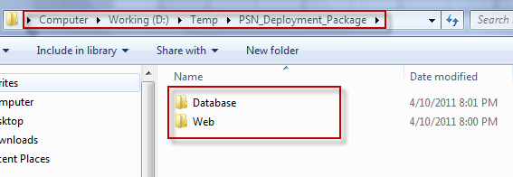

#### Deploy Database

* Open Microsoft SQL Server Management Studio (SSMS)
* Create a database named PSN

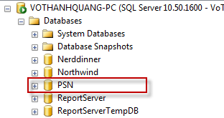

* Open file <deployment\_package>\Database\Schemas\Database Schemal.sql in SSMS
* Change working database in SSMS to PSN

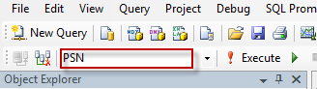

* Press F5 to run the script. Data tables should be created for PSN database

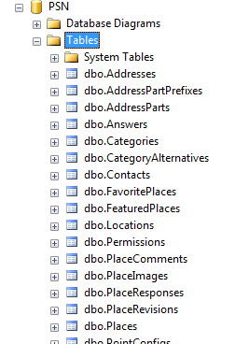

* Open file <deployment\_package>\Database\Data\PSN\_Reference data.sql in SSMS
* Press F5 to run the script. Reference data should be inserted to PSN database. For example the following is data of Permissions table:

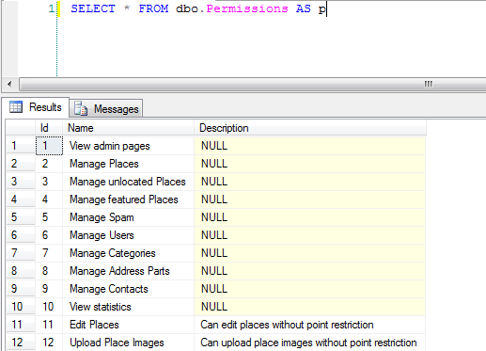

* The database contains one user with login account: [admin@place.vn/123456](mailto:admin@place.vn/123456). This user has full privileges to the system.

#### Deploy web application

* Register ASP.NET with IIS: open command line tool with admin privilege, change working folder to C:\Windows\Microsoft.NET\Framework64\v4.0.30319

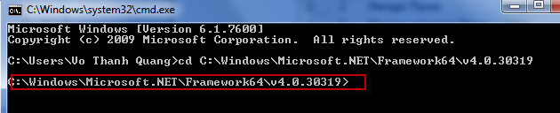

* Type aspnet\_regiis –i and press enter to register ASP.NET 4.0 to IIS

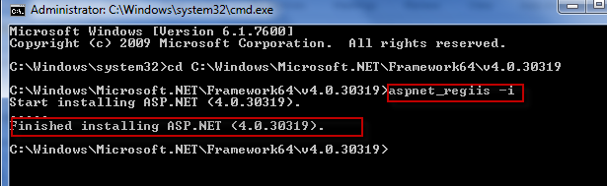

* Open IIS by opening start menu, type iis and press enter

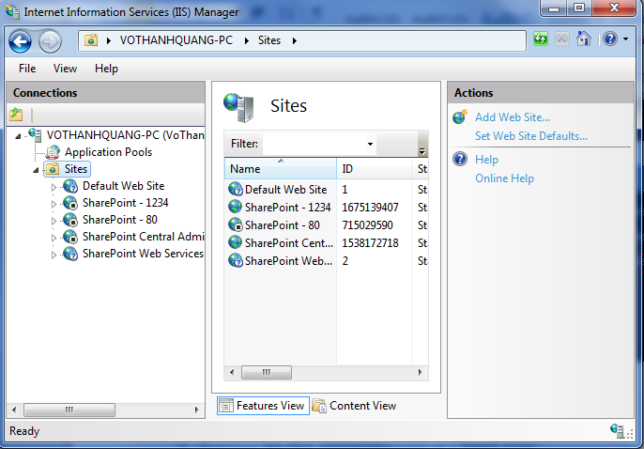

* Select Application Pools menu on the left menu bar, then select DefaultAppPool, click on Advanced Settings menu on the right bar, then open Identity window, choose Built-in account as LocalSystem:

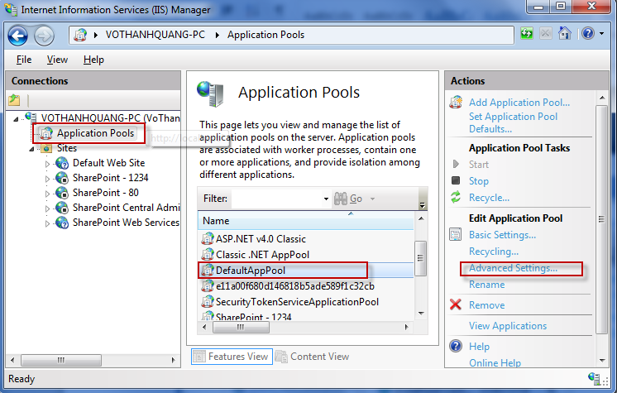

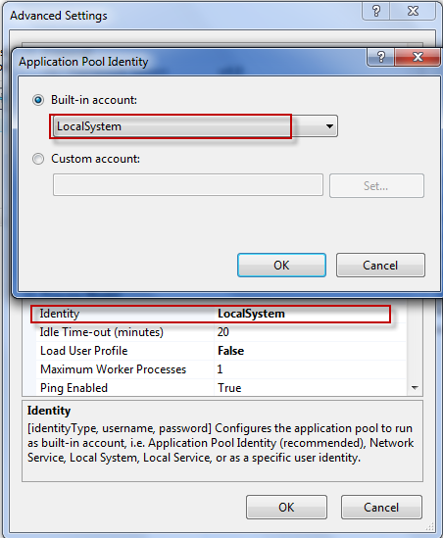

* Copy contents of <deployment\_package>\Web folder to another working folder. This folder will be the physical path of the web app. For example: D:\Apps\PSN

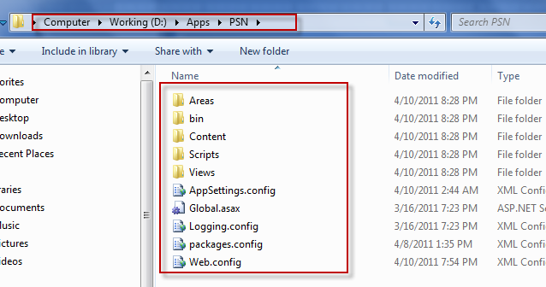

* Back to IIS Manager windows, create an application for Default Web Site named psn

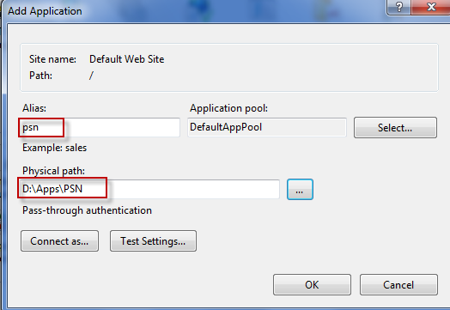

* Test the application by entering localhost/psn/ in to address bar of the browser. The application should show up:

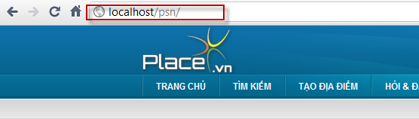

* Try logging in with admin account: [admin@place.vn/123456](mailto:admin@place.vn/123456). The system should log you in successfully.

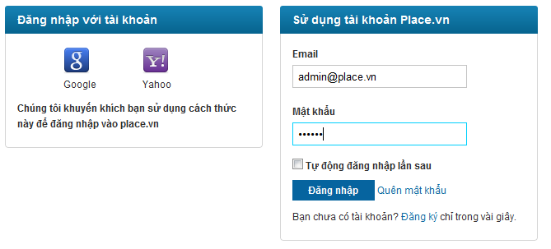

#### Change configurations

##### **Change logging config**

* Open file Logging.config in the application physical path
* Change the log files for errors and general to an absolute file path or relative file path to the application

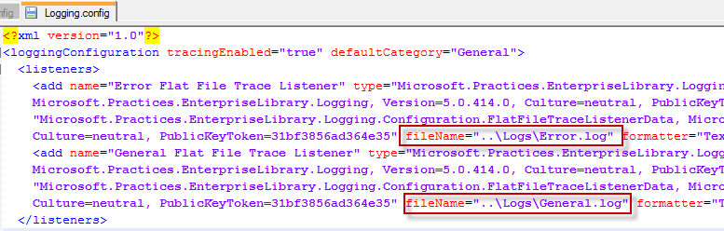

##### **Change system config**

* Open file AppSettings.config in the application physical path

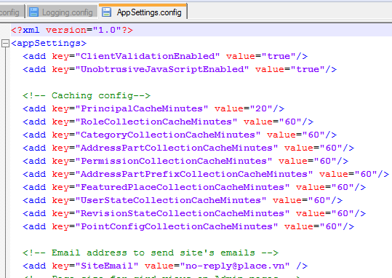

* Change config values appropriately

### Setting up the environment at Client side

The system is accessed via web browsers. The client machine should be installed with one of the following browsers: Firefox 3.0 and higher, Chrome, Internet Explorer 7.0 and higher, Opera 11 and higher.

## User’s Guide

### General Guide

#### Login

##### **Login with Google or Yahoo account**

**Method 1:**

There are some actions that require the user to be logged in. A message will show up as following:

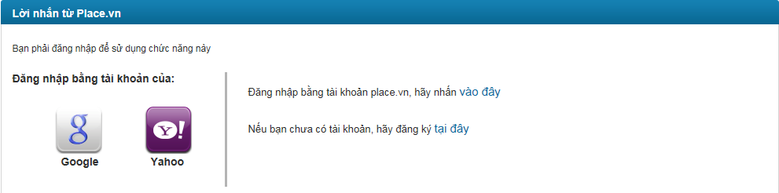

Click on Google or Yahoo icon to login with those providers’ accounts.

**Method 2**:

Click “Đăng nhập” button at the top of the page:



The user will be redirected to the login page

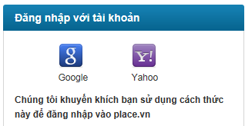

Click Google or Yahoo icon.

Notice: If this is the first time you login into website, you will be redirected to login page of Google or Yahoo. After you enter username and password and click sign in, you need to confirm to use your existing account to login place.vn.

##### **Login with PSN account**

**Method 1:**

There are some actions that require the user to be logged in. A message will show up as following:



Click “vào đây” hyperlink and you will be redirected to login page

**Method 2**:

You can click “Đăng nhập” button at the top of the page



You will be redirected to login page

Login page:

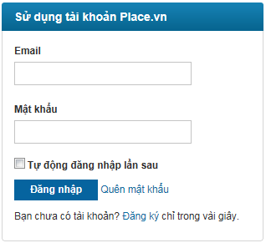

Enter your email and password and click “Đăng nhập” button to log into our system.

You can check “Tự động đăng nhập lần sau” box to save time of logging into the system again later.

#### View your profile

Click your username at login panel at the top right corner of the website will get you redirected to your Profile page. This page has 2 tabs as the following picture:

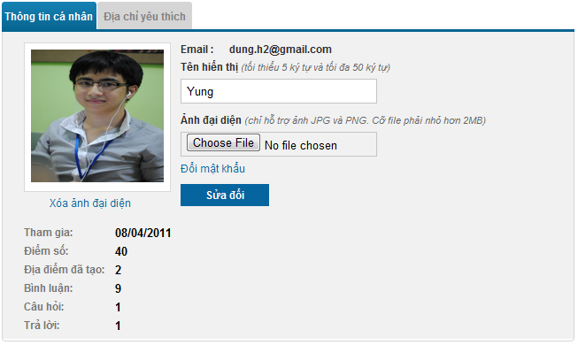

* “Thông tin cá nhân” tab
* At this tab, you can view some information of yourself: email, registered date, current point, number of places created, number of comments, questions and answers posted. Besides, you can easily change other information including: Display Name, Avatar and password.
* After changing some information, you have to click “Sửa đổi” button to save the changes.
* You can change your avatar but its type must be JPG or PNG and its size must be smaller than 2MB.
* If you want to change password, you can click “Đổi mật khẩu” hyperlink, a popup will appear.

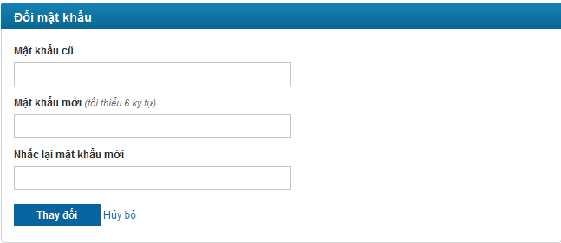

You have to type old password, new password and confirmed password before clicking “Thay đổi” button to change password. If you want to cancel this action, you can click to “Hủy bỏ” hyperlink to redirect to View Profile page.

* “Địa chỉ yêu thích” tab

All your favorite places will be shown at here. Each place has place name, rating, address, comment number and view number.

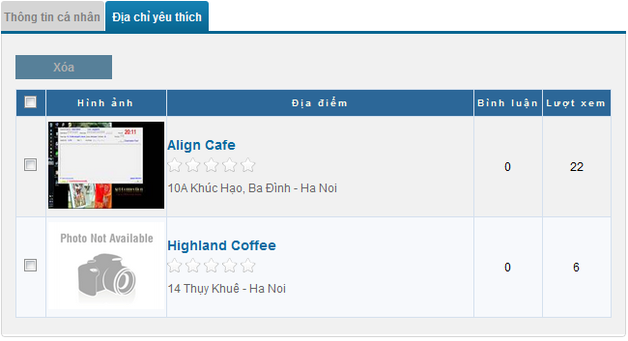

Each place’s name is a hyperlink which allows you to [view place details](#_View_place_details_1) information. You can also delete some places from list by tick boxes beside place which you want to delete and click to “Xóa” button at the top of list. You can check all boxes quickly by tick first checkbox which besides “Hình ảnh” title.

#### Quick Search

Search is the most used function in almost every website. You can access to this page quickly by click to “Tìm kiếm” button at navigation bar.

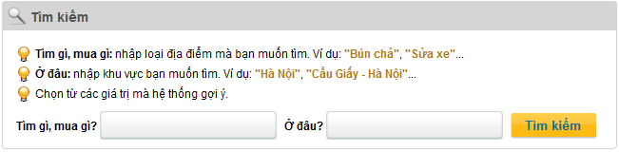

“Tìm gì, mua gì” is for category searching and “Ở đâu” is for address part searching. There is a suggest list displayed below as you typing:

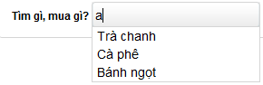

After inputting information, you have to click to “Tìm kiếm” button to begin searching. If there isn’t any result which matches with conditions you typed, you will see a message: “Không tìm thấy địa điểm nào!”

Search engine just focus on Category. So if there isn’t result matches with Address Part typed, all places belongs to Category typed will be displayed. Besides, you can sort results easily by place’s rating, place’s view number and place’s comment number

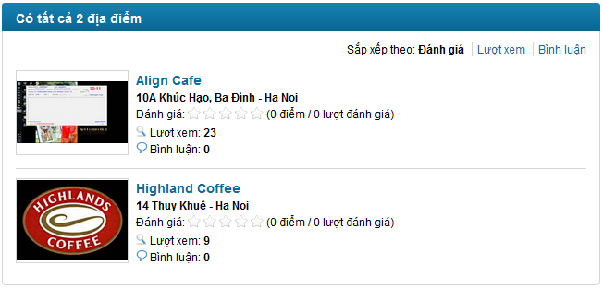

When you click to any place’s name, place’s details information will be displayed at [View Place Details](#_View_place_details_1) page.

#### View place details

View place details page will be divided to 3 parts:

* Information

All information of place will be displayed including: detail address, phone number, category, rating, location on map, view number, visited number, description, images.

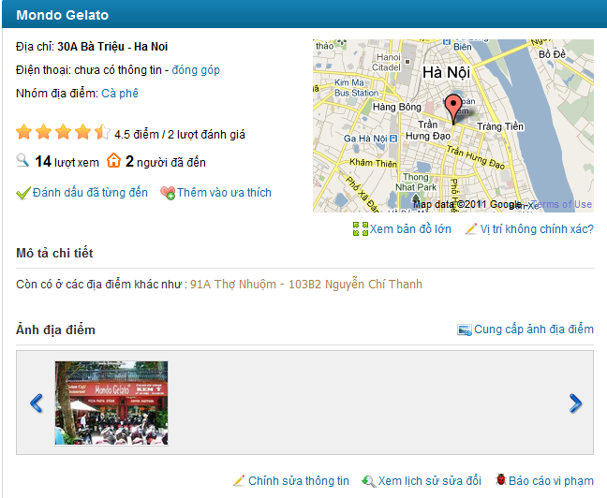

You can:

* Change place information by click to “Đóng góp” or “Chỉnh sửa thông tin” hyperlink.
* If default map is too small with you, you can click to “Xem bản đồ lớn” hyperlink to see larger map.
* if you realize that this place wasn’t located exactly? You can click to “Vị trí không chính xác?” hyperlink and choose location you think it’s true. This can also be done by clicking to “Chỉnh sửa thông tin” hyperlink and edit place location.
* You can upload pictures for current viewing place by click to “Cung cấp ảnh địa điểm” hyperlink.
* You can rate a place base on your opinion.
* If you has visited the place you are viewing in the past, you can click to “Đánh dấu đã từng đến” hyperlink. Visited number make the place is trustable.
* You can add a place to your favorite list
* You Can view edit history of a place

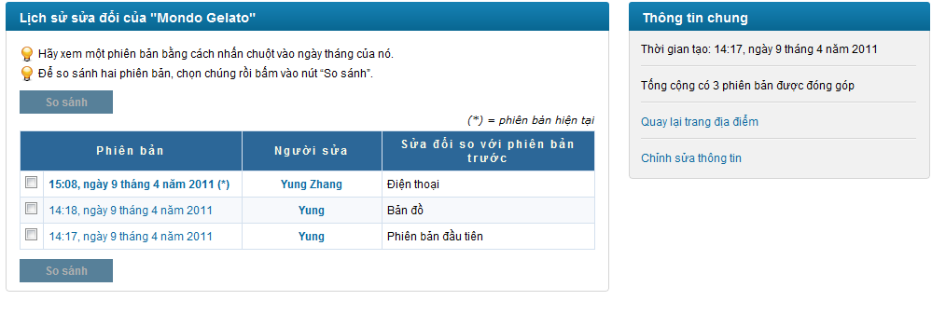

You can view edited information between 2 version by choose 2 revisions and click to “So sánh” button. A new popup will appear and show content of 2 revisions with differences displayed in red background.

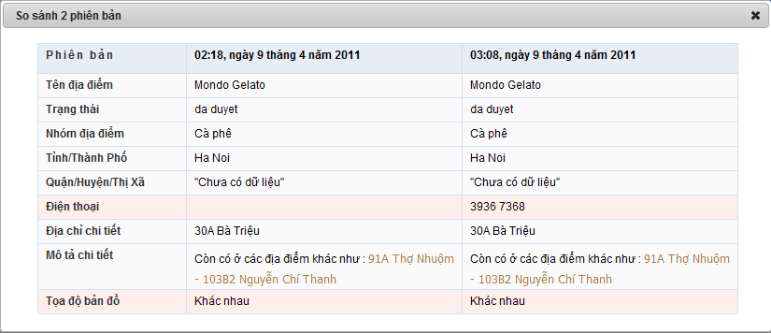

* You can report a place as spam by click to “Báo cáo vi phạm” hyperlink. We always welcome your support to build a better website.
* Comments

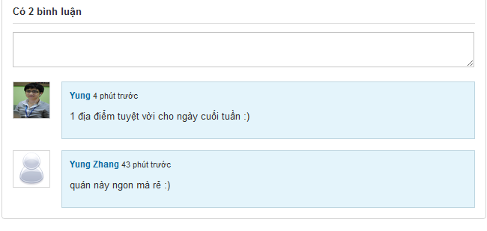

This part displays all comments of current place. Each comment has information of creator, created time and content.

**Take a notice: you need log in first to be able to post, vote, report or delete comments.**

You can vote for comments that weren’t post by yourself by click to thumb up or thumb down symbol. Or you can report it as spam by click to flag symbol.

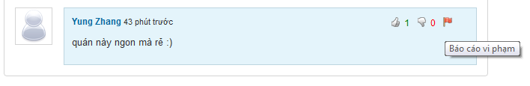

With your own comment, you can’t click to thumb up, thumb down symbol and flag symbol is replaced by X symbol which used for delete your comment

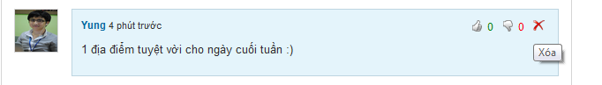

You can post a comment by typing into text box and click to “Bình luận” to or click to “Bỏ qua” button to cancel this action.

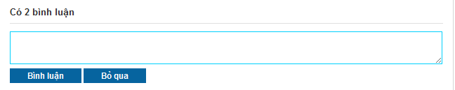

* Suggest other places which has relation to current place

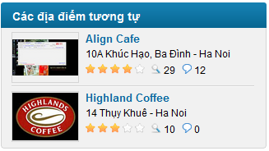

#### View question and answer

##### **View Q&A page**

To view Q&A page, you need click to “Hỏi & Đáp” menu in navigator.



At this page, If you want to create a new question, you can click to “Gửi câu hỏi mới” hyperlink and [“Tạo câu hỏi mới”](#_Create_a_new) page will be opened.

Each question is displayed with: creator, created tine, Title, view number, answer number, vote up and down number

If you want to view question details, click to question title.

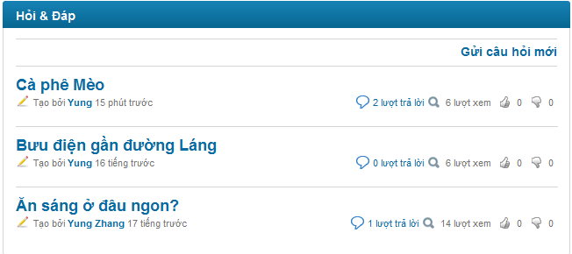

On the right side of Q&A page will show 10 hottest questions (based on views) and most contributors (based on number of answers posted by these users). All information will be updated each hour.

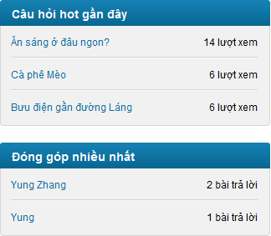

##### **View question details**

Go to question detail page by clicking to question title hyperlink.

**Take notice that:**

* + **You can’t vote for your own question**
  + **You must log in to be able to vote question, report question or post answer.**
  + **You can only edit your own question**

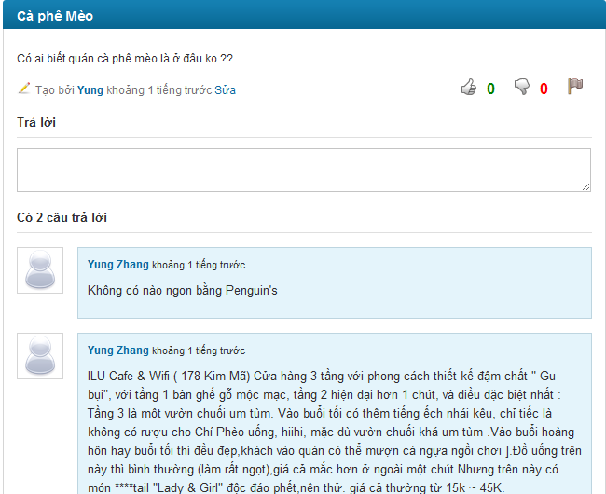

* You can Report question as spam by clicking to “Báo cáo vi phạm” button. You can input reason in pop-up before clicking to “Báo cáo” button (reason isn’t required)

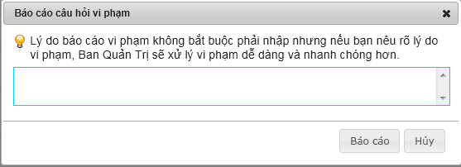

* The way to post answer, vote question, vote answer you can reference to post new comment at [View place details](#_View_place_details)

#### View other user’s profile

To view a user profile, you need to click to that user name (displayed as hyperlink). Other user profile page includes some basic information such as: name, avatar, created date, user point, number of place created by this user, number of comment, question and answer posted by this user.

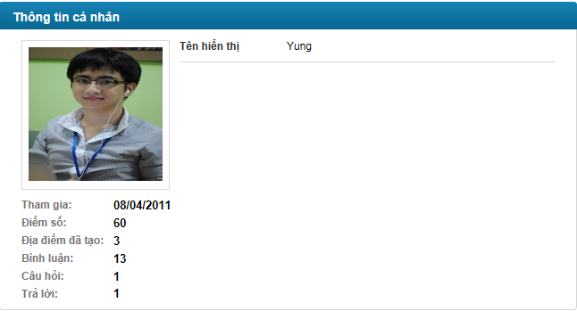

### Form Guide



#### Register a new PSN account and Activation

To be able to access all functions for users on our system, you should register an account or using your Google account or Yahoo account.

Registering a PSN account can be done by following steps:

* Click to “Đăng kí” button on register panel on the top right corner of the website. This panel is always visible for everyone at every page.



* You will be redirected to register page with register form:

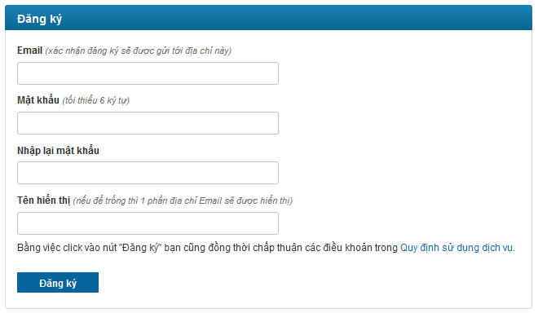

* Enter your valid email. Each email can only be used for registering once. Your mail must be valid in order to get activation email from our system.
* Enter your password and re-enter it again. 2 passwords must be matched
* Enter your desired display user name. If you leave this text box blank, your display user name will be generated from your email address.

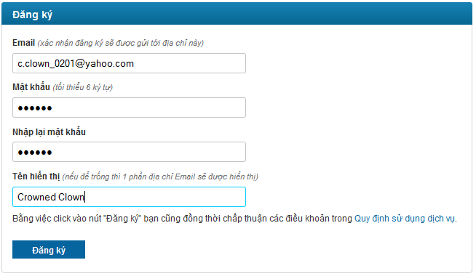

* Click “Đăng ký” button. Success message will be displayed:

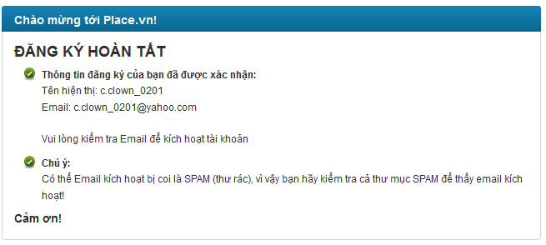

* An activation email will be sent to your registered email address

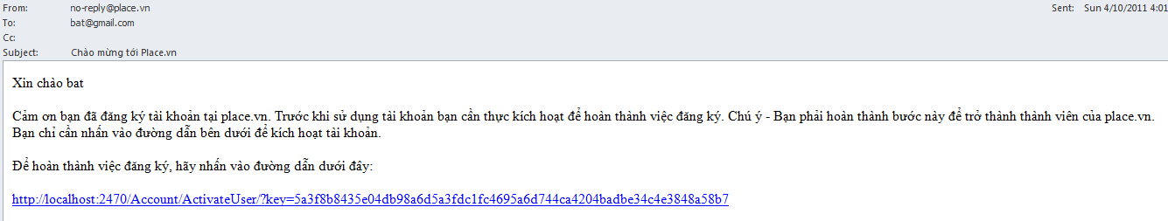

* Click to hyperlink in email and your account will be active

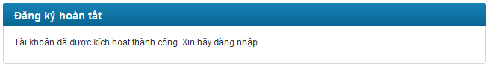

#### Forgot password

This feature is just used with Place.vn account.

Sometimes because of any reason, you forget password, so you can’t login to website by place.vn account. Don’t worry because you can recover password by following steps:

* Click “Đăng nhập” button at the top of the page



* You will be redirected to login page



* Click “Quên mật khẩu” button.

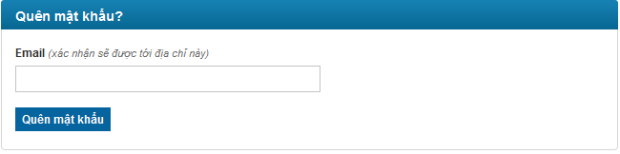

* Enter your email and click “Quên mật khẩu” button. Success message will be displayed

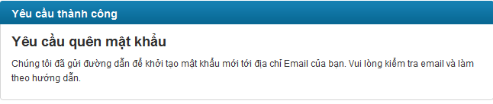

* Confirmation email will be sent to your registered email address

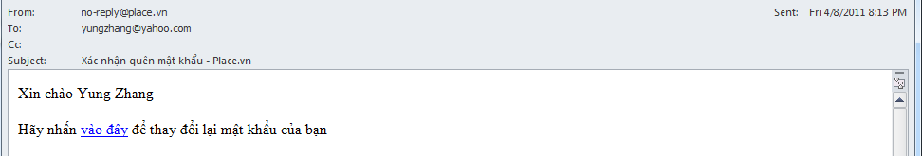

* Click to “vào đây” hyperlink in email
* Enter your password and re-enter it again. 2 passwords must be matched. Click “Thay đổi” button

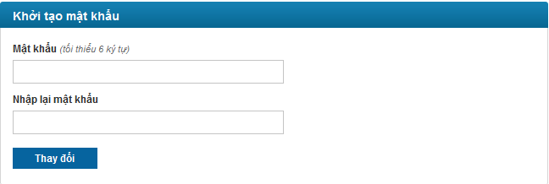

* Success message will be displayed

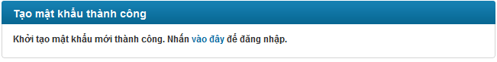

* You can login with your PSN account and above password.

#### Create a new place

* To create a new place, click to “Tạo địa điểm” in the main menu at head page.



* You will be redirected to Create Place Page.

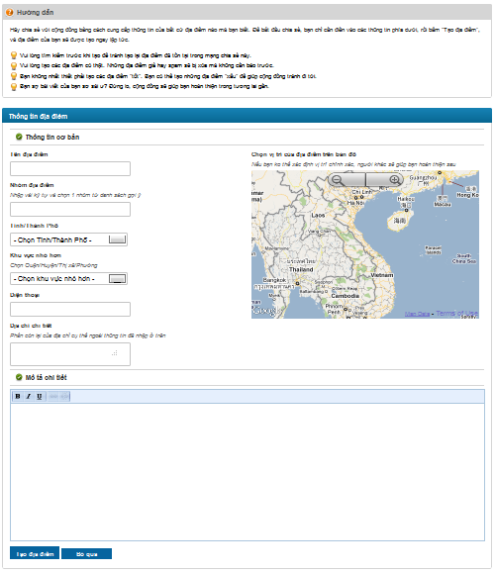

* First, fill in basic information for new place as following form:

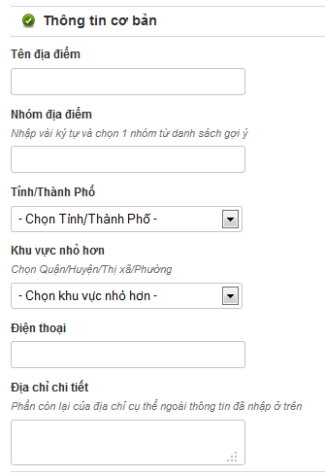

* + “Tên địa điểm”: enter place name. This is required and must be lesser than 200 characters
  + “Nhóm địa điểm”: enter place category. This is required. There will be a suggest list displayed below as you typing into the text box. You must choose 1 category from suggested list. If your category is different, you can’t create a new place. You can only create place for valid categories in the system

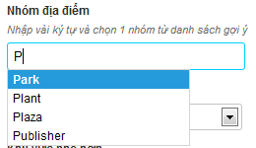

* + “Tỉnh/Thành phố”: choose province or city from list. You can’t enter new province or new city
  + “Quận/huyện/thị xã/phường”: choose district, town and ward from list. You can’t enter new district, new town or new ward.
  + “Điện thoại”: enter place phone number
  + “Địa chỉ chi tiết”: enter place detail address, all remains part of place’s address except parts that was selected from 2 combo boxs above.
* Fill in detail description, comment, review… about new place:

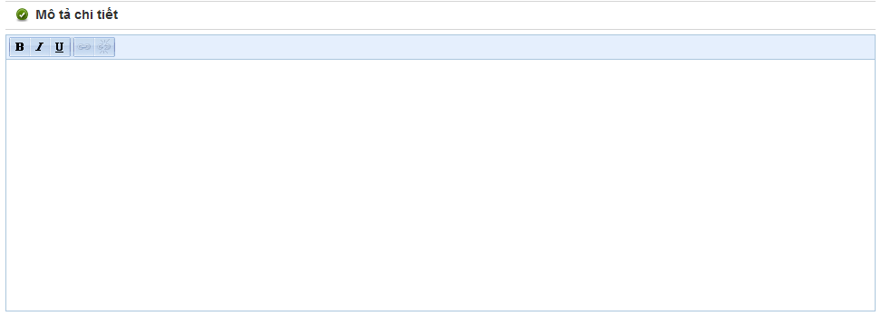

* Mark the place in map

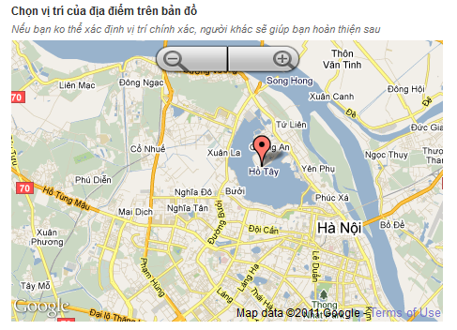

* Final, click to “Tạo địa điểm” button or cancel creating by click to “Bỏ qua” button. Click to “Tạo địa điểm” button will redirect you to detail page of new place. Click to “Bỏ qua” button will redirect you back to home page.

#### Create a new question

* To create a new question, first you need to go to “Hỏi & Đáp” page by clicking to “Hỏi & Đáp” tab in main menu at head page



* You will be redirect to Q&A page. At Q&A page, click to “Gửi câu hỏi mới”.

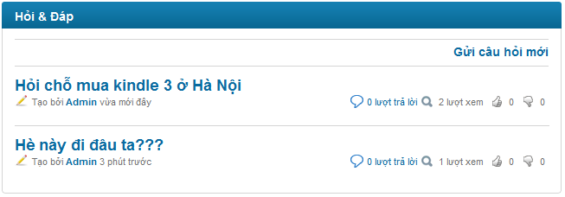

* You will be redirect to Create Question page

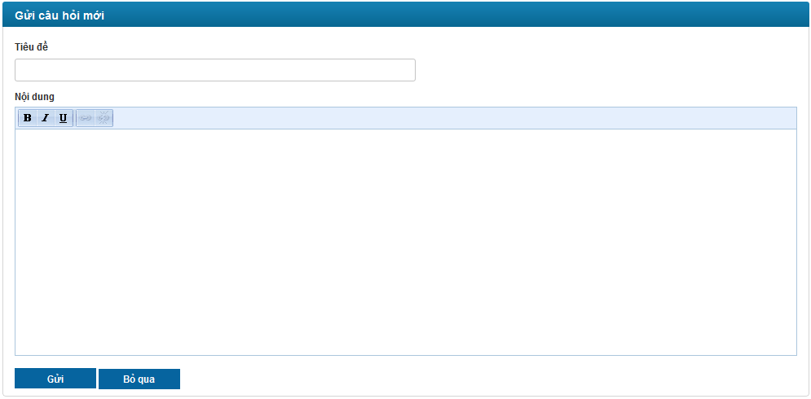

* + “Tiêu đề”: enter question’s title. This is required and must be lesser than 100 characters
  + “Nội dung”: enter question’s content. This is required.
* Click to “Gửi” button to post new question. You will be redirect to Question Detail page of new question
* If you don’t want to post new question. Click to “Bỏ qua” button and get redirected back to Q&A page

#### Create an answer

You can post answer for question by enter answer content into text area below “Trả lời”.

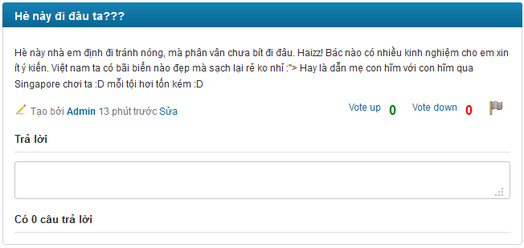

Click to text area, 2 button will appear: “Trả lời” and “Bỏ qua”

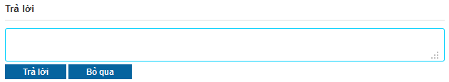

Enter your answer. Take notice that you can’t post a blank answer.

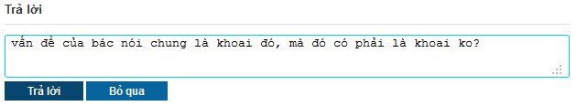

Click to “Trả lời” button, your answer will be posted and displayed at answer area. If you don’t want to post your answer anymore, click to “Bỏ qua” button and answer text box will be back to normal.

#### Create a new contact

You can contact with us by create new contact. Do as following:

* Click to “Liên hệ” tab at bottom of web page



* You will be redirect to Contact page

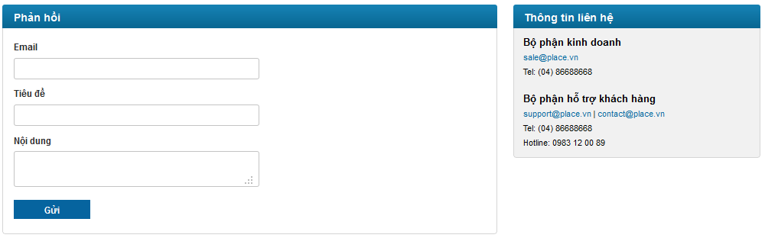

* Fill in your email address. This address must be valid in order to get our reply.
* Fill in the title and content of the message you want to send to us
* Finally, click to “Gửi” button

### Admin Guide



#### Manage Places



##### **Unlocated Places**

All unlocated places will be displayed in this page. To locate any place, you click to “Set location” button at row which contains that place.

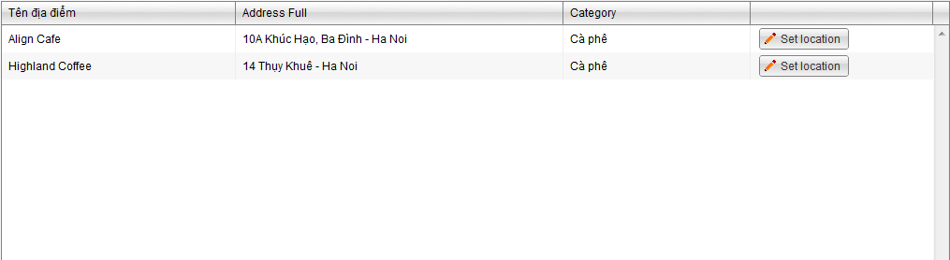

You choose location in the map which is displayed in pop-up then click to “Save” button. So message “location set successfully” will replace position of Set location button. Press F5 and that place will be removed from list of this page.

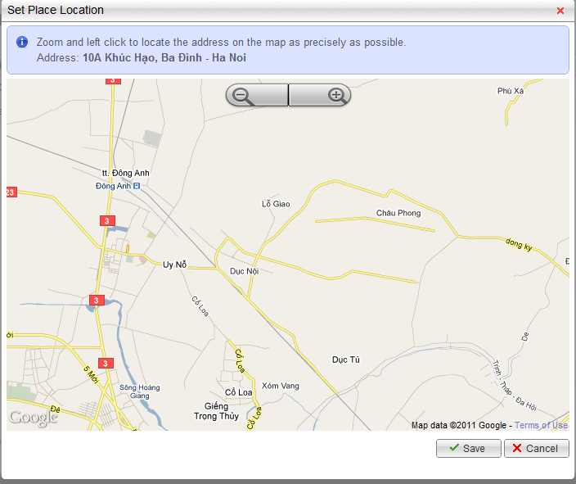

##### **Featured Places**

Featured place is place which has paid to have high rank in searching result of any category in a period of time.

You can create new featured place by clicking to “Create a new record” button. Next, input required information including:

* Place Id: id of place. When you input this Id, Place Name will be displayed automatically at the Place Name field. (Default value is 0)
* Category Name: category which place belongs to.
* Rank: rank you want place has (only from 1 to 3)
* Valid From: beginning of featured time.
* Valid To: ending of featured time. This time must later than Valid From

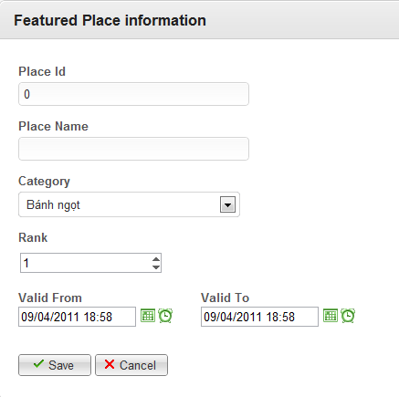

After inputting all required information, click “Save” button to finish. This place will be display at the list of Featured Places immediately. You can edit or delete this place anytime you want.

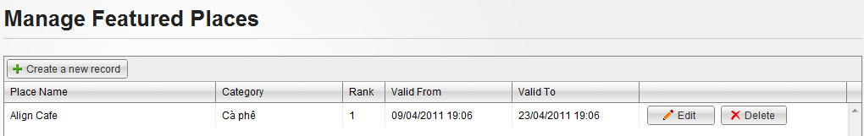

#### Manage Spam

Go to Admin page and click to Spam menu on the right side to see 4 sub menus: Reported Places, Reported Comments, Reported Questions and Reported Answers. Click to 1 of 4 sub menus to go to correspond manage page.

##### **Manage Reported Places**

This page will display places reported as spam

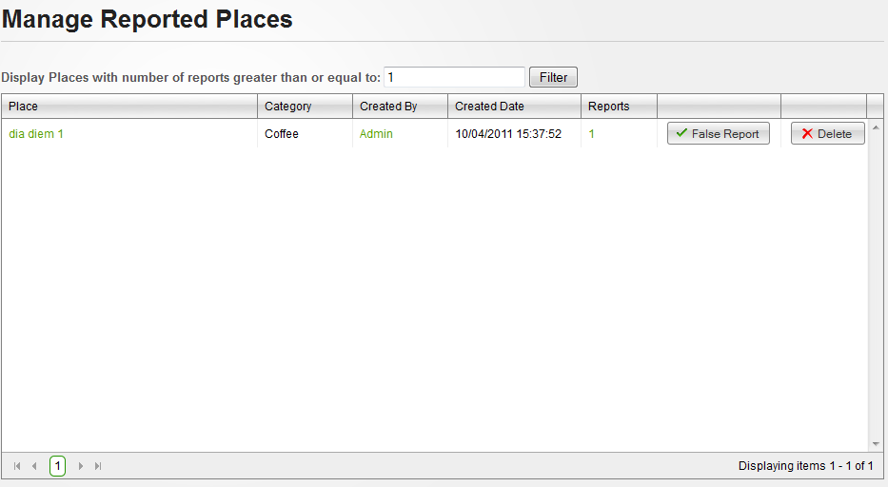

Each reported place will be displayed with place name, place’s category, place’s creator name, place’s created date, number of times get reported and 2 button “False Report” and “Delete”

There is a filter helps you get reported places with expected report number:



You can click to place name hyperlink to view detail reported place, click to creator name hyperlink to view information about the creator or click to report number to view detail of all reports (Who report, when and what reason) in a popup

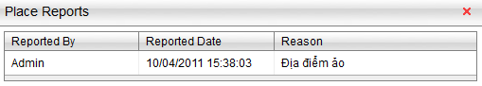

After checking all need information. If you decide that the place was falsely reported, click to “False Report” button to delete all reports belong to selected place. If not, click to “Delete” button to delete selected place and all reports belong to it.

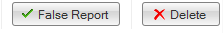

##### **Manage Reported Comments**

This page will display comments reported as spam

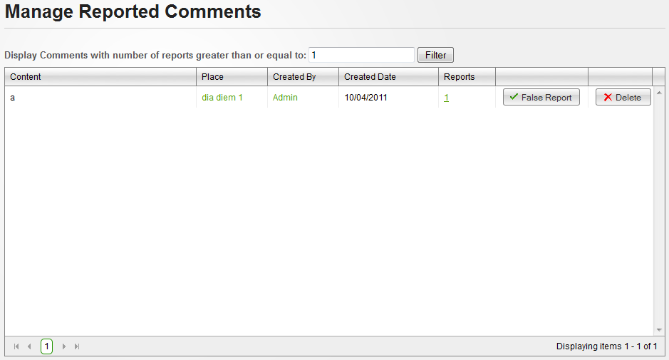

Each reported comment will be displayed with content, comment’s place, comment’s creator name, comment’s created date, number of times get reported and 2 button “False Report” and “Delete”

There is a filter helps you get reported comment with expected report number:



You can click to place name hyperlink to view detail of the place the comment belong to, click to creator name hyperlink to view information about the creator or click to report number to view detail of all reports (Who report, when and what reason) in a popup

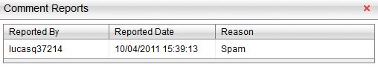

After checking all need information. If you decide that the comment was falsely reported, click to “False Report” button to delete all reports belong to selected comment. If not, click to “Delete” button to delete selected comment and all reports belong to it.



##### **Manage Reported Questions**

This page will display questions reported as spam

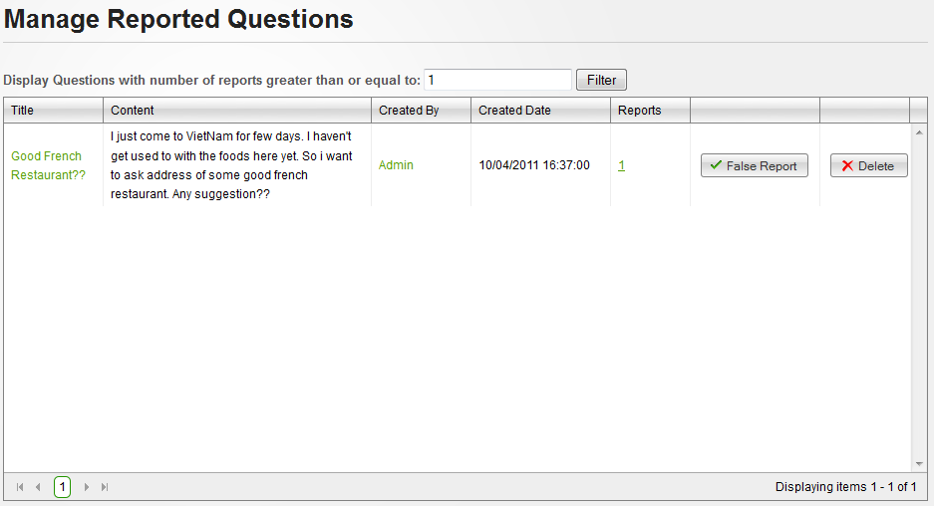

Each reported question will be displayed with question title, content, creator name, created date, number of times get reported and 2 button “False Report” and “Delete”

There is a filter helps you get reported questions with expected report number:



You can click to question title hyperlink to view detail reported question, click to creator name hyperlink to view information about the creator or click to report number to view detail of all reports (Who report, when and what reason) in a popup

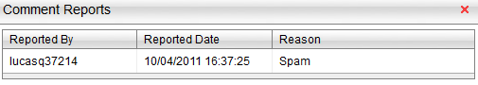

After checking all need information. If you decide that the place was falsely reported, click to “False Report” button to delete all reports belong to selected question. If not, click to “Delete” button to delete selected question and all reports belong to it.



##### **Manage Reported Answers**

This page will display answers reported as spam

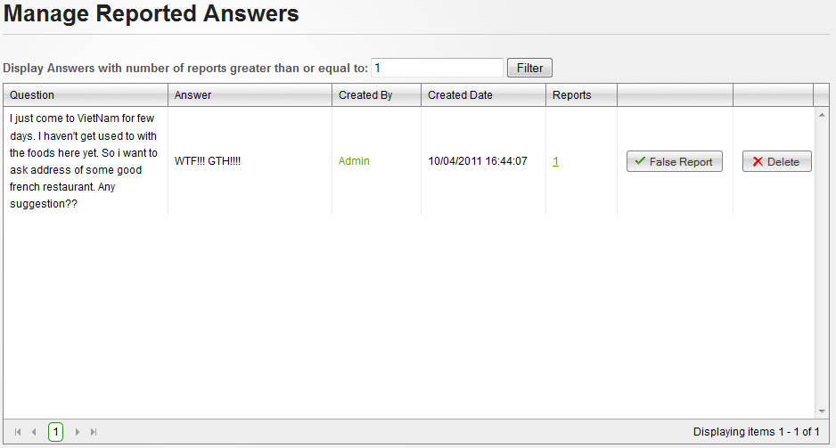

Each reported answer will be displayed with question content, answer content, answer’s creator name, answer’s created date, number of times get reported and 2 button “False Report” and “Delete”

There is a filter helps you get reported answers with expected report number:



You can click to creator name hyperlink to view information about the creator or click to report number to view detail of all reports (Who report, when and what reason) in a popup

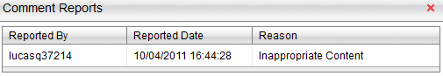

After checking all need information. If you decide that the place was falsely reported, click to “False Report” button to delete all reports belong to selected answer. If not, click to “Delete” button to delete selected answer and all reports belong to it.



#### Manage Users



##### **Manage Users**

This page manages all users existed in the sytem.

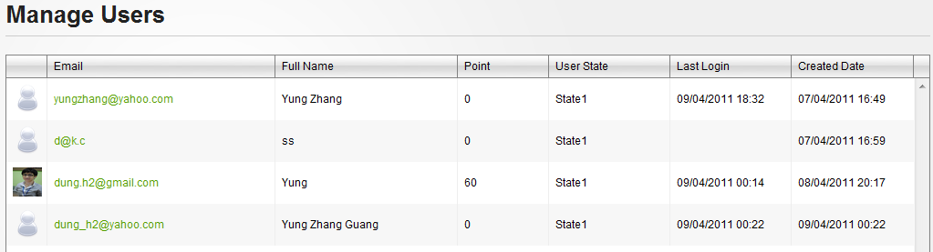

You can view user details by clicking to Email hyperlink of any user you want. View Details User page will appear including some information: Email, Full Name, Point, User State, Roles, Last Logged in, and Registered Date. At this page, you can delete user by clicking to “Delete” button or click to “Edit” button to change user’s information.

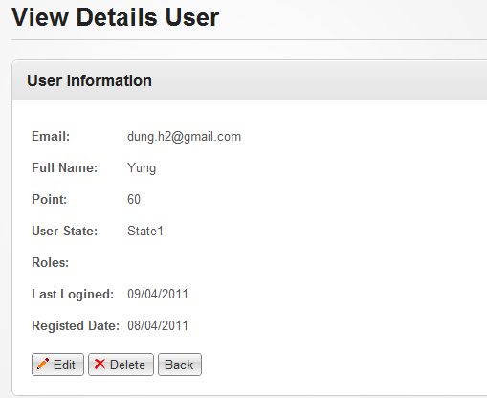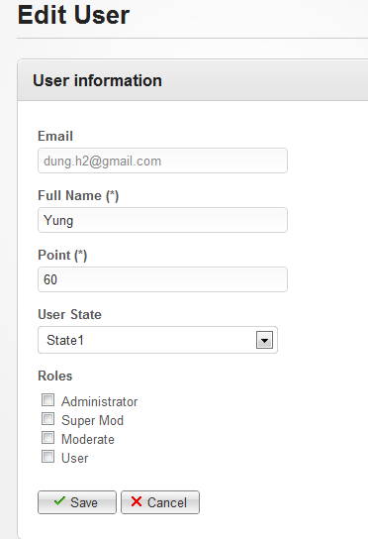

At Edit User page, you can change all user’s information except email. Click to “Save” button to save changes or “Cancel” to return to previous page.

##### **Manage Roles**

This page manages all roles which are used in website. You can delete any role by clicking to “Delete” button at same row which contains that role.

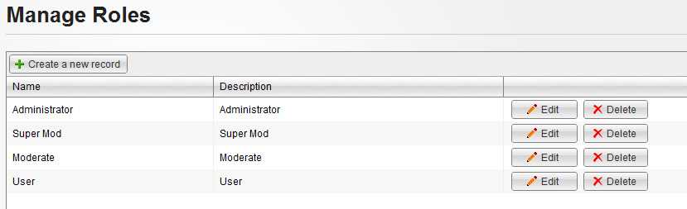

If you want to create a new role: click to Create a new record at the below of title page. Create a Role page will appear as the below picture. Name is required and must not exist in database while Description and Permission are not. Finally, you have to click to “Save” button to finish creating. A notification will be displayed at the top of page, announce creating successfully.

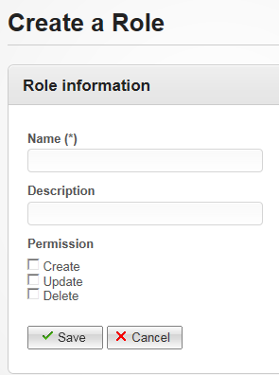

If you want to change some information of created role in the past, click to Edit button at same row which contains that role. Edit a role page will appear as same as the below picture. You can change anything you want before clicking to Save button to confirm changes.

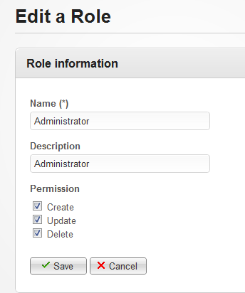

#### Manage Categories

This page manages all categories which are used in website. You can delete any category by clicking to “Delete” button at same row which contains that category.

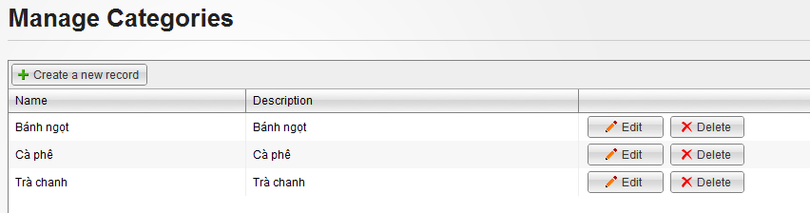

If you want to create a new category: click to Create a new record at the below of title page. Create a Category page will appear as the below picture. Name is required and must not exist in database while Description and Alternative Names are not. Finally, you have to click to “Save” button to finish creating. A notification will be displayed at the top of page, announce creating successfully.

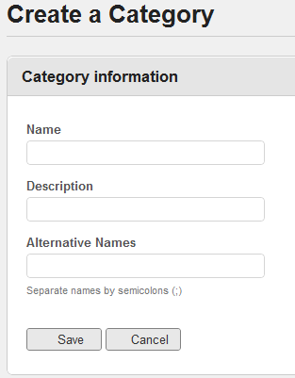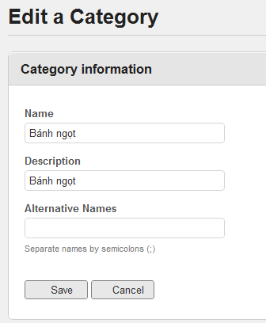

If you want to change some information of created category in the past, click to Edit button at same row which contains that category. Edit a category page will appear as same as the below picture. You can change anything you want before clicking to Save button to confirm changes.

#### Manage Address Parts

This page manages all address parts which are used in website. You can delete any address part by choosing that address in the tree then clicking to “Delete” button at the bottom.

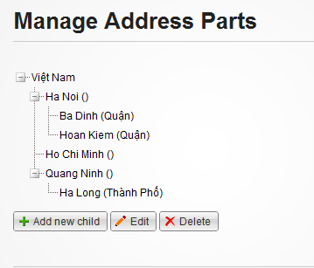

If you want to create a new address part: click to Add new child at the bottom of tree view. Create an Address Part page will appear as the below picture. You can input Name and Prefix, locate address on the map. Finally, you have to click to “Save” button to finish creating. A notification will be displayed at the top of page, announce creating successfully.

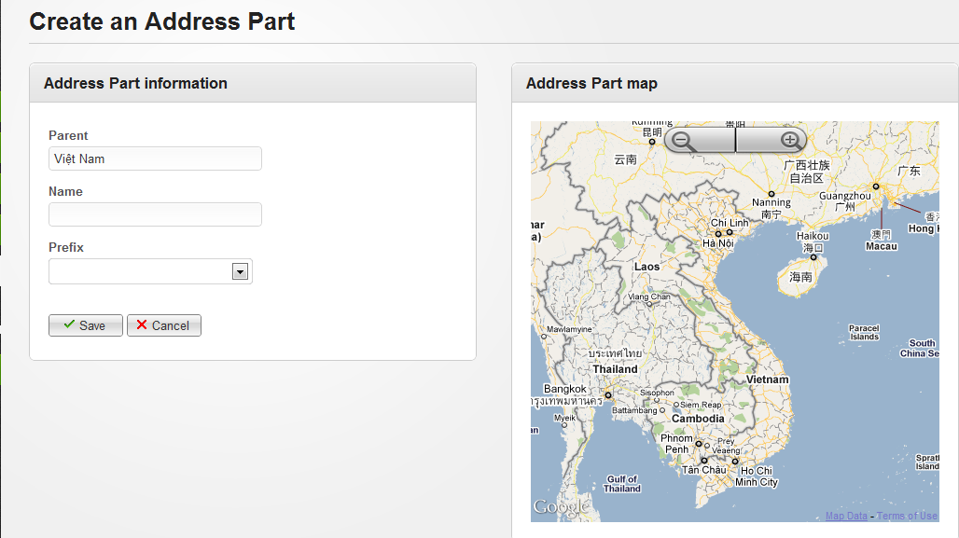

If you want to change some information of created address part in the past, choose that address part and click to “Edit” button at the bottom of page. Edit Address Parts page will appear as same as the below picture. You can change anything you want before clicking to Save button to confirm changes.

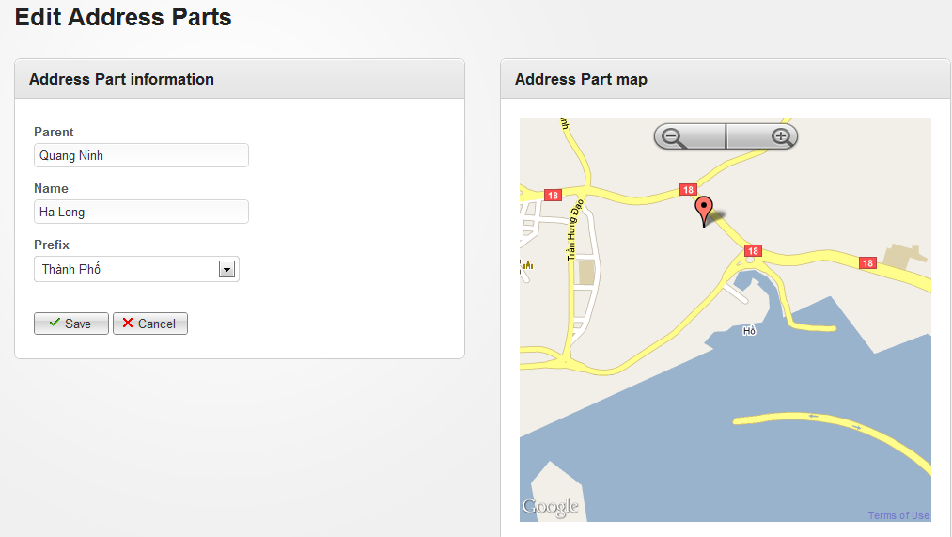

#### Manage Contacts

This page manages all contacts which are sent from user. You can sort them follow conditions: Checked, Uncheck and All by choosing any condition in drop down list then clicking to “Filter” button.

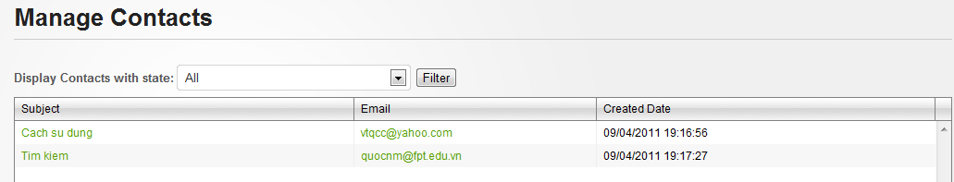

You can view contact details by clicking Subject hyperlink of any contact. You can see Subject and content of message. After reading, you click to “Mark as Checked” so that we can ignored it at another checking. You can also click to Email hyperlink at Manage Contacts page to send your reply to that user.

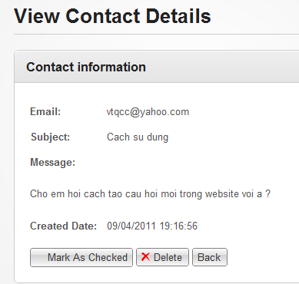

# Appendix

## Glossary

None

## References

[1] Google Places:

<http://www.google.com/places/>

<http://places.google.com/business>

[2] Facebook Places:

<http://www.facebook.com/places/>

[3] Thodia.vn:

<http://thodia.vn/hcm>

[4] Infomap.vn

<http://infomap.vn/ha-noi/home.html>

[5] Diadiem.com

<http://www.diadiem.com/vn/>

[6] Waterfall model:

<http://en.wikipedia.org/wiki/Waterfall_model>

[7] .NET Naming Guidelines:

<http://msdn.microsoft.com/en-us/library/ms229002.aspx>

[8] FxCop rules and Code Analysis for Managed Code Warnings

<http://msdn.microsoft.com/en-us/library/ee1hzekz.aspx>

[9] Wikipedia, 2011, 'Use case', 8 February, viewed 10 February 2011

<http://en.wikipedia.org/wiki/Use_case>

[10] Jeff Atwood,  2011, 'Suggested Edits and Edit Review' blog, February 5th, Stack Exchange, viewed 10 February 2011

<http://blog.stackoverflow.com/2011/02/suggested-edits-and-edit-review>

[11] Microsoft, ' ASP.NET MVC Framework ', viewed 18 February 2011

<http://www.asp.net/mvc/whatisaspmvc>

[12] MSDN, ' UML Class Diagrams: Guidelines ', viewed 18 February 2011

<http://msdn.microsoft.com/en-us/library/dd409416.aspx>

[13] MSDN, ' UML Sequence Diagrams: Guidelines ', viewed 18 February 2011

<http://msdn.microsoft.com/en-us/library/dd409389.aspx>

[14] Wikipedia, ' Dependency Injection ', viewed 18 February 2011

<http://en.wikipedia.org/wiki/Dependency_injection>